For the analyses of the climatic variables, two time periods were chosen: 30 years (to trace the long-lasting climatic effects) and 30 days (short weather effect, on average over a couple generations for different localities, to account for maternal/grand-maternal effects). 14 climatic variables data (see the list below) was downloaded from the NASA database using R package “nasapower” and PCA analysis was done with “FactoMineR” package.

List of the climatic variables used in PCA:

TS Earth Skin Temperature (C)

T2M Temperature at 2 Meters (C)

QV2M Specific Humidity at 2 Meters (g/kg)

RH2M Relative Humidity at 2 Meters (%)

T2MDEW Dew/Frost Point at 2 Meters (C)

T2MWET Wet Bulb Temperature at 2 Meters (C)

TS_MAX Earth Skin Temperature Maximum (C)

TS_MIN Earth Skin Temperature Minimum (C)

T2M_MAX Temperature at 2 Meters Maximum (C)

T2M_MIN Temperature at 2 Meters Minimum (C)

T2M_RANGE Temperature at 2 Meters Range (C)

FROST_DAYS Frost Days (Days)

PRECTOTCORR Precipitation Corrected (mm/day)

ALLSKY_SFC_LW_DWN All Sky Surface Longwave Downward Irradiance (W/m^2)

PCA for 30 days data PCA for 30 years data

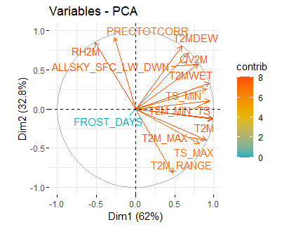 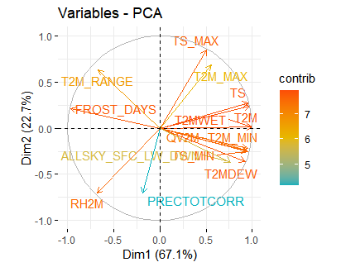

First two PCs in both datasets had eigen values >1 explaining 94.7% (30 days) and 89.8% (30 years) and were used in the further analyses.

PCA for 30 days data PCA for 30 years data

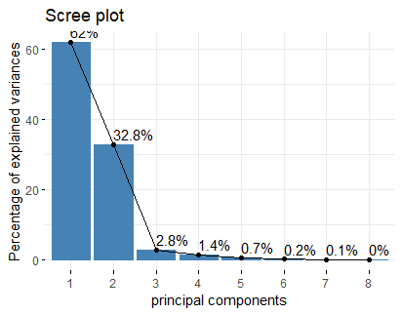 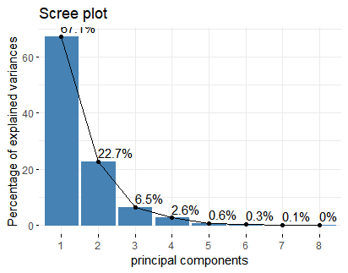

The populations are separated in two dimensions rather differently in two datasets - possibly because the short-term climate data (30 days) does not include winter (cold season).

PCA for 30 days data PCA for 30 years data

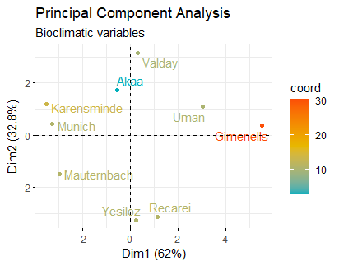 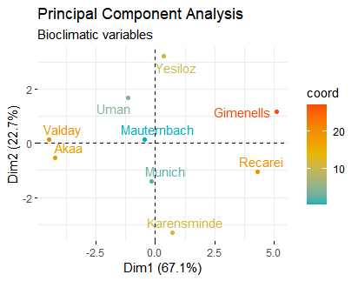

Contribution of PCs

PC1 is mostly affected by the temperature values (but not only), while precipitation/humidity is among strongest contributors to PC2.

PCA for 30 days data PCA for 30 years data

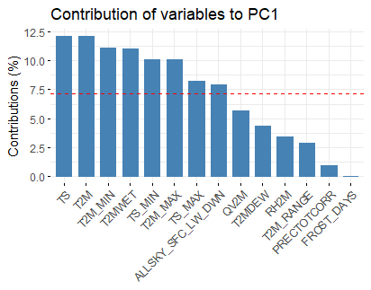 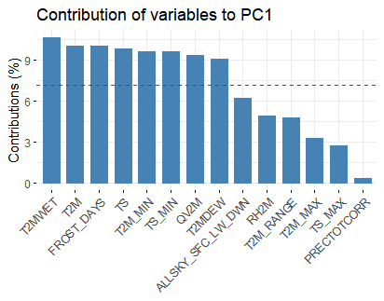

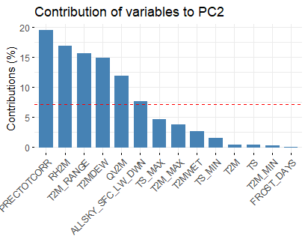 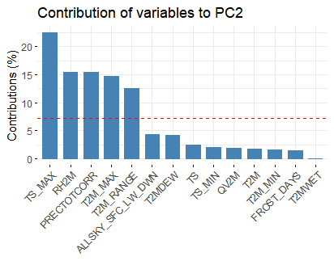

Correlation with geographical coordinates

PCA for 30 days data PCA for 30 years data

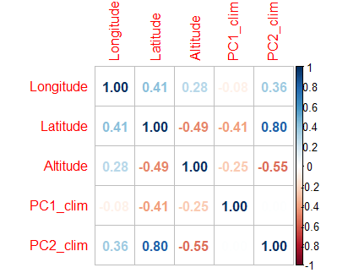 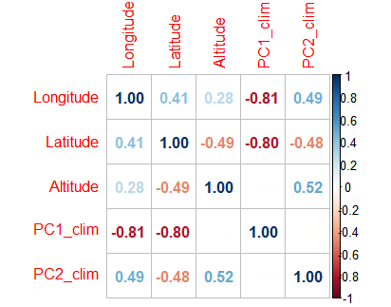

Analysis of the trait PCA (Ewan) with the climate data PCA (above).

|  |  |  |  |  |  |  |  |  |  |  |  |  |  |  |  |
| --- | --- | --- | --- | --- | --- | --- | --- | --- | --- | --- | --- | --- | --- | --- | --- |
| trait PC |  | PC1 | PC1 | PC1 | PC1 |  | PC2 | PC2 | PC2 | PC2 |  | PC3 | PC3 | PC3 | PC3 |
| dataset |  | F9 | M9 | F9max | F9max+ |  | F9 | M9 | F9max | F9max+ |  | F9 | M9 | F9max | F9max+ |
|  | clim PC |  |  |  |  |  |  |  |  |  |  |  |  |  |  |
|  |  |  |  |  |  |  |  |  |  |  |  |  |  |  |  |
| 30 days |  |  |  |  |  |  |  |  |  |  |  |  |  |  |  |
|  |  |  |  |  |  |  |  |  |  |  |  |  |  |  |  |
| Lm | PC1 |  |  |  |  |  | ** | *** | *** | *** |  |  |  |  |  |
|  | PC2 |  | ** |  |  |  | *** | *** | *** | *** |  | * |  |  |  |
|  |  |  |  |  |  |  |  |  |  |  |  |  |  |  |  |
| 30 years |  |  |  |  |  |  |  |  |  |  |  |  |  |  |  |
|  |  |  |  |  |  |  |  |  |  |  |  |  |  |  |  |
| Lm | PC1 |  |  |  |  |  | *** | *** | *** | *** |  | *** | ** | ** | *** |
|  | PC2 |  | *** |  |  |  | *** | *** | *** | *** |  |  | * | * | *** |

|  |
| --- |
| model overdispersed |

There is a strong association of trait PC2 with climate PCs in both datasets. However, the association of the trait PC3 with climate PCs is clear in 30-years dataset (in 30-day dataset - only clim PC2 shows association in F9 set).