Tata Cara Penggunaan Postman:

1. Register (https://final-project-payment.herokuapp.com/api/AuthManagement/Register)

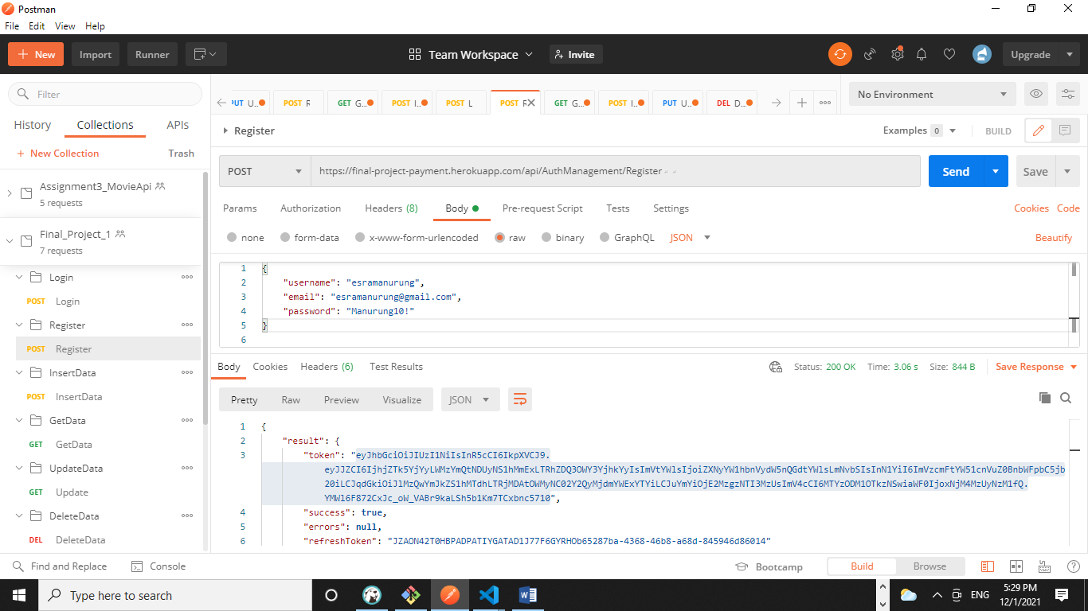

1. Login (https://final-project-payment.herokuapp.com/api/AuthManagement/Login)

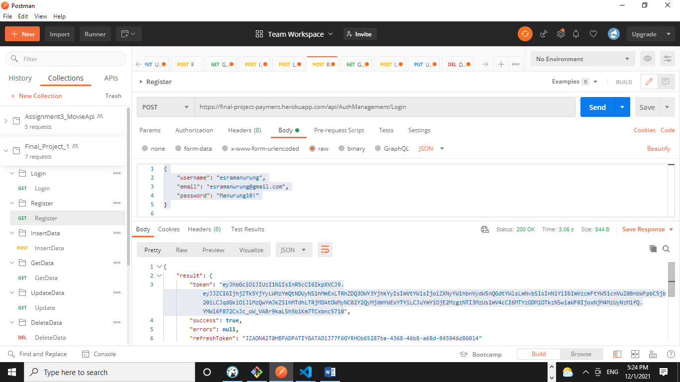

1. InsertData (https://final-project-payment.herokuapp.com/api/Payment)

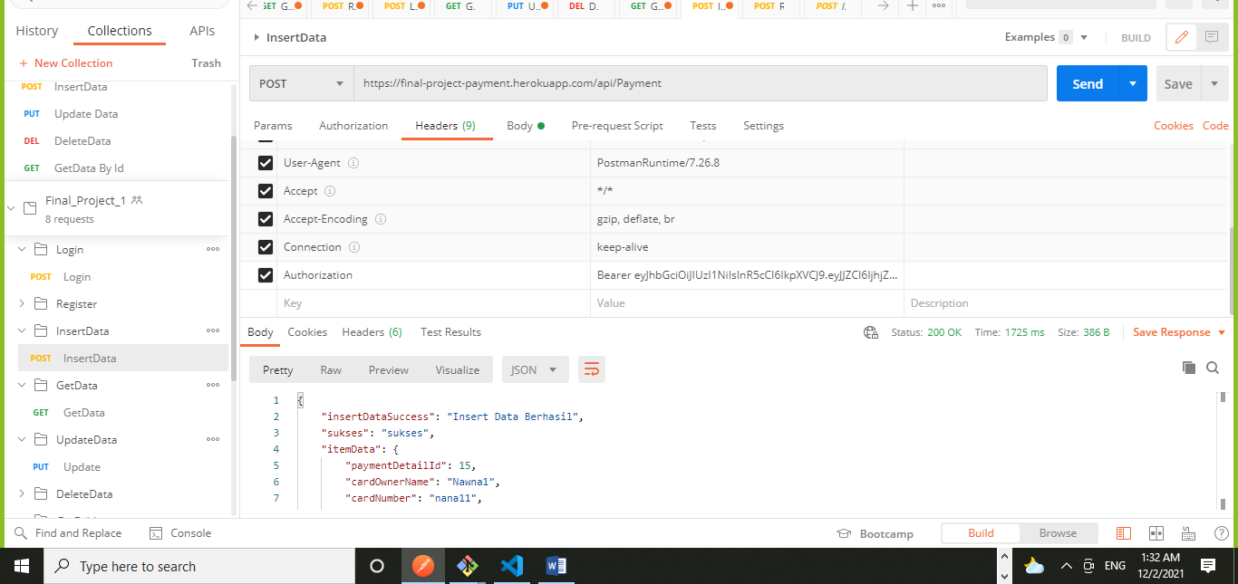

1. UpdateData (https://final-project-payment.herokuapp.com/api/Payment/14)

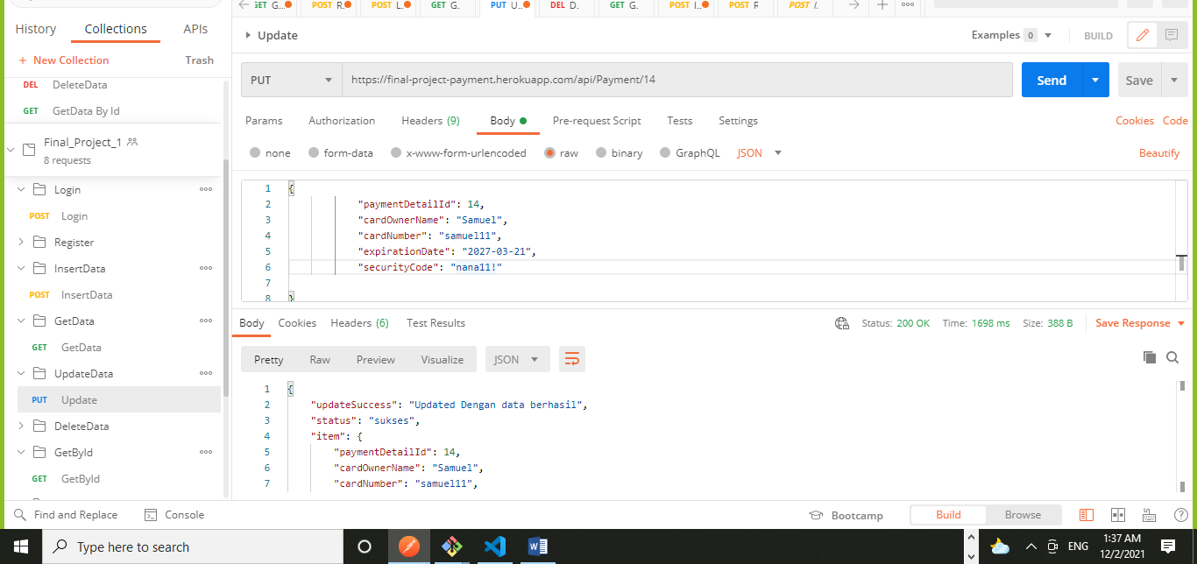

1. Get Data(https://final-project-payment.herokuapp.com/api/Payment)

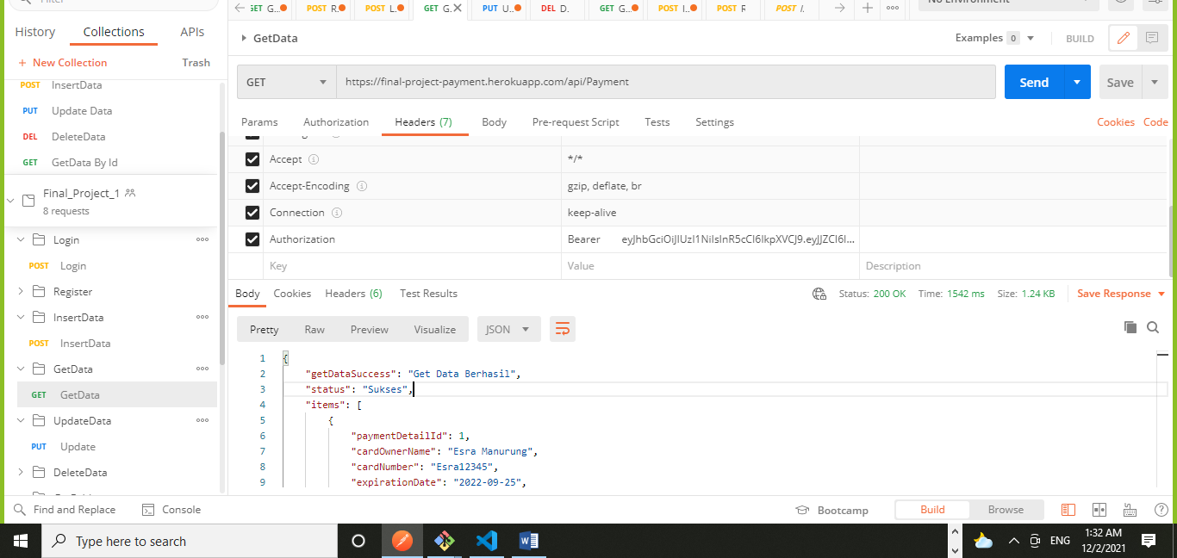

1. DeleteData (https://final-project-payment.herokuapp.com/api/Payment/15)

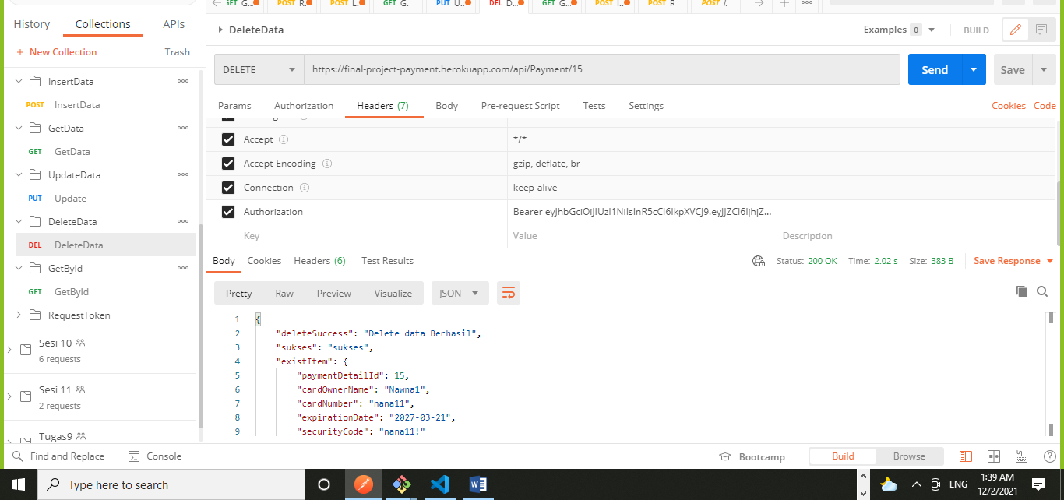

1. GetDataById (https://final-project-payment.herokuapp.com/api/Payment/12)

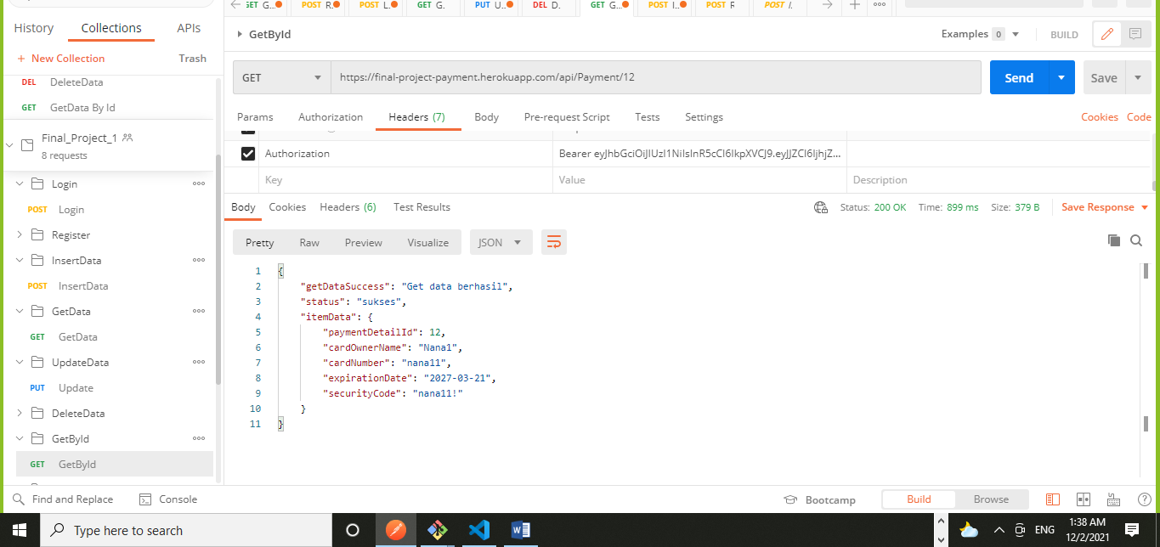

1. Refresh Token (https://final-project-payment.herokuapp.com/api/AuthManagement/RefreshToken)

