Phase 1 Project Report
Skill Gap Analyzer for Data Analyst and Data Scientist Roles
Course: DSA 502 – Data Science with AI
Student: Esrat Jahan
Project Type: NLP / Text Analytics
Phase: Proposal, Data Audit, EDA, and Baseline Model

This Phase 1 report presents the project foundation for a Skill Gap Analyzer that studies real job postings for Data Analyst and Data Scientist roles. The report documents the project motivation, data audit, exploratory data analysis, baseline NLP model, evaluation results, and a concrete plan for Phase 2.

1. Project Overview
The purpose of this project is to analyze real-world job postings and identify the skills most frequently required for Data Analyst and Data Scientist positions. Many students and early-career professionals struggle to understand what employers expect in the job market. As a result, they often learn tools without knowing which ones matter most for the roles they want. This project addresses that problem by using a data-driven approach to summarize market demand and later compare a user’s skills with employer requirements.
The long-term product goal is to develop a Skill Gap Analyzer that accepts a user’s current skills, compares them to real job requirements, and returns a skill match score, a list of missing skills, and short AI-based recommendations for improvement. Phase 1 focuses on building the project foundation: defining the problem, auditing the data, conducting exploratory analysis, and establishing a reproducible baseline model.

2. Problem Statement and Research Question
This project asks: What skills are most frequently required for Data Analyst and Data Scientist jobs, and how can those requirements be used to identify skill gaps for job seekers? The project is motivated by the practical needs of students, career changers, and early-career professionals who want to align their learning with actual job market demand. The baseline analytic task in Phase 1 is to distinguish between Data Analyst and Data Scientist postings using textual job information. This supports the larger goal because it reveals which terms, skills, and descriptions separate the two roles.
The working hypothesis is that both roles will share foundational skills such as Python and SQL, but Data Scientist postings will emphasize machine learning, modeling, and advanced statistical terms more frequently than Data Analyst postings. Data Analyst roles are expected to place relatively more emphasis on reporting, dashboarding, business analysis, and visualization tools.

3. Dataset Description and Data Card Summary

The dataset used in this project was obtained from the Kaggle platform, which provides publicly available datasets for research and educational purposes. Specifically, the project uses the Data Science Job Postings and Skills dataset, which contains job postings related to data science roles. The dataset includes information such as job titles, organizations, job locations, job descriptions, and required technical skills.
To prepare the data for analysis, multiple files from the dataset were merged into a single consolidated table containing job titles, organizations, locations, skill lists, and job summaries. Each row in the dataset represents one job posting. For the Phase 1 analysis, the project focuses specifically on job postings that can be categorized as either Data Analyst or Data Scientist based on keywords in the job title. The merged dataset contains both structured attributes and unstructured textual data, making it appropriate for Natural Language Processing (NLP) techniques used in the baseline model.
Key fields in the dataset include job_title, company, location, job_skills, and job_summary. The target label used in the baseline model, referred to as role_label, was derived from job title keywords rather than provided directly in the original dataset. As a result, the target variable is partially rule-based and should be interpreted with caution. In particular, some job postings may contain hybrid or non-standard titles that blur the distinction between Data Analyst and Data Scientist roles.
Because the dataset is derived from publicly available job postings, the privacy risk associated with the data is minimal. The dataset does not contain personal information about individuals and focuses only on job-related attributes. However, it is important to acknowledge potential limitations and biases in the dataset. Online job postings may reflect platform-specific trends, regional hiring patterns, or industry-specific demands. Consequently, the dataset may not fully represent the entire labor market.
Despite these limitations, the dataset provides a realistic and informative snapshot of current employer demand for data-related skills. It therefore serves as a suitable foundation for analyzing skill requirements and developing the Skill Gap Analyzer system proposed in this project.
Dataset Source:
Kaggle – Data Science Job Postings and Skills Dataset
https://www.kaggle.com/datasets/asaniczka/data-science-job-postings-and-skills

4. Data Audit
A data audit was conducted before modeling to understand the structure, quality, and limitations of the dataset. The audit included review of data shape, column types, missingness, and duplicate behavior. This step is important because the quality of the downstream model depends on the quality of the source data.
The audit identified missing values in some optional fields such as location and job summary. Duplicate checks were performed using the job link field to detect reposted or repeated postings. Sanity checks were also used to validate whether titles, skills, and summary text were consistent enough for downstream text analysis. These checks helped confirm that the dataset was suitable for a Phase 1 prototype, while also revealing areas that should be improved during Phase 2.

5. Exploratory Data Analysis (EDA)
Exploratory Data Analysis was used to understand role distribution, missingness, text length, and the most common skills and terms appearing in the job postings. The purpose of EDA in this project is not only descriptive; it also supports modeling decisions. For example, the role distribution plot helps assess class balance, while skill and term plots reveal whether there are meaningful textual differences between Data Analyst and Data Scientist postings.

Figure 1. Exploratory Analysis Output
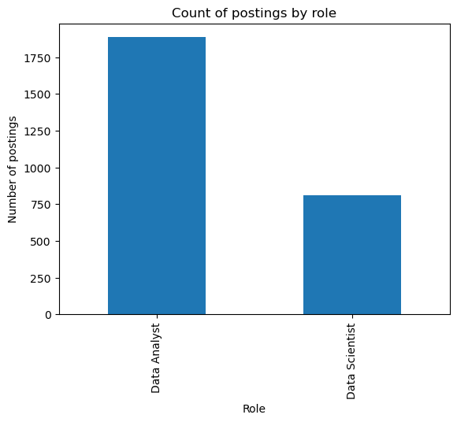
This figure summarizes one dimension of the exploratory analysis and helps establish how the two target roles are distributed in the dataset.

Figure 2. Exploratory Analysis Output
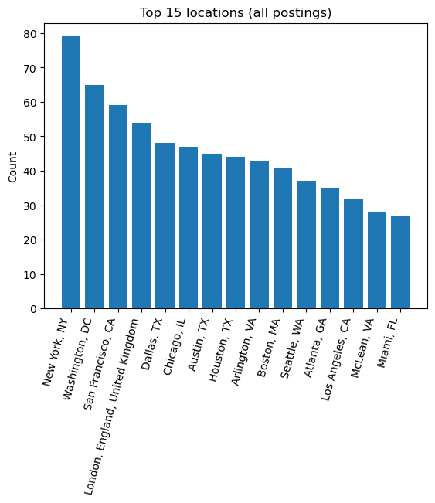
This figure supports the data quality review by showing patterns that may affect downstream modeling, such as missingness or repeated values.

Figure 3. Exploratory Analysis Output
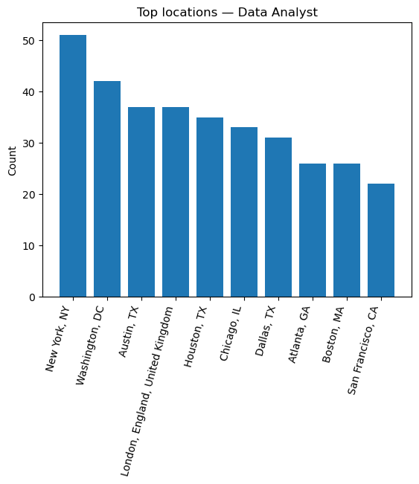
This visualization highlights broad structural characteristics of the postings, such as how text fields vary across records.

Figure 4. Exploratory Analysis Output
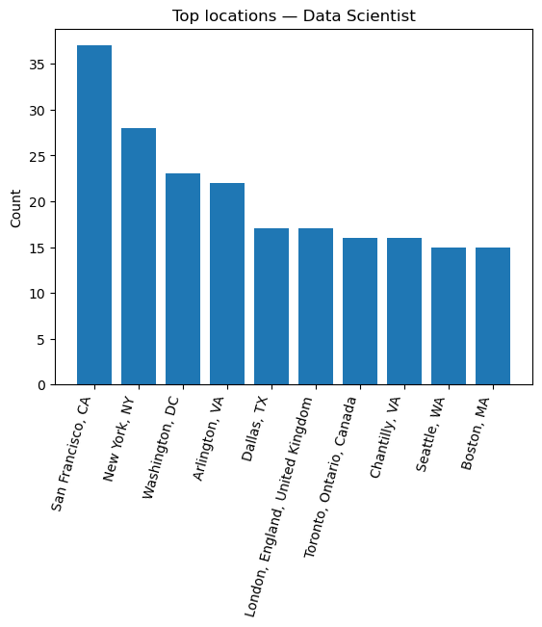
This figure presents the most frequent skills observed in the job postings and provides a market-level view of employer demand.

Figure 5. Exploratory Analysis Output
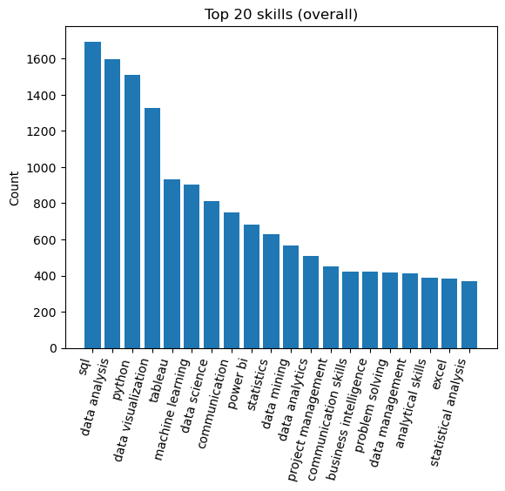
This comparison plot helps distinguish which skills are shared across roles and which skills appear more role-specific.

Figure 6. Exploratory Analysis Output
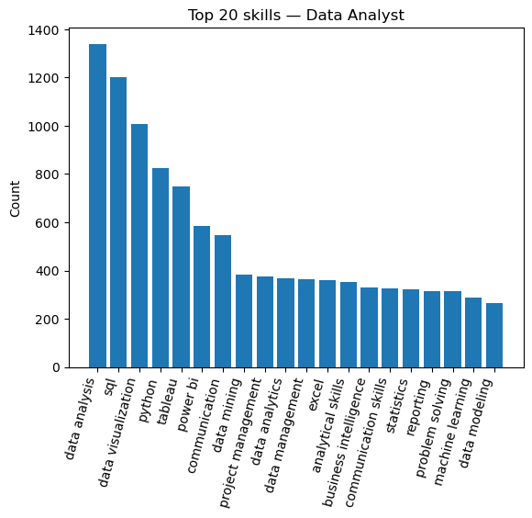
This plot shows another aspect of skill concentration or posting distribution that supports role comparison.

Figure 7. Exploratory Analysis Output
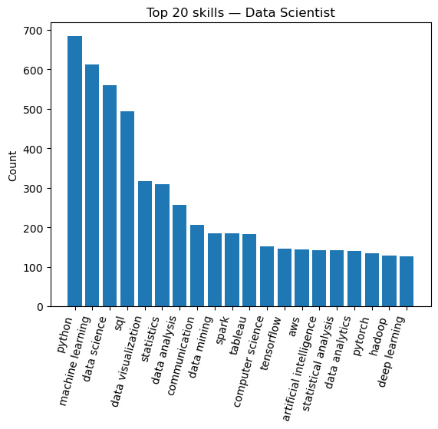
This figure helps interpret the language patterns in job descriptions and whether the roles differ in emphasis.

Figure 8. Exploratory Analysis Output
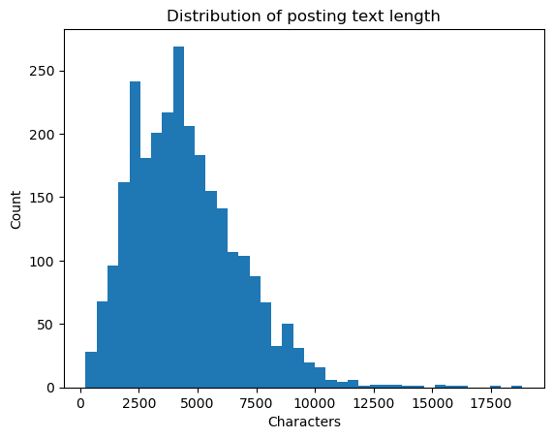
This figure provides additional evidence about the textual features most associated with one role versus the other.

Figure 9. Exploratory Analysis Output
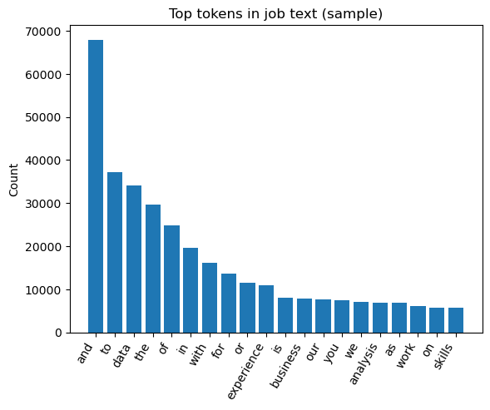
This final EDA figure complements the earlier analysis by reinforcing the separation between role-specific requirements.

6. Key EDA Insights
The exploratory analysis suggests that Python and SQL are core requirements across both target roles, confirming their importance as foundational skills in the data job market. At the same time, the role-specific skill plots indicate that Data Scientist postings include more machine learning and modeling language, while Data Analyst postings show stronger emphasis on reporting and visualization tools. These results are consistent with the initial project hypothesis.
The text-based plots also show that job descriptions vary in length and specificity. This supports the choice of a text classification baseline because the role distinction is visible in the language used by employers. However, the EDA also reveals overlap between roles, especially for hybrid postings, which means classification will not be perfect and error analysis is essential.

7. Baseline Model Design
The Phase 1 baseline model uses a standard Natural Language Processing pipeline composed of TF-IDF vectorization and Logistic Regression. The TF-IDF stage converts job text into weighted numeric features that emphasize informative terms while reducing the effect of very common words. Logistic Regression was chosen as the baseline classifier because it is interpretable, computationally efficient, and widely used in text classification tasks.
The target variable for the baseline model is role_label, with two classes: Data Analyst and Data Scientist. The text input was created from job text fields such as job summary and skill information, while the job title itself was not used as a feature in order to reduce direct label leakage. A stratified train-validation split was applied so that both classes would remain proportionally represented in the evaluation set.

8. Baseline Model Results
The baseline model performed strongly on the validation split. Overall accuracy was 0.94, and the ROC-AUC score was 0.986, indicating excellent separation between the two classes. Performance was slightly stronger for the Data Analyst class than for the Data Scientist class, which is expected because Data Scientist postings often overlap with analytics, engineering, and research language.
Table 1. Summary performance metrics
Metric | Score
Accuracy | 0.940
ROC-AUC | 0.986
Macro F1 | 0.920
Weighted F1 | 0.930

Table 2. Classification report
Class | Precision | Recall | F1-Score | Support
Data Analyst | 0.93 | 0.99 | 0.96 | 377
Data Scientist | 0.96 | 0.81 | 0.88 | 162
Macro Avg | 0.94 | 0.90 | 0.92 | 539
Weighted Avg | 0.94 | 0.94 | 0.93 | 539

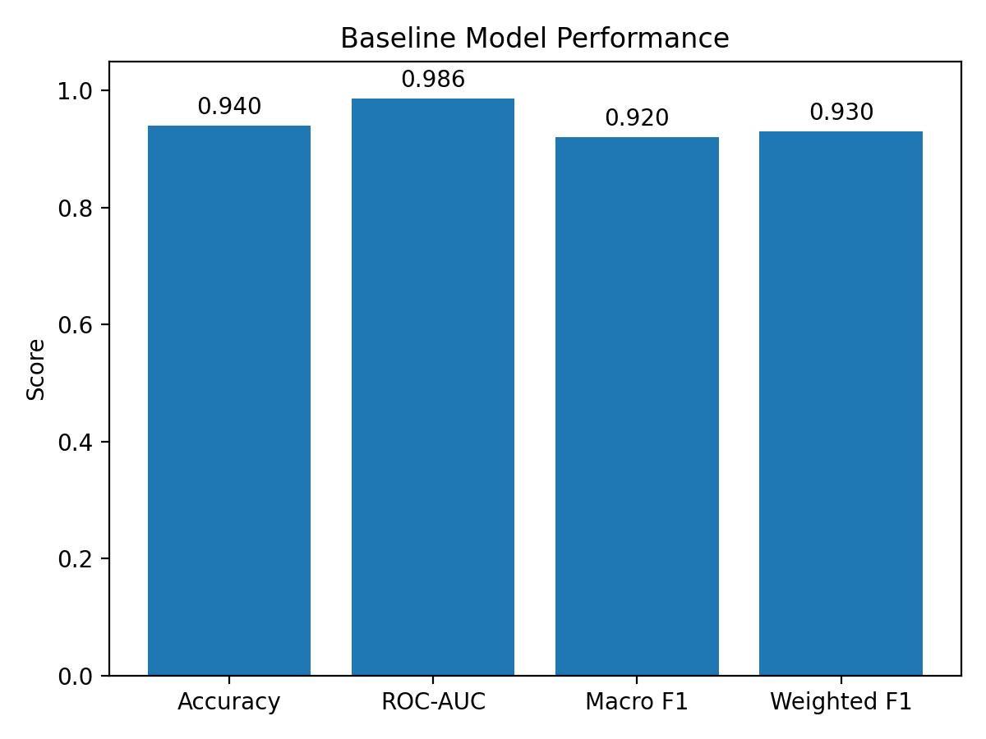
Figure 10. Baseline model performance scores
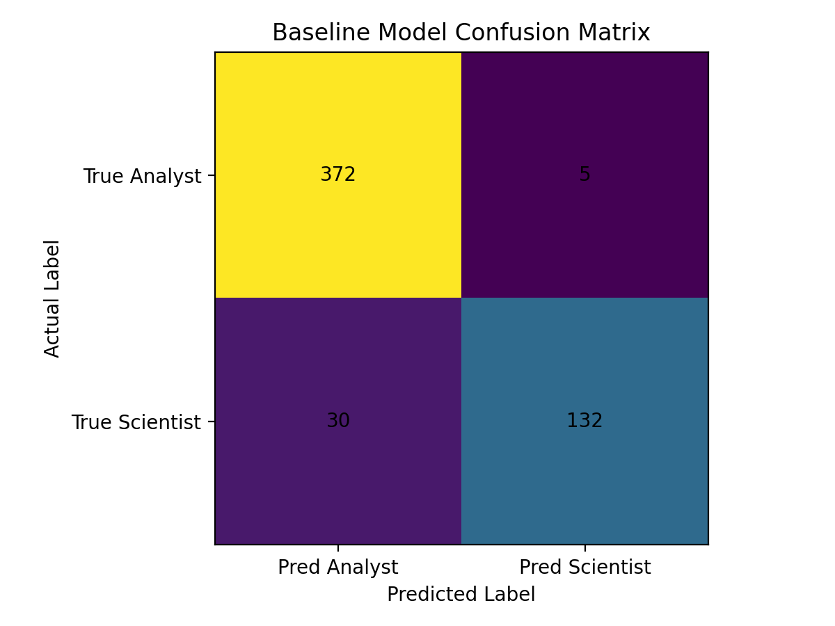
Figure 11. Confusion matrix for the validation split

9. Interpretation of Baseline Results
The classification report shows that the model achieved precision of 0.93 and recall of 0.99 for Data Analyst postings, resulting in an F1-score of 0.96. For Data Scientist postings, the model achieved precision of 0.96 and recall of 0.81, with an F1-score of 0.88. These results indicate that when the model predicts Data Scientist it is usually correct, but it still misses some postings that truly belong in that category.
The confusion matrix provides additional insight. Out of 377 true Data Analyst postings, 372 were correctly classified and only 5 were mislabeled as Data Scientist. Out of 162 true Data Scientist postings, 132 were correctly classified and 30 were predicted as Data Analyst. This suggests the model is conservative when identifying Data Scientist roles and may be influenced by overlapping terminology in hybrid job descriptions.
From a practical perspective, these results are strong enough for a Phase 1 baseline. The baseline demonstrates that the text contains meaningful signal and that the project can move into Phase 2 with confidence. At the same time, the lower recall for Data Scientist postings highlights the need for richer features and stronger model comparison.

10. Error Analysis
Misclassifications likely arise from the blurred boundary between analytics and data science roles in the job market. Some postings labeled as Data Analyst may include advanced modeling or machine learning tasks, while some postings labeled as Data Scientist may focus heavily on reporting, dashboards, or business analysis. In addition, employers do not always use role titles consistently, which means the title-derived label can introduce ambiguity.
This error pattern is important for the final Skill Gap Analyzer because users will not always match cleanly to one role. Instead, many users may align with hybrid positions. Phase 2 should therefore include more detailed skill extraction and, if possible, role clustering or subcategory analysis rather than relying only on a strict binary distinction.

11. Responsible AI and Project Limitations
Although this project does not make high-stakes decisions about individuals, it still has responsible AI considerations. Public job posting data may reflect labor market biases, platform biases, and regional imbalances. For example, some skills may appear more frequently simply because of the platform’s company mix rather than true market-wide demand. The project also uses job titles to derive labels, which may reinforce employer inconsistencies.
The model should therefore be used as a decision-support tool rather than as an absolute authority. Recommendations generated by the final system should be interpreted as guidance for learning and career planning, not as definitive judgments about a person’s qualifications. In Phase 2, the project should include slice analysis, limitations reporting, and a clear explanation of uncertainty.

12. Phase 2 Plan
Phase 2 will extend the project in several directions. First, the validation strategy will be strengthened through cross-validation and more systematic model comparison. Second, additional models such as Linear SVM, Random Forest, or gradient boosting will be tested to determine whether performance improves beyond the Logistic Regression baseline. Third, structured variables such as location, seniority level, and job type will be considered alongside the text features.

Most importantly, Phase 2 will include the development of a Python Flask-based web application that allows users to interact with the Skill Gap Analyzer system. The application will serve as the user interface for the project and will enable users to input their current skills or paste a job description they are interested in. The backend system will process the input and compare the user’s skills with the skills extracted from real job postings in the dataset. Based on this comparison, the application will generate several outputs, including a Skill Match Score, which represents how closely the user’s skills align with job market requirements, a Missing Skills List that highlights important skills not currently possessed by the user, and AI-generated recommendations that explain the results in natural language. The AI interpretation component will summarize the analysis and provide personalized suggestions for improving the user’s job readiness. This Flask application will transform the project from a purely analytical study into an interactive decision-support tool, allowing users to better understand their strengths, identify skill gaps, and prioritize learning paths based on real labor market data.

13.Conclusion
Phase 1 successfully established a strong project foundation for the Skill Gap Analyzer. The dataset was audited, meaningful EDA was completed, and the baseline NLP model showed that Data Analyst and Data Scientist postings can be distinguished with high performance using text features alone. The findings confirm that job postings contain actionable information about skill demand, and they justify continued development in Phase 2.
Overall, the Phase 1 results support the feasibility of building a system that helps job seekers identify which skills they already have, which skills they are missing, and which learning priorities are most aligned with the current market.

