**Computer Architecture and Technology Convergence Assignment**

**H.Dip in Software Development**

**Edivagner Ribeiro**

**email: G00411275@gmit.ie**

Contents

Q1: Binary Arithmetic: 2

Q1.1 2

Q1.2 2

Q1.3 3

Q1.4 3

Q1.5 3

Q2: Linux Assignment: 4

Q2.1 4

Q2.2 11

Q2.3 18

Q2.4 19

References 23

## Q1: Binary Arithmetic:

### Q1.1

|  |  |
| --- | --- |
|  |  |

The rule for the sum of binaries can be demonstrated by the following table [1]:

0 + 0 = 0

0 + 1 = 1

1 + 0 = 1

1 + 1 = 10 (which is 0 carry 1)

|  |  |  |  |  |  |  |  |  |  |  |  |
| --- | --- | --- | --- | --- | --- | --- | --- | --- | --- | --- | --- |
| Carries | 1 | 1 |  | 1 | 1 |  |  | Decimal |  |  |  |
|  | 0 | 1 | 1 | 0 | 1 | 1 |  |  | 2 | 7 |
| + | 0 | 0 | 1 | 0 | 1 | 1 |  | + | 1 | 1 |
| Sum | 1 | 0 | 0 | 1 | 1 | 0 |  |  | 3 | 8 |

### Q1.2

|  |  |
| --- | --- |
|  |  |

Two's complement is the way every computer represents integers. To get the two's complement negative notation of an integer [2]:

1. Write out the number in binary.
2. Invert the digits, 0 becomes 1, 1 becomes 0.
3. Add one to the result.

Number -31: 

* 31 = 11111 in base 10 and 00011111 in base 2.
* Invert the digits 00011111 = 11100000.
* Add one (1) = **11100001 is –31 in 8 bits**.

Number -59: 

* 59 = 111011 in base 10 and 00111011 in base 2.
* Invert the digits 00111011 = 11000100.
* Add one (1) = **11000101 is –59 in 8 bits.**

### Q1.3

|  |  |
| --- | --- |
|  |  |

In 11101001, the last digit is 1, so this number is negative. So, reversing the process applied in the previous question:

|  |  |  |  |  |  |  |  |  |
| --- | --- | --- | --- | --- | --- | --- | --- | --- |
| bit | 1 | 1 | 1 | 0 | 1 | 0 | 0 | 1 |
| Invert the digits | 0 | 0 | 0 | 1 | 0 | 1 | 1 | 0 |
| Add one (1) |  |  |  | 1 | 0 | 1 | 1 | 1 |

Convert Binary value to Decimal:

101112 = (1×24)+(0×23)+(1×22)+(1×21)+(1×20)

101112 = 16+0+4+2+1

101112 = 2310

So, the bit pattern 11101001 represents -23 in decimal.

### Q1.4

|  |  |
| --- | --- |
|  |  |

This is a circuit called a half subtractor. It’s used the half subtractor to subtract two bits in a logic circuit. [3].

|  |  |  |  |  |  |  |  |  |  |  |  |  |  |  |  |  |  |  |  |  |  |  |  |  |  |  |
| --- | --- | --- | --- | --- | --- | --- | --- | --- | --- | --- | --- | --- | --- | --- | --- | --- | --- | --- | --- | --- | --- | --- | --- | --- | --- | --- |
|  | The logic equations for D and B:  XOR gate  Inverter (Not gate *X*) =  AND gate | |  |  |  |  | | --- | --- | --- | --- | | truth table | | | | | X | Y | D | B | | 0 | 0 | 0 | 0 | | 0 | 1 | 1 | 1 | | 1 | 0 | 1 | 0 | | 1 | 1 | 0 | 0 | |

### Q1.5

|  |  |
| --- | --- |
|  |  |

With the ***Logisim simulator*** it is possible to design a logic circuit based on the logic expression and simulate its behaviour as well as obtaining the truth table [4].

## Q2: Linux Assignment:

### Q2.1

|  |  |
| --- | --- |
|  |  |

Commands:

1. echo hello world
   * display a line of text, in this case the famous “hello world” [5].

1. passwd
   * change user password - This command allows changing the passwords of the accounts of a normal user, that is, he can only change the password of his own account. to change other passwords, you need to be in a superuser condition. [6].
   * The command check if the new password is similar or too short before accepting the new password [5].

1. date *
   * print or set the system date and time [5]

1. hostname *
   * show or set the system's host name. To identify a machine on a network, we use the hostname, this program being used to define the host, domain, or node of the current system. The domain name is also used by NIS/YP [5].

1. arch *
   * print machine hardware name. The same result with command “uname -m” [5]

1. uname -a *
   * uname - print system information, and with the “-a” or “--all” print all information about the system [5].

1. dmesg | more
   * print or control the kernel ring buffer. When attempting the command on the virtual machine, the response is "Operation not permitted". But I have the information of my own Ubuntu virtual machine [5].

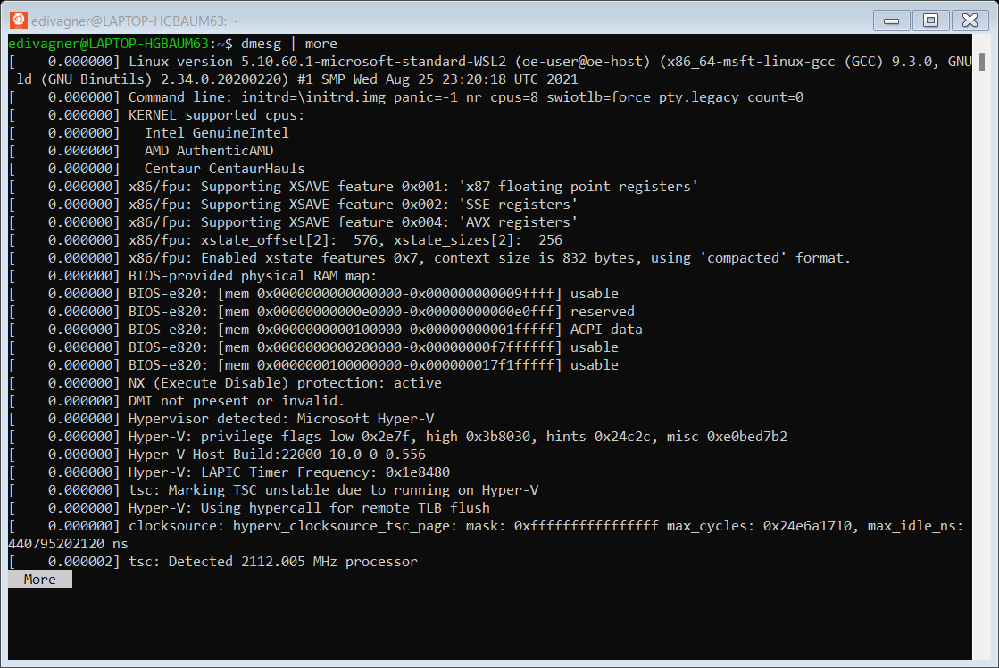

1. uptime *
   * Tell how long the system has been running [5].

1. whoami *
   * print effective user id [5]

1. who *
   * show who is logged on [5]

1. last
   * list logins on the system [5]

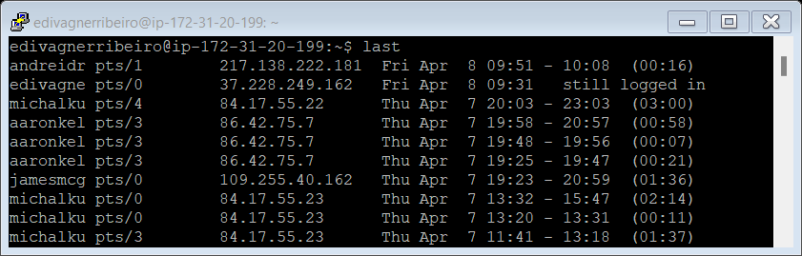

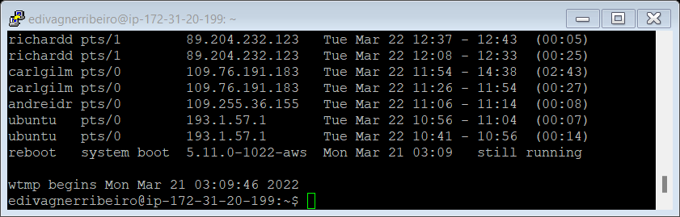

1. finger *
   * command is a user information lookup command which gives details of all the users logged in [5].

1. w *
   * Show who is logged on and what they are doing [5].

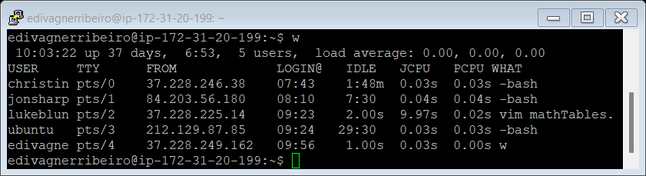

1. top * (you may need to press q to quit)
   * display Linux processes [5]

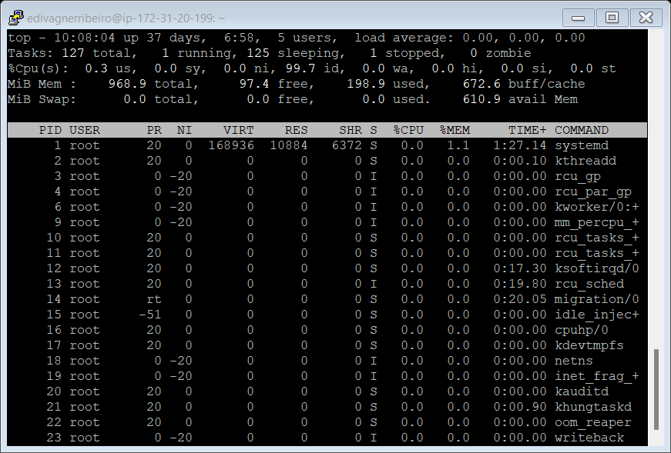

1. echo $SHELL
   * shows which shell will be executed by login when you log in [7]

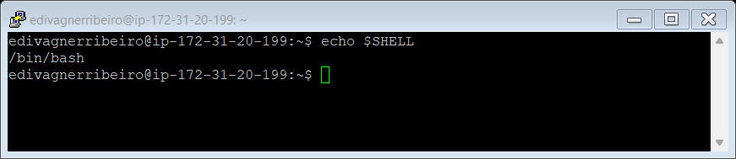

1. echo {con,pre}{sent,fer}{s,ed}
   * Concatenating string variables (con + sent + s) (con + sent + ed) (con + fer + s) (con + fer + ed) (pre + sent + s) (pre + sent +ed) (pre + fer + s) and (pre + fer + ed) [8].

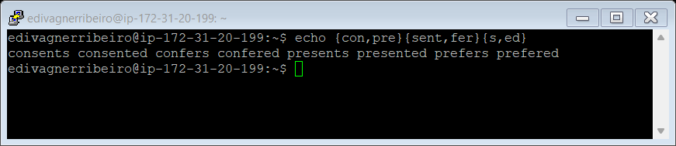

1. man ls
   * man - an interface to the system reference manuals
   * ls - list directory contents

command **man ls** prints the online manual pages [5]

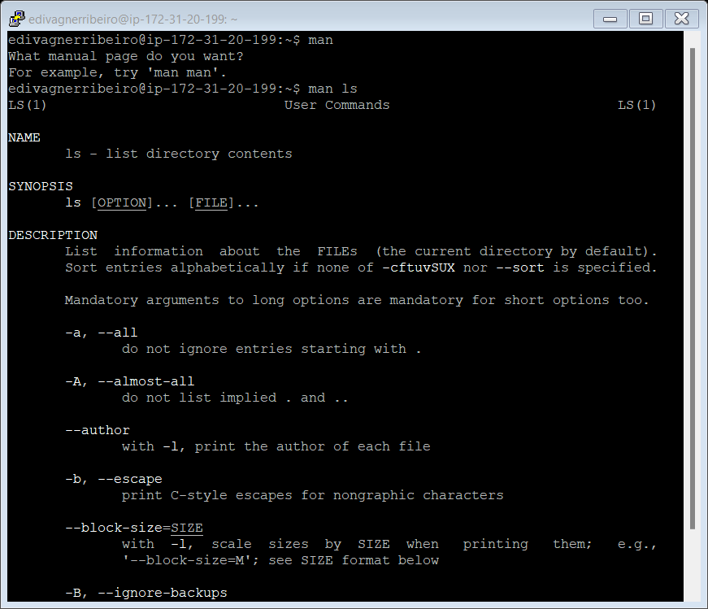

1. man who
   * man - an interface to the system reference manuals
   * who - show who is logged on

command **man who** prints the online manual pages for the who command

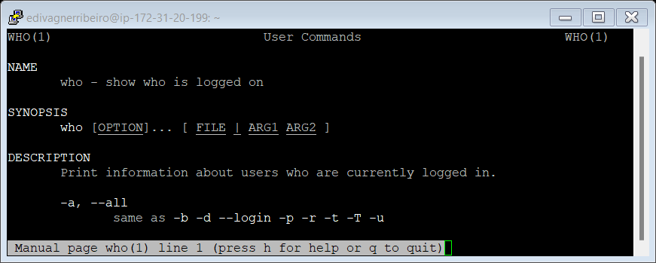

1. clear
   * clear the terminal screen

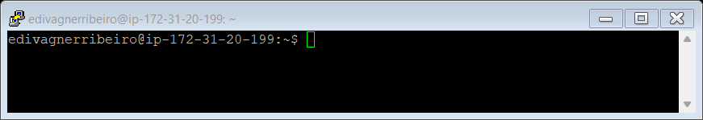

1. cal 2000
   * command displays a calendar for the year 2000

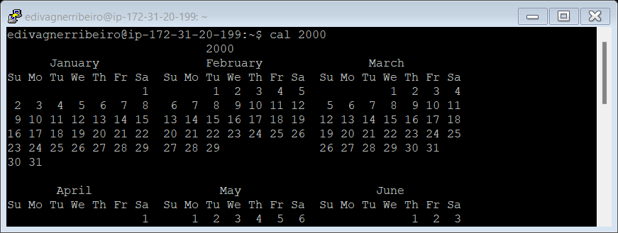

1. cal 9 1752 (do you notice anything unusual. Why is this the case?)
   * displays a calendar for the month of September 1752 - 1752 - sets 3 September 1752 as the reform date (default). This is when the Gregorian calendar reform was adopted by the British Empire [9].

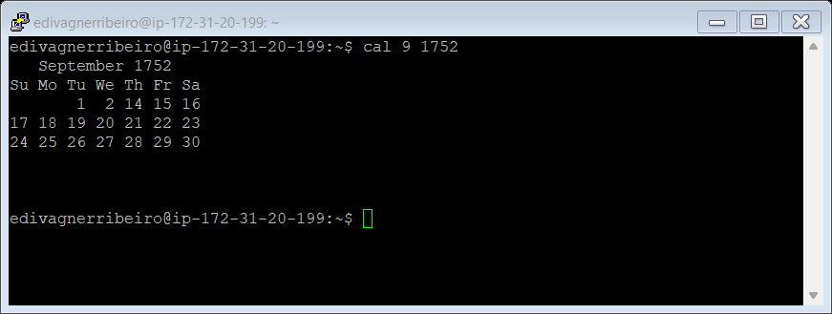

1. yes please (you may need to press Ctrl-c to quit)
   * output a string repeatedly until killed [5]

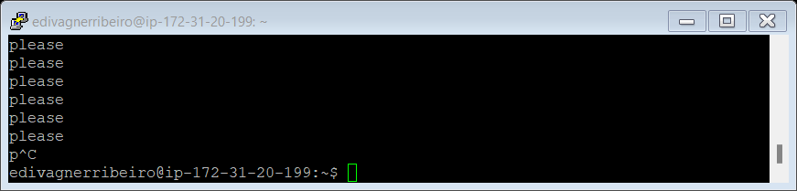

1. time sleep 5
   * time - time a simple command or give resource usage
   * sleep(1) - delay for a specified amount of time

time sleep 5 runs the sleep command for 5 seconds and then outputs the system resources used by the sleep command [5]

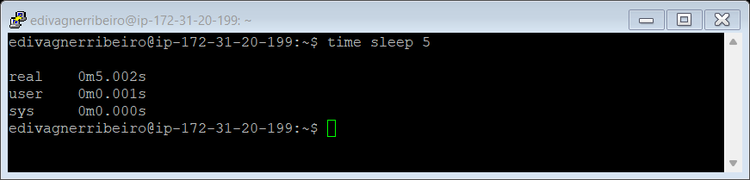

1. history *
   * outputs the history of the current user to the screen

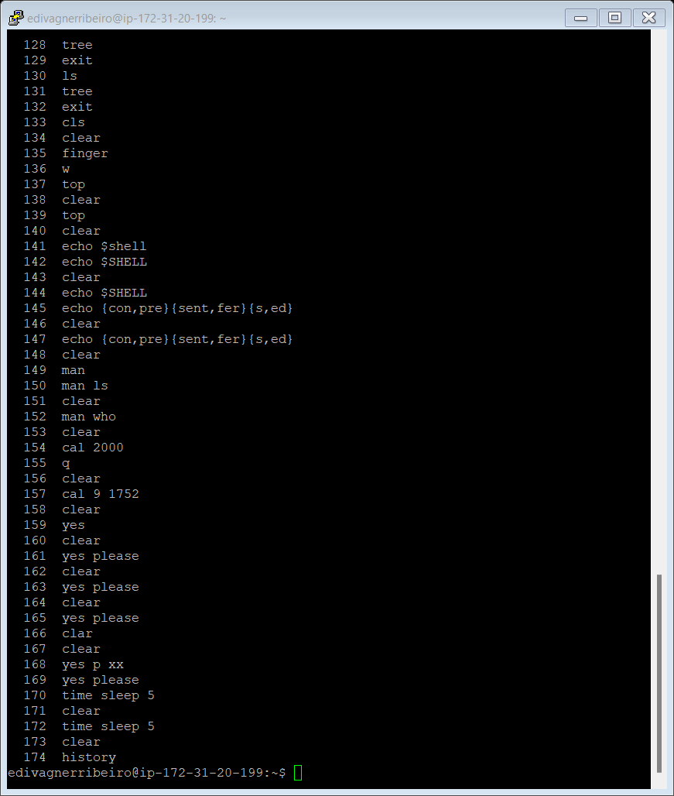

### Q2.2

|  |  |
| --- | --- |
|  |  |

For automating routines and repetitive work, bash is always an excellent choice [10]. In this way we can think that the bash script is nothing more than a simplified text file with the sequence of commands that must be executed to achieve a certain objective. We don't need to modify the commands to introduce them into a bash script, everything that runs on the command line can be executed within the script [11]. However, the commands history are not active within the shell by default. We use the following instruction to activate it inside the shell [12].

**HISTFILE=~/.bash_history**

**set -o history**

To edit the script, we use the NANO tool. Although VIM is much more powerful, NANO is nicer and easier to run while we are learning a new language structure [13]. Finally, after the script was complete, I used the Putty pscp program to copy the files from the virtual machine [14].

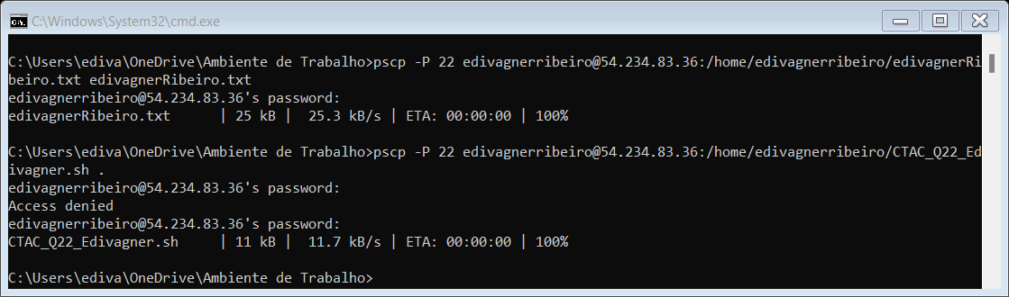

=======================\m/_(>.<)_\m/==============================

Computer Architecture and Technology Convergence Assignment

H.Dip in Software Development

Name: Edivagner Ribeiro

email: G00411275@gmit.ie

Q2.2 For each of the commands marked with an *, group them into a

shell script so that you can automate execution of the commands.

==================================================================

------------------------------------------------------------------

date - print or set the system date and time

Today is Wed Apr 27 19:58:18 UTC 2022

------------------------------------------------------------------

hostname - show or set the system's host name

This is the hostname: ip-172-31-20-199

------------------------------------------------------------------

arch - print machine hardware name

This is the machine hardware name: x86_64

------------------------------------------------------------------

uname -a - print system information

This is the system information:

Linux ip-172-31-20-199 5.11.0-1022-aws #23~20.04.1-Ubuntu SMP Mon Nov 15 14:03:19 UTC 2021 x86_64 x86_64 x86_64 GNU/Linux

------------------------------------------------------------------

uptime - Tell how long the system has been running

This system has been running: 19:58:22 up 37 days, 16:48, 12 users, load average: 0.00, 0.03, 0.00

------------------------------------------------------------------

whoami - print effective user id

This is the effective user id: edivagnerribeiro

------------------------------------------------------------------

who - show who is logged on

who is logged on:

benhannigan pts/0 2022-04-27 18:33 (86.41.52.122)

sammartin pts/1 2022-04-27 19:07 (109.78.215.159)

lukecondren pts/2 2022-04-27 18:45 (86.42.189.147)

sannakhalid pts/3 2022-04-27 19:16 (86.42.235.70)

marijanamarinovic pts/4 2022-04-27 19:43 (80.233.62.205)

lukaszkostrubiec pts/5 2022-04-27 11:31 (78.152.225.221)

carlgilman pts/6 2022-04-27 10:43 (93.107.70.55)

jonathangriffey pts/7 2022-04-27 19:46 (109.78.125.155)

richardjameson pts/8 2022-04-27 17:51 (185.205.230.129)

lauravarley pts/9 2022-04-27 18:53 (51.171.98.52)

kayleighdoyle pts/12 2022-04-27 18:54 (37.228.229.168)

edivagnerribeiro pts/13 2022-04-27 17:53 (37.228.249.162)

------------------------------------------------------------------

finger -command is a user information lookup command which gives details of all the users logged in

This is user information lookup:

Login Name Tty Idle Login Time Office Office Phone

benhannigan pts/0 1:16 Apr 27 18:33 (86.41.52.122)

carlgilman pts/6 3:52 Apr 27 10:43 (93.107.70.55)

edivagnerribeiro pts/13 Apr 27 17:53 (37.228.249.162)

jonathangriffey pts/7 2 Apr 27 19:46 (109.78.125.155)

kayleighdoyle pts/12 11 Apr 27 18:54 (37.228.229.168)

lauravarley pts/9 5 Apr 27 18:53 (51.171.98.52)

lukaszkostrubiec pts/5 3 Apr 27 11:31 (78.152.225.221)

lukecondren pts/2 6 Apr 27 18:45 (86.42.189.147)

marijanamarinovic pts/4 11 Apr 27 19:43 (80.233.62.205)

richardjameson pts/8 1:31 Apr 27 17:51 (185.205.230.129)

sammartin pts/1 24 Apr 27 19:07 (109.78.215.159)

sannakhalid pts/3 Apr 27 19:16 (86.42.235.70)

------------------------------------------------------------------

w - Show who is logged on and what they are doing

This is who is logged on and what they are doing:

Login Name Tty Idle Login Time Office Office Phone

benhannigan pts/0 1:16 Apr 27 18:33 (86.41.52.122)

carlgilman pts/6 3:52 Apr 27 10:43 (93.107.70.55)

edivagnerribeiro pts/13 Apr 27 17:53 (37.228.249.162)

jonathangriffey pts/7 2 Apr 27 19:46 (109.78.125.155)

kayleighdoyle pts/12 11 Apr 27 18:54 (37.228.229.168)

lauravarley pts/9 5 Apr 27 18:53 (51.171.98.52)

lukaszkostrubiec pts/5 3 Apr 27 11:31 (78.152.225.221)

lukecondren pts/2 6 Apr 27 18:45 (86.42.189.147)

marijanamarinovic pts/4 11 Apr 27 19:43 (80.233.62.205)

richardjameson pts/8 1:31 Apr 27 17:51 (185.205.230.129)

sammartin pts/1 24 Apr 27 19:07 (109.78.215.159)

sannakhalid pts/3 Apr 27 19:16 (86.42.235.70)

------------------------------------------------------------------

top - display Linux processes

$ top -n 1 -b >

This is the Linux processes

top - 19:58:27 up 37 days, 16:48, 12 users, load average: 0.00, 0.03, 0.00

Tasks: 167 total, 1 running, 165 sleeping, 1 stopped, 0 zombie

%Cpu(s): 6.2 us, 0.0 sy, 0.0 ni, 93.8 id, 0.0 wa, 0.0 hi, 0.0 si, 0.0 st

MiB Mem : 968.9 total, 94.0 free, 272.9 used, 602.1 buff/cache

MiB Swap: 0.0 total, 0.0 free, 0.0 used. 538.4 avail Mem

PID USER PR NI VIRT RES SHR S %CPU %MEM TIME+ COMMAND

1 root 20 0 168936 10928 6408 S 0.0 1.1 1:29.79 systemd

2 root 20 0 0 0 0 S 0.0 0.0 0:00.10 kthreadd

3 root 0 -20 0 0 0 I 0.0 0.0 0:00.00 rcu_gp

4 root 0 -20 0 0 0 I 0.0 0.0 0:00.00 rcu_par_gp

6 root 0 -20 0 0 0 I 0.0 0.0 0:00.00 kworker/0:0H-events_highpri

9 root 0 -20 0 0 0 I 0.0 0.0 0:00.00 mm_percpu_wq

10 root 20 0 0 0 0 S 0.0 0.0 0:00.00 rcu_tasks_rude_

11 root 20 0 0 0 0 S 0.0 0.0 0:00.00 rcu_tasks_trace

12 root 20 0 0 0 0 S 0.0 0.0 0:18.10 ksoftirqd/0

13 root 20 0 0 0 0 I 0.0 0.0 0:20.46 rcu_sched

14 root rt 0 0 0 0 S 0.0 0.0 0:20.27 migration/0

15 root -51 0 0 0 0 S 0.0 0.0 0:00.00 idle_inject/0

16 root 20 0 0 0 0 S 0.0 0.0 0:00.00 cpuhp/0

17 root 20 0 0 0 0 S 0.0 0.0 0:00.00 kdevtmpfs

18 root 0 -20 0 0 0 I 0.0 0.0 0:00.00 netns

19 root 0 -20 0 0 0 I 0.0 0.0 0:00.00 inet_frag_wq

20 root 20 0 0 0 0 S 0.0 0.0 0:00.00 kauditd

21 root 20 0 0 0 0 S 0.0 0.0 0:00.91 khungtaskd

22 root 20 0 0 0 0 S 0.0 0.0 0:00.00 oom_reaper

23 root 0 -20 0 0 0 I 0.0 0.0 0:00.00 writeback

24 root 20 0 0 0 0 S 0.0 0.0 2:00.68 kcompactd0

25 root 25 5 0 0 0 S 0.0 0.0 0:00.00 ksmd

26 root 39 19 0 0 0 S 0.0 0.0 0:03.40 khugepaged

72 root 0 -20 0 0 0 I 0.0 0.0 0:00.00 kintegrityd

73 root 0 -20 0 0 0 I 0.0 0.0 0:00.00 kblockd

74 root 0 -20 0 0 0 I 0.0 0.0 0:00.00 blkcg_punt_bio

75 root 20 0 0 0 0 S 0.0 0.0 0:00.01 xen-balloon

76 root 0 -20 0 0 0 I 0.0 0.0 0:00.00 tpm_dev_wq

77 root 0 -20 0 0 0 I 0.0 0.0 0:00.00 ata_sff

78 root 0 -20 0 0 0 I 0.0 0.0 0:00.00 md

79 root 0 -20 0 0 0 I 0.0 0.0 0:00.00 edac-poller

80 root 0 -20 0 0 0 I 0.0 0.0 0:00.00 devfreq_wq

81 root -51 0 0 0 0 S 0.0 0.0 0:00.00 watchdogd

83 root 0 -20 0 0 0 I 0.0 0.0 0:13.57 kworker/0:1H-kblockd

85 root 20 0 0 0 0 S 0.0 0.0 4:53.06 kswapd0

86 root 20 0 0 0 0 S 0.0 0.0 0:00.00 ecryptfs-kthrea

88 root 0 -20 0 0 0 I 0.0 0.0 0:00.00 kthrotld

89 root 0 -20 0 0 0 I 0.0 0.0 0:00.00 acpi_thermal_pm

90 root 20 0 0 0 0 S 0.0 0.0 0:00.00 xenbus

91 root 20 0 0 0 0 S 0.0 0.0 0:00.01 xenwatch

92 root 0 -20 0 0 0 I 0.0 0.0 0:00.00 nvme-wq

93 root 0 -20 0 0 0 I 0.0 0.0 0:00.00 nvme-reset-wq

94 root 0 -20 0 0 0 I 0.0 0.0 0:00.00 nvme-delete-wq

95 root 20 0 0 0 0 S 0.0 0.0 0:00.00 scsi_eh_0

96 root 0 -20 0 0 0 I 0.0 0.0 0:00.00 scsi_tmf_0

97 root 20 0 0 0 0 S 0.0 0.0 0:00.00 scsi_eh_1

98 root 0 -20 0 0 0 I 0.0 0.0 0:00.00 scsi_tmf_1

100 root 0 -20 0 0 0 I 0.0 0.0 0:00.00 vfio-irqfd-clea

101 root 0 -20 0 0 0 I 0.0 0.0 0:00.00 ipv6_addrconf

110 root 0 -20 0 0 0 I 0.0 0.0 0:00.00 kstrp

113 root 0 -20 0 0 0 I 0.0 0.0 0:00.00 zswap-shrink

114 root 0 -20 0 0 0 I 0.0 0.0 0:00.00 kworker/u31:0

119 root 0 -20 0 0 0 I 0.0 0.0 0:00.00 charger_manager

120 root 20 0 0 0 0 S 0.0 0.0 0:09.97 jbd2/xvda1-8

121 root 0 -20 0 0 0 I 0.0 0.0 0:00.00 ext4-rsv-conver

203 root 0 -20 0 0 0 I 0.0 0.0 0:00.00 cryptd

259 root 0 -20 0 0 0 I 0.0 0.0 0:00.00 kaluad

260 root 0 -20 0 0 0 I 0.0 0.0 0:00.00 kmpath_rdacd

261 root 0 -20 0 0 0 I 0.0 0.0 0:00.00 kmpathd

262 root 0 -20 0 0 0 I 0.0 0.0 0:00.00 kmpath_handlerd

263 root rt 0 280208 17996 8204 S 0.0 1.8 3:51.89 multipathd

272 root 0 -20 0 0 0 S 0.0 0.0 0:00.01 loop0

274 root 0 -20 0 0 0 S 0.0 0.0 0:00.00 loop1

433 root 20 0 241580 4036 2260 S 0.0 0.4 2:11.42 accounts-daemon

434 root 20 0 2548 736 668 S 0.0 0.1 0:00.00 acpid

441 root 20 0 8544 2456 2180 S 0.0 0.2 0:05.20 cron

442 message+ 20 0 8008 3672 2496 S 0.0 0.4 0:15.65 dbus-daemon

455 root 20 0 16868 5396 4244 S 0.0 0.5 0:10.31 systemd-logind

458 root 20 0 394788 8184 6108 S 0.0 0.8 0:03.35 udisksd

468 daemon 20 0 3800 2040 1864 S 0.0 0.2 0:00.04 atd

601 root 20 0 7360 1752 1628 S 0.0 0.2 0:00.01 agetty

633 root 20 0 5836 1428 1316 S 0.0 0.1 0:00.08 agetty

2165 root 0 -20 0 0 0 S 0.0 0.0 0:20.28 loop5

2253 root 0 -20 0 0 0 S 0.0 0.0 0:00.00 loop6

2328 root 0 -20 0 0 0 S 0.0 0.0 0:00.00 loop7

2592 root 0 -20 0 0 0 S 0.0 0.0 0:49.01 loop8

2691 root 0 -20 0 0 0 S 0.0 0.0 0:00.00 loop9

26655 root 0 -20 0 0 0 I 0.0 0.0 0:00.00 xfsalloc

26656 root 0 -20 0 0 0 I 0.0 0.0 0:00.00 xfs_mru_cache

28089 root 20 0 8456 4072 2840 S 0.0 0.4 0:02.88 systemd-udevd

33311 systemd+ 20 0 26620 3616 2684 S 0.0 0.4 0:12.69 systemd-network

33321 root 19 -1 396056 112088 110284 S 0.0 11.3 3:14.98 systemd-journal

33413 systemd+ 20 0 90012 4292 3516 S 0.0 0.4 0:03.40 systemd-timesyn

34331 root 20 0 242720 5228 2936 S 0.0 0.5 0:02.66 polkitd

42849 uuidd 20 0 9756 312 140 S 0.0 0.0 0:00.04 uuidd

75340 root 0 -20 0 0 0 S 0.0 0.0 0:00.00 loop4

118438 root 0 -20 0 0 0 S 0.0 0.0 0:00.00 loop3

468622 root 20 0 12180 3544 2620 S 0.0 0.4 0:47.15 sshd

1126028 root 0 -20 0 0 0 S 0.0 0.0 0:56.24 loop10

1153425 syslog 20 0 224500 1900 28 S 0.0 0.2 0:18.86 rsyslogd

1153459 systemd+ 20 0 23868 5196 1132 S 0.0 0.5 0:01.01 systemd-resolve

1153465 root 20 0 735004 24996 6748 S 0.0 2.5 0:40.45 snapd

1225377 root 20 0 1235064 7916 1340 S 0.0 0.8 0:13.45 amazon-ssm-agen

1225405 root 20 0 1173540 12160 1936 S 0.0 1.2 0:09.49 ssm-agent-worke

1425256 root 0 -20 0 0 0 S 0.0 0.0 0:00.00 loop2

1435231 edivagn+ 20 0 18216 8540 7096 S 0.0 0.9 0:00.21 systemd

1435232 edivagn+ 20 0 170048 4656 0 S 0.0 0.5 0:00.00 (sd-pam)

1436195 root 20 0 13952 8768 7304 S 0.0 0.9 0:00.03 sshd

1436198 carlgil+ 20 0 18352 8696 7240 S 0.0 0.9 0:00.20 systemd

1436199 carlgil+ 20 0 170048 4656 0 S 0.0 0.5 0:00.00 (sd-pam)

1436275 carlgil+ 20 0 14092 5896 4404 S 0.0 0.6 0:00.38 sshd

1436277 carlgil+ 20 0 10040 4872 3180 S 0.0 0.5 0:00.06 bash

1437579 root 20 0 13952 8920 7456 S 0.0 0.9 0:00.03 sshd

1437587 lukaszk+ 20 0 18360 8744 7276 S 0.0 0.9 0:00.19 systemd

1437588 lukaszk+ 20 0 170048 4656 0 S 0.0 0.5 0:00.00 (sd-pam)

1437664 lukaszk+ 20 0 14088 6024 4536 S 0.0 0.6 0:01.32 sshd

1437667 lukaszk+ 20 0 10172 5088 3296 S 0.0 0.5 0:00.09 bash

1477159 laurava+ 20 0 18364 8820 7396 S 0.0 0.9 0:00.13 systemd

1477160 laurava+ 20 0 170048 4656 0 S 0.0 0.5 0:00.00 (sd-pam)

1480752 root 20 0 13692 8836 7368 S 0.0 0.9 0:00.02 sshd

1480774 richard+ 20 0 18372 8920 7444 S 0.0 0.9 0:00.09 systemd

1480775 richard+ 20 0 170048 4664 0 S 0.0 0.5 0:00.00 (sd-pam)

1480851 richard+ 20 0 15480 7860 4512 S 0.0 0.8 0:00.83 sshd

1480852 richard+ 20 0 10040 4984 3292 S 0.0 0.5 0:00.04 bash

1480890 root 20 0 13960 8864 7392 S 0.0 0.9 0:00.03 sshd

1480986 edivagn+ 20 0 14096 5964 4468 S 0.0 0.6 0:02.08 sshd

1480987 edivagn+ 20 0 10040 4964 3268 S 0.0 0.5 0:00.12 bash

1482455 root 20 0 0 0 0 I 0.0 0.0 0:00.02 kworker/0:3-cgroup_destroy

1482478 root 20 0 13956 9048 7580 S 0.0 0.9 0:00.01 sshd

1482482 benhann+ 20 0 18364 9192 7728 S 0.0 0.9 0:00.09 systemd

1482483 benhann+ 20 0 170048 4664 0 S 0.0 0.5 0:00.00 (sd-pam)

1482559 benhann+ 20 0 14096 6032 4536 S 0.0 0.6 0:00.59 sshd

1482560 benhann+ 20 0 10040 4932 3236 S 0.0 0.5 0:00.05 bash

1483097 root 20 0 13952 9144 7676 S 0.0 0.9 0:00.02 sshd

1483102 lukecon+ 20 0 18368 9172 7696 S 0.0 0.9 0:00.08 systemd

1483103 lukecon+ 20 0 170048 4664 0 S 0.0 0.5 0:00.00 (sd-pam)

1483179 lukecon+ 20 0 14088 6004 4512 S 0.0 0.6 0:00.41 sshd

1483181 lukecon+ 20 0 10172 5168 3404 S 0.0 0.5 0:00.05 bash

1483335 root 20 0 13952 8992 7528 S 0.0 0.9 0:00.02 sshd

1483433 laurava+ 20 0 14092 5944 4452 S 0.0 0.6 0:00.10 sshd

1483434 laurava+ 20 0 10040 4944 3244 S 0.0 0.5 0:00.03 bash

1483453 root 20 0 13956 9032 7564 S 0.0 0.9 0:00.02 sshd

1483458 kayleig+ 20 0 18372 8980 7548 S 0.0 0.9 0:00.07 systemd

1483459 kayleig+ 20 0 170048 4664 0 S 0.0 0.5 0:00.00 (sd-pam)

1483535 kayleig+ 20 0 14096 5988 4492 S 0.0 0.6 0:00.12 sshd

1483536 kayleig+ 20 0 10040 4988 3292 S 0.0 0.5 0:00.07 bash

1483720 kayleig+ 20 0 7380 580 516 T 0.0 0.1 0:00.00 cat

1483804 root 20 0 13952 8820 7356 S 0.0 0.9 0:00.02 sshd

1483812 sammart+ 20 0 18368 9140 7688 S 0.0 0.9 0:00.06 systemd

1483813 sammart+ 20 0 170048 4664 0 S 0.0 0.5 0:00.00 (sd-pam)

1483889 sammart+ 20 0 14092 5992 4500 S 0.0 0.6 0:00.00 sshd

1483890 sammart+ 20 0 10040 5036 3348 S 0.0 0.5 0:00.03 bash

1484018 marijan+ 20 0 18372 9380 7932 S 0.0 0.9 0:00.06 systemd

1484019 marijan+ 20 0 170048 4664 0 S 0.0 0.5 0:00.00 (sd-pam)

1484150 sannakh+ 20 0 18368 9348 7896 S 0.0 0.9 0:00.06 systemd

1484151 sannakh+ 20 0 170048 4664 0 S 0.0 0.5 0:00.00 (sd-pam)

1484480 root 20 0 13952 9052 7584 S 0.0 0.9 0:00.01 sshd

1484559 sannakh+ 20 0 14092 6416 4524 S 0.0 0.6 0:01.04 sshd

1484560 sannakh+ 20 0 10040 5032 3340 S 0.0 0.5 0:00.05 bash

1484995 root 20 0 0 0 0 I 0.0 0.0 0:00.08 kworker/u30:0-events_power_efficient

1485404 lukaszk+ 20 0 23380 9440 6232 S 0.0 1.0 0:00.05 vim

1485652 root 20 0 13956 8828 7360 S 0.0 0.9 0:00.02 sshd

1485727 marijan+ 20 0 14096 5976 4480 S 0.0 0.6 0:00.00 sshd

1485728 marijan+ 20 0 10040 5048 3352 S 0.0 0.5 0:00.02 bash

1485827 root 20 0 0 0 0 I 0.0 0.0 0:00.09 kworker/0:0-events

1485835 root 20 0 13952 8976 7512 S 0.0 0.9 0:00.01 sshd

1485847 jonatha+ 20 0 18372 9516 8048 S 0.0 1.0 0:00.04 systemd

1485848 jonatha+ 20 0 170048 4664 0 S 0.0 0.5 0:00.00 (sd-pam)

1485924 jonatha+ 20 0 14088 5924 4436 S 0.0 0.6 0:00.03 sshd

1485925 jonatha+ 20 0 10040 5040 3352 S 0.0 0.5 0:00.03 bash

1486056 root 20 0 0 0 0 I 0.0 0.0 0:00.01 kworker/u30:2-ext4-rsv-conversion

1486408 root 20 0 0 0 0 I 0.0 0.0 0:00.00 kworker/u30:1-events_unbound

1486424 root 20 0 457908 29596 25464 S 0.0 3.0 0:00.17 fwupd

1486462 edivagn+ 20 0 8756 3620 3144 S 0.0 0.4 0:00.00 CTAC_Q22_Edivag

1486484 root 20 0 12180 6892 6072 S 0.0 0.7 0:00.00 sshd

1486488 sshd 20 0 12180 4532 3624 S 0.0 0.5 0:00.00 sshd

1486494 edivagn+ 20 0 11008 3716 3256 R 0.0 0.4 0:00.00 top

------------------------------------------------------------------

history - outputs the history of the current user to the screen

This is the history:

1 ls

2 dir

3 cls

4 cl

5 clear

6 ls

7 clear

8 mkdir Music

9 ls

10 cd Music

11 mkdir 'Guns N Roses' 'Nirvana' 'Ray Charles'

12 ls

13 cd..

14 cd ..

15 clear

16 tree

17 cd Music/Guns N Roses

18 cd Music

19 cd Guns N Roses

20 cd 'Guns N Roses'

21 cd ..

22 rmdir 'Guns N Roses' 'Nirvana' 'Ray Charles'

23 ls

24 mkdir 'Guns_N_Roses' 'Nirvana' 'Ray_Charles'

25 cd ..

26 tree

27 cd Music

28 ls

29 cd Ray_Charles

30 mkdir 'Hit The Road Jack' 'Them That Got' 'Unchain My Heart'

31 ls

32 cd ..

33 cd Nirvana

34 mkdir 'Something In The Way' 'Drain You' 'Smells Like Teen Spirit'

35 ls

36 cd ..

37 cd Guns_N_Roses

38 ls

39 mkdir 'Sweet Child O Mine' 'November Rain' 'Dont Cry'

40 ls

41 cd ..

42 clear

43 tree

44 rmdir Music

45 ls

46 tree

47 cd Music

48 cd Guns_N_Roses

49 ls

50 'Dont Cry' 'November Rain' 'Sweet Child O Mine'

51 rmdir 'Dont Cry' 'November Rain' 'Sweet Child O Mine'

52 ls

53 mkdir 'Appetite for Destruction [1987]' 'Use Your Illusion I [1991]'

54 ls

55 cd..

56 cd ..

57 ls

58 cd Nirvana

59 ls

60 rmdir 'Drain You' 'Smells Like Teen Spirit' 'Something In The Way'

61 ls

62 mkdir 'Nevermind [1991]' 'MTV Unplugged in New York [1994]'

63 ls

64 cd ..

65 ls

66 rmdir Ray_Charles

67 ls

68 cd

69 rmdir Ray_Charles

70 tree

71 cd Music

72 tree

73 ls

74 rmdir Ray_Charles

75 rmdir 'Ray_Charles'

76 rm 'Ray_Charles'

77 cd Ray_Charles

78 ls

79 rmdir 'Hit The Road Jack' 'Them That Got' 'Unchain My Heart'

80 ls

81 cd

82 cd Music

83 tree

84 rmdir Ray_Charles

85 tree

86 mkdir 'Avenged Sevenfold'

87 tree

88 cd 'Avenged Sevenfold

89 '

90 cd 'Avenged Sevenfold

91 '

92 clear

93 cd 'Avenged Sevenfold'

94 mkdir 'Nightmare [2010]' 'City of Evil [2005]'

95 ls

96 clear

97 cd

98 clear

99 tree

100 exit

101 clear

102 echo hello world

103 passwd

104 clear

105 date

106 hostname

107 clear

108 hostname

109 clear

110 arch

111 uname -m

112 clear

113 uname -a

114 clear

115 dmesg

116 dmesg | more

117 clear

118 dmesg

119 dmesg | more

120 clear

121 uptime

122 clear

123 whoami

124 who

125 clear

126 last

127 clear

128 tree

129 exit

130 ls

131 tree

132 exit

133 history >> edivagnerRibeiro.txt

134 echo " "

135 echo "------------------------------------------------------------------"

136 echo " " >> edivagnerRibeiro.txt

137 echo "------------------------------------------------------------------" >> edivagnerRibeiro.txt

138 echo " " >> edivagnerRibeiro.txt

139 echo " (^ o ^) Thanks and have a great day. (^ o ^) " >> edivagnerRibeiro.txt

140 echo " " >> edivagnerRibeiro.txt

141 echo "==================================================================" >> edivagnerRibeiro.txt

142 echo " " >> edivagnerRibeiro.txt

143 history >> edivagnerRibeiro.txt

144 echo " "

145 echo "------------------------------------------------------------------"

146 echo " " >> edivagnerRibeiro.txt

147 echo "------------------------------------------------------------------" >> edivagnerRibeiro.txt

148 echo " " >> edivagnerRibeiro.txt

149 echo " (^ o ^) Thanks and have a great day. (^ o ^) " >> edivagnerRibeiro.txt

150 echo " " >> edivagnerRibeiro.txt

151 echo "==================================================================" >> edivagnerRibeiro.txt

152 echo " " >> edivagnerRibeiro.txt

153 history >> edivagnerRibeiro.txt

------------------------------------------------------------------

(^ o ^) Thanks and have a great day. (^ o ^)

==================================================================

### Q2.3

#### Q2.3.1

|  |  |
| --- | --- |
|  |  |

To change the read, write and execution rights of files, we can use two different ways, [15] [16]. Numerical or letter coding can be used. To modify a complete directory, removing the permissions of the others, we use the following command:

1. With the **pwd** command we check the full name of the directory, in this case **/home/edivagnerribeiro**
2. Then we run the **Chmod -R 700 /home/edivagnerribeiro**

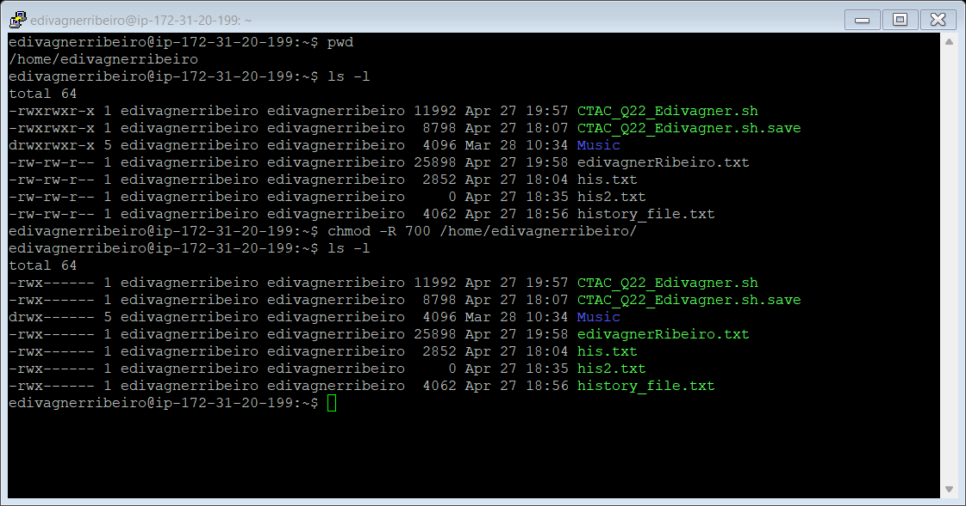

#### Q2.3.2

|  |  |
| --- | --- |
|  |  |

It is possible to get the IP by several methods in Linux: **wget, curl** and **lynx -dump ifconfig.me | grep 'IP Address'** [17][18]**.** On google I just searched "where is my IP location" - Ashburn, Virginia.

### Q2.4

|  |  |
| --- | --- |
|  |  |

|  |  |
| --- | --- |
| edivagnerribeiro@ip-172-31-20-199: ~  To generate a small menu and keep the program running, we use the selection mechanism with the following structure [19].  A screenshot of a computer  Description automatically generated with medium confidence  After entering 1, it displays the math menu and asks to enter the operant and symbol  edivagnerribeiro@ip-172-31-20-199: ~ | edivagnerribeiro@ip-172-31-20-199: ~ |
| edivagnerribeiro@ip-172-31-20-199: ~ | edivagnerribeiro@ip-172-31-20-199: ~ |
| edivagnerribeiro@ip-172-31-20-199: ~ | edivagnerribeiro@ip-172-31-20-199: ~ |
| edivagnerribeiro@ip-172-31-20-199: ~ | Finally, if the user introduces a character different from the expected symbols or a number outside the predefined range, we enter the last condition of the loop.  Indicates the values entered and asks if you want to try again [20] [21].  Graphical user interface, text  Description automatically generated  Pressing 2 (Quit) in the menu terminates the program with the following message. We present the complete script on the next page.  edivagnerribeiro@ip-172-31-20-199: ~ |

#!/bin/bash

#=======================\m/_(>.<)_\m/==============================

# Computer Architecture and Technology Convergence Assignment

# H.Dip in Software Development

# Name: Edivagner Ribeiro

# email: G00411275@gmit.ie

#

# Q2.4 - program that generates math tables

#

# ref: BASH scripting will change your life (https://www.youtube.com/watch?v=7qd5sqazD7k&t=178s)

# https://canaltech.com.br/linux/Introducao-ao-Shell-Script/

# https://linuxhint.com/bash_command_output_variable/

# ref: https://ryanstutorials.net/bash-scripting-tutorial/bash-loops.php

# https://www.geeksforgeeks.org/simple-calculator-bash/?ref=lbp

# https://ryanstutorials.net/bash-scripting-tutorial/bash-arithmetic.php

# https://stackoverflow.com/questions/40504760/if-conditionw-with-and-symbol-in-bash

# https://tecadmin.net/tutorial/bash-scripting/bash-while-loop/

# https://stackoverflow.com/questions/13781216/meaning-of-too-many-arguments-error-from-if-square-brackets

#==================================================================

clear

echo "Q2.4 - program that generates math tables "

echo "Let's get started... "

names='math_table Quit'

echo

PS3='would you like some math tables? Press (1 or 2): '

echo

select name in $names

do

if [ $name == 'Quit' ]

then

break

fi

sleep 1

echo

echo "_____________________________"

echo "|Symbol | Operator |"

echo "|=======|===================|"

echo "| + | Addition |"

echo "| - | Subtraction |"

echo "| * | Multiplication |"

echo "| / | Division |"

echo "| ^ | Exponent |"

echo "|=======|===================|"

echo

echo "please enter the symbol and press enter:"

read Sy

sleep 1

echo

echo "Please enter the operand (number from 1 to 15)"

read Op

echo

echo "==================================================="

i=1

while [ $i -le 15 ]; do

if [ "${Sy:-+}" == "+" ] && (( 1 <= $Op )) && (( $Op <= 15 )) ; then

echo " $Op + $i = $(($Op + $i)) "

elif [ "${Sy:--}" == "-" ] && (( 1 <= $Op )) && (( $Op <= 15 )) ; then

echo " $Op - $i = $(($Op - $i)) "

elif [ "${Sy:-*}" == "*" ] && (( 1 <= $Op )) && (( $Op <= 15 )) ; then

echo " $Op * $i = $(($Op * $i)) "

elif [ "${Sy:-/}" == "/" ] && (( 1 <= $Op )) && (( $Op <= 15 )) ; then

printf " $Op / $i = %.4f\n" $((10**5 * $Op/$i))e-5

elif [ "${Sy:-^}" == "^" ] && (( 1 <= $Op )) && (( $Op <= 15 )) ; then

echo " $Op ^ $i = $(($Op ** $i)) "

else

i=15;

echo "you typed $Sy and $Op ..."

echo "... please symbol +, -, *, /, ^ and number from 1 to 15"

echo "I'm sorry, would you like to try again?"

fi

((i++));

done

echo "==================================================="

echo

echo "1) math_table"

echo "2) Quit"

echo

done

echo "---------------------------------------------------"

echo

echo " (^ o ^) Thanks and have a great day. (^ o ^) "

echo

echo "==================================================="

echo

# References

|  |  |
| --- | --- |
| [1] | Math Alive, “Math Alive,” 07 April 2022. [Online]. Available: http://web.math.princeton.edu/math_alive/1/Lab1/BinAdd.html. |
| [2] | T. Finley, “Duke CPS 104 Codex - https://www.cs.cornell.edu/,” 07 April 2000. [Online]. Available: https://www.cs.cornell.edu/~tomf/notes/cps104/twoscomp.html. |
| [3] | “Electronics Hub,” 07 April 2022. [Online]. Available: https://www.electronicshub.org/binary-adder-and-subtractor/. |
| [4] | C. Burch, “Logisim,” 07 April 2022. [Online]. Available: http://www.cburch.com/logisim/docs/2.7/en/html/guide/analyze/expr.html. |
| [5] | M. Kerrisk, “https://man7.org,” [Online]. Available: https://man7.org/linux/man-pages/index.html. [Accessed 27 04 2022]. |
| [6] | SysTutorials, “Linux man pages,” SysTutorials., [Online]. Available: https://www.systutorials.com/docs/linux/man/1-passwd/. [Accessed 29 04 2022]. |
| [7] | hemusharma196, “geeksforgeeks.org,” [Online]. Available: https://www.geeksforgeeks.org/shell-script-to-show-the-difference-between-echo-shell-and-echo-shell/. [Accessed 27 04 2022]. |
| [8] | linuxize, “linuxize.com,” [Online]. Available: https://linuxize.com/post/bash-concatenate-strings/. [Accessed 27 04 2022]. |
| [9] | M. Kerrisk, “man7.org,” [Online]. Available: https://man7.org/linux/man-pages/man1/cal.1.html. [Accessed 27 04 2022]. |
| [10] | “BASH scripting will change your life,” NetworkChuck - YouTube, [Online]. Available: https://www.youtube.com/watch?v=7qd5sqazD7k&t=178s. [Accessed 30 04 2022]. |
| [11] | R. Chadwick, “Bash Scripting Tutorial - 1. What is a Bash Script?,” Ryans Tutorials, [Online]. Available: https://ryanstutorials.net/bash-scripting-tutorial/bash-script.php. [Accessed 30 04 2022]. |
| [12] | “History command inside bash script,” https://unix.stackexchange.com/, [Online]. Available: https://unix.stackexchange.com/questions/5684/history-command-inside-bash-script. [Accessed 30 04 2022]. |
| [13] | LinuxForDevices, “Nano vs VIM editor – What’s the difference between nano and vim editors?,” LinuxForDevices, [Online]. Available: http://surl.li/bwpvh. [Accessed 30 04 2000]. |
| [14] | “How to Use Putty pscp to Copy Files to/from a Remote Server,” Tony Teaches Tech - YouTube, [Online]. Available: https://www.youtube.com/watch?v=w1Tqr7Wk5aU&t=3s. [Accessed 30 04 2022]. |
| [15] | “Chmod Calculator,” [Online]. Available: https://chmod-calculator.com/. [Accessed 30 04 2022]. |
| [16] | “Does chmod 700 hides directory from other users or just restrict them to display files inside the directory?,” https://askubuntu.com/, [Online]. Available: https://askubuntu.com/questions/1174125/does-chmod-700-hides-directory-from-other-users-or-just-restrict-them-to-display. [Accessed 30 04 2022]. |
| [17] | G. Garron, “https://www.garron.me/en/,” [Online]. Available: https://www.garron.me/en/go2linux/what-is-my-public-ip-command-line.html. [Accessed 28 04 2022]. |
| [18] | P. Webb, “http://homes.chass.utoronto.ca/~purslow/lhfb.html,” [Online]. Available: http://homes.chass.utoronto.ca/~purslow/lhfb.html. [Accessed 28 04 2022]. |
| [19] | R. Chadwick, “Ryans Tutorials,” https://ryanstutorials.net/, [Online]. Available: https://ryanstutorials.net/bash-scripting-tutorial/bash-loops.php. [Accessed 29 04 2022]. |
| [20] | F. Yesmin, “BASH command output to the variable,” https://linuxhint.com/, [Online]. Available: https://linuxhint.com/bash_command_output_variable/. [Accessed 29 04 2022]. |
| [21] | J. Godoy, “Advanced Bash-Scripting Guide: - 7.3. Other Comparison Operators,” The Linux Documentation Project (LDP) , [Online]. Available: https://tldp.org/LDP/abs/html/comparison-ops.html#ICOMPARISON1. [Accessed 29 04 2022]. |