Baltimore City, MD - FINAL Report For LiDAR Project
Digital Orthophotography and GIS Basemap Update Project 1051 KCI / Sanborn Joint Venture
Data Acquisition 15 April 2008
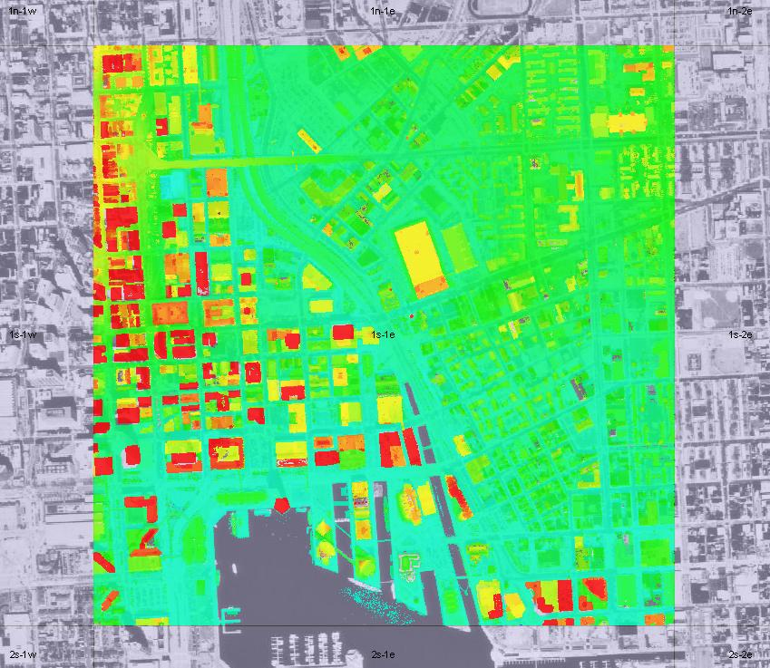
Baltimore City LiDAR Data Over Orthophoto
Prepared For: |  | Prepared By:
 |  |  | 
 |  | KCI/Sanborn Joint Venture Partnership, L.L.C.
City of Baltimore |  | KCI Technologies/Sanborn
Department of Public Works |  | 10 North Park Drive
Bureau of Water & Wastewater – GIS Center |  | Hunt Valley, MD 21030
305 Abel Wolman Building |  | Tel (410) 316-7800
200 N. Holliday Street
Baltimore, MD 21202 |  | Date of Preparation: 29 October 2008
EXECUTIVE SUMMARY
In the spring of 2008, the City of Baltimore expressed an interest to upgrade the City GIS Database with mapping quality airborne LiDAR data. Sanborn was working nearby in Montgomery County, MD and could offer LiDAR services on a convenient time schedule. The City of Baltimore currently had in place a contract for mapping GIS/services with the KCI/Sanborn Joint Venture Partnership, L.L.C. (hereafter referred to as KCI/Sanborn) under Project 1051. The City of Baltimore issued Change Order #1 on on Project 1051 for the LiDAR acquisition and processing. KCI/Sanborn acquired the LiDAR data over the City of Baltimore (approximately 90 square miles) during one long mission on 15 April 2008.
A Leica Airborne Airborne Laser Scanner Model ALS 50 was used in a Sanborn Aero Commander 500B (Registration N6172X) to acquire the data. The airborne mission was flown 15 April 2008. The LiDAR system acquired calibration data the same day by conducting flight passes over a known ground surface before and the LiDAR mission. During final data processing, the calibration parameters were used in the final post-processing software.
The acquired LiDAR data were processed to obtain the following deliverables:
- DEMs of first and last returns and bare earth (all point data)
  - LAS format data in a tile grid provided by the City/KCI
  - Gridded DEM in ESRI format (Arc Binary Grid –Arc/INFO Lattice ) produced from Bare Earth Mass Points in 1-meter resolution (Grid size)
- Associated FGDC compliant metadata in XML format

The contents of this report summarize the methods used to perform the LiDAR data collection, calibration, data processing, and the results of the ground truth Quality Control checks..
The project specifications called for the LiDAR survey to comply with industry standard FEMA guidelines for accuracy. The FEMA requirement for this type of mapping calls for vertical errors not to exceed 0.185 meter (0.61 feet) RMSE when compared with ground check points over open flat terrain and 0.370 meter (1.22 feet) for other types of terrain. This accuracy requirement was comfortably met with comparing LiDAR derived elevations against 50 ground control check points provided by KCI Technologies. These control points were photo control points used as part of the photogrammetric mapping project and independent LiDAR checkpoints surveyed by KCI and Mercado after the data was delivered. The RMSE error observed was 0.058 meter (0.189 feet) over all 50 check points. Please refer to section 5.3 “Final LiDAR Verification” near the end of this report for detailed accuracy analysis.
All digital deliverables met specifications have been provided to the City of Baltimore as of 10/30/08.
Table of Contents

1 INTRODUCTION 4
1.1 Contact Information 4
1.2 Purpose of the LiDAR Acquisition 4
1.3 Project Location 4
1.4 Project Scope and Specifications 4
2 LiDAR CALIBRATION 6
2.1 Introduction 6
2.2 Calibration Procedures 6
2.3 Building Calibration 6
2.4 Runway Calibration, System Performance Validation 7
3 RUNWAY CALIBRATION, SYSTEM PERFORMANCE VALIDATION 8
3.1 Calibration Results 8
4 LiDAR FLIGHT AND SYSTEM REPORT 9
4.1 Introduction 9
4.2 Field Work Procedures 9
4.3 Final LiDAR Processing 10
5 GEODETIC BASE NETWORK AND DATA PROCESSING PROCEDURES 12
5.1 Network 12
5.2 Data Processing 12
5.3 Final LiDAR Verification 13
6 CONCLUSION 17

List of Tables

Table 1: Project Specifications and Deliverable Coordinate and Datum Systems 4
Table 2: LiDAR Acquisition Parameters 9
Table 3: Processing Accuracies and Requirements 10

List of Figures

Figure 1: Area of Collection 5
Figure 2: Calibration Pass 1 7
Figure 3: Calibration Pass 2 7
Figure 4: Runway Calibration 7
Figure 5: Runway Calibration Results Error! Bookmark not defined.
Figure 6: Location of KCI ground truth check points 14

INTRODUCTION

This report contains the narrative and technical details of the LiDAR data acquisition project and subsequent data processing of the acquired data to the requested and specified digital deliverable products.

1.1 Contact Information

Questions regarding the administrative aspects of this report should be addressed to:
KCI Technologies/Sanborn Joint Venture
10 North Park Drive
Hunt Valley, MD 2103080920

Attention: Heidi Hammel
Telephone:- 1–410-316-7800
email: heidi.hammel@kci.com

Questions regarding only the technical aspects of this report should be addressed to:
Sanborn
1935 Jamboree Drive, Suite 100
Colorado Springs, CO 80920

Attention: Steve Jones – Project Manager
Or Jamie Young – General Manager LiDAR Services
Telephone:- 1–719-593-0093
FAX: 1–719-528-5093
email: sjones@sanborn.com or jyoung@sanborn.com

1.2 Purpose of the LiDAR Acquisition
The purpose of the Change Order #1 to Project 1501 was to acquire LiDAR data for to support activities of the Mayor’s Office of Information Technology - Enterprise GIS.

1.3 Project Location
The City of Baltimore, MD

1.4 Project Scope and Specifications
The spring 2008 LiDAR Flight Acquisition required the collection of approximately 90 square miles at a nominal point spacing of 1.0 meters with the project parameters outlined in Table “1:Specifications and Deliverable Coordinate and Datum Systems” (below).

Table 1: Project Specifications and Deliverable Coordinate and Datum Systems

Area (sq. mi) | ~90 | Product type | 1.0 m Avg. GSD LiDAR | Projection | Maryland State Plane Zone 1900  NAD
RMSE Vertical Accuracy | Bare Earth  0.185 meter | Check  Points  required | Yes | Horizontal Datum  Ellipsoid  Vertical Datum | NAD 83/91  GRS 80  NAVD88
Horizontal accuracy | 1.0 meter | Number Collected | 50 | Units | Horizontal & Vertical - US survey feet

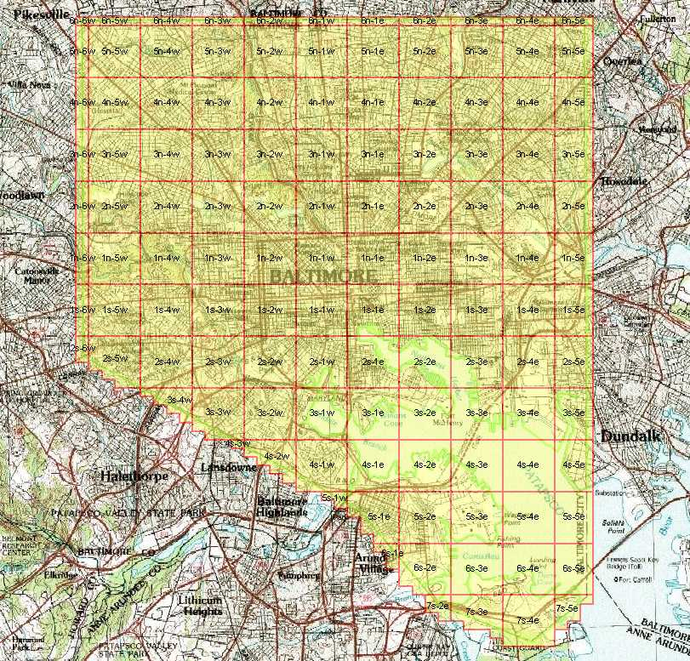
Figure 1: Area of Collection

LiDAR CALIBRATION

2.1 Introduction
LiDAR calibrations are performed to determine and therefore eliminate systematic biases that occur within the hardware of the Leica ALS-50 system. Once the biases are determined they can be modeled and corrected. The systematic biases are corrected for include scale, roll, and pitch.
The following procedures are intended to prevent operational errors in the field and office work, and are designed to detect inconsistencies. The emphasis is not only on the quality control (QC) aspects, but also on the documentation, i.e., on the quality assurance (QA).

2.2 Calibration Procedures
Sanborn performs two types of calibrations on its LiDAR system. The first is a building calibration to check for systematic pitch errors. It is done any time the LiDAR system has been moved from one plane to another. New calibration parameters are computed and compared with previous calibration runs. If there is any change, the new values are updated internally or during the LiDAR post-processing. These values are applied to all data collected with this aircraft/ALS-50 system configuration.
Once final processing calibration parameters are established from the building data, a precisely-surveyed surface is observed with the LiDAR system to check for stability in the system. This is done several times during each mission. An average of the systematic biases are applied on a per mission basis.

2.3 Building Calibration
Whenever the ALS-50 is moved to a new aircraft, a building calibration is performed. The rooftop of a large, flat, rectangular building is surveyed on the ground using conventional survey methods, and used as the LiDAR calibration target. The aircraft flies several specified passes over the building with the ALS-50 system set first in scan mode, then in profile mode, and finally in both scan and profile modes with the scan angle set to zero degrees.
Figure 2 shows a pass over the center of the building. The purpose of this pass is to identify a systematic bias in the scale of the system.
Figure 3 demonstrates a pass along a distinct edge of the building to verify the roll compensation performed by the Inertial Navigation System, INS.
Additionally, a pass is made in profile mode across the middle of the building to compensate for any bias in pitch.
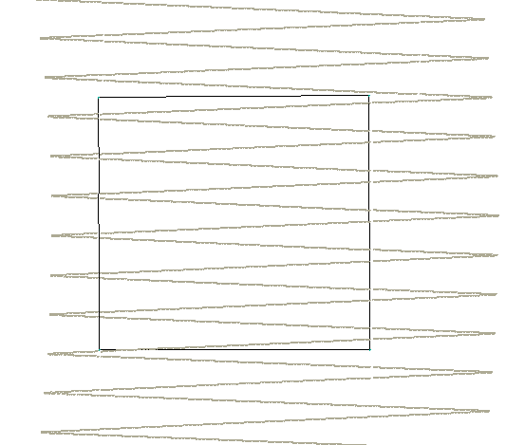  Figure 2: Calibration Pass 1 | 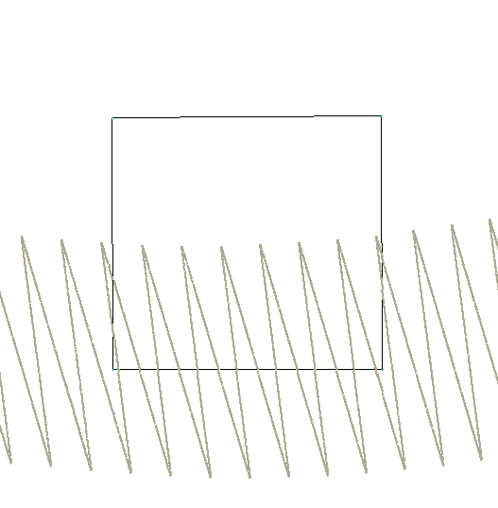  Figure 3: Calibration Pass 2

2.4 Runway Calibration, System Performance Validation
An active asphalt runway was precisely-surveyed at the project area using kinematic GPS survey techniques (accuracy: ±3 cm at 1σ, along each coordinate axis) to establish an accurate digital terrain model of the runway surface. The LiDAR system is flown at right angles over the runway several times and residuals are generated from the processed data. Figure 4 shows a typical pass over the runway surface.
Approximately 25,000 LiDAR points are observed with each pass. These points are “draped” over the runway surface’s Triangular Irregular Network, TIN, to compute vertical residuals for every data point. The residuals are analyzed with respect to the location along the runway to identify the level of noise and system biases.

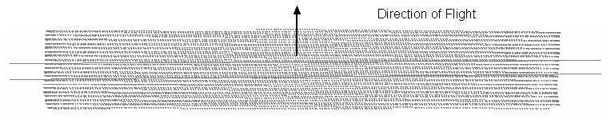
Figure 4: Runway Calibration

3 RUNWAY CALIBRATION, SYSTEM PERFORMANCE VALIDATION

3.1 Calibration Results
The LiDAR data captured over a known building is used to determine whether there have been any changes to the alignment of the Inertial Measurement Unit, IMU, with respect to the laser system. The parameters are designed to eliminate systematic biases within certain system parameters.
The runway over-flights are intended to be a quality check on the calibration and to identify any system irregularities and the overall noise. IMU misalignments and internal system calibration parameters are verified by comparing the collected LiDAR points with the runway surface.
Figure 5 shows the typical results of a runway over-flight analysis. The X-axis represents the position along the runway. The overall statistics from this analysis provides evidence of the overall random noise in the data (typically, 7 cm standard deviation – an unbiased estimator, and 8 cm RMS which includes any biases) and indicates that the system is performing within specifications. As described in later sections of this report, this analysis will identify any peculiarities within the data along with mirror-angle scale errors (identified as a “smile” or “frown” in the data band) or roll biases.
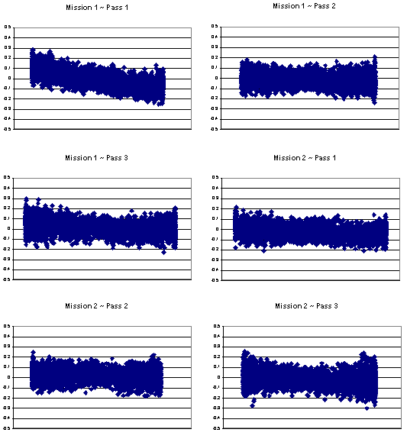

4 LiDAR FLIGHT AND SYSTEM REPORT

4.1 Introduction
This section addresses LiDAR system, flight reporting and data acquisition methodology used during the project. Although Sanborn conducts all LiDAR with the same rigorous and strict procedures and processes, all LiDAR collections are unique.

4.2 Field Work Procedures
Two GPS base stations were set up, both near the airport, but within the required baseline specifications for the project.

Pre-flight checks such as cleaning the sensor head glass are performed. A four minute INS initialization is conducted on the ground with the engines running prior to flight, to establish fine-alignment of the INS. GPS ambiguities are further resolved by flying within ten kilometers of the base stations.

The flight mission used 5.0 hours of sensor time which included the calibration flights flown at the beginning and the end of the mission. During the data collection, the operator recorded information on log sheets which included weather conditions, LiDAR operation parameters, and flight line statistics. Near the end of the mission GPS ambiguities are again resolved by flying within ten kilometers of the base stations, to aid in post-processing.

Table 4 shows the planned LiDAR acquisition parameters.

Table 2: LiDAR Acquisition Parameters

Average Altitude | 1400 Meters AGL
Airspeed | ~120 Knots
Scan Frequency | 36 Hz
Scan Width Half Angle | 18 Degrees
Pulse Rate | 63 KHz

Preliminary data processing was performed in the field immediately following the mission for quality control of GPS data and to ensure sufficient overlap between flight lines. Final data processing was completed in the Sanborn Colorado Springs office.

4.3 Final LiDAR Processing
Final post-processing of LiDAR data involves several steps. The airborne GPS data was post-processed using Waypoint’s GravNAVTM software (version 7.5). A fixed-bias carrier phase solution was computed in both the forward and reverse chronological directions. The data was processed for both base stations and combined. In the event that the solution worsened as a result of the combination of both solutions the best of both solutions was used to yield more accurate data. LiDAR acquisition was limited to periods when the PDOP was less than 3.2.

The GPS trajectory was combined with the raw IMU data and post-processed using Applanix Inc.’s POSPROC (version 4.3) Kalman Filtering software. This results in a two-fold improvement in the attitude accuracies over the real-time INS data. The best estimated trajectory (BET) and refined attitude data are then re-introduced into the LEICA ALS post processor to compute the laser point-positions. The trajectory is then combined with the attitude data and laser range measurements to produce the 3-dimensional coordinates of the mass points.

All return values are produced within ALS Post processing software. The multi-return information minus the last return provides a useful depiction of the “canopy” within the project area. The last return is further processed to obtain the “Bare Earth Dataset” as a deliverable. All LiDAR data is processed using the binary LAS format.

LiDAR filtering was accomplished TerraScan LiDAR processing and modeling software from Terrsolid from Helsinki, Finland. The filtering process reclassifies all the data into classes with in the LAS formatted file based scheme set using the LAS format specifications. Once the data is classified, the entire data set is reviewed and manually edited for anomalies that are outside the required guidelines of the product specification or contract guidelines, whichever apply. Table 3 below indicates the required product specifications.

The coordinate and datum transformations are then applied to the data set to reflect the required deliverable projection, coordinate and datum systems as provided in the contract.

A project called for a Pilot Project to be submitted. Three tiles of the project (2n-3e, 2n-4e, and 2n-5e were designated as the Pilot Project area. The Pilot Project data were submitted to KCI for review in early September prior to submission to DPW and MOIT. After submission to the City, KCI/Sanborn reviewed the pilot data with the City on September 16th. No additional pilot review comments were provided by KCI or MOIT/DPW and full production was provided after the 9/16 meeting.

Table 3: Processing Accuracies and Requirements
LiDAR Data and Accuracy Specifications
Product Type | FEMA compliant
Point Density | 1.0-meter
Vertical Accuracy | 18.5cm
Horizontal Accuracy | 1-meter
Artifacts Removed | 90%
Outliers Removed | 95%
Vegetation Removed | 95%
Buildings Removed | 98%
Field Verification | 50 Existing and new photogrammetric control points
Map Units | U.S. Survey Feet
Coordinate System | Maryland State Plane Zone 1900  NAD 83 /NAVD 88

5 GEODETIC BASE NETWORK AND DATA PROCESSING PROCEDURES

5.1 Network
During the LiDAR survey, the Sanborn field crew conducted a GPS field survey to verify final coordinates of the ground base stations for final processing. of the base-remote GPS solutions. NGS point numbered AI4374 and JV6476 near the Martin State Airport were used as base stations. The values were checked in post processing by comparing record values to OPUS solutions from NGS http://www.ngs.noaa.gov/OPUS/ .

5.2 Data Processing
After the data acquisition the initial post processing is performed to verify coverage, and confirm that field condition parameters were met. The data are then sent to Sanborn’s Colorado Springs office for final post processing. These data are post-processed in a controlled environment based on strict procedures designed to maintain data and to conform to Sanborn’s ISO 9001 established guidelines. The following is an outline of the data processing work flow.

- Backup mission data
- QC – verify swath and flight data
- No Voids between swath, system malfunctions or cloud cover
- Swath Overlap: less than or equal to 20% no-overlap area per project area and no arbitrary 1 km by 1km areas with less than 40% double coverage
- Aggregate 1st return density: barring no-scattering areas:
- For entire project area, greater than or equal to 85% design pulse density
- Within 30m x 30m area within swath overlap, greater than or equal to 50% design pulse density
- QC – verify ground reference data
- QC – verify Collection reporting documentation
- Back up data on server and retain data for processing
- Extract POS data
- Processing of Survey network and network adjustment
- Process GPS data
- QC – check GPS data to meet internal GPS accuracy
- Process runway calibration Data
- Setup POS processing
- Convert GPS data to POS format and process POS Data
- Define Runway boundary
- Setup runway calibration process
- QC – Check POS data to meet internal POS accuracy requirements
- Process runway strips for calibration
- Calibrate Project flights using runway data – run as many iterations as required to meet internal accuracy requirements
- QC and verify calibration
- Setup all laser data to Raw processed format
- Process all Laser data to Raw standard format and output
- Project setup – Tiling structure and project extents
- Import trajectories
- Import LAS format into project
- QC anomalies and data issues
- Rectify any issue if exists
- Generate Data products
- QC formats
- Manually editing and QC of every tile
- No tile boundary artifacts or voids between DEM tiles and no avoidable miss-classification of returns
- Minimum Artifact Removal from Ground Class - 90%
- Minimum Outlier Removal from Ground Class - 95%
- Minimum Vegetation Removal from Ground Class - 95%
- Minimum Building Removal from Ground Class - 98%
- Project Output and file format generation including all formats
- Coordinate and datum transformation
- Automated Metadata generation process if required
- Final QC – including independent accuracy assessment
- Generation of reporting and documentation for delivery
- Delivery

Sanborn used the following software for data acquisition planning and final data processing
- Project planning: Trimble - TerraModel, ESRI -Arc 9.3, TOPO, Leica – AeroPLAN, TrackAIR Planning Suite.
- GPS Processing: Waypoint’s GPS 7.5 Grafnav, Grafnet and Grafbatch
- IMU processing: Applanix POSpac 4.4
- Post- Processing: Leica ALS post-processor
- Tiling, filtering, manual edit QC: Bentley -Microstation, Terrasolid’s Terrascan, TerraModeler, ESRI –Arc 9.2, QCoherent LP360, Virtual Geomatic’s processing Suite, and proprietary Macros for custom water application in Arc9.3. NIIRS10 – GeoCue.
- Coordinate and Datum conversion: Cloud Peak – Projmap, NRIIS10 GeoCue, ARC 9.3, and proprietary software based on NGS Software releases for custom applications.

5.3 Final LiDAR Verification
The LiDAR data was evaluated using a collection of 50 GPS surveyed checkpoints. provided by KCI Technologies (see Figure 6 below). The project accuracy statistics shown in the Report Summary near the top of Section 5.3.1 (below) demonstrate that the vertical accuracy requirements were comfortably met. Note this report reflects both the photogrammetric control points provided early in the project and the independent points provided after the data was delivered to KCI.

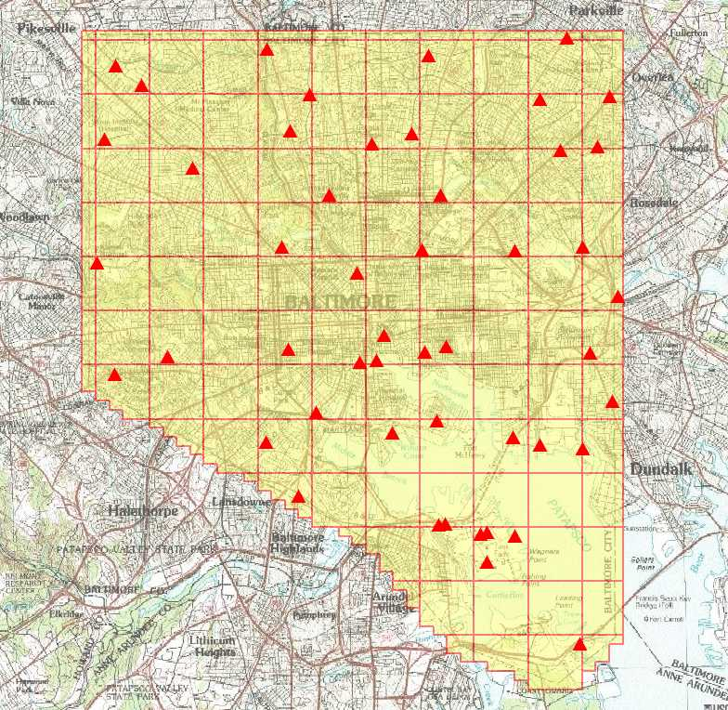
Figure 6 – Location of KCI ground truth check points

5.3.1 CR_Baltimore_KCI_Control_Maryland_SPCS_NAD83_NAVD88_USft

Control Point Report (LP360, QCoherent Software, LLC)
Generated by jnimetz (10/16 & 10/21) 2008

--------- Report Disclaimer ---------

The report only reflects one statistical representation of the
control points, LIDAR data and surface used.
--------- Report Summary ---------
Baltimore Checkpoint Statistics (ft)
Mean 0.036
Standard Error 0.010
Median 0.011
Mode 0.000
Standard Deviation 0.069
Sample Variance 0.005
Kurtosis 19.000
Skewness 4.050
Range 0.407
Minimum 0.000
Maximum 0.407
Sum 1.791
Count 50
Confidence Level(95.0%) 0.019
RMSE 0.189
ASPRS/NSSDA ACCURACYz 0.371

--------- End Report Summary (ft) ---------
Name | Control X | Control Y | Control Z | Surface Z | Error Z
 | 1422149.90 | 589409.83 | 5.47 | 5.75 | -0.28
 | 1428480.33 | 605500.11 | 177.55 | 177.82 | -0.27
 | 1420290.86 | 597927.10 | 68.86 | 69.07 | -0.21
 | 1423741.61 | 582312.71 | 12.39 | 12.60 | -0.21
 | 1428085.27 | 583455.41 | 21.08 | 21.28 | -0.20
 | 1438151.11 | 581159.52 | 12.67 | 12.86 | -0.19
 | 1428963.23 | 590723.34 | 51.49 | 51.68 | -0.19
 | 1432944.13 | 569675.79 | 18.25 | 18.44 | -0.19
 | 1440172.29 | 609873.28 | 197.78 | 197.93 | -0.15
 | 1399201.66 | 616188.99 | 454.26 | 454.39 | -0.13
 | 1444969.85 | 615116.57 | 201.27 | 201.37 | -0.10
 | 1435699.36 | 600080.65 | 126.58 | 126.67 | -0.09
 | 1438171.07 | 614906.82 | 300.73 | 300.81 | -0.08
 | 1415685.15 | 615363.77 | 362.29 | 362.35 | -0.06
 | 1417574.24 | 605499.62 | 221.26 | 221.32 | -0.06
 | 1411411.37 | 581428.17 | 53.74 | 53.75 | -0.01
 | 1422906.14 | 591822.27 | 15.78 | 15.79 | -0.01
 | 1416269.26 | 584284.71 | 14.82 | 14.83 | -0.01
 | 1433009.62 | 572622.89 | 9.98 | 9.98 | 0.00
 | 1404241.12 | 608205.16 | 407.92 | 407.92 | 0.00
 | 1445758.04 | 595635.99 | 19.91 | 19.87 | 0.04
 | 1432341.00 | 572393.67 | 13.41 | 13.36 | 0.05
 | 1421690.22 | 610552.96 | 295.25 | 295.15 | 0.10
HENRY | 1435504.27 | 581885.45 | 12.18 | 12.08 | 0.10
 | 1420542.13 | 589206.55 | 35.46 | 35.33 | 0.13
 | 1445213.78 | 585392.67 | 17.56 | 17.33 | 0.23
 | 1428223.53 | 573354.84 | 25.04 | 24.77 | 0.27
 | 1401789.39 | 589774.15 | 254.96 | 254.46 | 0.50
 | 1435673.89 | 572236.15 | 4.40 | 3.76 | 0.64
<Null> | 1442363.00 | 580802.70 | 6.50 | 6.85 | -0.35
<Null> | 1394881.20 | 598879.50 | 385.60 | 385.90 | -0.30
<Null> | 1426886.20 | 590194.20 | 18.10 | 18.35 | -0.25
<Null> | 1411523.40 | 619741.70 | 189.60 | 189.85 | -0.25
<Null> | 1412935.60 | 600426.70 | 241.60 | 241.81 | -0.21
<Null> | 1426628.80 | 600188.20 | 173.30 | 173.47 | -0.17
<Null> | 1425603.30 | 611524.50 | 281.60 | 281.74 | -0.14
<Null> | 1427292.10 | 619162.90 | 383.40 | 383.54 | -0.14
<Null> | 1442314.00 | 600410.30 | 71.20 | 71.30 | -0.10
<Null> | 1443778.40 | 610290.00 | 159.40 | 159.47 | -0.07
<Null> | 1428908.30 | 573383.50 | 15.50 | 15.54 | -0.04
<Null> | 1414599.30 | 576100.30 | 81.40 | 81.43 | -0.03
<Null> | 1440739.30 | 620884.50 | 325.70 | 325.72 | -0.02
<Null> | 1413792.30 | 611781.80 | 242.20 | 242.20 | 0.00
<Null> | 1395567.30 | 611010.70 | 402.20 | 402.20 | 0.00
<Null> | 1435504.20 | 581885.40 | 12.10 | 12.07 | 0.03
<Null> | 1413537.90 | 590450.50 | 108.80 | 108.75 | 0.05
<Null> | 1443053.50 | 590133.30 | 95.00 | 94.93 | 0.07
<Null> | 1396603.30 | 588008.50 | 233.40 | 233.33 | 0.07
<Null> | 1442075.60 | 561691.60 | 23.90 | 23.79 | 0.11
<Null> | 1396719.40 | 618166.40 | 436.80 | 436.67 | 0.13

6 CONCLUSION

There were few problems encountered during the data acquisition and subsequent data processing. The data are highly consistent and comfortably met the project vertical accuracy requirements.
The FEMA requirements call for vertical errors not to exceed 0.185 meter (0.61 feet) RMSE when compared with ground check points over open flat terrain and 0.370 meter (1.22 feet) for other types of terrain. The LiDAR derived elevations for this project compared against 50 ground control check points showed the RMSE error observed was 0.058 meter (0.189 feet).

