Gwangmyeong-Siheung Parcel Structure Interpretation
ArcGIS Pro Add-in User Guide
Version 2.0 · November 2026 · Built for ArcGIS Pro 3.6 (also runs on 3.7)

Contents
1. Overview
1.1 What changed in v2.0
1.2 Processing at a glance
2. Installation and requirements
2.1 Requirements
2.2 Installation (distribution package)
2.3 Building on a development PC
3. Input data
3.1 What you provide
3.2 Supported formats and coordinates
3.3 Recommended image conditions
3.4 Base data bundled with the add-in
3.5 Reference building layer and building register link
4. Ribbon
5. How to use
5.1 Running the interpretation
5.2 Viewing results on the map
5.3 Sample review
5.4 Candidate screening (required before the field survey)
5.5 Field survey
5.6 Parcel map PDF
5.7 Run history and reuse
5.8 Recommended workflow
6. Outputs
6.1 Folder structure
6.2 Report (A4 HTML) contents
6.3 Appendix 1 and 1-2 shapefile fields
6.4 Parcel states and object grades
6.5 How unregistered structures are determined
6.6 How new and removed are determined
6.7 Parcel-level building register check
7. Cautions when using the results
8. Troubleshooting
9. Appendix: command line and data refresh
9.1 Command line
9.2 Refreshing the base data (development PC)
10. Appendix: terms
11. Version history

1. Overview
This add-in takes two aerial images of the Gwangmyeong-Siheung public housing district (a baseline and a comparison date), interprets the structures on every cadastral parcel in the district, and produces a public-agency report (A4 HTML) and GIS data ready for LH/GH compensation work. You only choose the image files and their dates. The district boundary, cadastre, reference building layer (GIS building integrated data and road-name address buildings), building register and permit data are bundled with the add-in.
- Structure status of each parcel: 16,636 parcels in five states (registered + detected, registered only, detected only, none, insufficient imagery)
- Reference building layer: 12,549 buildings combining the MOLIT GIS building integrated data and road-name address buildings. Each building carries its building-register link and violation flag; the layer is the classifier's training truth and the basis for 'registered' (3.5)
- Unregistered structures: structures detected outside register-linked buildings, split into 'no map, no register' (Appendix 1) and 'mapped but no register' (Appendix 1-2), plus 'possibly attached' and 'low confidence' (shapefiles and CSV included, 6.5)
- Parcel-level building register check (title, basic outline, attached lots): 'no register' and 'exceeds register area' as supporting flags (6.7)
- Violation buildings (from the building integrated data) shown in the report, appendix shapefiles and survey sheet
- List of suspected new and removed structures between the two dates (report Appendix 2)
- Candidate screening: review each model candidate on before/after images and drop false positives before the field survey (5.4)
- Sample review and field survey results fed back into the report as accuracy figures (5.3, 5.5)
- Parcel map PDF, field survey sheet (Excel) and a geodatabase for Field Maps (5.5, 5.6)
Model results are candidates, not confirmed findings. In a random sample review only about 50–55% of change candidates were real building or structural changes. Shifted shadows, brightness differences on pitched roofs, bare soil turned into concrete paving, vehicles and stockpiles, and colour or reflection changes on greenhouses and containers look like real change in the imagery and cannot be separated by tuning thresholds. Before the field survey, people screen the candidates on before/after images (5.4) and only parcels that need checking go to the field. The output helps choose survey targets; it does not decide legality, eligibility for compensation or structure use.

1.1 What changed in v2.0
v2.0 changes what counts as a registered building. The way structures are found (Felzenszwalb segmentation, a spatially cross-validated classifier, cross-checking with pixel change detection) is the same as in v1.x.
Item | v1.3 | v2.0
Building reference | VWorld road-name address buildings, 5,107 | GIS building integrated data 11,190 + road-name buildings not in it 1,359 = 12,549
Classifier training truth | Road-name address buildings | The whole reference layer (whether it is a roof, regardless of register)
Counted as 'registered' | All road-name address buildings | Only the 3,342 buildings linked to the building register
Unregistered classes | Independent / possibly attached / low confidence | Independent (no map, no register) / no register (mapped) / possibly attached / low confidence
Appendices | Appendix 1 (independent unregistered) | Appendix 1 (no map, no register) + Appendix 1-2 (mapped, no register)
Violation buildings | None | Violation flag of the building data shown per parcel and on the survey sheet
Small building recall (20–50 m²) | 6.6% (2022) · 9.6% (2024) | 16.6% (2022) · 20.8% (2024)
ArcGIS Pro | 3.5 or later | 3.6 or later (does not load in 3.5)
Accuracy figures | Four sample review rounds (independent 59% etc.) | New basis, so a new sample review is required (qa/review1, 177 samples prepared)

Do not compare v2.0 numbers directly with v1.x. The truth set changed from 4,816 to 8,920 buildings (20 m² and larger), so the recall denominator differs, and 'registered' means something else. v1.x run folders still open, but Appendix 1-2 and the 'no register' class only appear after a v2.0 run.

1.2 Processing at a glance
- Image preparation: both images become 0.25 m RGB and are aligned (images without coordinates are registered automatically).
- Pixel change detection: change probability on a 1 m grid (used to cross-check new/removed).
- Segmentation: the image reduced to 0.5 m is split into segments of similar colour and brightness (711 tiles).
- Classifier: segments overlapping the reference layer are trained as structures and distant ones as non-structures; every segment gets a structure probability. 0.6 or higher is a structure.
- Registration check: structure blobs outside register-linked buildings become unregistered and are split into four classes by building outline and register.
- Change: blobs absent in 2022 and present in 2024 are new candidates, the reverse removed candidates; agreement with pixel change detection gives grades A and B.
- Parcels and report: aggregation by parcel, report, Appendix 1 and 1-2 shapefiles, review samples and evidence images.

2. Installation and requirements

2.1 Requirements
Item | Requirement
Operating system | Windows 10/11 64-bit
ArcGIS Pro | 3.6 or later. Built with the Pro 3.6 SDK (.NET 8); it also runs on 3.7 without reinstalling (Esri add-ins are forward compatible). It does not load in Pro 3.5 (use v1.3 there). Pro is also used to convert ECW and MrSID
Disk | 1–2 GB per run on the output drive; the run stops beforehand if less than 3 GB is free. The installed folder is about 1.8 GB (analysis Python, base data, 2022 reference image)
Memory | 16 GB or more recommended (segmentation uses several processes)
Analysis Python | Included in the package (no separate installation); works offline

2.2 Installation (distribution package)
- Unzip GwangmyeongInterpretation.zip (about 1 GB) to a drive with free space; this creates the GwangmyeongInterpretation folder.
- Close ArcGIS Pro.
- Open PowerShell in the GwangmyeongInterpretation folder and run: powershell -ExecutionPolicy Bypass -File install.ps1
- To install elsewhere, add -InstallDir D:\GwangmyeongInterpretation (default C:\GwangmyeongInterpretation). Use drive D if drive C is short of space.
- Open ArcGIS Pro; the [광명시흥 판독] (Gwangmyeong-Siheung interpretation) tab appears on the ribbon.
- On first use, open [판독 실행] (Run interpretation) > [옵션 및 환경] (Options and environment) > [환경 점검] (Check environment) and confirm the analysis Python is found.
If the tab is missing, check the security policy under Pro Options > Add-In Manager > Options. If it allows only digitally signed add-ins, you need a build signed with your organisation's certificate. On a PC that had v1.x, install.ps1 replaces the old add-in; previous run folders and results are kept.

2.3 Building on a development PC
cd arcgis_addin\GwangmyeongInterpretation
dotnet build -c Release
→ copy bin\Release\GwangmyeongInterpretation.esriAddinX to Documents\ArcGIS\AddIns\ArcGISPro
Whole package: powershell -ExecutionPolicy Bypass -File arcgis_addin\build_dist.ps1 -Dest D:\dist\GwangmyeongInterpretation -Zip
ArcGIS Pro is not needed on the build PC (only the .NET 10 SDK); the Pro 3.6 reference assemblies come from NuGet. build_dist.ps1 checks desktopVersion 3.6.0, ArcGIS assemblies 13.6 or lower, .NET 8 or lower, and that the DLL inside the package is the one just built, and stops if any check fails.

3. Input data

3.1 What you provide
Item | Description | Example
Baseline image | The earlier aerial orthoimage (required) | 2022-12-01 orthoimage (ECW)
Baseline date | YYYY-MM-DD, YYYY-MM or YYYY | 2022-12-01
Comparison image | The later aerial image (required); coordinates are optional | 2024 aerial photo (JPG)
Comparison date | Must be later than the baseline | 2024
Output folder | A folder named after the run time is created inside | D:\Gwangmyeong_runs

3.2 Supported formats and coordinates
Any raster GDAL can open works: GeoTIFF, ECW, JPEG2000, MrSID, ERDAS IMG, JPG/PNG (with or without a world file), VRT and so on. Images are handled according to their coordinates.
Coordinates | Example | Handling
CRS and coordinates | EPSG:5186 GeoTIFF, lat/lon GeoTIFF | Reprojected to the analysis CRS (EPSG:5186)
Coordinates but no CRS | ECW saved as LOCAL_CS (2022 original) | Treated as EPSG:5186 if the coordinates overlap the district
No coordinates | JPG without world file (2024 original) | Registered automatically to the 2022 image (SIFT features → tile phase correlation)

Every image is cut to the district boundary plus 50 m as a 0.25 m RGB GeoTIFF, then the remaining offset to the baseline is measured by 0.25 m tile phase correlation and corrected. The registration error (RMSE) is recorded in report Table 3. Automatic registration of the original 2024 JPG agreed with the earlier manual registration within 0.1 m.

3.3 Recommended image conditions
- RGB colour, pixel size 0.5 m or finer (0.25 m recommended). Finer originals (e.g. the 3.8 cm ECW) are reduced to 0.25 m automatically.
- Cover the whole district. Parcels outside the image become 'insufficient imagery'.
- 16-bit images are converted to 8-bit. Greyscale works but interpretation quality drops.
- The closer the season and time of day of the two images, the fewer false positives from shadows and vegetation.
- Images with a wrong CRS (offset by tens of metres or more) are not corrected; the completion dialog warns about them.

3.4 Base data bundled with the add-in
Data | Size | Use
District boundary | VWorld public housing district boundary, 12.71 km² | Analysis extent
Continuous cadastral map | 21,448 polygons → 16,636 parcels after removing duplicates | Aggregation unit
Reference building layer (buildings_ref.gpkg) | 12,549 buildings (3,342 register-linked, 168 violations) | Classifier training truth, registration check (3.5)
GIS building integrated data (source) | 17,502 around the district (11,190 inside) | Material for the reference layer
Road-name address buildings (VWorld) | 5,107 buildings | Completes the reference layer; pixel change detection
Building register title records | 6,763 records | Building-level register match, parcel check (building area), new-construction recall
Register basic outline · attached lots | 7,078 · 5,435 records | Parcel check (incl. buildings spanning several lots)
Building permit basic outline | 9,164 records | Recall check by construction start date
2022-12-01 orthoimage (0.25 m) | about 0.7 GB | Reference for automatic registration

The base data was downloaded in October–November 2026 (building integrated data last updated 2026-10-05). Chapter 9 explains how to refresh it.

3.5 Reference building layer and building register link
This is the key data of v2.0. It links building outlines (the map) and the building register (registration) building by building, so 'there is a building on the map' and 'it is in the register' are judged separately.
Composition
Part | Buildings | Content
GIS building integrated data | 11,190 | MOLIT GIS building integrated data (VWorld national key data API). Each outline has PNU, register link number, violation flag, use, structure and approval date
Road-name buildings only | 1,359 | Road-name address buildings not overlapping the integrated data (representative point not within 0.5 m)
Total (reference layer) | 12,549 | Used as classifier truth and for map checks
of which register-linked | 3,342 | 'Registered' buildings; structures on them are excluded from unregistered
of which not linked | 9,207 | On the map but not in the register (sheds, barns, temporary buildings, greenhouses; median about 30 m²)
of which violations | 168 | Violation flag (Y) of the building data; 159 parcels

How the register link is decided
- Integrated data buildings: 'linked' if the register link number (buld_idntfc_no) is present, otherwise 'not linked'.
- That number uses a different numbering from the register hub key (mgmBldrgstPk), so it cannot be joined directly. Linked buildings are matched to title records in the same parcel on building area, total floor area (±0.5 m²) and approval date, and the key and main use of the record that matches on two or more are attached. Of 2,775 linked buildings, 2,123 match on all three; 2,221 received a title record.
- Road-name buildings only: no link information, so they count as 'linked' when the parcel has a register record (same assumption as v1.x).
- Violations: the violation flag of the building data is used as is.
Limitations
- The building data may still contain outlines of demolished buildings. Confirm in candidate screening (5.4) that Appendix 1-2 targets really stand in the image.
- Road-name-only buildings are judged by parcel, so an unpermitted building on a parcel that also has a registered building can appear 'linked'.
- About 550 linked integrated-data buildings without a matching title record, and linked road-name-only buildings, have empty key and main-use fields. This does not affect the registration check.
- Pixel change detection still uses the road-name address buildings, as in v1.x.

4. Ribbon

Figure 1. The [광명시흥 판독] tab (drawing of the button layout; labels are shown in Korean in the add-in)
Button | Function
판독 실행 (Run interpretation) | Takes the images, dates and output folder and runs the whole process (5.1)
보고서 열기 (Open report) | Opens the current report HTML in the default browser (the latest one if regenerated)
보고서 다시 만들기 (Rebuild report) | Rebuilds only the report and Appendix 1/1-2 shapefiles with review, screening and survey input; earlier files are not overwritten (5.3)
결과 레이어 추가 (Add result layers) | Adds the result layers and both images to the current map as a group (5.2)
결과 폴더 (Result folder) | Opens the output folder in Explorer
실행 이력 (Run history) | Lists past runs to reopen report, layers or folder, or to select one as the current result (5.7)
후보 판독 (Candidate screening) | Review model candidates (Appendix 1, 1-2, new, removed) one by one as survey target, false positive or undecided; false positives are left out of the survey export (5.4)
표본 검수 (Sample review) | Judge review samples one by one to measure precision (5.3)
현장조사 내보내기 (Export field survey) | Creates the Excel survey sheet and survey.gdb for Field Maps, excluding screening false positives (5.5)
현장조사 결과 가져오기 (Import field survey) | Reads the completed sheet or gdb into the report (5.5)
필지 도면 PDF (Parcel map PDF) | One A4 page per Appendix 1 parcel, saved as one PDF (5.6)

Review, survey and map buttons act on the 'current result' (the last run, or the run selected in the history).

5. How to use

5.1 Running the interpretation
- Click [판독 실행] (Run interpretation).
- Choose the baseline and comparison images with [찾아보기] (Browse) and enter the dates.
- Check the output folder (default: \광명시흥_판독 on the drive with the most free space).
- Optionally open [옵션 및 환경] (Options): pixel change detection cross-check (on by default; needed for new/removed grades A and B), add layers when done, open report when done.
- Click [판독 실행]. The step, elapsed time and log are shown; [취소] (Cancel) stops the run.
- When finished, the result layers are added and the report opens. Issues (change detection failure, registration problems) are reported in a dialog.
Step | Content | Time (approx.)
1 Prepare baseline image | Format conversion, CRS decision, 0.25 m resampling, offset correction against the reference | 1–6 min
2 Prepare comparison image | Same; automatic registration if no coordinates | 1–6 min
3 Pixel change detection | Ensemble change probability on a 1 m grid, for cross-checking new/removed | about 3–5 min
4 Segmentation, classifier, parcels | 0.5 m segmentation (711 tiles), cross-validated classifier, reference building and register check, parcel aggregation, evidence images, review samples | about 15–25 min
5 Report | A4 report HTML, Appendix 1/1-2 shapefiles | 1–2 min

Running the same images again finds the earlier result by image hash and reuses steps 1–4, so it finishes in about 3 minutes. The reuse key includes the hash of the reference building layer, so caches made with v1.x are not reused and v2.0 interprets from scratch.

5.2 Viewing results on the map
[결과 레이어 추가] (or automatically after a run) adds these layers in a group named '광명시흥 판독 <run time>'.
Layer | Content
붙임 1 · 미등재(도면·대장 없음) Appendix 1: no map, no register | Same list as report Appendix 1 (shapefile). Red outline and fill
붙임 1-2 · 미등재(도면 있음·대장 없음) Appendix 1-2: mapped, no register | Same list as report Appendix 1-2 (shapefile). Purple outline and fill
필지 판독 상태 (Parcel status) | Five parcel states in colour
미등재 구조물 필지 (Unregistered parcels) | Flagged parcels by class (no map no register red / mapped no register purple / possibly attached orange / low confidence grey); hidden when the Appendix 1 layer is present
신규·소멸 의심(A·B) (Suspected new/removed) | Yellow = new, blue = removed
미등재 판독 덩어리 (Detected blobs) | Structure blobs in parcels: U = no map no register (red), R = mapped no register (purple), UA = possibly attached (orange). Hidden by default
기준·비교 시기 영상 (Images) | Prepared 0.25 m images (comparison hidden by default)

To see the reference building layer itself, drag app\data\projects\gwangmyeong_siheung_aerial\processed\buildings_ref.gpkg from the installation folder onto the map and symbolise by the reg field (연계 linked / 미연계 not linked).

5.3 Sample review
Accuracy is estimated by people checking a stratified random sample on the imagery. A run on new images creates the samples (qa/review1, 177 for Gwangmyeong-Siheung v2.0) and the report shows 'not yet reviewed'. Because v2.0 has a new basis, this review is required to get accuracy figures.
- Click [표본 검수] (Sample review) to open the docked pane. Enter the reviewer's name (stored in the judge column).
- Look at each sample and choose ① structure ② not a structure ③ cannot tell (keys 1, 2, 3). A note can be added.
- Each judgement is saved immediately and the next sample appears. ←/→ move, 'unreviewed only' shows the rest, 'follow on map' pans the map.
- When done, click [보고서 다시 만들기] (Rebuild report) to put the precision in the report.
Reports are saved in <output folder>\<run time>\interpretation\reports\. [보고서 다시 만들기] and [현장조사 결과 가져오기] do not overwrite earlier files; they add the creation time (_YYYYMMDD_HHMMSS) to the report and appendix shapefile names. So a report open in the browser or an appendix layer on the map does not cause a failure. The completion dialog shows the new paths and [보고서 열기] opens the latest report.
Stratum | When it is a 'structure'
Unregistered · land category ○ (lot, field, paddy, pasture, forest, other) | At least one blob inside the yellow line is a structure that is not part of a registered building (shed, greenhouse, container, temporary building). Edges of registered roofs, paving and trees are 'not'
Unregistered · mapped, no register | A real structure stands inside the yellow line (the unregistered building is there). Bare ground, paving or trees after demolition are 'not'
Unregistered · possibly attached | Attached to a registered building but a separate structure (extension, annex, temporary roof) is a 'structure'; just the edge of the same roof is 'not'
Unregistered · road or river land | Same as independent (stratum with many paving and vehicle false positives)
Suspected new A | A structure absent on the left (baseline) appears inside the yellow line on the right (comparison). Roof painting, awnings, vehicles and shadows are 'not'
Suspected removed (all) | The structure inside the yellow line on the left is really gone on the right

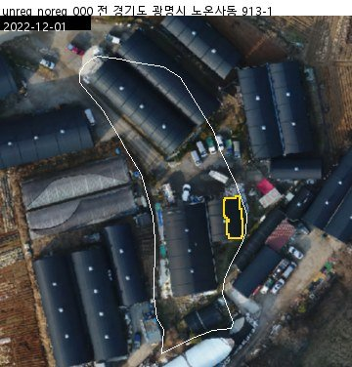
Figure 2. Review sample (unregistered · mapped, no register; yellow line = detected blob, white line = parcel boundary)
The sample size and population of each stratum are stored in the review sheet (qa_labels.csv); the report gives stratum-weighted precision with a 95% Wilson interval. The 'mapped, no register' stratum is reported separately and not mixed into the independent precision.

5.4 Candidate screening (required before the field survey)
Model results are candidates, so screen them once by eye before making the survey sheet and send only parcels that need checking. Targets and numbers are the same as in the survey: U001… = Appendix 1, R001… = Appendix 1-2, A01… = suspected new A, G01… = suspected removed A/B. The Gwangmyeong-Siheung v2.0 run has 1,185 (U 469, R 647, A 30, G 39).
- Click [후보 판독] (Candidate screening). It builds the screening sheet and before/after images for each candidate (70 m extent to show context) and opens the review pane in screening mode. Only the first time takes a few minutes; later it continues where you left off.
- Look at the left (baseline) and right (comparison) images and the map, then choose ① survey target ② false positive (excluded) ③ undecided (keys 1, 2, 3). For a false positive choose the cause first. The criteria for each class are shown at the top of the pane.
- Each judgement is saved and the next candidate appears. 'Unreviewed only' shows the rest. Candidates that need zooming or checking against the register or permits can be left as ③; they stay on the survey sheet.
- When done, click [현장조사 내보내기] in the pane. Only false positives are dropped; numbers stay the same.
- [보고서 다시 만들기] adds 'IV-4 Candidate screening results' (judgements by class, false-positive causes) to the report.
Class | ① Survey target | ② False positive (excluded)
Unregistered (U) · Appendix 1 | A real structure with no building outline inside the yellow line (shed, greenhouse, container, temporary building) | Edge of a registered roof, paving, trees, vehicles
Unregistered (R) · Appendix 1-2 | The unregistered building inside the yellow line really stands in the image | Already demolished (bare ground), paving, trees, vehicles
Suspected new (A) | A structure absent at the baseline really appears inside the yellow line | Shifted shadow, pitched-roof brightness, soil → paving, vehicles or stockpiles, colour change of greenhouses or containers
Suspected removed (G) | The baseline structure is really gone | Only hidden by shadow or brightness; the structure is still there

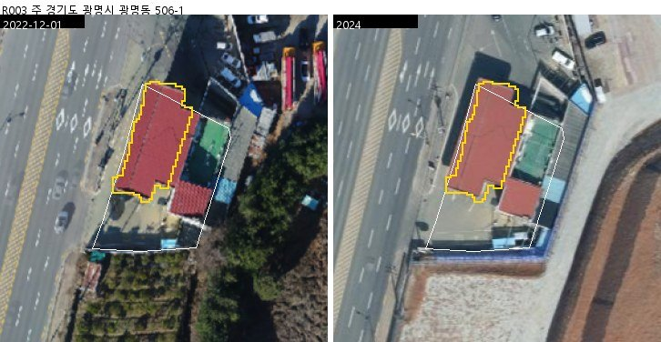
Figure 3. Screening image (unregistered · no register R003: the roof of a house that has an outline but no register record was detected; the parcel has one violation building)
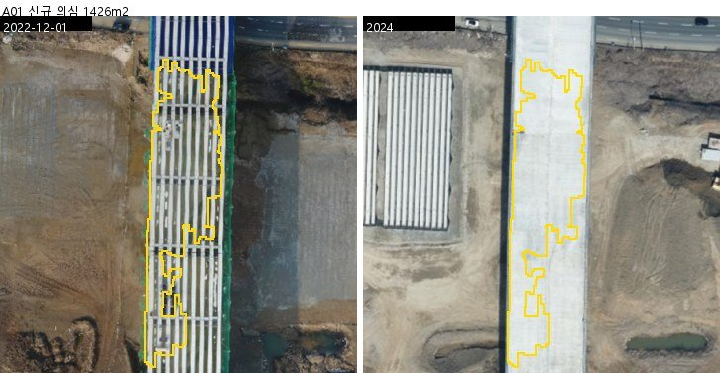
Figure 4. Screening image (suspected new A01: left baseline, right comparison, yellow line = candidate)
Time needed (approx.): a simple check takes about 3 seconds per candidate. 1,185 candidates take a little over an hour to check, and with zooming and register lookups one person can screen them within a day. Appendix 1-2 (R) is fastest because you only check whether the building stands. This screening secures the reliability of what goes to the field.

5.5 Field survey
[현장조사 내보내기] (Export field survey) prepares these targets: U001… = Appendix 1 unregistered (no map, no register) parcels, R001… = Appendix 1-2 unregistered (mapped, no register) parcels (same numbering as the appendices), A01… = suspected new A, G01… = suspected removed A/B (same numbering as Appendix 2). Targets marked as false positives in screening (5.4) are left out (undecided and unscreened ones stay).
Output | Content
현장조사표.xlsx (survey sheet) | Per target: evidence thumbnail, survey number, class, PNU, address, land category, detected area, lat/lon and result columns (drop-downs). Parcels with violation buildings get '[위반건축물 N동]' (N violation buildings) after the address. Includes an instruction sheet
survey.gdb · survey_points | One point per target; result fields with coded-value domains, Korean aliases and attachments enabled
survey.gdb · survey_areas | Survey extents (parcel or object polygons)
images\<survey no>.jpg | Evidence images at full size

Result column | Values
구조물 실재 (Structure exists) | 있음 yes / 없음 no / 확인불가 cannot tell (for removed: 'yes' if really gone)
용도 (Use) | House / storage / barn / greenhouse / container / factory or workshop / other
물건조서 등재 (In property list) | Yes / no / cannot tell ('yes' exists + 'no' listed = possibly missing from the property list)
Surveyor · date · photo file · remarks | Free text

Figure 5. Survey evidence image (suspected new A01: left baseline, right comparison)
- Surveying with Excel: print the sheet or fill it on a tablet, then [현장조사 결과 가져오기] (Import) > [예] (Yes) and choose the Excel file.
- Surveying with Field Maps: publish survey_points to ArcGIS Online/Enterprise, collect, download as a geodatabase, then [현장조사 결과 가져오기] > [아니오] (No) and choose the .gdb folder (found by the survey number field even if the layer is renamed).
- After import the report gets 'IV-3 Field survey results' (field precision by class, possibly missing from the property list, use) and a 'field' column in Appendix 1 and 1-2.
- Exporting again keeps the previous sheet and gdb with the date and time added to their names.

5.6 Parcel map PDF
- One A4 portrait page per Appendix 1 parcel: baseline image above, comparison image below (same extent), target parcel (red), detected blobs (yellow, both no-map and no-register blobs), parcel boundaries (white), scale and north arrow, and an information box (PNU, address, land category, status, parcel, registered and unregistered areas, field check boxes).
- Progress is shown in the run window; the result is saved as '필지도면_붙임1_<time>.pdf' in the run folder (about 4 minutes for 470 parcels) and can be opened right away.
- Maps are drawn by the analysis Python (no Pro map or layout is used, so Pro work is not affected). Print quality is A4 at 150 dpi.

5.7 Run history and reuse
- [실행 이력] (Run history) lists the runs in the output folder (date, input images, duration, parcels, unregistered no-map, unregistered no-register, new A, removed A/B, reused). v1.x runs leave the no-register column empty.
- From the list you can open the report, layers or folder, or [현재 결과로 선택] (Use as current result) to make another run the target of review and survey.
- The reuse cache is in _cache inside the output folder. It uses hard links and takes no extra disk space; if deleted, the next run rebuilds it.

5.8 Recommended workflow
The recommended order for using the results in compensation work. Each step is reflected when the report is rebuilt.
Step | Task | Button / output | Purpose
1 | Run | [판독 실행] → report, Appendix 1 and 1-2 | Build the candidate lists
2 | Sample review | [표본 검수] → [보고서 다시 만들기] | Precision by class (how far to trust each list)
3 | Candidate screening | [후보 판독] | Drop false positives, fix survey targets
4 | Property list check | Compare Appendix 1, then 1-2 (SHP/CSV) with the property list | Find structures possibly missing from the list
5 | Field survey | [현장조사 내보내기] → survey → [현장조사 결과 가져오기] | Confirm existence, use, listing
6 | Reporting | [보고서 다시 만들기], [필지 도면 PDF] | Final report and maps

- Priority: Appendix 1 (neither map nor register) is the most likely to be missing from the property list. Appendix 1-2 may be known buildings because they are on the map, but they have no register record, so they come second. 'Possibly attached' is only for checking extensions and annexes of registered buildings.
- Parcels with violation buildings (marked in the report and survey sheet) are likely to have parts outside the register; check them on site too.
- 'Exceeds register area' parcels from the parcel-level check are a supporting list of suspected extensions or temporary structures (6.7).

6. Outputs

6.1 Folder structure
<output folder>\<run time>\
project.yaml · run_info.json run settings · input hashes, registration, duration, key figures
data\imagery\t0_0.25m.tif, t2_… prepared images
comparisons\t0_t2\ pixel change detection
interpretation\
reports\…_official.html A4 public-agency report
reports\appendix1_unregistered_parcels\ (+ .zip) Appendix 1 no map, no register: SHP, CSV, field notes
reports\appendix1b_mapped_without_register\ (+ .zip) Appendix 1-2 mapped, no register: SHP, CSV, field notes
reports\parcel_interpretation.csv parcel table (all parcels)
reports\interpretation_summary.json key figures (incl. reference building composition)
vectors\parcel_interpretation.gpkg parcel results (polygons)
vectors\structure_change_objects.gpkg detected blobs (new, removed, unregistered; tier = A/B/C/U/R/UA)
evidence\new_A\ evidence images for suspected new
qa\review1\ review sample images and sheet
screen\ screening sheet (screen_labels.csv) and before/after images
survey\ survey sheet, survey.gdb, results

6.2 Report (A4 HTML) contents
- Cover · summary (four key figures; purpose, method, findings, cautions, recommendations) · contents
- I Overview (background, district, project history and provisional baseline date)
- II Data and method (data list incl. reference building composition, processing flow, interpretation figure)
- III Results (parcel status; by legal district with independent, no-register and attached columns; four-class unregistered table; 2-1 building data and register check with Table 8-1 reference composition and Table 8-2 parcel-level check; new/removed; maps and examples)
- IV Accuracy (classifier, sample review, field survey, candidate screening)
- V Use and next steps · Appendix 1 (no map, no register), 1-2 (mapped, no register), 2 (new/removed), 3 (review by round), 4 (related notices)
- Ctrl+P in the browser prints in A4 pages.
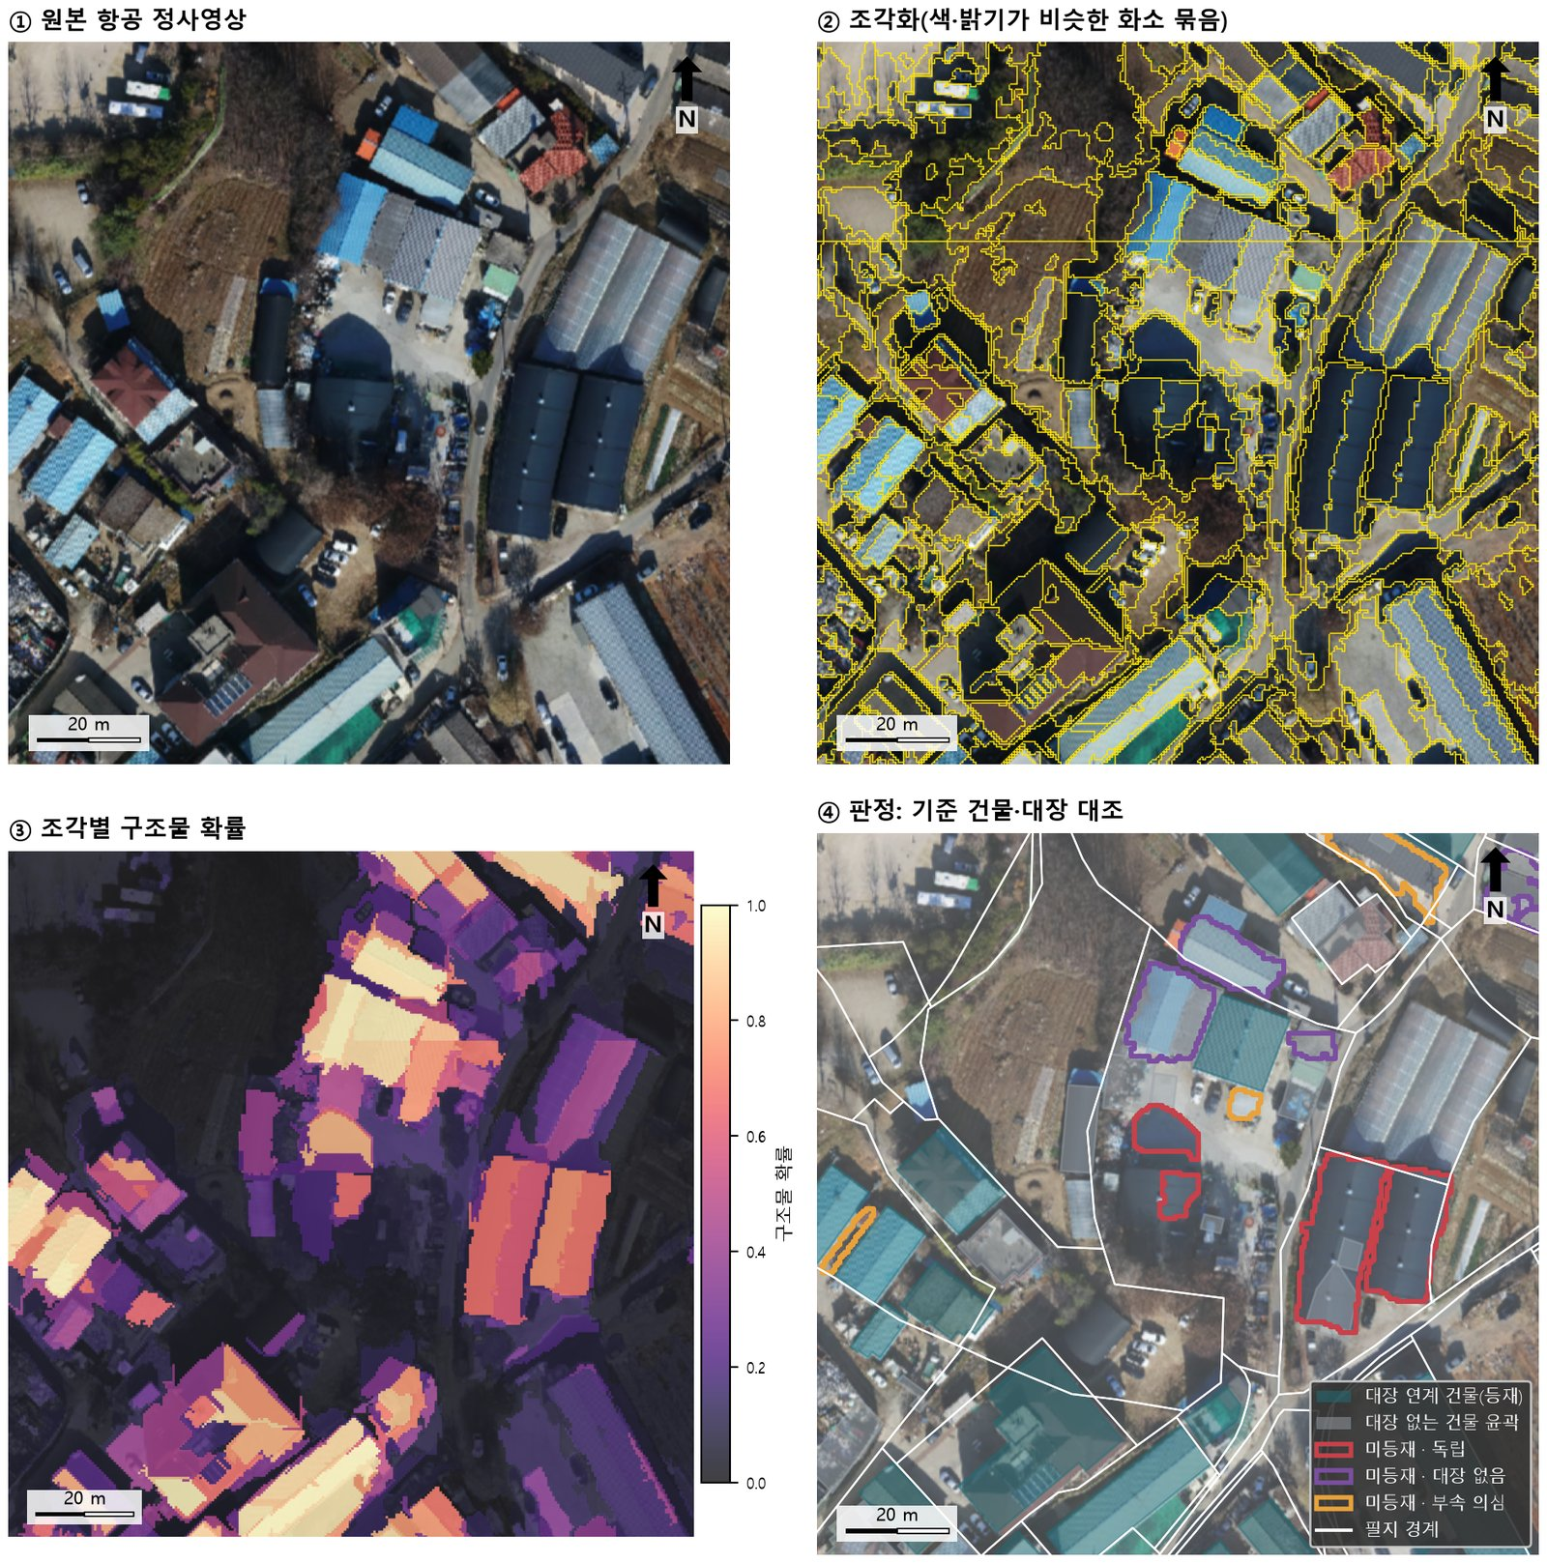
Figure 6. Report figure: interpretation steps (original → segments → structure probability → reference building and register check). In ④ teal = register-linked buildings, grey = outlines without register, red = independent, purple = no register, orange = possibly attached
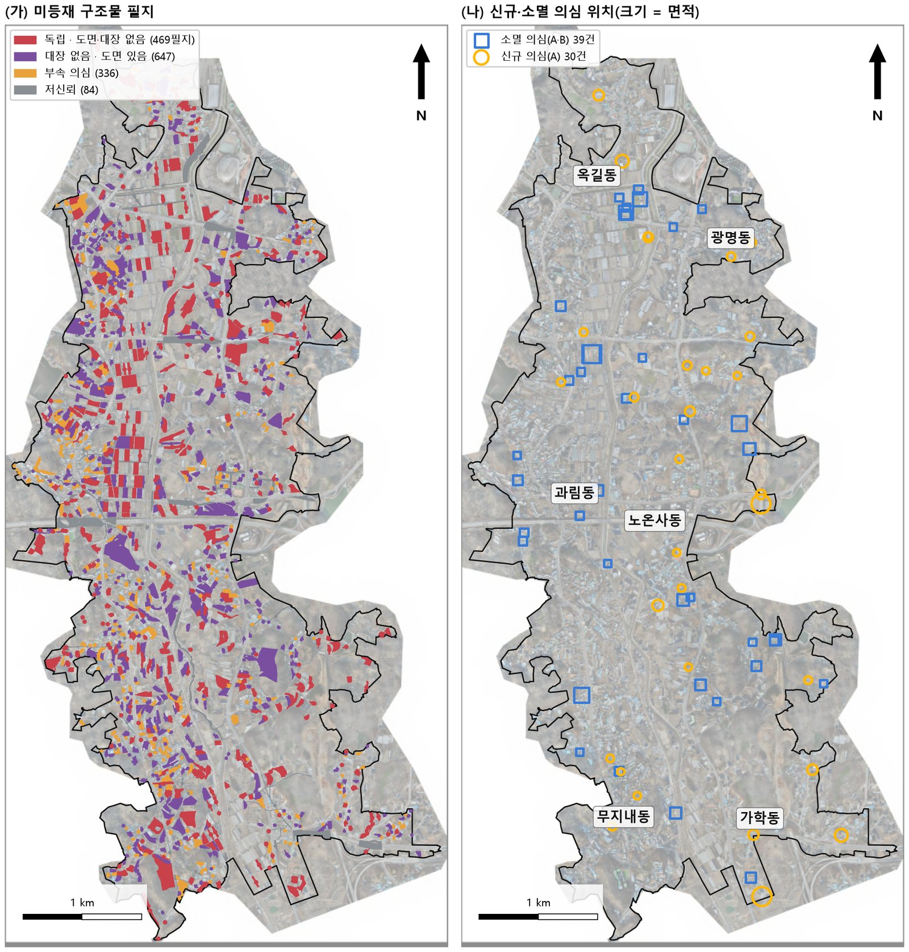
Figure 7. Report figure: unregistered parcels by class and suspected new/removed locations
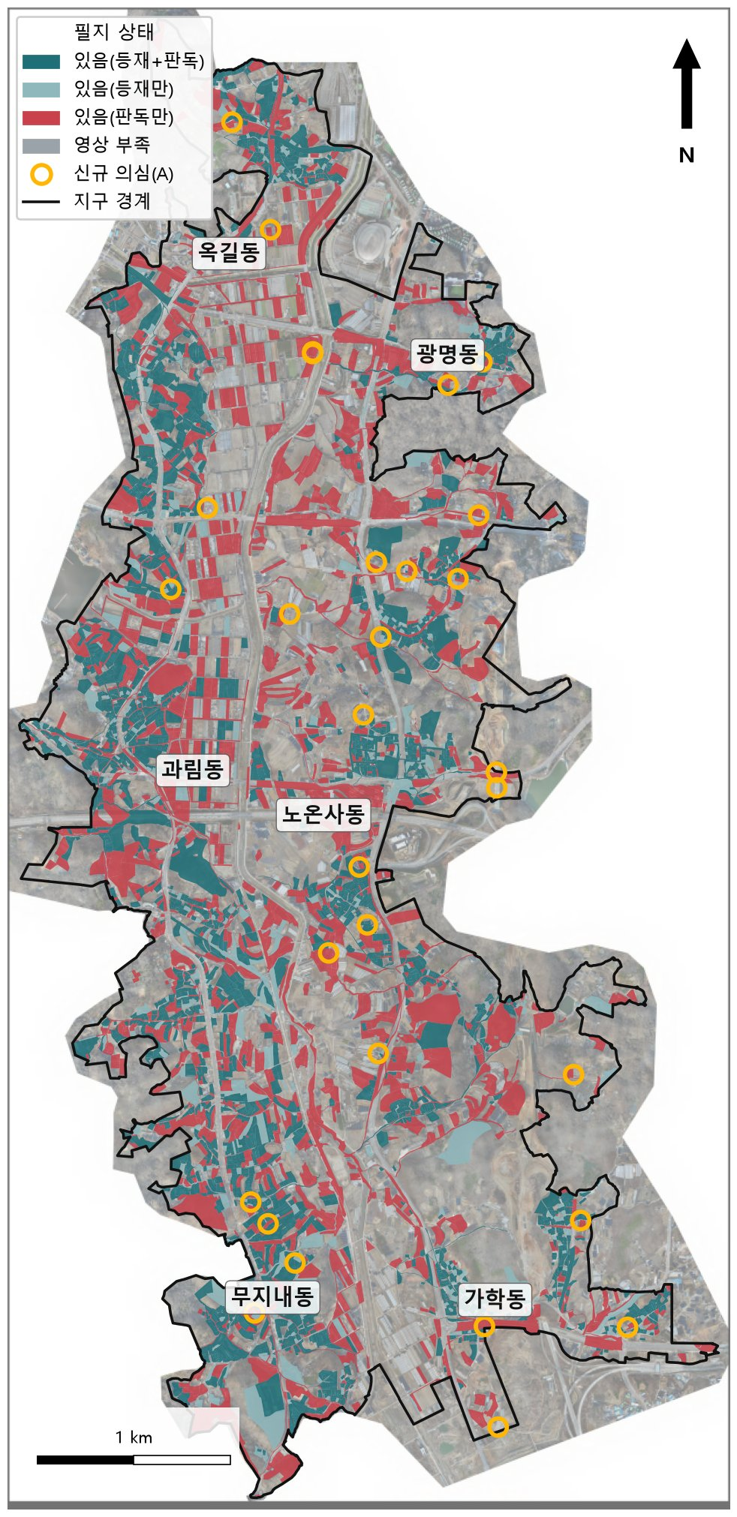
Figure 8. Report figure: parcel status map

6.3 Appendix 1 and 1-2 shapefile fields
Field | Description
SEQ | Sequence number, same as in the report appendix table (PNU order) and as the number in survey IDs U001…/R001…
PNU | Parcel number (19 digits)
ADDR · JIMOK | Lot address · land category
N_OBJ | Number of unregistered blobs (outside register-linked buildings + 1 m)
N_NOMAP · N_NOREG | Of these: blobs on no building outline · blobs on outlines without register
UNREG_M2 | Total area of unregistered blobs (m²)
REG_M2 · MAP_M2 | Register-linked building area · all building outline area in the parcel (m², regardless of register)
VIOLT_N | Number of violation buildings in the parcel (building integrated data)
PARCEL_M2 | Parcel area (m²)
STATUS | Parcel status at the baseline
REG_N | Number of register records with this parcel as main or attached lot (0 = no register)
REG_ARCH | Total register building area (m², main lot)
REG_CHK | Parcel-level register check: no register / exceeds register area / registered (6.7)

Both appendices have the same fields. 필드설명.txt in the same folder lists them, and the CSV opens directly in Excel (UTF-8 BOM). CRS EPSG:5186, encoding UTF-8 (.cpg included); drag it straight into Pro.
Example | Reading
Appendix 1, N_NOMAP 2, MAP_M2 0, REG_M2 0 | No building outline in the parcel but two structure blobs detected → first priority for a missing property
Appendix 1-2, N_NOREG 1, MAP_M2 460, REG_M2 156, REG_CHK no register | A structure on an outline without register, and no register record for the parcel → suspected unpermitted building
Appendix 1-2, REG_M2 285, REG_CHK registered | The parcel has a registered building but the blob is on another, unregistered building → suspected unregistered annex or shed
VIOLT_N 1 or more | The building data marks a violation building → check extensions or change of use outside the register on site

6.4 Parcel states and object grades
Value | Meaning
있음(등재+판독) registered + detected | Register-linked building present and a structure detected in the imagery (2,576 parcels)
있음(등재만) registered only | Register-linked building but nothing detected, mostly missed detections (674)
있음(판독만) detected only | Structure in the imagery without a register-linked building, including structures on outlines without register (1,760)
없음 / 영상 부족 none / insufficient imagery | No structure in either source (11,585) / sliver parcels at the boundary (41)
Unregistered independent / no register / attached / low confidence | No map, no register (469) / on an outline without register (647) / connected to a registered roof (336) / road or river land (84)
New/removed A · B · C | A = agrees with pixel change detection and does not overlap reference outlines; B = agrees, on an outline (roof replacement or rebuilding possible); C = classifier only (not listed)
Object tier U · R · UA | Unregistered blob grade: U = on no outline; R = 50% or more on an outline without register; UA = attached to a registered roof

6.5 How unregistered structures are determined
Unregistered means 'a structure detected outside register-linked buildings', decided in this order.
- Pixels with structure probability 0.6 or higher in the baseline image are structures.
- Register-linked building outlines widened by 1 m (registration margin) are removed.
- Connected blobs of the remaining pixels are kept if they are 20 m² or larger and fill at least 0.6 of their minimum rotated rectangle (removing 1-pixel strips and irregular paving).
- Each blob gets a grade; the first rule that matches applies: (a) 50% or more on an outline without register (widened by 1 m) → R (no register); (b) connected along the detected roof to a register-linked building → UA (possibly attached); (c) otherwise → U (independent).
- Blobs are collected per parcel; the first rule that matches applies: road, ditch, river, embankment or railway land → low confidence; any U blob → independent (Appendix 1); any R blob → no register (Appendix 1-2); only UA → possibly attached.
Parcel case | Class
One shed where there is no outline (U) | Independent → Appendix 1
Shed on an outline without register (R) + container with no outline (U) | Independent → Appendix 1 (U first)
Only a house on an outline without register (R) | No register → Appendix 1-2
Only an extension roof attached to a register-linked house (UA) | Possibly attached
Paving blob on road land (U) | Low confidence

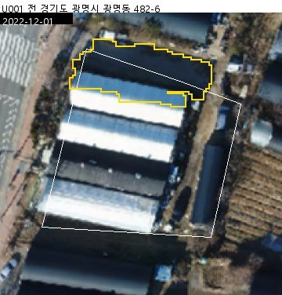
Figure 9. Survey evidence image (unregistered · no map, no register U001)

6.6 How new and removed are determined
- Blobs with probability below 0.3 at the baseline and 0.6 or higher at the comparison are new candidates, the reverse removed candidates. Pixels between the two thresholds count for neither.
- The earlier structure extent is widened by 1 m and removed so edges from registration error are not new; pixels in shadow at either date are removed.
- If the mean pixel change probability reaches the threshold, the two methods agree. Agreeing blobs overlapping reference outlines by less than 50% are A, 50% or more B; non-agreeing blobs are C (not listed).
- Gwangmyeong-Siheung v2.0: new A 30, B 8 / removed A 37, B 2.

6.7 Parcel-level building register check
Parcels with detected structures are matched by PNU to the building register (title, basic outline, attached lots) and get REG_CHK. It supports the building-level decision (6.5).
REG_CHK | Rule | Gwangmyeong-Siheung v2.0
대장 없음 no register | No register record has this parcel as main or attached lot | 1,996 parcels
대장 면적 초과 exceeds register area | Detected area is more than twice the register building area and at least 50 m² larger (suspected extension or temporary structure) | 70 parcels
대장 있음 registered | Otherwise | 2,270 parcels

- The median ratio of detected area to register building area is 1.08 (1,682 comparable parcels), so detected areas agree well with the register.
- Records spanning several lots and parcels without a PNU are not compared by area.
- If the register lot number was not updated after a cadastral split or merger, a parcel can show 'no register' although a record exists. Facilities outside the register's scope such as greenhouses also show 'no register'.

7. Cautions when using the results
- Model results are change and unregistered candidates. Screen all of them with [후보 판독] (5.4) before the field survey and send only confirmed and undecided ones.
- v2.0 changes the training truth and the registration basis (road-name buildings → building integrated data + register), so v1.x accuracy figures (independent 59% etc.) no longer apply. Run a new sample review (5.3) to get accuracy.
- Classifier building recall is 35% (2022) and 42% (2024) on 8,920 reference buildings of 20 m² or more, and only 17–21% below 50 m². Small or dark roofs are often missed, so 'no structure' is not evidence that nothing is there.
- Appendix 1 (no map, no register) is the first-priority list for checking against the property list and Appendix 1-2 (mapped, no register) the second. Check all evidence images before using new/removed results.
- v2.0 finds more small structures, so Appendix 1 has more parcels (469) than v1.3 (297). Most of the additions are structures of about 50–70 m² that overlap no building outline; their precision must be confirmed by the sample review.
- The building data may still contain outlines of demolished buildings. Confirm in screening that Appendix 1-2 targets really stand in the image.
- If the imagery is later than the provisional baseline date (2021-02-24, public inspection), the report states that it does not show the situation at that date. Imagery from around the baseline can be interpreted the same way.
- Re-registering and resampling the comparison image can change counts slightly even for the same area.

8. Troubleshooting
Symptom | Cause and fix
No tab on the ribbon | The add-in is missing or blocked by the signature policy. Check Documents\ArcGIS\AddIns\ArcGISPro and the Add-In Manager security settings
No tab in Pro 3.5 | v2.0 needs Pro 3.6 or later. Upgrade Pro or use v1.3
'Python을 찾지 못했습니다' (Python not found) | Set the analysis Python in [옵션 및 환경] to python\python.exe of the package and run [환경 점검]
'여유 공간이 …GB뿐입니다' (only … GB free) | Choose an output folder on a drive with space (1–2 GB per run)
ECW or MrSID cannot be opened | ArcGIS Pro (3.6 or later) Python (arcgispro-py3) is required; check the Pro installation
CRS error (EPSG code is unknown, proj.db) | A PROJ_LIB variable set by PostgreSQL/PostGIS hides the analysis Python's projection data. The add-in clears it for its runs; when running from the command line, clear PROJ_LIB, PROJ_DATA and GDAL_DATA first
'자동 정합 실패' (automatic registration failed) | The image without coordinates shows another place or overlaps too little; check its extent
Completion: position consistently off | The image CRS may be wrong; check the original CRS and run again
Completion: pixel change detection failed | No new/removed A or B. Check the log and run again (failed results are not cached)
No Appendix 1-2 layer or 'no register' class | The run was made with v1.x; run again with v2.0
Same images but no reuse | v1.x caches are not reused because the reference layer differs (expected). After one v2.0 run, reuse works again
Review or survey sheet cannot be saved | The file is open in Excel or another program; close it and retry
Exporting the survey again fails | survey.gdb is in use by Pro or another program; remove its layers from the map and retry

9. Appendix: command line and data refresh

9.1 Command line
The same processing can run without the add-in (from the interpretation code folder).
python -u -m src.interpretation.addin_run --out D:\Gwangmyeong_runs\run1 ^
--t0 <baseline image> --t0-date 2022-12-01 --t2 <comparison image> --t2-date 2024
python -m src.interpretation.addin_run --out <run folder> --report-only (rebuild report)
python -m src.interpretation.addin_run --out <run folder> --screen-export (screening sheet and images)
python -m src.interpretation.addin_run --out <run folder> --survey-export (survey sheet and gdb)
python -m src.interpretation.addin_run --out <run folder> --survey-import <file> (import survey results)
python -m src.interpretation.addin_run --out <run folder> --sheets (parcel map PDF)
Options: --no-change (skip change detection) --no-cache (no cache) --pro-python <Pro python.exe>

9.2 Refreshing the base data (development PC)
When the building data or register is updated, download them again on the development PC, rebuild the reference layer and rebuild the package. A VWorld API key (VWORLD_API_KEY) and a data.go.kr key approved for the building register hub must be in .env.
python -c "from src.data.project_acquisition import *; c=load_project('config/projects/gwangmyeong_siheung_aerial.yaml'); \
a=acquire_official_aoi(c); acquire_building_register(c); acquire_register_linkage(c); print(acquire_buildings_ref(c, a))"
→ data\projects\gwangmyeong_siheung_aerial\raw\gis_buildings\gis_buildings.geojson (building data source)
→ data\projects\gwangmyeong_siheung_aerial\processed\buildings_ref.gpkg (reference layer)
Then rebuild the package with build_dist.ps1 -Zip
Download the title records first so the building-level register match (main use, key) is attached. The building data comes from the VWorld national key data WFS (getBldgisSpceWFS, dt_d010) in EPSG:5186; if a request has more than 1,000 features the extent is split into four and requested again.

10. Appendix: terms
Term | Meaning
Reference building layer | Building outlines from the GIS building integrated data plus road-name address buildings (12,549); classifier truth and map check
Map (도면) | Building outlines of the reference layer. 'Mapped' = the map has a building outline there
Register-linked building (registered) | An outline linked to the building register (3,342); structures on it are not unregistered
Unregistered · independent | Parcel with a structure on no building outline (Appendix 1)
Unregistered · no register | Parcel with structures only on outlines without register (Appendix 1-2)
Possibly attached | Parcel with only blobs connected to a registered roof (extension or annex, or just the edge of the same roof)
Low confidence | Unregistered on road, ditch, river, embankment or railway land (many paving and vehicle false positives)
Segment | Group of pixels with similar colour and brightness (Felzenszwalb); the classifier scores each segment
Blob | Connected area of structure pixels; unit for unregistered and new/removed decisions
Recall | Share of reference buildings detected as structures
Precision | Share of detected results that are real structures (from the sample review)
Candidate screening | People checking candidates on before/after images before the field survey

11. Version history
Version | Date | Main changes
2.0 | 2026-11 | Reference building layer (GIS building integrated data + road-name buildings + building register), new training truth and registration basis, 'no register' class and Appendix 1-2, violation buildings, built for ArcGIS Pro 3.6
1.3 | 2026-11 | Candidate screening, parcel-level building register check (REG_CHK), native Pro 3.5 build
1.2 | 2026-11 | One build for Pro 3.5–3.7, survey and run-window fixes
1.1 | 2026-11 | Fixes from v1.0 testing, hardening against Pro crashes
1.0 | 2026-10 | First release: run, report, sample review, field survey, parcel map PDF

