Thesis Plan: What We Will Cover and Test
This thesis tests whether a drone can run a vision-language model (VLM) onboard, with an event camera and a spiking neural network (SNN) as a fast safety reflex.
Working title: Onboard vision-language control for a small drone with a neuromorphic safety reflex: a feasibility study on edge hardware.

1. Introduction
Vision-language models usually run on a ground station or in the cloud, because a small drone's onboard computer is weak. This thesis keeps the VLM onboard and lets fast reflexes cover the seconds it spends thinking.
- Problem: compute, latency and power limits onboard a small drone
- Idea: PX4 keeps the drone stable, an event-camera SNN reflex stops it, a VLM picks the goal every 1–10 s
- Research questions:
  - RQ1: Can a small quantised VLM on a Jetson Orin-class board find a named target fast and accurately enough to steer by?
  - RQ2: How much mission time does VLM latency cost when reflexes handle obstacles, and does it ever cost safety?
  - RQ3: How early and how reliably does the SNN reflex detect approaching obstacles, and which ones does it miss?
  - RQ4: How much power does each part draw on the same board?

2. Background and related work
The review covers the two halves of the system and the few works that already combine them.
- Event cameras and spiking neural networks; looming (an object growing in view) as an obstacle cue
- Neuromorphic drone flight, anchored on the supervisor's paper: Paredes-Vallés et al., fully neuromorphic vision and control for drone flight (a spiking network turns events into optical flow and sends thrust and attitude commands to PX4 at about 200 Hz, on Intel Loihi)
- Small VLMs that fit an Orin-class board: SmolVLM2, Moondream2, PaliGemma 2, Qwen2.5-VL 3B
- Onboard vision-language drone navigation: GRaD-Nav++ and the survey on aerial vision-language navigation, which lists onboard deployment as an open problem
- SNN reflex plus language model: Neuro-LIFT (event camera, Llama-3.2-3B on a Jetson Nano, text only)
- Fully spiking vision-language-action models: SpikeVLA
- PX4 offboard control and its failsafes

3. System design
The drone gets three layers: PX4 keeps it stable, reflexes stop it, and the VLM decides where to go.
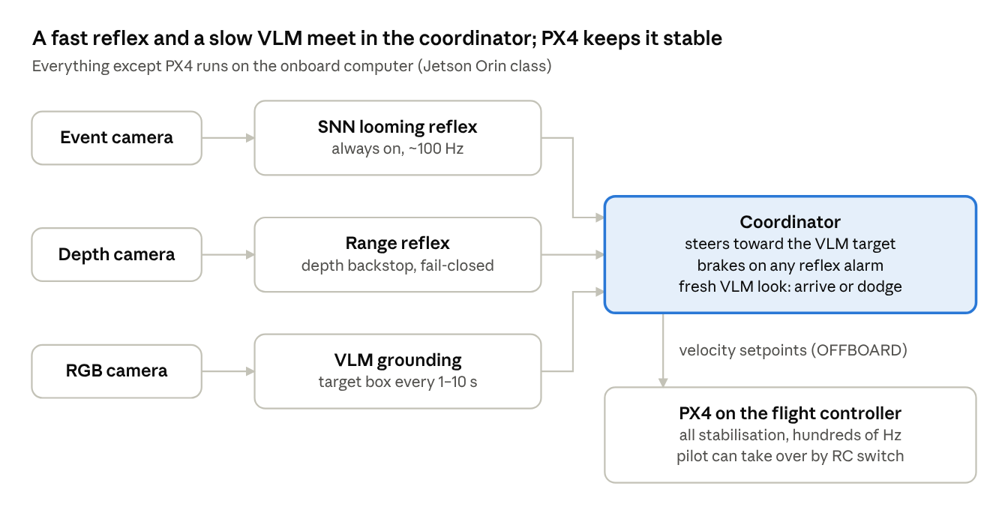
planned onboard stack · 3 sensors, 3 modules, 1 coordinator
A slow or dead VLM only costs progress; if a reflex goes silent, the drone holds still and then lands.
Low-level control stays with PX4 on the flight controller, as on the TU Delft drone (Pixhawk 4 Mini). Our coordinator sends velocity setpoints, one level above their thrust and attitude commands.

4. Implementation
The prototype software exists; everything that touches PX4, real sensors or a real VLM is still to do.
- ☒ Python prototype: SNN looming detector, coordinator, VLM client, safety rules (85 tests, synthetic simulator)
- ☒ Synthetic simulator: event camera, textured world, point-mass drone, test scenarios
- ☐ PX4 software-in-the-loop (SITL) simulation with Gazebo
- ☐ Simulated event camera in Gazebo (rendered video converted to events with v2e)
- ☐ A real VLM served on the Jetson (llama.cpp, Ollama or vLLM); a first test on the PC through Ollama is ready to run
- ☐ Sensor drivers on the Jetson: event camera, depth camera, RGB camera (written, untested)
- ☐ Power logging on the Jetson (written, unverified)
- ☐ (stretch) Gyro derotation, obstacle memory for dodges, a slow final approach to the target

5. Experiments
- ☐ 5.1 VLM benchmark on the Jetson (RQ1). Vary model, quantisation and image size; measure latency, valid-answer rate, target localisation error and energy per query.
- ☐ 5.2 VLM update rate vs mission (RQ2). Re-run the latency sweep with the latencies measured in 5.1; measure mission time, time spent waiting and collisions.
- ☐ 5.3 SNN reflex on real event data (RQ3). Record runs with and without obstacles; measure false alarms, alarm distance and time-to-contact, then re-tune the thresholds.
- ☐ 5.4 Power budget (RQ4). On one board: idle vs SNN vs VLM vs both; watts per part and joules per VLM query.
- ☐ 5.5 Closed-loop ablation in PX4 SITL (RQ2, RQ3). In a simulated X500 set to the real drone's mass and inertia: SNN only, depth only, both, neither, against textured, blank and thin obstacles; measure collisions, stops and mission time.
- ☐ 5.6 Hardware tests (stretch). Props-off bench run, then a tethered or netted test, then a supervised flight with a safety pilot.

6. Results and discussion
The discussion answers one question: is onboard VLM control feasible on an Orin-class board, and at what cost?
- Latency, accuracy and power per model and setting (RQ1, RQ4)
- How often the VLM must run, and what a slow VLM costs (RQ2)
- Where the neuromorphic reflex fails (blank walls, glass, thin poles and wires) and why a depth sensor backs it up (RQ3)
- The gap between the synthetic simulator, PX4 simulation and real data
- Weight, power and size of the full sensor set on a small drone

7. Conclusion and future work
- Answers to RQ1–RQ4
- Run the SNN on a neuromorphic chip (e.g. SynSense Speck, BrainChip Akida) instead of the CPU
- Fully spiking vision-language-action models
- Obstacle memory or a local map for smarter avoidance
- Multi-drone coordination, each drone with its own onboard model

Open points to agree on
- ☐ Hardware: nothing bought yet. Bench phase about €3,530 (€2,400 of it the event camera), flight phase about €1,570. Can the lab lend an event camera or a Jetson?
- ☐ Scope: proposal is bench and simulation results as the core, real flight as a stretch goal
- ☐ Timeline: no strict deadline; agree on milestones

