**Budapesta 15-17 Dec.**

Ziua 1-Pesta (partea unde avem cazarea)

Ora plecare ? 6-6:30

Cafelutsa undeva

-parlamentul

-papucii de langa dunare

Check in 15:00

balaceala? Am vz ceva cu tematica romana in interior sau aquapark

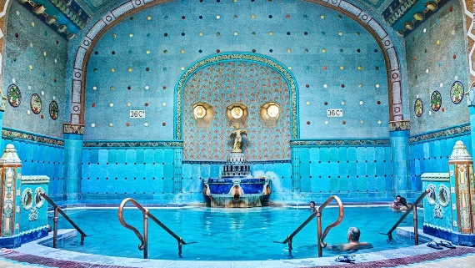

-patinoar city park

**-**St. Stephen’s Basilica-view frumi daca urci la targu de Craciun

**

-**Vajdahunyad Castle**

**-Váci utca-cel mai mare targ**

Ziua 2

-suntem la 4 min de new York café cafa acolo?rezervare

-Chain bridge

-Buda castle-Fisherman s bastion

-gellert hill se vede frumi de sus la apus

-plimbareala iar prin targuri Christmas market,fashion street

-garden of lights

-croaziera dunare? Sa nu fie drecu inghetata

-circ? =)))))

Ziua 3

Check out 10

-zoo? Cel mai mare din eu

-LAM museum

