Cairo University  
Faculty of Computers and Information



**CS251**

**Software Engineering I**

Project Name

Software Design

Team Names

Month & Year

Contents

Instructions [To be removed] 3

Team 3

Document Purpose and Audience 3

System Models 3

I. Class diagrams 3

Important Algorithm 5

II. Sequence diagrams 5

Class - Sequence Usage Table 7

Ownership Report 8

Policy Regarding Plagiarism: 8

References 8

Authors 8

# Team

|  |  |  |  |
| --- | --- | --- | --- |
| **ID** | **Name** | **Email** | **Mobile** |
| 20140050 | Esraa Ahmed Gaber | [Roaa.ahm96@gmail.com](mailto:Roaa.ahm96@gmail.com) | 01142840837 |
| 20140137 | Sarah Adel Elsayed | [Adelsarah491@yahoo.com](mailto:Adelsarah491@yahoo.com) | 01152557384 |
| 20140012 | Ahmed Gamal Mahmoud | [Ahmedg404@yahoo.com](mailto:Ahmedg404@yahoo.com) | 01145962292 |

# Document Purpose and Audience

**This document shows the class diagram and sequence diagram of the project and the relations between them.**

**The expected audience of this document is the project manager.**

# System Models

## I. Class diagrams

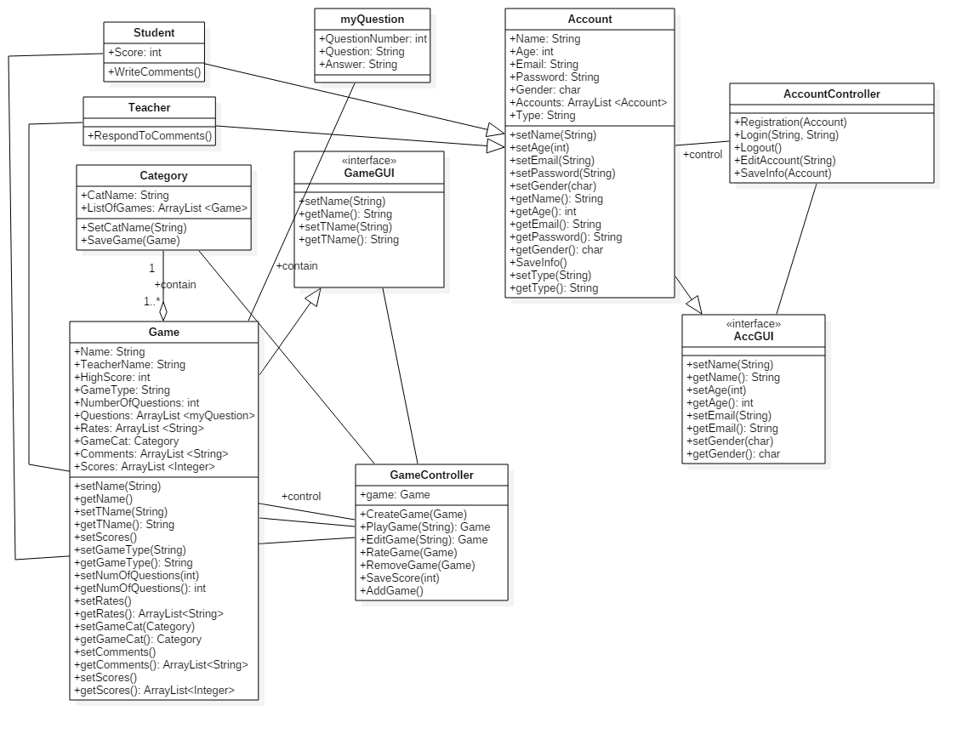

| **Class ID** | **Class Name** | **Description & Responsibility** |
| --- | --- | --- |
| 1 | Teacher | Teacher is a user have account and who allowed to create , update , try games and reply to comments. |
| 2 | Student | Student is a user have account and who allowed to play , rate games and write comments to games. |
| 3 | Account | Is the account that each user must have to use the website and contains his information. |
| 4 | AccountController` | Is an model controller that used to control with account class and it contains all functions related to this account. |
| 4 | AccGUI | Is an interface class uses to connect AccCntroller class to the user. |
| 5 | Category | Is the class of the category of the games the website support to users and each of it have games of this category. |
| 6 | Game | Class of game contain the information of each game for each category. |
| 7 | GameController | Is an model controller that used to control with Game class and it contains all functions related to this Game. |
| 8 | GameGUI | Is an interface class uses to connect GameCntroller class to the user. |
| 9 | myQuestion | It contains question number, question,it’s answer. |

### Important Algorithm

No algorithms used.

## II. Sequence diagrams

Sequence diagrams are:

-Registration (Teacher,Student)

- Add Game (Teacher)

-Play Game (Student)

Respectively.

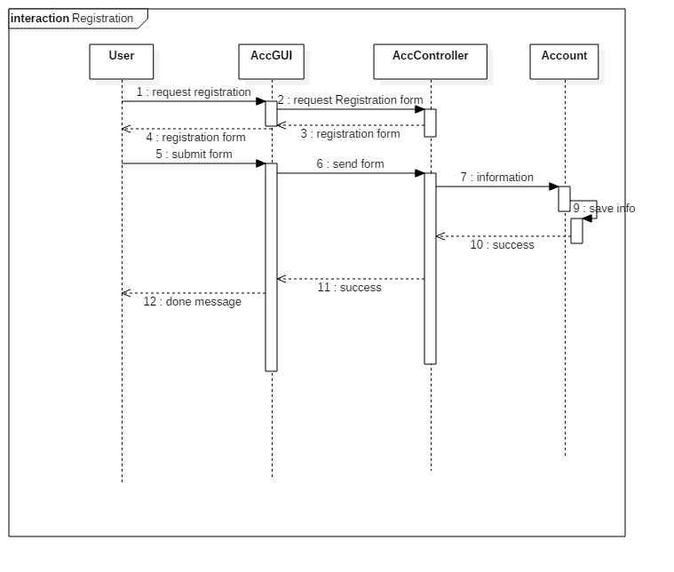

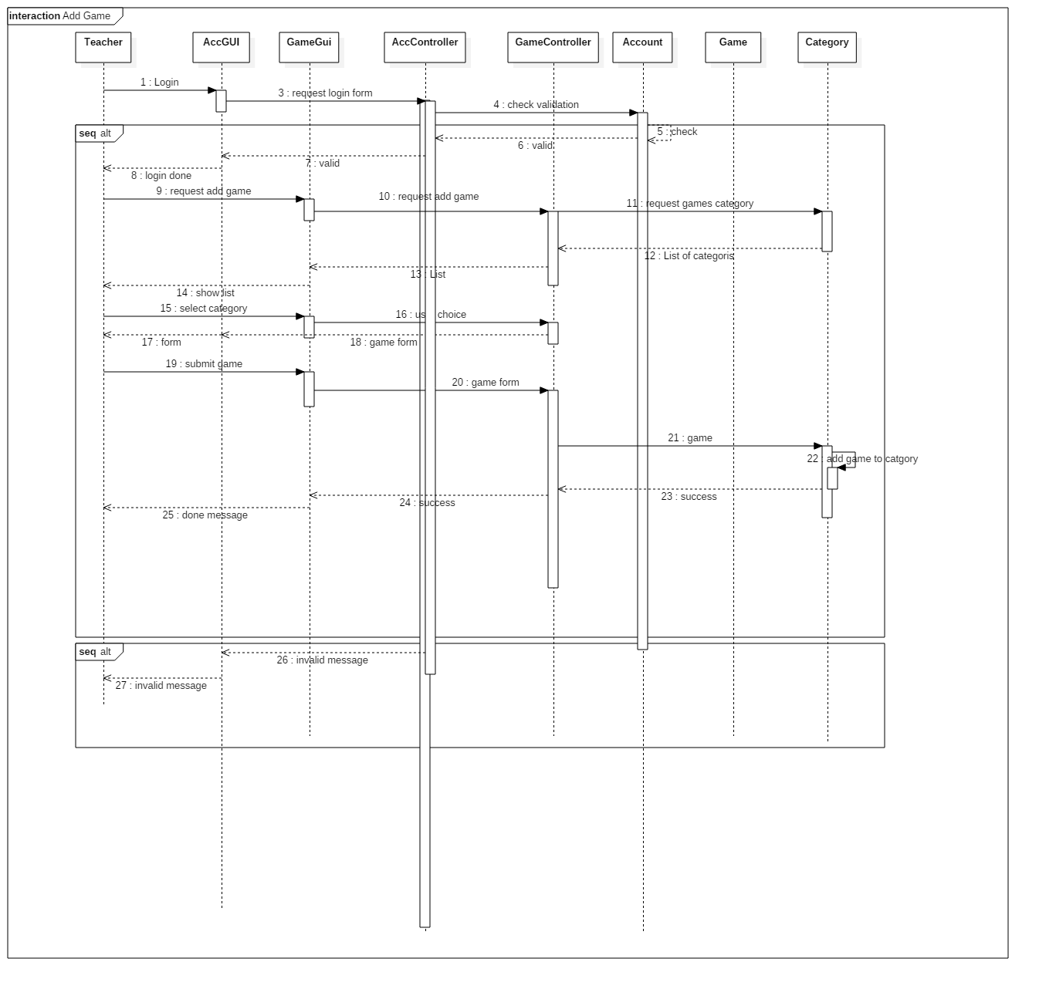

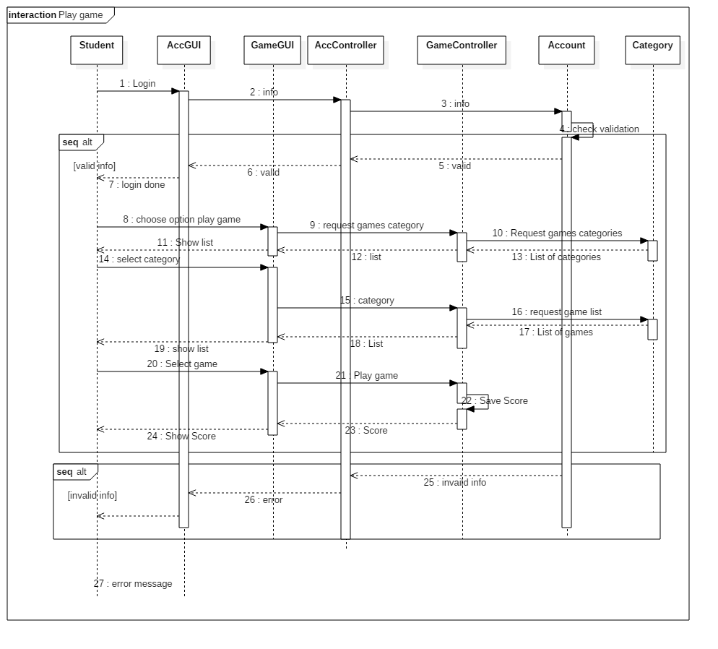

### Class - Sequence Usage Table

| **Class Name** | **Sequence Diagrams** | **Overall used methods** |
| --- | --- | --- |
| Teacher | 1, 2 | Create Account  Login  Add game |
| Student | 1,3 | Create Account  Login  Play game |
| Account | 1,2,3 | Check valid information  Save new account |
| Game | 3 | Add game to games list |
| Category | 2,3 | Return games category  Return list of games |
| AccController | 1,2,3 | Send registration form to accController |
| AccGUI | 1,2,3 | Connect game controllers to the user in GUI way. |
| GameController | 2,3 | Create game  Play game  Save score |
| GameGUI | 2,3 | Connect account controllers to the user in GUI way. |
| myQuestion | 2,3 | Each game contains number of questions and this class contains question’s details. |

# Ownership Report

|  |  |
| --- | --- |
| **Item** | **Owners** |
| Sequence Diagram | *All* |
| Class diagram | *All* |
| Implementation Code | *All* |

# Policy Regarding Plagiarism:

**Students have collective ownership and responsibility of their project. Any violation of academic honesty will have severe consequences and punishment for ALL team members.**

1. تشجع الكلية على مناقشة الأفكار و تبادل المعلومات و مناقشات الطلاب حيث يعتبر هذا جوهريا لعملية تعليمية سليمة
2. ساعد زملاءك على قدر ما تستطيع و حل لهم مشاكلهم فى الكود و لكن تبادل الحلول غير مقبول و يعتبر غشا.
3. أى حل يتشابه مع أى حل آخر بدرجة تقطع بأنهما منقولان من نفس المصدر سيعتبر أن صاحبيهما قد قاما بالغش.
4. قد توجد على النت برامج مشابهة لما نكتبه هنا أى نسخ من على النت يعتبر غشا يحاسب عليه صاحبه.
5. إذا لم تكن متأكدا أن فعلا ما يعد غشا فلتسأل المعيد أو أستاذ المادة.
6. فى حالة ثبوت الغش سيأخذ الطالب سالب درجة المسألة ، و فى حالة تكرار الغش سيرسب الطالب فى المقرر.

# References

* http://www.mhhe.com/engcs/compsci/pressman/graphics/Pressman5sepa/common/cs1/design.pdf

# Authors

* Mostafa Saad and Mohammad El-Ramly (Edited by Mohamed Samir)

**Github file link:**

https://github.com/essahmed96/SoftwarePhase2/blob/master/CS251-OmarKhaled-20140050-SRSDocument.docx