OPERATING SYSTEMS
Assignment-1
System Calls Through Assembly Language
SYED ASAD ZAMAN
p18-0034
Department of Computer Science

Number of experiments run :
N = 50
Average ‘user time’ for hello (int-based calls):
I = 0.169400
Average ‘user time’ for hello2 (syscall-based calls):
S = 0.221600
Percentage speedup: (I-S)*100/I = ((0.169400 – 0.221600)) * 100 / 0.169400
= -129.81%

Int Based Call:
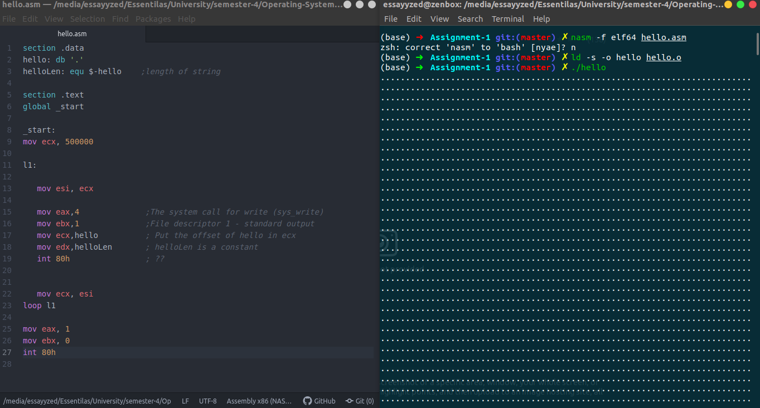
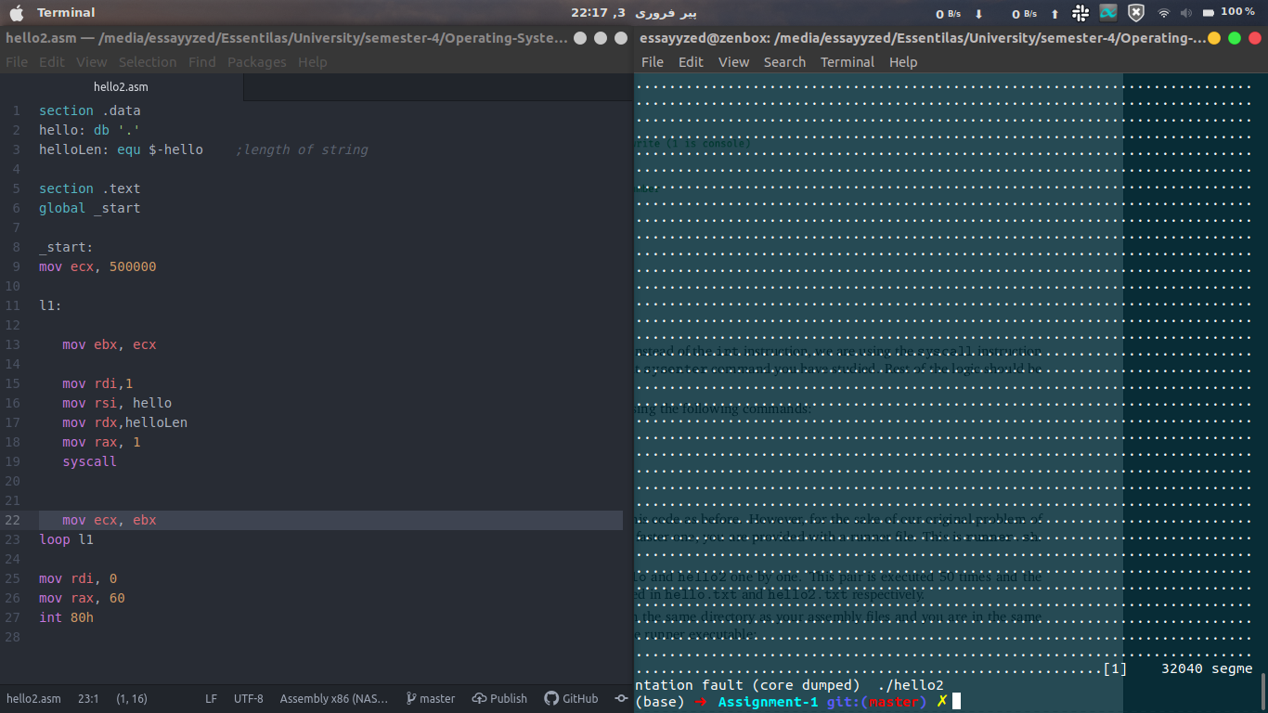
System Call Based
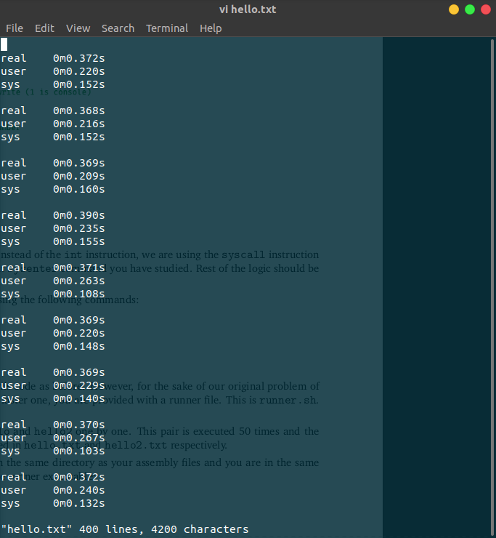
Execution Time of INT Based Call

Execution Time of Sys Based Call
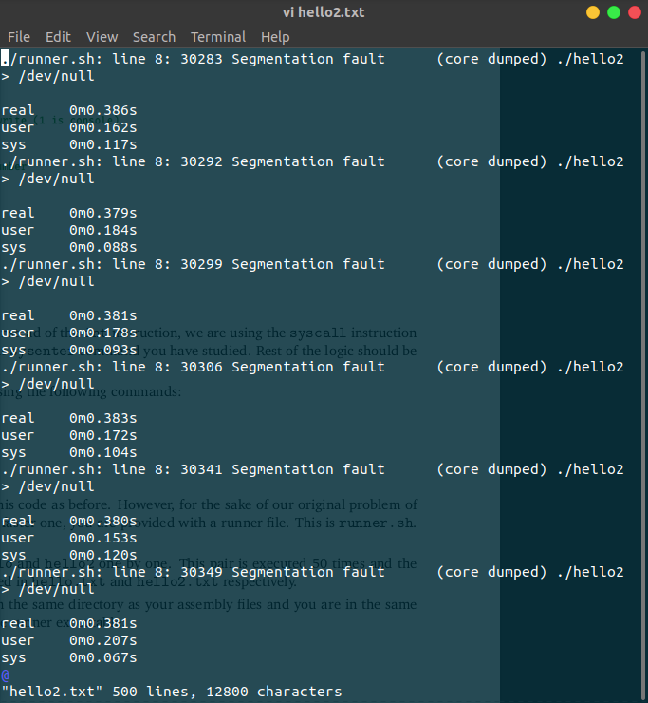

Memory & Time Usage Info.

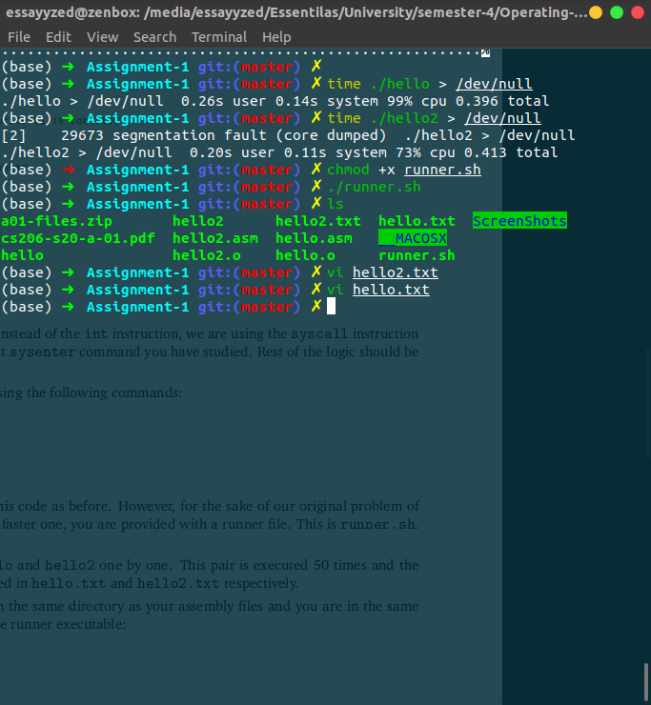

Average Time (Both Sys & INT based Calls)
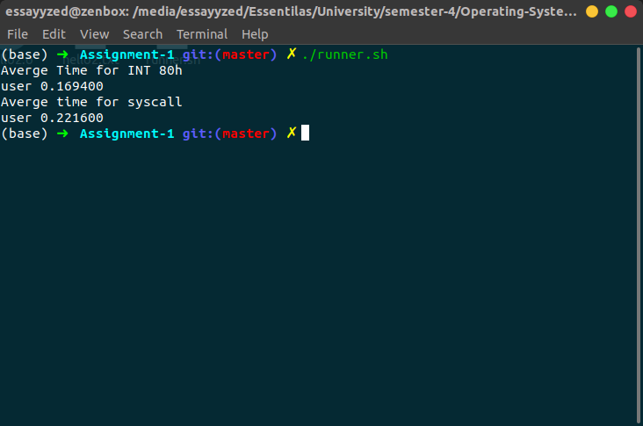
Note:
why did we issue 500k syscalls?
We issued 500k syscalls in order to find the time in microsecond in any other case we won’t be able to compute it because it won’t take to much time.

Why not less or more?
In case of less we won’t be able to find the time because it is so much less that it is approximately zero(0).
In case of More it will be unstoppable at certain level and will take too much time.

Why did we run the experiment 50 times?
In order to find Average time taken by both the calls.. in other case we won’t be able to compute the average time taken.

