Fareast International University



# LAB Report Course ID: CSE 3116

**Course Name: Artificial Intelligence LAB**

Submitted by

Zahid Hassan Fahad

Department of Computer Science ID: 17320001

Submitted to Ahmed Shafkat

Lecturer Department of Computer Science

### Remarks:

**Date: 1/05/2021**

**Introduction**

In this course we learned the basics of AI algorithms and it’s several implementations in real life. We used SWI-Prolog compiler for all our code practices.

**Ai Introduction –**

## Artificial intelligence (AI) refers to the simulation of human intelligence in machines that are programmed to think like humans and mimic their actions. The term may also be applied to any machine that exhibits traits associated with a human mind such as learning and problem-solving.

## Importance-

* AI technology is important because it enables human capabilities – understanding, reasoning, planning, communication and perception – to be undertaken by software increasingly effectively, efficiently and at low cost.
* General analytical tasks, including finding patterns in data, that have been performed by software for many years can also be performed more effectively using AI.
* The automation of these abilities creates new opportunities in most business sectors and consumer applications.
* Significant new products, services and capabilities enabled by AI include autonomous vehicles, automated medical diagnosis, voice input for human-computer interaction, intelligent agents, automated data synthesis and enhanced decision-making.
* AI has numerous, tangible use cases today that are enabling corporate revenue growth and cost savings in existing sectors.

## Goals of Artificial Intelligence

* To make a world with less physical activities those can be achieved by implementing Ai.
* Making things easier for humans.
* Ensuring to make the best use of technology.

**Code 01**

**Basic facts & query**

Knowledge-base:

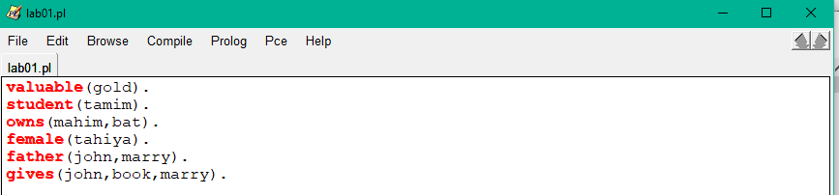

Explanation:

* + Here in knowledge base, I wrote some facts
  + For facts the first letter of the relationship must not be capital.
  + There should be a full stop sign after each fact.
  + In the bracket we put our subjects of the argument.
  + Once all the facts are written then we will go to query section and then cross-check our knowledge base.
  + In query section if relationship query matches with the database, then it will return “true” or else it will return “false”.

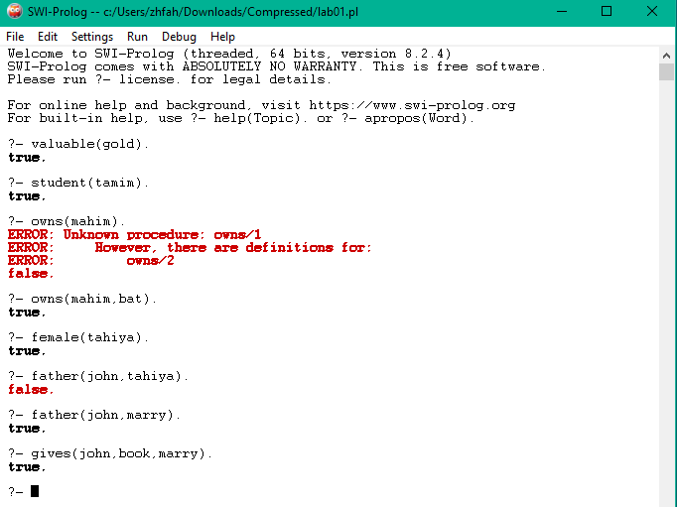**Query Output picture**

**Code 02**

**Anonymous Variables & Rules**

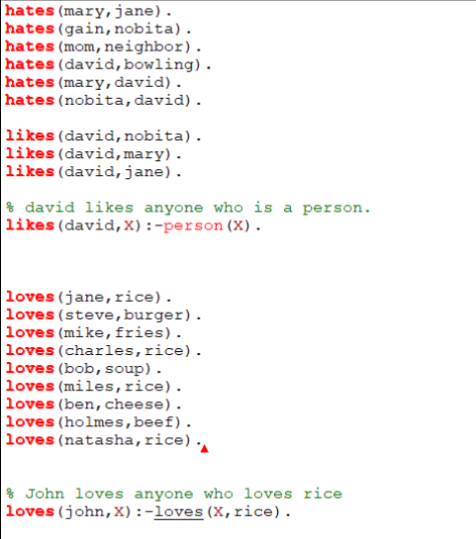

Explanation:

* For rules we put “: -” between facts and reasons.
  + A variable will show all the similar true results depending on “and” or “or” condition and after each result we need to enter a “;” to see the next result until the list ends.
  + Anonymous variable “_” looks for match in the facts and then replaces one subject to match the complete fact as long as other conditions matches.

**Query Output:**

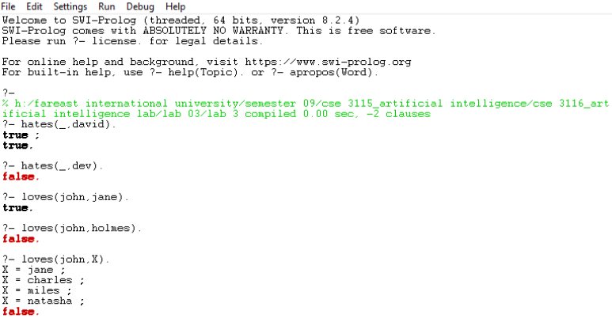

**Code 3**

**Variable**

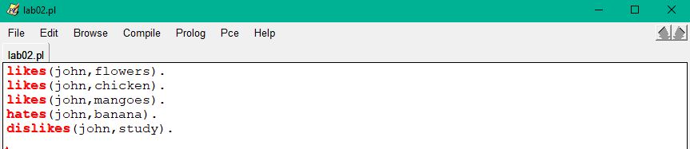

**Explanation**

* A variable will show all the similar true results depending on “and” or “or” condition and after each result we need to enter a “;” to see the next result until the list ends.
* “And” condition is represented by “,” and “or” condition is represented by “;”.
* For “and” condition all the facts must match with database, while for “or” condition minimum one fact needs to be matched.
* We can stop generating the results by entering a “.” After certain number of results.

**Output:**

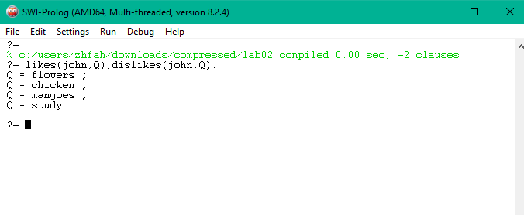

**Code 4**

**Family tree**

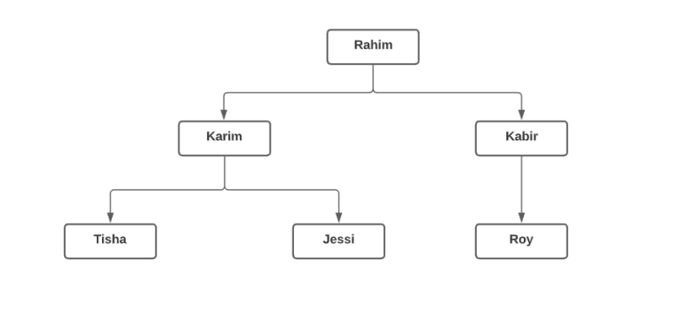

**Knowledge base:**

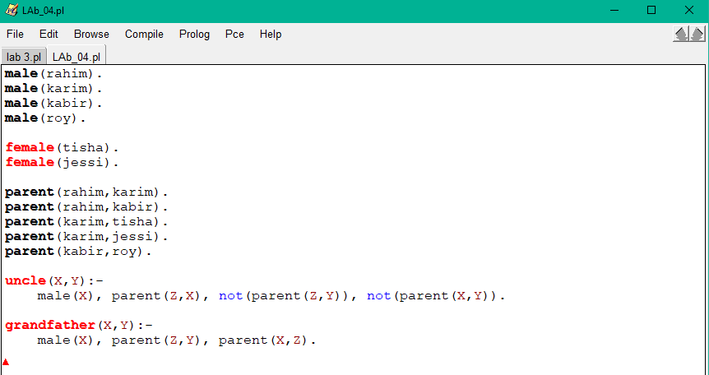

**Explanation:**

**Same as previous ones except it is following a tree**

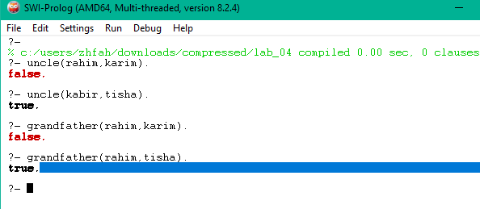

**Learnings of this Lab**

* **Importance of Artificial Intelligence in day-to-day life.**
* **SWI-Prolog compiler.**
* **different facts and rules in Artificial Intelligence.**
* **Learned some Coding regarded to prologue**

**Conclusion**

**This course really did give me some raw Ai knowledges. Though I was busy doing my job but with the help of our course teacher, I was able to gather a lot of knowledge. I also learned all the basic coding steps which will help me to make a step forward to the Ai world.**