IrisFiles Test Document
Plain paragraph with formatting: bold
Unicode: café — naïve — 日本語 — Ω≈ç√∫ — Здравствуйте — مرحبا
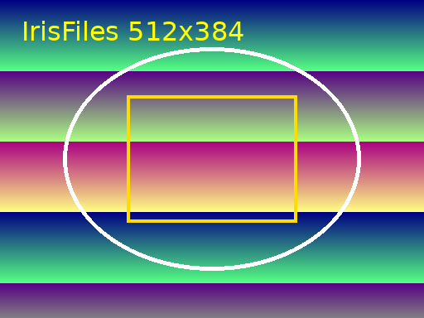

Second Page
Line 0: the quick brown fox jumps over the lazy dog. 0123456789.
Line 1: the quick brown fox jumps over the lazy dog. 0123456789.
Line 2: the quick brown fox jumps over the lazy dog. 0123456789.
Line 3: the quick brown fox jumps over the lazy dog. 0123456789.
Line 4: the quick brown fox jumps over the lazy dog. 0123456789.
Line 5: the quick brown fox jumps over the lazy dog. 0123456789.
Line 6: the quick brown fox jumps over the lazy dog. 0123456789.
Line 7: the quick brown fox jumps over the lazy dog. 0123456789.
Line 8: the quick brown fox jumps over the lazy dog. 0123456789.
Line 9: the quick brown fox jumps over the lazy dog. 0123456789.
Line 10: the quick brown fox jumps over the lazy dog. 0123456789.
Line 11: the quick brown fox jumps over the lazy dog. 0123456789.
Line 12: the quick brown fox jumps over the lazy dog. 0123456789.
Line 13: the quick brown fox jumps over the lazy dog. 0123456789.
Line 14: the quick brown fox jumps over the lazy dog. 0123456789.
Line 15: the quick brown fox jumps over the lazy dog. 0123456789.
Line 16: the quick brown fox jumps over the lazy dog. 0123456789.
Line 17: the quick brown fox jumps over the lazy dog. 0123456789.
Line 18: the quick brown fox jumps over the lazy dog. 0123456789.
Line 19: the quick brown fox jumps over the lazy dog. 0123456789.
Line 20: the quick brown fox jumps over the lazy dog. 0123456789.
Line 21: the quick brown fox jumps over the lazy dog. 0123456789.
Line 22: the quick brown fox jumps over the lazy dog. 0123456789.
Line 23: the quick brown fox jumps over the lazy dog. 0123456789.
Line 24: the quick brown fox jumps over the lazy dog. 0123456789.
Line 25: the quick brown fox jumps over the lazy dog. 0123456789.
Line 26: the quick brown fox jumps over the lazy dog. 0123456789.
Line 27: the quick brown fox jumps over the lazy dog. 0123456789.
Line 28: the quick brown fox jumps over the lazy dog. 0123456789.
Line 29: the quick brown fox jumps over the lazy dog. 0123456789.

