Jailbreaking your reference lists: the OpenCitations project strikes again

Abstract
In this poster paper we provide an overview of the OpenCitations project and of its main outcome, the OpenCitations Corpus, which is an open repository of scholarly citation data made available under a Creative Commons public domain dedication, which provides in RDF accurate citation information harvested from the scholarly literature.
RASH version of this paper: https://rawgit.com/essepuntato/opencitations/master/papers/occ-demo-iswc2016.html

Introduction
Databases of citation data are among the most attractive and used artefacts in the Scholarly Communication domain. They are the main tool used by researchers for getting knowledge about a particular topic, and by scientists in Bibliometrics, Informetrics, and Scientometrics for analysing complex relations existing between huge graphs of citations of scholarly works. On the other hand, they are also used for institutional goals, since they are still one of the main worldwide mechanisms for the assessment of the quality of research by means of (sometimes questionable) metrics and indicators calculated from such citation databases. While many of them, e.g. Microsoft Academic Graph and Google Scholar, are freely accessible, those ones that are considered most authoritative by institutions worldwide, i.e. Scopus and Web of Science, can be accessed only by paying a conspicuous fee. For instance, UK research universities each pay tens of thousands of pounds annually for having granted the access to these databases [5].
Reference lists from academic articles are the core elements of scholarly communication, since they permit the attribution of credit and integrate our independent research endeavours – and the cruel reality is that they are not freely available at all. In the current age where Open Access is considered a necessary practice in research, as also endorsed by institutions such as the European Union in its Horizon 2020 programme, “citation data now needs to be recognized as a part of the Commons – those works that are freely and legally available for sharing – and placed in an open repository, where they should be stored in appropriate machine-readable formats so as to be easily reused by machines to assist people in producing novel services” [5].
These are the main premises for the OpenCitations project (OC) and for the establishment of its Corpus (OCC), i.e. an open repository of scholarly citation data made available under a Creative Commons public domain dedication, which provides in RDF accurate citation information (bibliographic references) harvested from the scholarly literature. Initially developed as main outcome of the JISC Open Citations Project, and then adopted by the IS4OA as one of their academic Open Access services, the current instantiation of the OCC is hosted by the Department of Computer Science and Engineering (DISI) at the University of Bologna, and has just started to process reference lists of scholarly papers available in Europe PubMed Central since the beginning of July. In this paper we provide a brief overview of the OC main components that make possible the extraction and description of such reference lists into RDF.
The rest of the paper is organised as follows. In Related works we introduce some of the most recent related works in the area. In The OpenCitations Corpus we briefly summarise the main output of OpenCitations projects, i.e. the OCC, and the various tools developed for creating citation data in RDF. Finally, in Conclusions we conclude the paper sketching out some future works.

Related works
In the last years we have seen a growing interest within the Semantic Web community in creating and making available RDF dataset concerning bibliographic metadata of scholarly documents. While the list of such works is quite extensive, in this section we would like to describe four of the most important contributions in the area.
The Semantic Lancet Project [1] aims at building a Linked Open Dataset of scholarly publication metadata starting from the articles published by Elsevier. In particular, the current dataset contains SPAR-based [6] metadata about several papers published in the Journal of Web Semantics, including citation links marked with the motivations justifying them, and it is accompanied by several graphical interfaces that allow browsing and sense-making of such data.
Springer LOD [3] is an RDF dataset made available by Springer Nature that publishes Springer metadata about conferences as Linked Open Data (LOD). Its main focus in on proceedings volumes and the related conferences, instead of keeping track of the metadata of articles contained in such proceedings.
OpenAIRE (https://www.openaire.eu) [2] is an Horizon 2020 project which publishes metadata of more than 14 millions of publications and thousands of datasets. It makes available mechanism for searching, discovering and monitoring scientific outputs.
Finally, Scholarly Data [7] is a new project that refactors of the Semantic Web Dog Food so as to keep the dataset growing in good health, and adopts the new Conference Ontology (aligned with other existing models, e.g. SPAR [6]) for describing the data.

The OpenCitations Corpus
OpenCitations (http://opencitations.net,Twitter user: @opencitations; GitHub project at https://github.com/essepuntato/opencitations) is a project which aims at creating an open dataset of citation data, accompanied by specifications and other browsing tools – SPARQL endpoint, browsing interfaces, etc. – for supporting data consumers.Its main output is the creation of the Open Citations Corpus (OCC), an open repository of scholarly citation data made available under a Creative Commons public domain dedication (CC0), which provides accurate bibliographic references harvested from the scholarly literature (described using the SPAR Ontologies [6] according to the OCC metadata document [4]) that others may freely build upon, enhance and reuse for any purpose, without restriction under copyright or database law.
The OCC stores metadata relevant to these citations in RDF, specifically BibJSON encoded as JSON-LD and makes them available through a SPARQL endpoint and as downloadable datasets. In handles six different kinds of bibliographic entities:
- bibliographic resources (br) – resources that cites/is cited by another bibliographic resource (e.g. journal article), or that contains citing/cited resources (e.g. journals);
- resource embodiments (re) – physical or digital formats in which bibliographic resources were made available by its publisher;
- bibliographic entries (be) – textual bibliographic entries occurring in the reference list within a bibliographic resource, that references another bibliographic resources;
- responsible agents (ra) – agents having a certain role with respect to a bibliographic resource (e.g. authors, editors, publishers);
- agent roles (ar) – roles held by an agent with respect to a bibliographic resource;
- identifiers (id) – an external identifier (e.g. DOI , ORCID , PubMedID ) associated with the bibliographic entity.
The corpus URL (https://w3id.org/oc/corpus/) identifies the main aggregated dataset of the OCC, which is split in several sub-datasets, one for each of the aforementioned kind of entity included in the corpus, having a URL composed by the corpus URL plus the two-letter short name for the class of items (e.g. “be” for a bibliographic entry) followed by an oblique slash (e.g. https://w3id.org/oc/corpus/be/ for the sub-dataset containing bibliographic entries). Each dataset is described appropriately by means of Data Catalog Vocabulary and the VoID Vocabulary, and a SPARQL endpoint (powered by Blazegraph) has been also made available with all the entities included in the OCC.
A URL is assigned to each entity of each sub-dataset upon initial curation into the OCC. Each URL is composed by the sub-dataset URL in consideration plus a number assigned to each resource, unique among resources of the same type, which increments for each new entry in that resource class. For instance, the resource https://w3id.org/oc/corpus/be/537 is the 537th bibliographic entry created in the OCC (in the bibliographic entry sub-dataset). Each of these entities have also associated metadata describing their provenance by means of PROV-O and its PROV-DC extension. In particular, we keep track of the curatorial activities related to each OCC entity, as well as the agents involved in such activities and with which role.
OCC unique because provide citation info in RDF in CC0.
TODO
6 different kinds of resource
Information about the dataset
Provenance data for each resource in the corpus
Triplestore and SPARQL endpoint
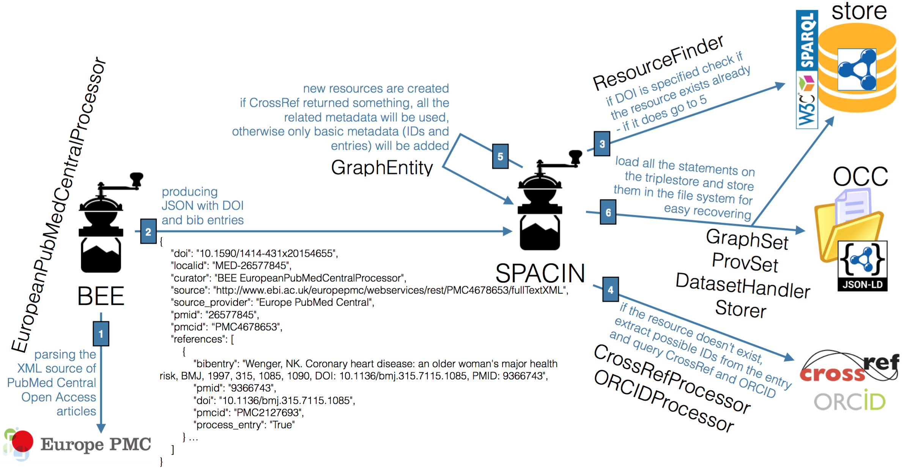Illustration 1: The steps involving BEE and SPACIN, and their related classes, in the production of the OpenCitations Corpus.
TODO

Conclusions
TODO
Linked existing dataset

References
- Bagnacani, A., Ciancarini, P., Di Iorio, A., Nuzzolese, A. G., Peroni, S., Vitali, F. (2014). The Semantic Lancet Project: A Linked Open Dataset for Scholarly Publishing. In EKAW 2014 Satellite Events: 101–105. http://dx.doi.org/10.1007/978-3-319-17966-7_10
- Alexiou, G., Vahdati, S., Lange, C., Papastefanatos G., Lohmann, S. (2016). OpenAIRE LOD services: Scholarly Communication Data as Linked Data. To appear in Proceedings of SAVE-SD 2016. http://cs.unibo.it/save-sd/2016/papers/html/alexiou-savesd2016.html
- Bryl, V., Birukou, A., Eckert, K., Kessler, M. (2014). What's in the proceedings? Combining publisher's and researcher's perspectives. In Proceedings of SePublica 2014. http://ceur-ws.org/Vol-1155/paper-01.pdf
- Peroni, S., Shotton, D. (2016). Metadata for the OpenCitations Corpus. figshare. https://dx.doi.org/10.6084/m9.figshare.3443876
- Peroni, S., Dutton, A., Gray, T., Shotton, D. (2015). Setting our bibliographic references free: towards open citation data. Journal of Documentation, 71 (2): 253–277. http://dx.doi.org/10.1108/JD-12-2013-0166
- Peroni, S. (2014). The Semantic Publishing and Referencing Ontologies. In Semantic Web Technologies and Legal Scholarly Publishing: 121–193. http://dx.doi.org/10.1007/978-3-319-04777-5_5
- Nuzzolese, A. G., Gentile, A. L., Presutti, V., Gangemi, A. (2016). Conference Linked Data – Our Web Dog Food has gone gourmet. To appear in Proceedings of ISWC 2016.

