ACF confidence bands calculation.

The 'Confidence bands' parameter determines which formula for generating the confidence bands will be used:

1. The 'Standard formula':

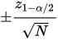
where N is the sample size, z is the quantile function of the standard normal distribution and α is the 0.05 significance level.

In this case, the confidence bands have fixed width that depends on the sample size. Fixed confidence bands example:
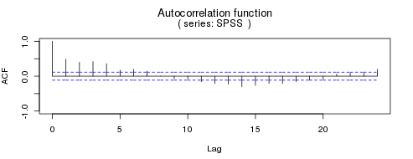

2. The 'Bartlett's formula':
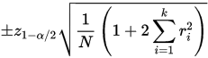
where k is the lag, N is the sample size, z is the quantile function of the standard normal distribution, α is the 0.05 significance level, ri is the estimated autocorrelation at lag i.
In this case, the confidence bands increase as the lag k increases.
Lag-dependent confidence bands example:
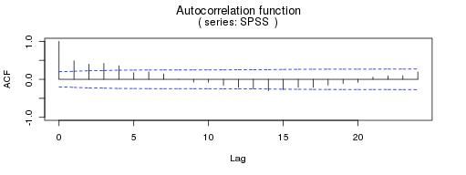
https://en.wikipedia.org/wiki/Correlogram

