Synchrony between time series.

The synchrony between two univariate time series of equal length is calculated as following:

Consider two time series X and Y of length N.

The vectors of changes, Cx and Cy, are created for each of the time series. The vector element Cx[i], where i = 1, 2, ..., N-1, is set to -1, 0 or 1, depending on the sign of the first derivative of X at the time point i:

Cx[i] = 1, if (X[i+1] – X[i]) > 0,
Cx[i] = 0, if (X[i+1] – X[i]) = 0,
Cx[i] = -1, if (X[i+1] – X[i]) < 0.

The Cy vector is calculated in similar way.

The Cx and Cy vectors are compared and the result is stored in
the vector of synchronies, Sxy. The vector element Sxy[i], where i = 1, 2, ..., N-1, is set to -1, 0 or 1, depending on the values in Cx[i] and Cy[i]:

Sxy[i] = 1, if Cx[i] = Cy[i], positive synchrony case,
Sxy[i] = -1, if Cx[i] = - Cy[i], negative synchrony case,
Sxy[i] = 0, if abs(Cx[i]+Cy[i]) = 1, no synchrony case.

Since the Cx[i] and Cy[i] have 3 possible values each,
the variants for the Sxy[i] value can be placed in a 3x3 matrix:

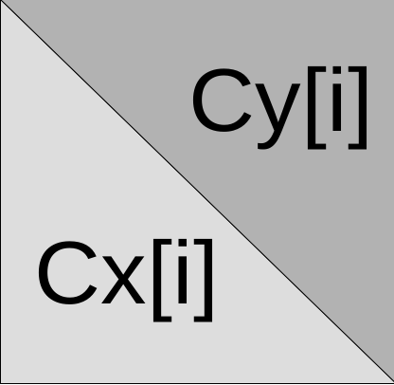
The Sxy[i] value depends on the
Cx[i] and Cy[i] values. It is 1,
if the X and Y time series
changes are synchronous at
the time point i.

The synchrony between the X and Y time series, S, is equal to:
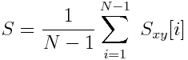
where N is the time series length, Sxy is
the vector of synchronies between X and Y
time series.

The synchrony value is varied from -1 to 1, where -1 is a perfect negative synchrony, 0 no synchrony and 1 a perfect positive synchrony.

Example for a positive and negative synchrony.
