**Supplementary Material**

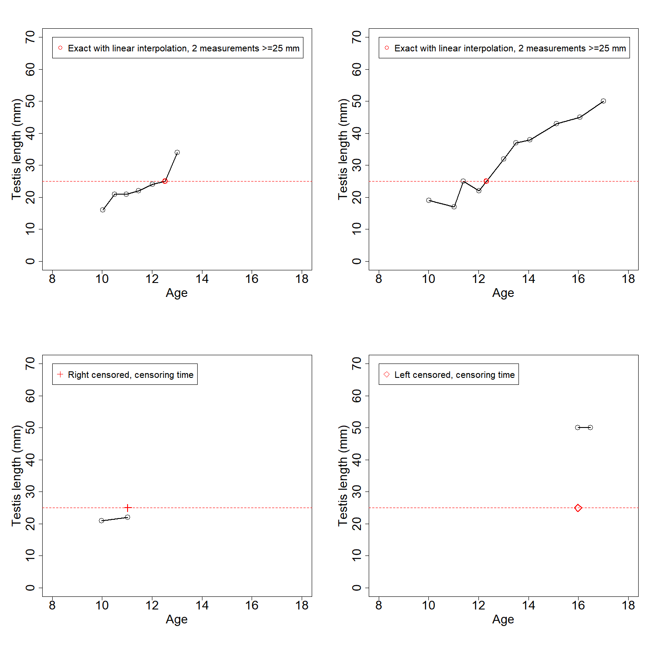

Supplementary Figure 1. Determined pubertal onsets based on the testis length measurements for four boys.

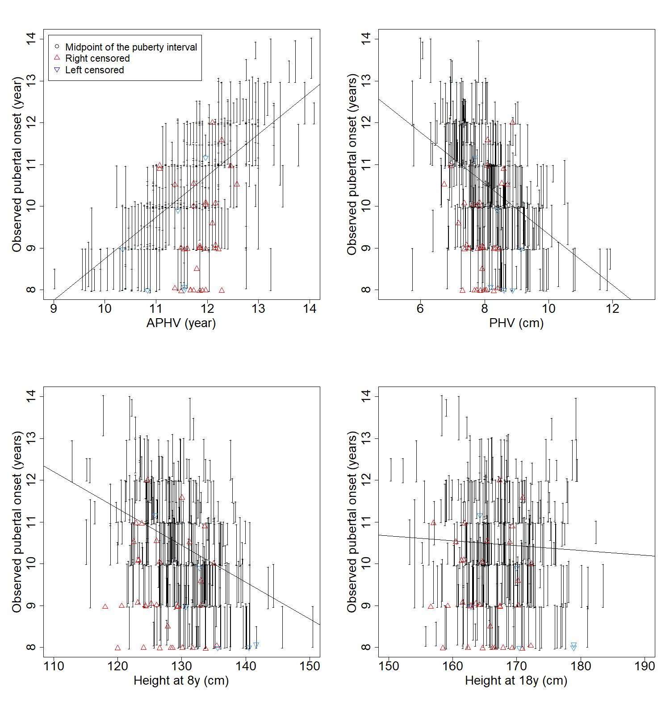

Supplementary Figure 2. For girls: Individual APHVs, PHVs, and estimated heights at the ages of 8 and 18 years plotted against the observed pubertal onset intervals. Lines are regression lines between the height markers and the midpoint of the observed pubertal interval.

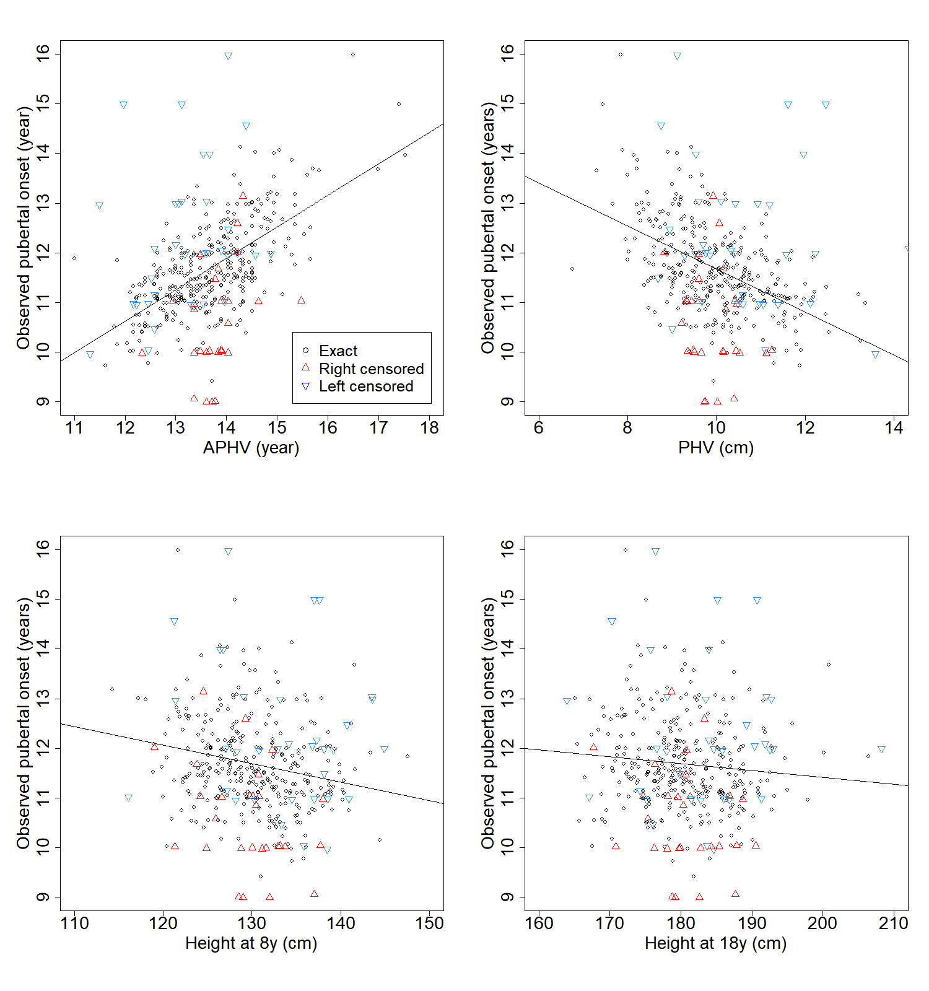

Supplementary Figure 3. For boys: Individual APHVs, PHVs, and estimated heights at the ages of 8 and 18 years plotted against the observed pubertal onsets. Lines are regression lines between the height markers and the observed pubertal onsets.

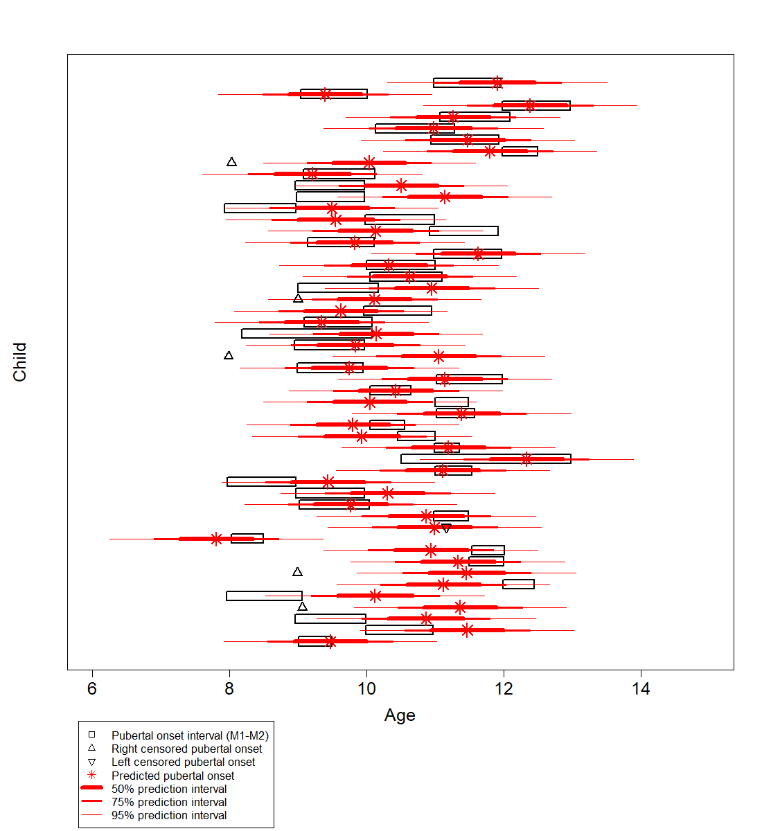

Supplementary Figure 4. The observed pubertal onset intervals and the predicted pubertal onsets with 50%, 75% and 95% prediction intervals for 50 randomly chosen girls.

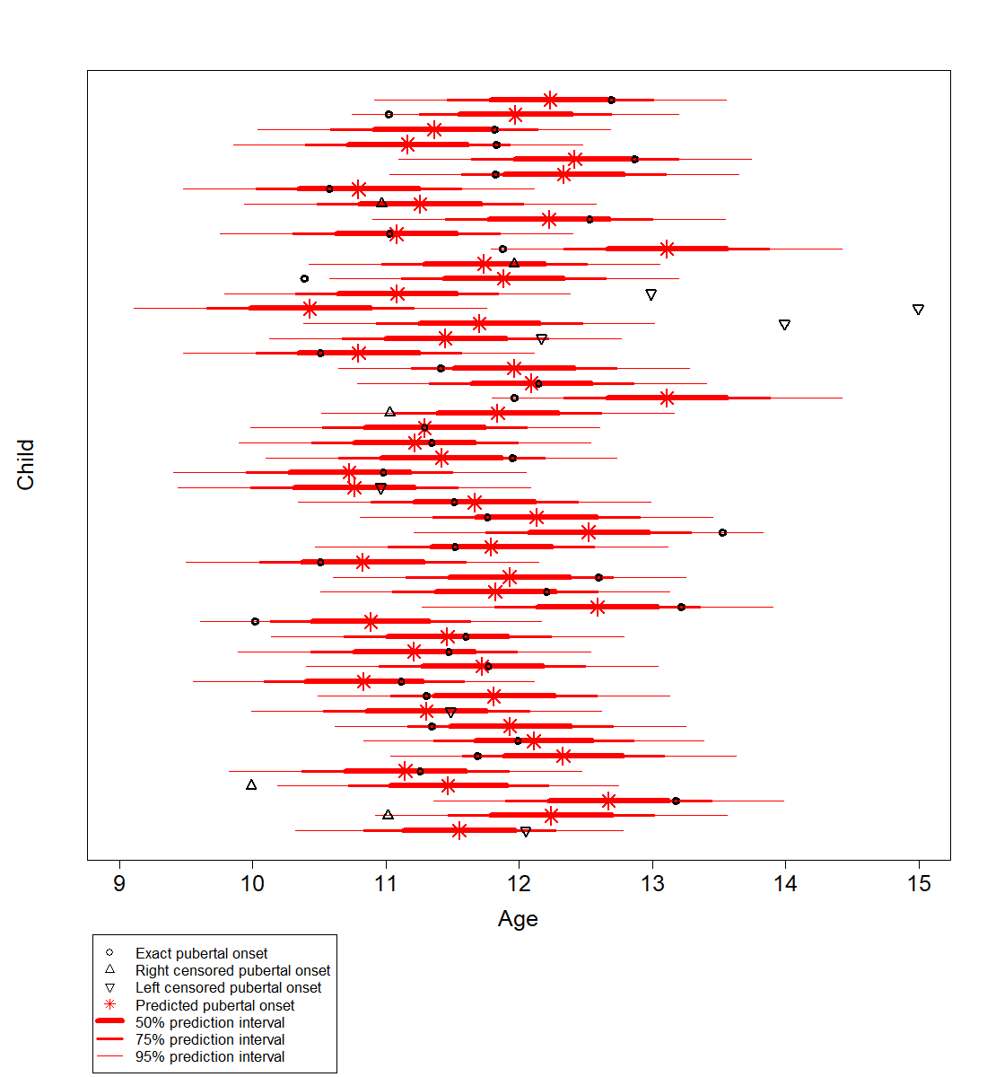

Supplementary Figure 5. The observed pubertal onsets and the predicted pubertal onsets with 50%, 75% and 95% prediction intervals for 50 randomly chosen boys.

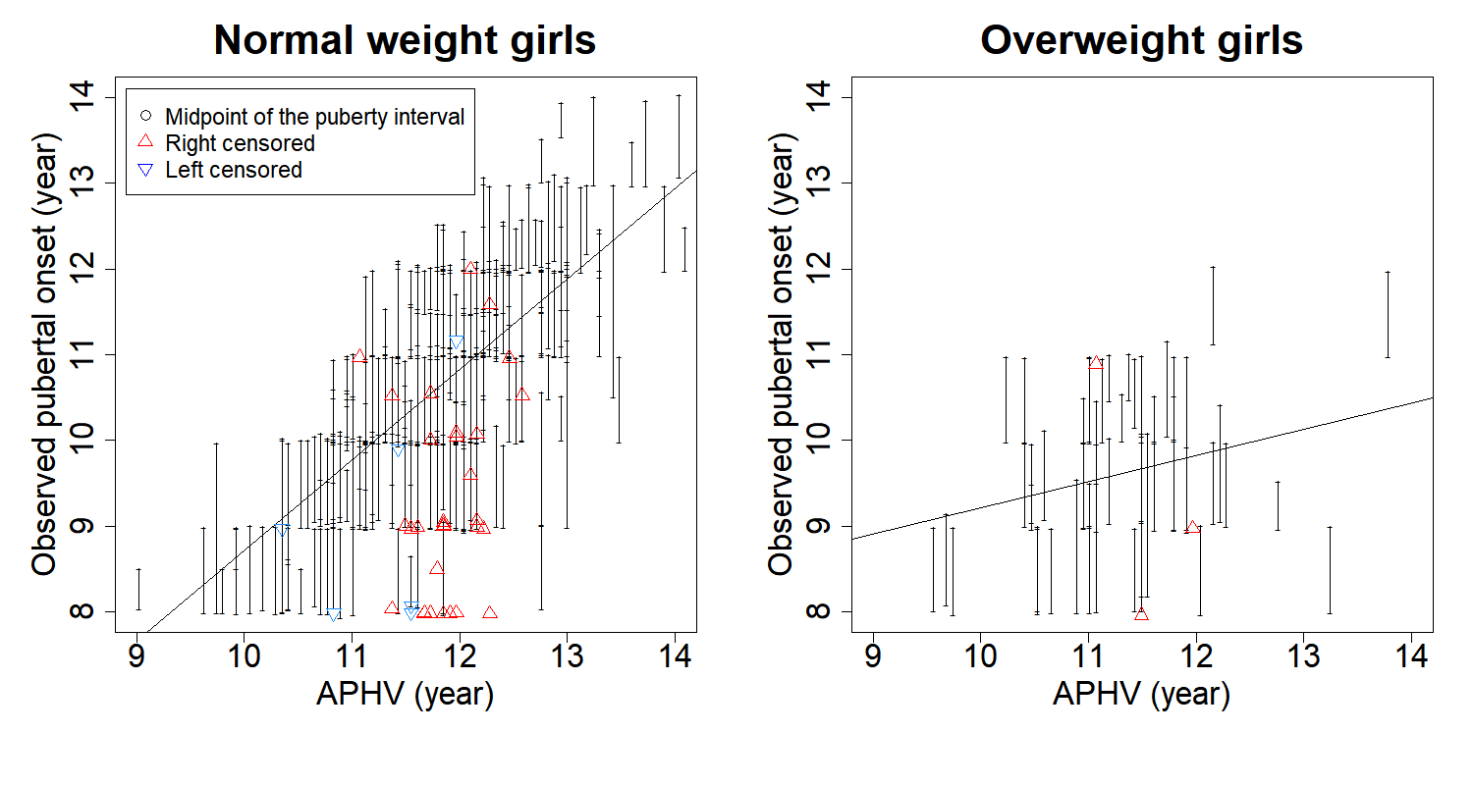

Supplementary Figure 6. Individual APHVs plotted against the observed pubertal onsets separately for normal weight and overweight girls. Lines are regression lines between the height markers and the midpoint of the observed pubertal onset interval.

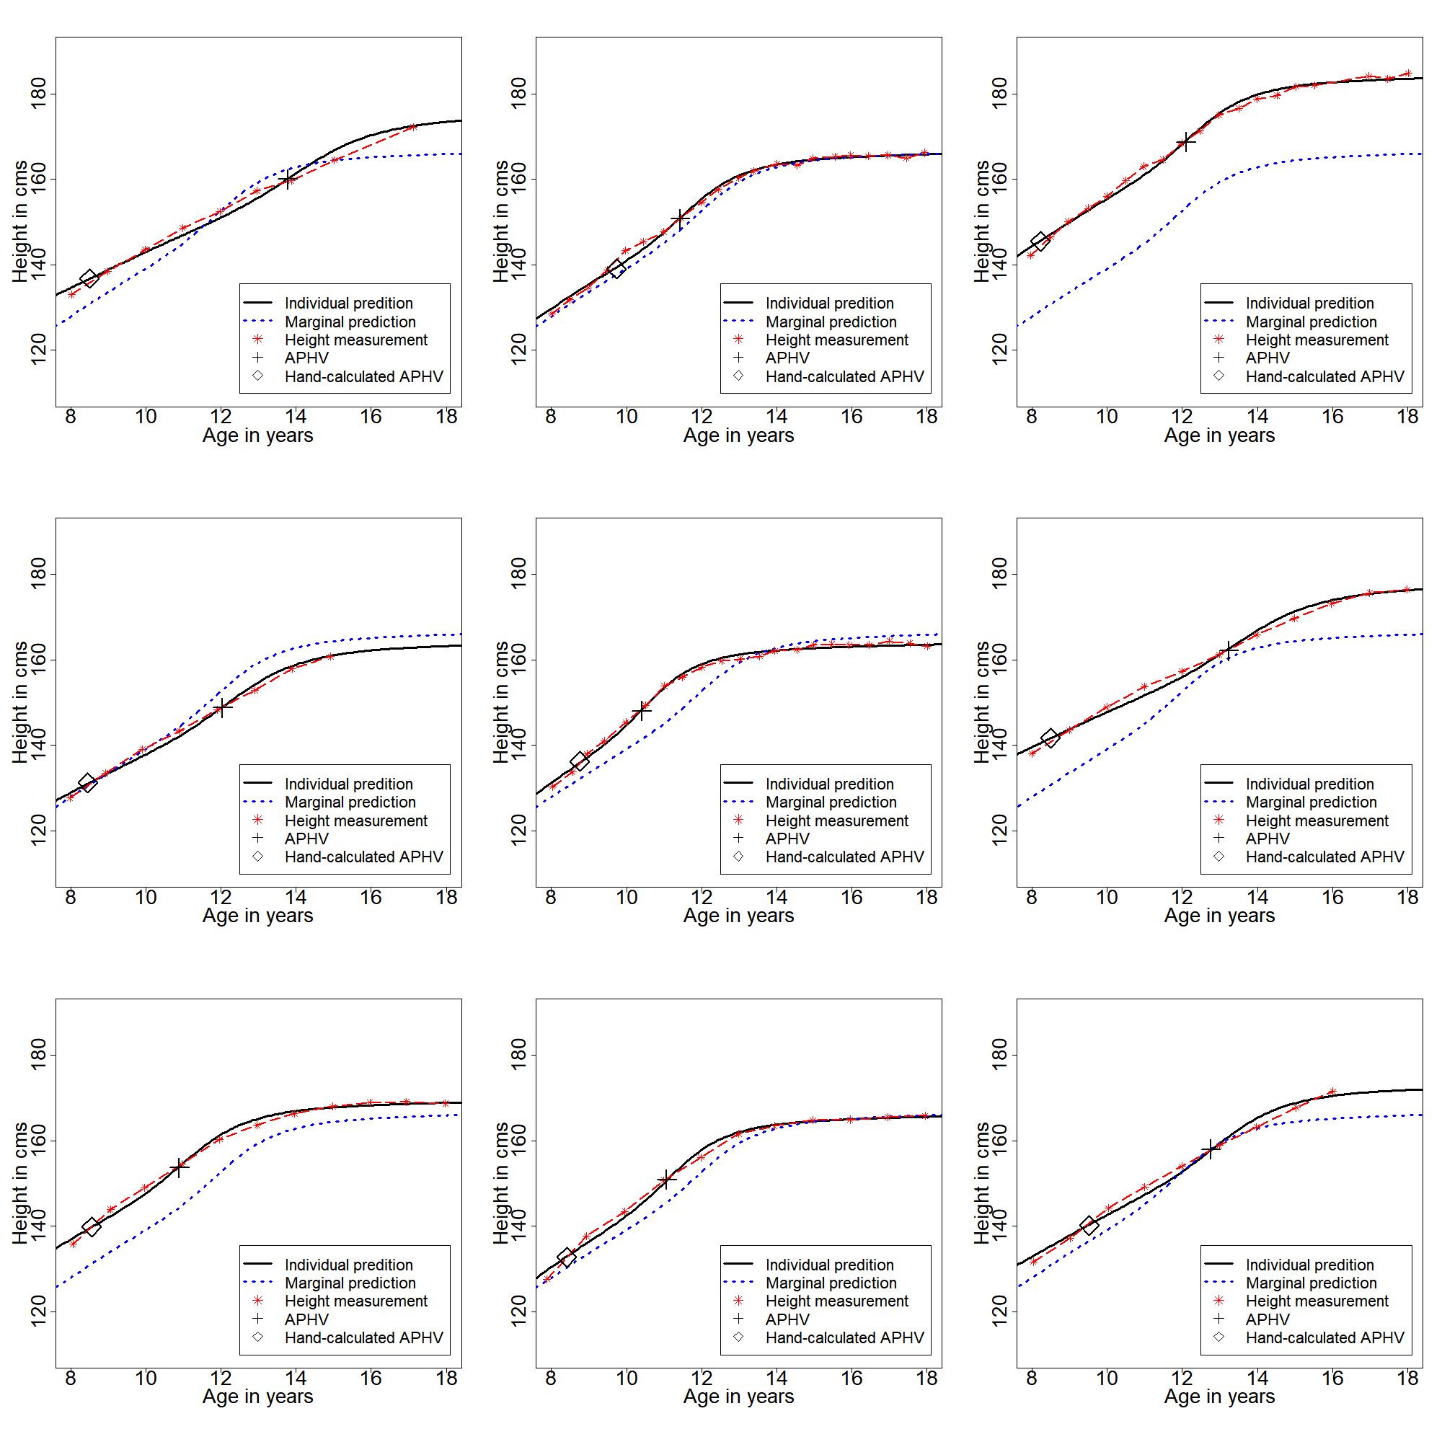

Supplementary Figure 7. SITAR curves for nine girls fulfilling the “combined” exclusion criterion.

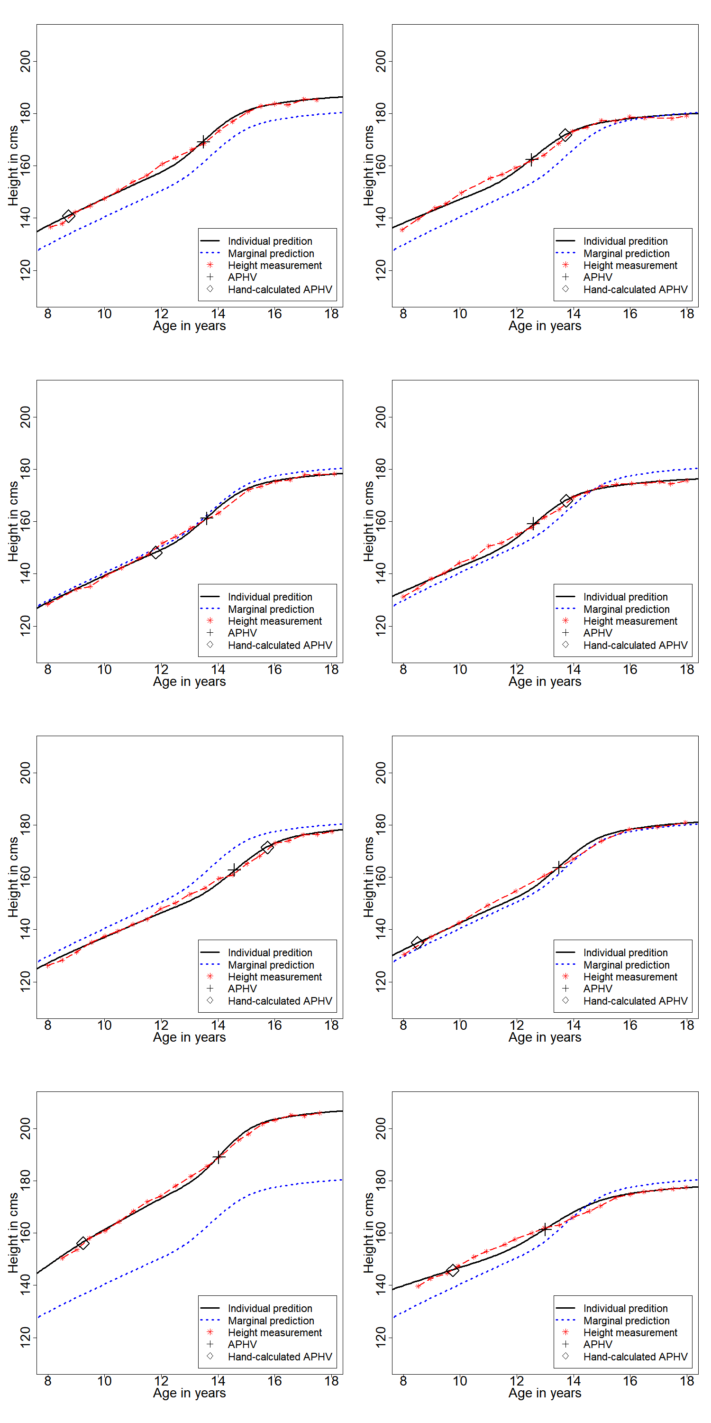

Supplementary Figure 8. SITAR curves for eight boys fulfilling the “combined” exclusion criterion.