**Software Engineering 2: Travlendar+**

**a**CCeptance **T**est **D**eliverable

Agostini Andrea, Ciampiconi Lorenzo, Es-skidri Rachid

January 13, 2018

CONTENTS

**Analized project** 3

*Authors:* 3

*Repositories:* 3

*Reference Documents* 3

**Installation Setup** 3

**User Esperience and acceptance test 4**

*User experience 4*

*Incoherences and discrepancies with Goals 5*

*Acceptance test 7*

**Conclusion notes** 9

# Analized project

## Authors:

Andrei Capastru - 898209

Luca Comoretto - 899615

Serghei Bordea - 898215

## Repositories:

Documents : <https://github.com/andreicap/BordeaCapastruComoretto>

Source Code & Deployment : <https://github.com/andreicap/travlendar>

## Reference Documents

* Design Document 1.0
* Requirement Analysis and Specification Document 1.2
* Implementation and Testing Deliverable 1.0
* ReadMe on Source Code & Deployment Repo

# Installation Setup

The documentation concerning the installation is clear and everything works fine. The app is properly deployed on Heroku and we didn’t find any incoherence or problem using the commercial site instead of the local version. The documentation for the local installation is clear and correct.

# USer EXperience and acceptance test

## User experience

The WebApp after the pressure of “My Calendar” shows up with a login that refers to Google Login, generally everything goes well, in one case an unexpected error appears after a sign out and re-sign in, we are not able to state if it depends by the behavior of the web app or by a Google behavior, but to restore the availability of the App it takes to re-open the page.

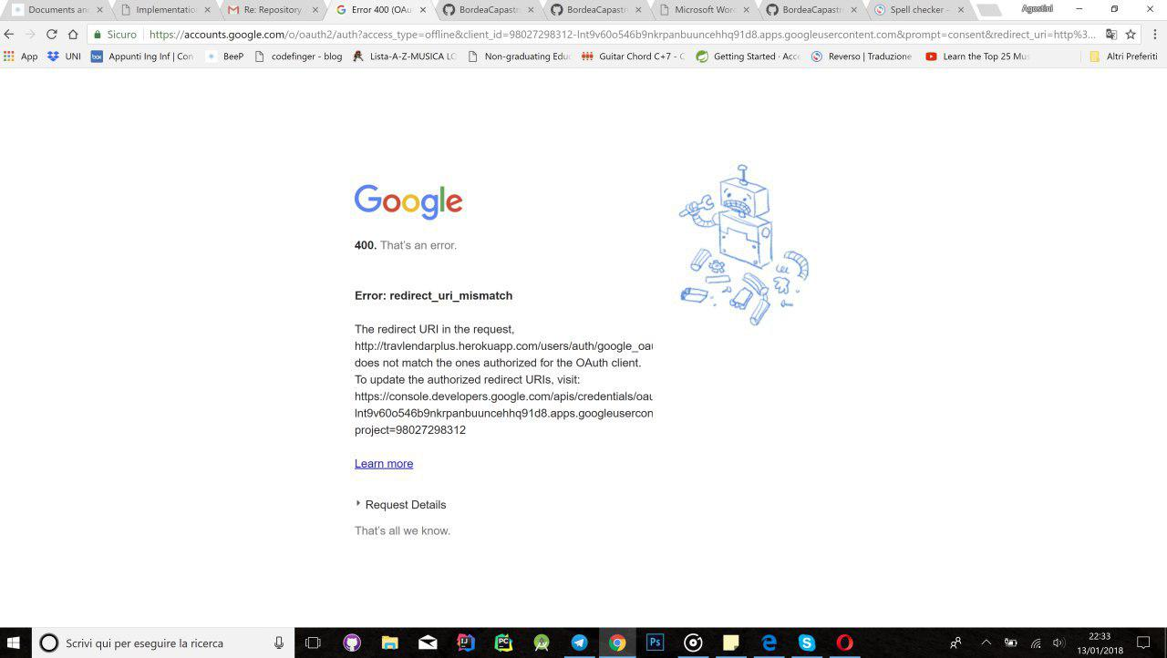

After the Login your daily calendar is shown (no calendar is shown for the previous or the future day), but there’s no way to add, delete or modify an event and this collide with the mockup from the **Design Document.**

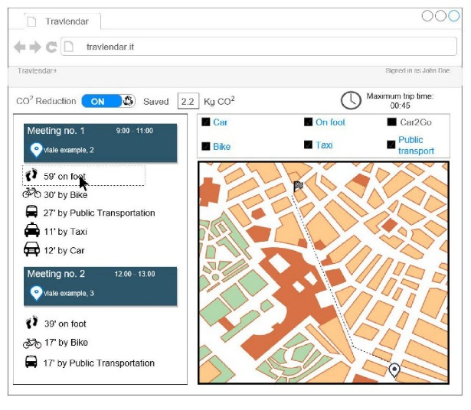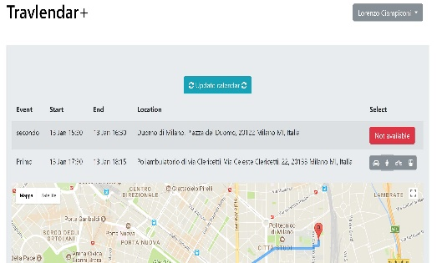

From this moment you are not able to interact with your profile and you information in any other way than open the standalone Google Calendar App and do the desired addition, modification or deletion of your event. **There’s no feature about preferences, mean handling or anything**, you can only delete your account but we don’t know what this means because no data persistences is required to grant the feature proposed at the moment, all data are handled by Google.

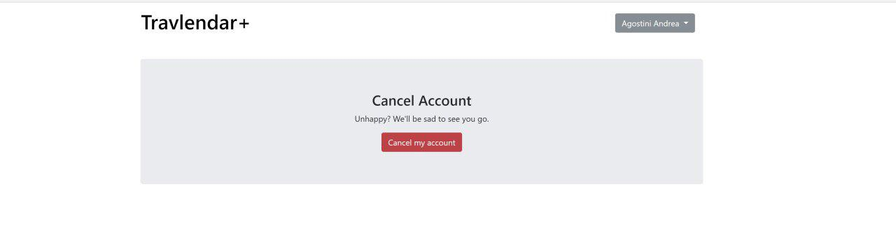

What appears if you edit an account 1

The main page is not bad at all: the Google Data are shown with an embedded page of Google Maps, the inclusion of suggested routes is a good one and the list of steps give some sense to the page. The way to choose the mean is really basic and **there’s no computation to help the user in the organization, the basic functionality is granted** thanks to the awesome work done by Google, the only thing you can do is fetching your events by the “update” button.

## incoherences and discrepancies with Goals

as stated in the rasd

**G1 Authentication:**

* Correct Google login.
* Import Calendar is correct (for the current day).
* Define Gps position not available.
* Login with outlook account not available.

Note: The authentication is well implemented, but you can access only if you have a Google account, we think that’s an hard constraint.

**G2 Scheduling:**

* Travel time for each meeting is available (only for the current day).
* Event creation not available from the web app.
* Event management (edit/add/delete) not available from the web app.
* Define departure location not available.
* Addition of travel event not available.

Note: Everything about this goal is not developed, so it’s impossible to add, delete and update event on the Travlendar+ Webapp but only by the Google Calendar. There’s no possibilities to add additional user informations.

**G3 Trip Planning:**

* User is able to receive travel time between two location.
* User is able to choose means of transport.
* -notifiation about delays not available.
* -suggestion on weather forecast not available.
* -nothing available from G3.7 to G3.13

Note: the user is able to choose the type of transport between two events by a button that change the travel mode of the embedded Google Maps, but there isn’t any control for the coherence during a day planning, it’s only a mirror to Google Maps and no extra-computation is done.  
No one of the information indicated in this goal is available (weather forecast, strikes etc…) and there’s no notification system.

**G4 Notifications:**

**Nothing Available**

Note: There’s no notification system at all.

**G5 Personalization:**

**Nothing Available.**

Note: it’s not possible to set preferences at all. In this goal there’s mention to car and bike sharing services, but there isn’t nothing developed about them.

## acceptance test

Note: The test are about a really few functionalities because most of them are not developed at all or they relate to external API without any extra computation. The functionalities that we are able to test are only about the fetching after an adding, a modifying or a deletion of an event, the way that they are showed up in the WepApp and the solutions proposed. The calculation of the solution it’s not handled by this APP at any stage, but it depends only on the Google Maps behavior.

**Test Cases:**

**1.**

|  |  |
| --- | --- |
| Flow: | * Add Event on Google Calendar that starts in 24 hours from the current time, with full description and a location that grants a solution. * Press Update Events on the WebApp |
| Result: | If there’s an event before the one just added and after current time a solution by Google Maps is proposed, else no solution is available. Note that if an event from which previously available a solution if it became an event from the past, the solution to the next event will disappear. |
| Expected Result: | The event appears and the solution is proposed. |

Note: the following test will be designed by the results of this one.

**2.**

|  |  |
| --- | --- |
| Flow: | * Add Event on Google Calendar that does not starts in 24 hours from the current time, with full description and a location that grants a solution. * Press Update Events on the WebApp |
| Result: | The event does not appear in the app. |
| Expected Result: | The event appears and the solution is proposed. |

**3.**

|  |  |
| --- | --- |
| Flow: | * Add Event on Google Calendar that starts in 24 hours from the current time, with full description and a location that has no solution (checking from google maps) from the one before. * Press Update Events on the WebApp |
| Result: | No notification appears, a notification will appear only if you make an extra step of choosing a mean with the buttons next to the event. |
| Expected Result: | The event appears and a notification of unreachability appears(). |

**4.**

|  |  |
| --- | --- |
| Flow: | * Add Event on Google Calendar that starts in 24 hours from the current time, that overlaps with one event that has previously solution. The location should grant a solution. * Press Update Events on the WebApp |
| Result: | The event appears and no notification is shown. |
| Expected Result: | The event appears and a notification of overlapping is shown. |

# conclusion notes

The web application doesn’t match with a lot of points of the documents delivered.   
First of all the user experience shown in the DD is almost completely absent. The biggest failings in our opinion are the impossibility of personalize the user profile, the shortage of every types of notification and the lack of a event management module. At the moment the application is nothing more than an a little extension of Google Calendar.