# MapFusion: A General Framework for 3D Object Detection with HDMaps

## Abstract 3D object detection is a key perception component in autonomous driving. Most recent approaches combine Lidar sensors or cameras. However, high-definition maps (HDMaps), a critical infrastructure for intelligent vehicles, remain under-utilized in enhancing object detection tasks. In this paper, we introduce MapFusion, a simple yet potent framework that integrates HDMap information into modern 3D object detector pipelines. By incorporating a FeatureAgg module for HDMap feature extraction and fusion, plus a MapSeg module as an auxiliary segmentation head, MapFusion shows independence from specific detectors and integrates effortlessly across various systems. The experimental validation of this framework across several baselines on a large public autonomous driving dataset demonstrates significant improvements in detection accuracy, enhancing mean Average Precision (mAP) by 1.27 to 2.79 points.

## I. Introduction Autonomous driving (AD) technology has received significant attention in recent years as it integrates complex robotics technologies such as perception, planning, and control. The perception module, crucial in AD systems, interprets the surrounding environment to inform downstream planning and control activities. This study advances the AD field by enhancing the robustness and accuracy of 3D object detection through the integration of HDMap information into detection pipelines, effectively reducing false positives and negatives associated with current Lidar-based detection methods.

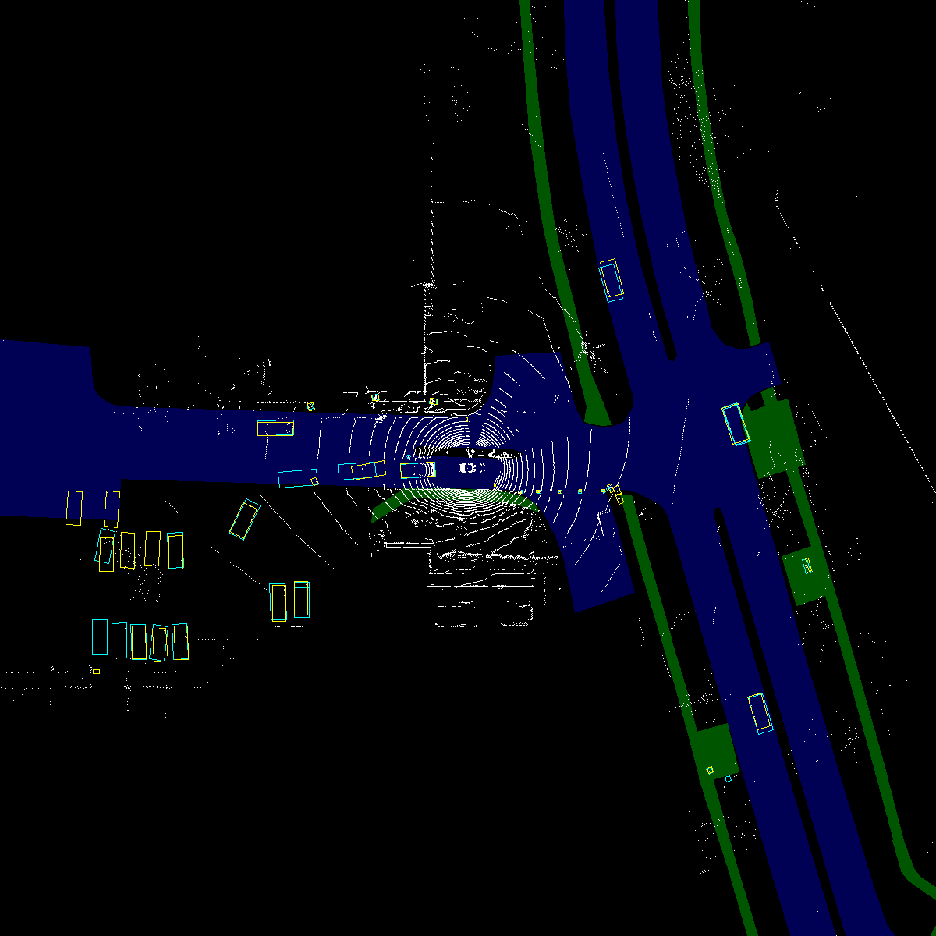

*Caption: "Effectiveness of MapFusion improving detection accuracy" | Explanation: "Panel (a) displays detection results from PointPillars, showing false positives marked by red circles. Panel (b) illustrates improved accuracy using MapFusion, eliminating false positives while aligning closely with the ground truth, represented by yellow rectangles." | Ref: PDF p.1*

## II. Related Work The development and enhancement of LiDAR-based 3D object detection have been pivotal. Approaches like point-based and voxel-based methods show significant diversity in handling point cloud data, each with their strengths. Systems such as VoxelNet and SECOND have advanced the computational efficiency of these operations, highlighting the role of system architecture in performance. Recently, the integration of comprehensive 3D mapping and camera data has shown potential in refining object detection tasks, yet these solutions often rely heavily on HDMap accuracy and availability.

## III. Proposed Approach MapFusion is proposed as a comprehensive solution designed to leverage HDMaps to enhance detection accuracy in AD systems. This framework consists of several components:

### A. Overview The MapFusion framework is segmented into two critical components: the standard 3D object detection block, and the map feature extraction block.

[Image missing: page2_img1.jpg] Caption: "MapFusion architectural overview" | Explanation: "This diagram presents the primary components of the MapFusion framework. The red dotted box represents the standard 3D object detection elements, and the blue box illustrates the map feature extraction and integration phase." | Ref: PDF p.2

### B. HDMap Representation HDMaps provide a rich source of topological and geometric data which are crucial in distinguishing between different road elements. The MapFusion framework utilizes a raster representation to fuse these elements effectively.

### C. FeatureAgg Module This module integrates voxel features from LiDAR data with map features derived from HDMaps, employing simple concatenation techniques to enhance feature representation and detection capability.

## IV. Experimental Results To validate MapFusion, we integrate it with three baseline detectors: SECOND, PointPillars, and CenterPoint, across the nuScenes dataset, showing improved object detection capabilities across multiple object categories and scenarios.

**Table 1. Experimental results on the nuScenes dataset**

| Method | NDS (%) | mAP (%) |  
|:------|--------:|--------:|  
| SECOND (w/o MF) | 60.80 | 49.62 |  
| SECOND (w/ MF) | 62.04 | 50.89 |  
| PointPillars (w/o MF) | 57.45 | 43.87 |  
| PointPillars (w/ MF) | 58.95 | 46.66 |  
| CenterPoint (w/o MF) | 67.13 | 59.43 |  
| CenterPoint (w/ MF) | 67.97 | 60.61 |

## V. Conclusion and Future Works MapFusion demonstrates a significant breakthrough in AD by integrating HDMap data into 3D object detection frameworks. Future work will aim to enhance MapFusion's applicability across different sensory data and explore the feasibility of map prediction techniques where HDMaps are unavailable.

## References [1] E. Yurtsever, et al., 2020. IEEE Access. 58,443–58,469 [2] E. Arnold, et al., 2019. IEEE Trans. Intelligent Transportation Systems. 20(10): 3782–3795 And others...