# MapFusion: A General Framework for 3D Object Detection with HDMaps

## Abstract

3D object detection is a key perception component in autonomous driving. Most recent approaches are based on LiDAR sensors or fused with cameras. We propose MapFusion, a framework integrating map information into 3D object detector pipelines, featuring a FeatureAgg module for HD Map feature extraction and a MapSeg module as an auxiliary segmentation head. Experimental results demonstrate improvements in mean Average Precision (mAP) on three baseline 3D object detection methods.

## I. Introduction

Autonomous driving (AD) has drawn significant attention due to its complex integration of various advanced robotics techniques including perception, planning, and control. The perception module, crucial for interpreting the surrounding environment, has traditionally utilized cameras for object detection, yet these fail to accurately recover 3D locations. Thus, active 3D sensors like LiDAR are essential for effective object detection in AD.

Based on diverse input representations, numerous LiDAR-based 3D object detectors have been proposed, categorized into point-based and voxel-based methods. However, the integration of HDMaps, which offer precise topological and geometric road information, has been underused though it can notably augment object detection, particularly in reducing false positives and false negatives.

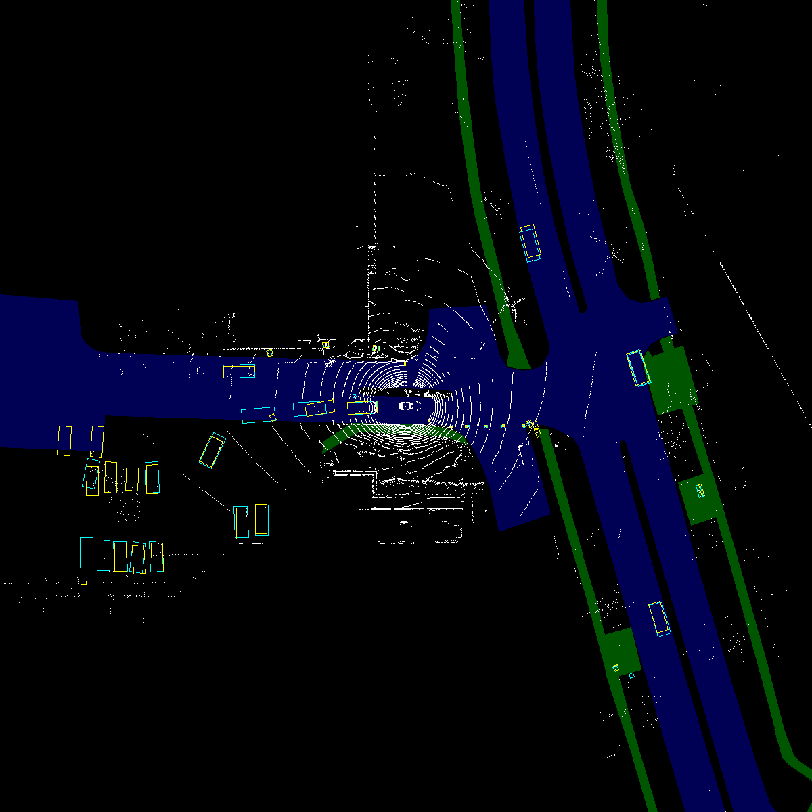

*Caption: "Comparison of detection results with and without MapFusion." | Explanation: "Figure 1 illustrates the detection results from PointPillars, highlighting the reduction of false positives when employing the MapFusion framework, as evident from the overlay of detection boxes on the road scene." | Ref: PDF p.1*

## II. Related Work

The field of LiDAR-based 3D object detection is vibrant with strategies ranging from projection of 3D point clouds into 2D to volumetric convolutional approaches. Early works like VoxelNet initiated the use of 3D concisions to detect objects from LiDAR point clouds. Recent innovations aim at improving accuracy by integrating structured information from the point cloud data into the detection process.

Despite the progress, the potential of HDMaps has been largely untapped, except in strategies like HDNet which use maps directly as inputs for enhancing object detection robustness and performance.

## III. Proposed Approach

### A. Overview

Our proposed MapFusion framework integrates HDMap information directly into standard 3D object detection workflows, enhancing detection accuracy. It consists of a standard object detection block and a novel map feature extraction block. The extracted map features are combined with voxel features from the object detection block to augment the detection process.

[Image missing: page2_img1.jpg] Caption: "Overview of the MapFusion framework." | Explanation: "Figure 2 depicts the integration of the HDMap features with the standard LiDAR-based object detection pipeline, highlighting the separate modules such as the FeatureAgg and the auxiliary MapSeg segmentation head." | Ref: PDF p.2

### B. HDMap Representation

We use a rasterized representation of the HDMap focusing on elements crucial for driving such as drivable areas, walkways, and carparks. The map features are extracted through a 2D Feature Extractor, which preserves the dimensionality while enhancing the feature representation for subsequent fusion.

### C. FeatureAgg Module

The FeatureAgg module fuses HDMap-extracted features with the voxel features. Simple concatenation augmented with a 1×1 convolutional operation significantly enhances performance by effectively combining the different feature sets.

## IV. Experimental Results

MapFusion was evaluated against established baseline detectors like SECOND, PointPillars, and CenterPoint on the nuScenes dataset. Results revealed significant improvements across most object categories, particularly in challenging detection scenarios such as small objects or objects partially obstructed.

"**Table 1. Comparative performance overview**"

| Method | NDS (%) | mAP (%) | Improvement |  
|:------|:--------|:---------|:------------|  
| SECOND w/o MF | 60.80 | 49.62 | - |  
| SECOND w MF | 62.04 | 50.89 | +1.27 |  
| PointPillars w/o MF | 57.45 | 43.87 | - |  
| PointPillars w MF | 58.95 | 46.66 | +2.79 |  
| CenterPoint w/o MF | 67.13 | 59.43 | - |  
| CenterPoint w MF | 67.97 | 60.61 | +1.18 |

## V. Conclusion and Future Works

MapFusion significantly enhances 3D object detection through the integration of HDMaps, optimizing detection performance notably among all tested baselines. Future work will explore broader sensor integration and address limitations in HDMap availability.

### References

[1] E. Yurtsever, et al., "A survey of autonomous driving: Common practices and emerging technologies," IEEE Access, 2020.  
[2] E. Arnold, et al., "A survey on 3d object detection methods for autonomous driving applications," IEEE Transactions on Intelligent Transportation Systems, 2019.  
[3] S. Ren, et al., "Faster R-CNN: Towards real-time object detection with region proposal networks," NIPS, 2015.