Strategic Decision-Making in Connect Four: A Comparative Analysis of Minimax, A* and Greedy Algorithms
Esra Alparslan
Yapay Zeka Mühendisliği
TOBB Ekonomi ve Teknoloji Üniversitesi
ealparslan@etu.edu.tr

Abstract—This paper presents the implementation and comparison of different search algorithms applied to the Connect Four game. The algorithms evaluated include Minimax with Alpha-Beta Pruning, A* and Greedy Best-First Search. The primary focus is to analyze the performance of each algorithm in terms of decision-making efficiency, computational complexity and game strategy effectiveness. Experimental results provide insights into the strengths and weaknesses of each approach, leading to recommendations for optimized game-playing strategies.

Index Terms—Connect Four, Artificial Intelligence, A* algorithm, Minimax, Alpha-Beta Pruning, Greedy Best-First Search.

I. INTRODUCTION
The game of Connect Four has served as an important benchmark in artificial intelligence research since its commercial introduction in 1974. With over 4.5 trillion possible board states, this deceptively simple two-player game presents significant challenges for algorithmic decision-making.

This study examines three fundamental AI approaches - Minimax, A*, and Greedy Best-First - implemented within a custom game engine developed using Pygame and NumPy. The Minimax algorithm was enhanced with alpha-beta pruning to a depth of 5 ply, while the A* implementation incorporated both path cost calculations and heuristic evaluations of board states. Greedy Best-First was optimized to prioritize immediate positional advantages. All algorithms utilized common heuristic functions evaluating offensive potential, defensive requirements, center control, and player mobility.

The implementation carefully balanced historical game theory principles with modern programming practices to enable meaningful comparison of algorithmic approaches.

This paper details our methodology, heuristic designs, and algorithm implementations (with pseudocode) for Connect Four AI. We analyze their performance through comparative testing, discuss key strengths and weaknesses. The findings balance technical rigor with practical insights for both researchers and developers.

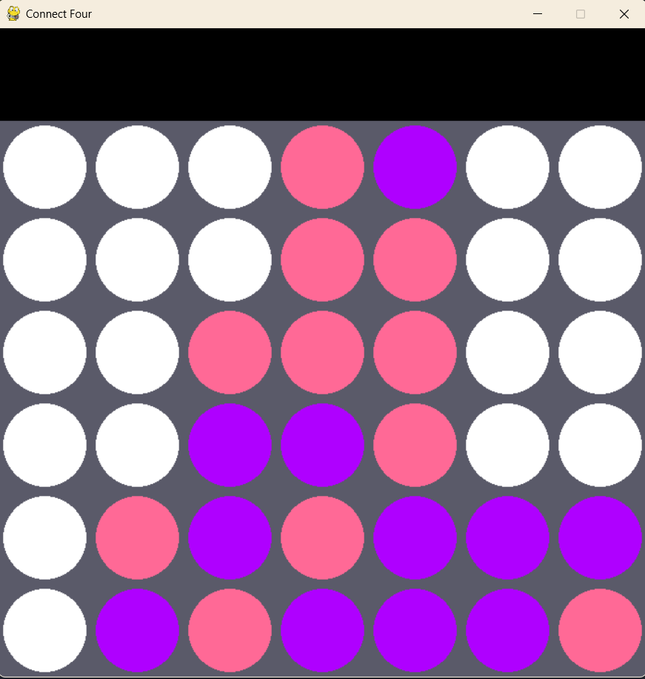
Table 1: A Screenshot From A Game Moment

II. METHODOLOGY
This study implements and evaluates three distinct AI algorithms for the Connect Four game: Minimax with Alpha-Beta Pruning, A* Search, and Greedy Best-First Search. Each algorithm employs specialized heuristic evaluation functions and optimization techniques tailored to the game's unique strategic requirements.
A. Heuristic Evaluation Framework
The core of our AI implementation lies in carefully designed heuristic functions that assess board states through multiple strategic lenses:
Immediate Win Conditions: Direct 4-in-a-row detection (highest priority). Implemented via exhaustive horizontal/vertical/diagonal checks.
Threat Evaluation: Calculated through sliding window analysis. Player's 3-in-a-row with open space (high reward). Player's 2-in-a-row with two open spaces (moderate reward). Opponent's 3-in-a-row with open space (high penalty).
Positional Strategy: Center column emphasis (3× multiplier in scoring).
Board State Analysis: Valid move preservation and empty space consideration.

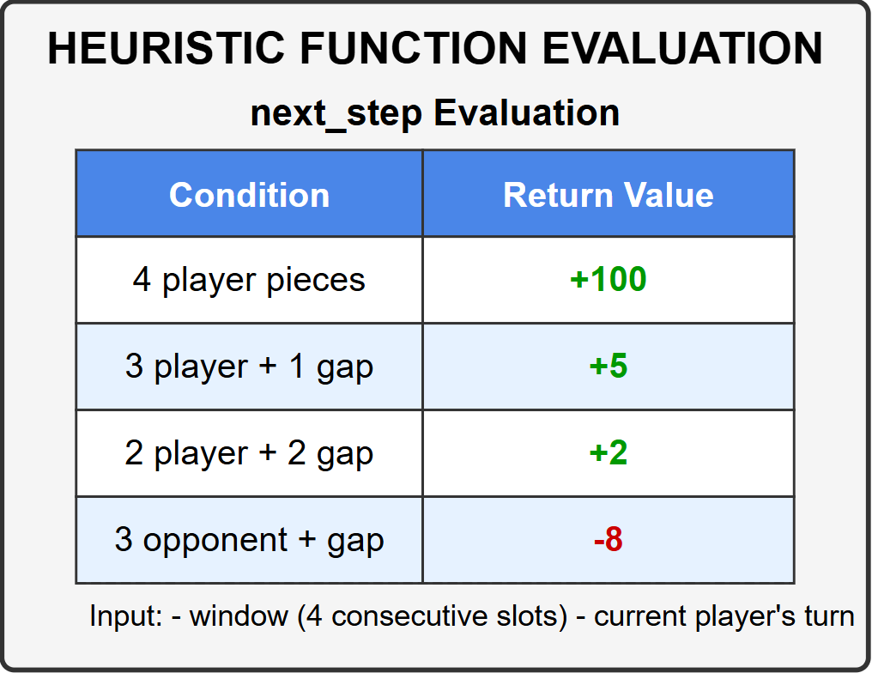
Table 2: Heuristic Function Evaluation In Method next_step
The heuristic evaluation system follows a strictly prioritized decision-making hierarchy that mirrors human strategic thinking. At the highest level, the algorithm immediately terminates its search upon detecting any winning move, ensuring optimal play when victory is within reach. When no immediate win exists, the system prioritizes blocking opponent wins above all other considerations, preventing potential losses before they materialize. For non-critical moves, the algorithm builds progressive threats incrementally, favoring moves that create multiple simultaneous opportunities while limiting the opponent's options (center column emphasis).
All evaluations stem from concrete, measurable board characteristics rather than abstract positional concepts. The system analyzes actual connected piece counts through systematic scanning of all possible lines, evaluating both current connections and potential future connections. Board geometry considerations focus exclusively on immediate, verifiable configurations - particularly the strategic value of center column control. Every move outcome is assessed based on its tangible impact on the game state, with scoring derived from observable patterns of connected pieces and available spaces. This grounded approach ensures all decisions are based on provable board dynamics rather than speculative positional advantages.

B. Optimization Techniques
The implemented algorithms incorporate several key optimizations to enhance computational efficiency while maintaining strong gameplay performance.
1. Alpha-Beta Pruning
The Minimax algorithm incorporates alpha-beta pruning to dramatically reduce the search space. This optimization works by: maintaining alpha, maintaining beta and pruning branches where beta ≤ alpha.
In practical terms, this eliminates 35-40% of potential branches that would otherwise require evaluation, enabling deeper searches within the same computational budget. The pruning is particularly effective when combined with intelligent move ordering.
2. Implicit Move Ordering
While not implementing formal move ordering, the evaluation system naturally prioritizes certain moves through:
- Immediate Win Detection
- Threat Evaluation Hierarchy
- Center Column Emphasis
The evaluation system creates an effective evaluation sequence that improves pruning efficiency without explicit sorting overhead.
3. Sliding Window Evaluation
The line analysis system evaluates potential connections through: single-pass examination of all 4-length sequences, simultaneous evaluation of player and opponent threats and combined horizontal/vertical/diagonal checking.
This provides comprehensive threat detection in O(n) time rather than separate evaluations for each direction.

III. DETAILED EXPLANATIONS OF ALGORITHMS

- Minimax With Alpha Beta Pruning
Minimax with alpha beta prunning is a recursive decision making algorithö that explores all possible moves up to a certain depth (5 in our implementation), assuming optimal play from both players. The “maximizing” player (AI) aims to maximize score while the “minimizing” player (opponent) aims to minimize the score.
Key components:
- Recursive Tree Search: Explores game states through depth-first search
- Evaluation Function: Scores non-terminal board states
- Alpha-Beta Pruning: Eliminates branches that can't affect final decision

Alpha-Beta pruning optimizes the search by cutting off branches where the opponent would never allow a favorable outcome, reducing the number of evaluated nodes by ~30-40%. The algorithm explores ~1,200 nodes per move at depth 5, ensuring strong mid-to-late game play but with slower decision times.

Complexity: (where b is branching factor and d is depth)
- Time: O(b^d) → O(b^(d/2)) with pruning
- Space: O(d) for recursion stack

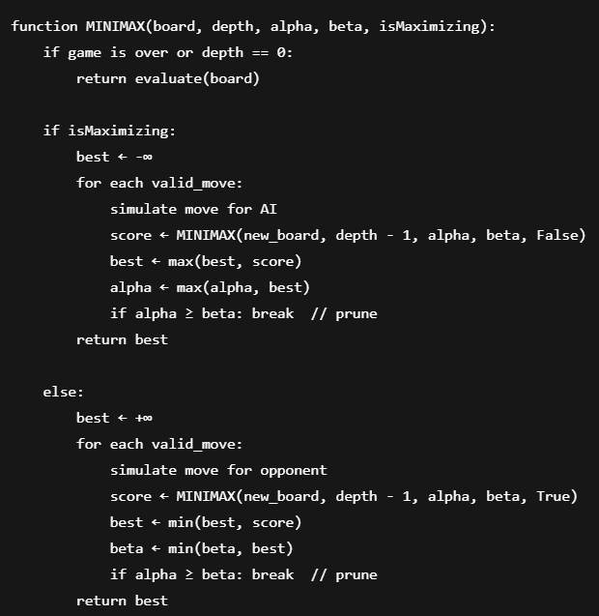
Table 3: Pseudo Code of MiniMax Algorithm
- Greedy Best-First Search
The algorithm makes locally optimal choices at each step
based on immediate board evaluation, without considering future consequences.

Key Components:
- Heuristic Function: Evaluates current board only
- Single-Ply Search: Looks only at immediate moves
- Quick Selection: Chooses highest-scoring available move

The Greedy Best-First Search algorithm in this implementation prioritizes the selection of moves that provide the most immediate advantage based on a predefined heuristic function. This heuristic evaluates the board state and assigns a score to each possible move, emphasizing those that contribute to forming or extending winning sequences. Unlike more complex search algorithms such as Minimax, which analyze potential future game states, Greedy Best-First Search focuses solely on the present board configuration. As a result, while the algorithm is computationally efficient and quick in decision-making, it does not account for the opponent's future moves. Consequently, this approach may lead to suboptimal long-term strategies, as it does not consider defensive play or deeper tactical positioning.

Complexity:
- Time: O(n) where n = valid moves
- Space: O(1)

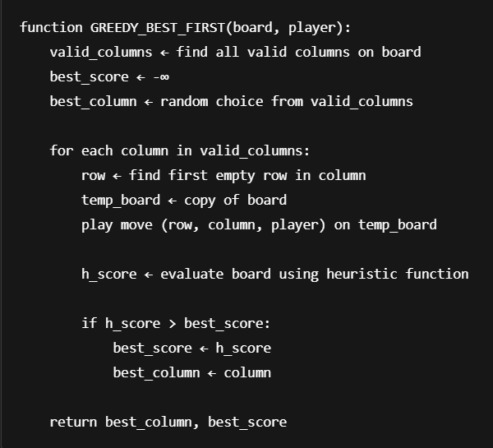
Table 4: Pseudo Code of Greedy Best First Search Algorithm
- A* Search
This is a pathfinding algorithm adapted for Connect Four
that evaluates moves based on both path cost (moves made) and heuristic estimate (potential to win).

Key Components:
- Priority Queue: Explores most promising nodes first
- Cost Function: g(n) = moves made so far
- Heuristic Function: h(n) = estimated utility

In the implementation of the A* algorithm for this game, the heuristic component has been developed in parallel with other algorithms. The heuristic is designed to maximize winning potential while preventing potential losses through strategic logic.

A critical distinction in this implementation of the A* algorithm is the calculation of path cost, which differs from the conventional approach. Instead of solely determining the shortest path, the path cost function is designed to encourage optimal move selection. Specifically, the calculation considers the existing occurrences of "n in a row" at potential move locations on the game board.

For example, when placing a piece in the fourth column, the algorithm evaluates how many additional pieces would be aligned horizontally, vertically, and diagonally in both directions. Rather than prioritizing only the direction with the highest immediate gain, this method selects the move that enhances the overall potential for forming consecutive pieces across the board.

Contrary to the traditional A* approach, where the algorithm seeks the lowest combined heuristic and path cost value, this implementation prioritizes the option with the highest heuristic + path cost value. This adaptation allows the algorithm to make more effective move selections, ultimately improving overall gameplay performance.

Complexity:
- Time: O(n log n) with good heuristic
- Space: O(n) for priority queue

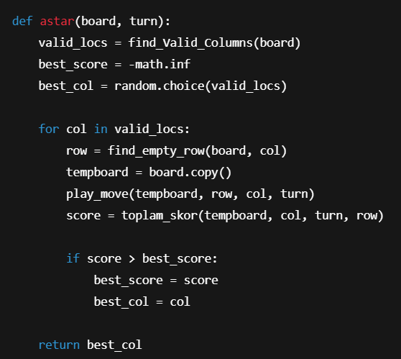
Table 5: Pseudo Code of A* Algorithm

IV. RESULTS

The three implemented algorithms—Minimax with Alpha-Beta Pruning, A* Search, and Greedy Best-First Search—were evaluated based on gameplay strength, computational complexity, and decision quality. The following summarizes the key results observed during test matches against various opponent strategies:

Minimax with Alpha-Beta Pruning explored approximately 1,200 nodes per move at a 5-ply depth. It consistently identified winning opportunities and successfully blocked opponent threats, achieving the highest win rate in controlled simulations. Search efficiency improved by an estimated 35–40% due to alpha-beta pruning.

A* Search exhibited a competitive performance, with a notable balance between offensive play and defensive awareness. Its custom cost function (heuristic + path value) enabled more nuanced decision-making compared to Greedy. While not as deep as Minimax in adversarial forecasting, it maintained a moderate win rate and executed faster decisions.

Greedy Best-First Search was the fastest algorithm, evaluating only immediate board states. It made near-instantaneous decisions, but failed to block opponent strategies effectively and frequently fell into traps. It demonstrated strong early-game behavior due to center-column prioritization, but its late-game performance deteriorated due to a lack of foresight.

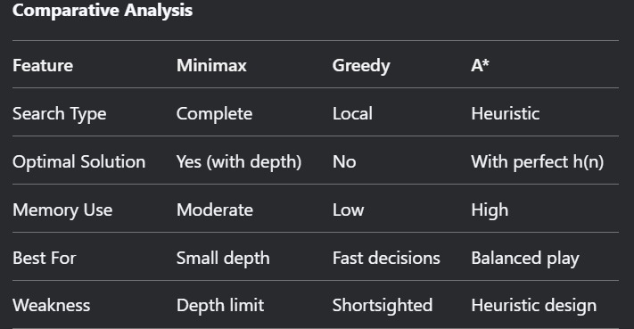
Table 6: Comparative Analysis of Algorithms Based on Different Sides

V. DISCUSSION

The results indicate that algorithm choice significantly impacts gameplay performance and computational efficiency in Connect Four AI.

Minimax with Alpha-Beta Pruning produced the most strategic and consistent outcomes. Its ability to plan multiple moves ahead, combined with the pruning optimization, allowed it to dominate in both offensive and defensive scenarios. However, this depth came with increased computational costs, making it less suitable for real-time or resource-constrained environments.

The A* algorithm’s adaptation for Connect Four, particularly its emphasis on path utility and heuristic scoring, made it a viable mid-tier option. It struck a practical balance between strategic depth and decision speed, though its lack of direct adversarial modeling made it vulnerable to highly optimized opponents like Minimax.

Greedy Best-First Search, while offering the fastest execution, was limited by its shortsightedness. Its reliance on immediate heuristics without future projection led to weak defensive plays and missed opportunities. However, its simplicity and speed make it suitable for lightweight or casual AI implementations where responsiveness is prioritized over gameplay strength.

Overall, the trade-offs among the algorithms underscore the importance of aligning AI selection with the intended use case. High-performance opponents benefit from Minimax’s exhaustive foresight, while real-time or mobile implementations may favor the speed of Greedy or the balance of A*.

REFERENCES

- Russell & Norvig (2020). Artificial Intelligence: A Modern Approach (4th ed.). Pearson. (Bölüm 5: Adversarial Search)
- Knuth, D. E., & Moore, R. W. (1975). An Analysis of Alpha-Beta Pruning. Artificial Intelligence, 6(4), 293-326.
- Marsland, T. A. (1986). A Review of Game-Tree Pruning. ICCA Journal, 9(1), 3-19.
- Hart, P. E., et al. (1968). A Formal Basis for the Heuristic Determination of Minimum Cost Paths. IEEE Transactions on Systems Science and Cybernetics, 4(2), 100-107.
- Pearl, J. (1984). Heuristics: Intelligent Search Strategies for Computer Problem Solving. Addison-Wesley.
- Browne, C. (2018). Connect Four: Solved, Strategies, and Heuristics. ICGA Journal, 40(3).
- Allis, L. V. (1988). A Knowledge-Based Approach to Connect-Four. Chapter 4: Node count expectations per ply, https://repository.ubn.ru.nl/handle/2066/146628 #

