Jacob Esswein

Project 1

Part D

CS 3130

Professor Galina

**Code:** 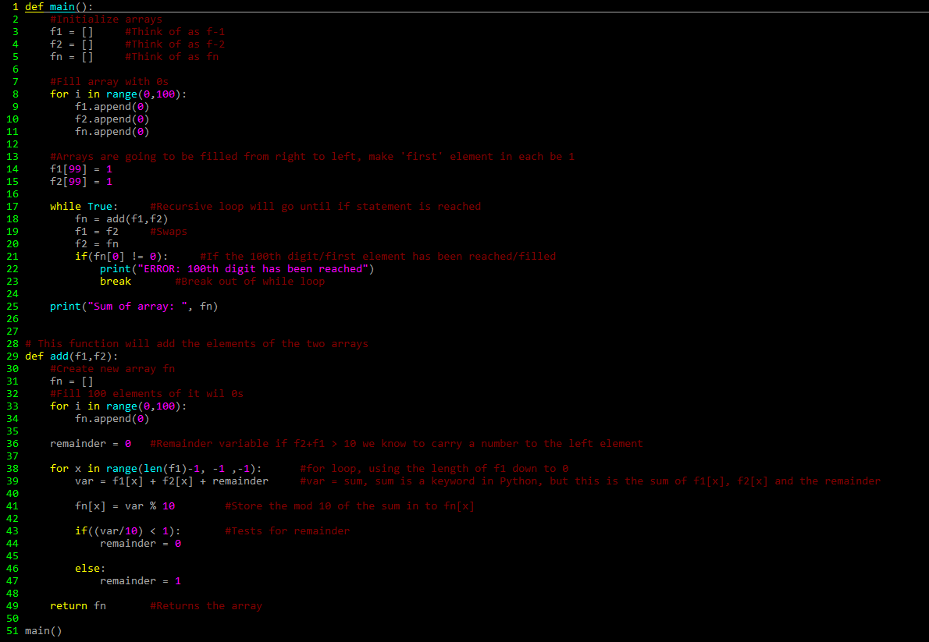

**Execution:** 