officedown template

Your Name

2022-06-28

This document presents most of the features of the package **officedown**.

Table of content

1.1. Table of content 2

1.2. List of figures 2

1.3. List of tables 2

1.4. Sections 3

1.4.1. A two columns section 3

1.4.2. End of two columns section 3

1.4.3. Landscape section 5

1.4.4. Normal section 6

1.5. Tables 7

1.5.1. Table 1 7

1.5.2. Table 2 7

1.5.3. Table 3 7

1.6. figures 8

1.6.1. A boxplot 8

1.6.2. A barplot 8

1.7. Lists 9

1.8. Reference 10

1.9. Citas y referencias bibliográficas 10

2. Referencias bibliográficas 10

## List of figures

**Figure** : A boxplot 8

**Figure** : What a barplot 9

## List of tables

**Table** : caption 1 7

**Table** : iris 7

**Table** : cars 8

## Sections

### A two columns section

Lorem ipsum dolor sit amet, consectetur adipiscing elit. Nulla eu pulvinar arcu, quis aliquam dui. In at cursus ante. Vestibulum non sagittis lacus. Duis vitae iaculis dui. Vivamus tempor, nibh ut pretium tempus, enim lorem dignissim quam, at euismod massa magna at magna. Sed facilisis dapibus diam nec volutpat. Maecenas facilisis dapibus egestas. Curabitur dignissim pharetra pulvinar. Nunc bibendum elit sed cursus congue.

Curabitur ligula quam, iaculis faucibus orci quis, vestibulum lobortis lectus. Suspendisse fringilla nisl pulvinar, laoreet tellus sed, sollicitudin tortor. Donec consequat congue erat in iaculis. Curabitur luctus tellus ut turpis iaculis, nec laoreet ligula scelerisque.

Lorem ipsum dolor sit amet, consectetur adipiscing elit. Nulla eu pulvinar arcu, quis aliquam dui. In at cursus ante. Vestibulum non sagittis lacus. Duis vitae iaculis dui. Vivamus tempor, nibh ut pretium tempus, enim lorem dignissim quam, at euismod massa magna at magna. Sed facilisis dapibus diam nec volutpat. Maecenas facilisis dapibus egestas. Curabitur dignissim pharetra pulvinar. Nunc bibendum elit sed cursus congue. Curabitur ligula quam, iaculis faucibus orci quis, vestibulum lobortis lectus. Suspendisse fringilla nisl pulvinar, laoreet tellus sed, sollicitudin tortor. Donec consequat congue erat in iaculis. Curabitur luctus tellus ut turpis iaculis, nec laoreet ligula scelerisque.

### End of two columns section

Lorem ipsum dolor sit amet, consectetur adipiscing elit. Nulla eu pulvinar arcu, quis aliquam dui. In at cursus ante. Vestibulum non sagittis lacus. Duis vitae iaculis dui. Vivamus tempor, nibh ut pretium tempus, enim lorem dignissim quam, at euismod massa magna at magna.

Lorem ipsum dolor sit amet, consectetur adipiscing elit. Nulla eu pulvinar arcu, quis aliquam dui. In at cursus ante. Vestibulum non sagittis lacus. Duis vitae iaculis dui. Vivamus tempor, nibh ut pretium tempus, enim lorem dignissim quam, at euismod massa magna at magna. Sed facilisis dapibus diam nec volutpat. Maecenas facilisis dapibus egestas. Curabitur dignissim pharetra pulvinar. Nunc bibendum elit sed cursus congue. Curabitur ligula quam, iaculis faucibus orci quis, vestibulum lobortis lectus. Suspendisse fringilla nisl pulvinar, laoreet tellus sed, sollicitudin tortor. Donec consequat congue erat in iaculis. Curabitur luctus tellus ut turpis iaculis, nec laoreet ligula scelerisque.

### Landscape section

Lorem ipsum dolor sit amet, consectetur adipiscing elit. Nulla eu pulvinar arcu, quis aliquam dui. In at cursus ante. Vestibulum non sagittis lacus. Duis vitae iaculis dui. Vivamus tempor, nibh ut pretium tempus, enim lorem dignissim quam, at euismod massa magna at magna. Sed facilisis dapibus diam nec volutpat.

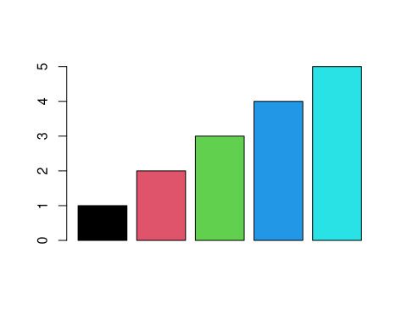

### Normal section

comprueba <- function(file_name = NULL, doc_format = NULL) { proj_dir <- getwd()  
 proj_files <- list.files(proj_dir)  
 if (!any(grepl(".Rproj", proj_files)))  
 stop("\nEl directorio de trabajo no contiene ning\u00fan proyecto de RStudio.",  
 "\nCambia al directorio principal creado con",  
 " la funci\u00f3n fisabio::nuevo_proyecto()")  
 if (is.null(file_name))  
 file_name <- "informe"  
 if (!grepl("/$", proj_dir))  
 proj_dir <- paste0(proj_dir, "/")  
 proj_opt <- readLines(proj_files[grep(".Rproj", proj_files)])  
 doc_format <- tolower(doc_format)  
 if (!any(grepl(doc_format, c("pdf", "docx", "odt", "beamer"))))  
 stop("\nEl formato que has escogido no est\u00e1 disponible o es err\u00f3neo.",  
 "\nLos posibles formatos son: pdf, docx, odt o beamer.")  
 if (doc_format %in% c("pdf", "beamer")) {  
 if (!any(grepl("knitr", proj_opt, ignore.case = TRUE))) {  
 stop("\nknitr no es la opci\u00f3n por defecto para compilar archivos LaTeX",  
 "\nVuelve a ejecutar la funci\u00f3n cuando lo hayas cambiado en:\n",  
 "Tools/Project Options/Sweave/Program Defaults")  
 }  
 }  
}  
1 + 1

1 + 1

## [1] 2

warning("nsfkkegf")

## Warning: nsfkkegf

Lorem ipsum dolor sit amet, consectetur adipiscing elit. Nulla eu pulvinar arcu, quis aliquam dui. In at cursus ante. Vestibulum non sagittis lacus. Duis vitae iaculis dui. Vivamus tempor, nibh ut pretium tempus, enim lorem dignissim quam, at euismod massa magna at magna. Sed facilisis dapibus diam nec volutpat. Maecenas facilisis dapibus egestas. Curabitur dignissim pharetra pulvinar. Nunc bibendum elit sed cursus congue. Curabitur ligula quam, iaculis faucibus orci quis, vestibulum lobortis lectus. Suspendisse fringilla nisl pulvinar, laoreet tellus sed, sollicitudin tortor. Donec consequat congue erat in iaculis. Curabitur luctus tellus ut turpis iaculis, nec laoreet ligula scelerisque.

Lorem ipsum dolor sit amet, consectetur adipiscing elit. Nulla eu pulvinar arcu, quis aliquam dui. In at cursus ante. Vestibulum non sagittis lacus. Duis vitae iaculis dui. Vivamus tempor, nibh ut pretium tempus, enim lorem dignissim quam, at euismod massa magna at magna. Sed facilisis dapibus diam nec volutpat. Maecenas facilisis dapibus egestas. Curabitur dignissim pharetra pulvinar. Nunc bibendum elit sed cursus congue. Curabitur ligula quam, iaculis faucibus orci quis, vestibulum lobortis lectus. Suspendisse fringilla nisl pulvinar, laoreet tellus sed, sollicitudin tortor. Donec consequat congue erat in iaculis. Curabitur luctus tellus ut turpis iaculis, nec laoreet ligula scelerisque.

## Tables

### Table 1

head(mtcars)

**Table** **1**: caption 1

| mpg | cyl | disp | hp | drat | wt | qsec | vs | am | gear | carb |
| --- | --- | --- | --- | --- | --- | --- | --- | --- | --- | --- |
| 21.0 | 6 | 160 | 110 | 3.90 | 2.620 | 16.46 | 0 | 1 | 4 | 4 |
| 21.0 | 6 | 160 | 110 | 3.90 | 2.875 | 17.02 | 0 | 1 | 4 | 4 |
| 22.8 | 4 | 108 | 93 | 3.85 | 2.320 | 18.61 | 1 | 1 | 4 | 1 |
| 21.4 | 6 | 258 | 110 | 3.08 | 3.215 | 19.44 | 1 | 0 | 3 | 1 |
| 18.7 | 8 | 360 | 175 | 3.15 | 3.440 | 17.02 | 0 | 0 | 3 | 2 |
| 18.1 | 6 | 225 | 105 | 2.76 | 3.460 | 20.22 | 1 | 0 | 3 | 1 |

### Table 2

head(iris)

**Table 2**: iris

| Sepal.Length | Sepal.Width | Petal.Length | Petal.Width | Species |
| --- | --- | --- | --- | --- |
| 5.1 | 3.5 | 1.4 | 0.2 | setosa |
| 4.9 | 3.0 | 1.4 | 0.2 | setosa |
| 4.7 | 3.2 | 1.3 | 0.2 | setosa |
| 4.6 | 3.1 | 1.5 | 0.2 | setosa |
| 5.0 | 3.6 | 1.4 | 0.2 | setosa |
| 5.4 | 3.9 | 1.7 | 0.4 | setosa |

### Table 3

head(cars)

**Table** **3**: cars

| speed | dist |
| --- | --- |
| 4 | 2 |
| 4 | 10 |
| 7 | 4 |
| 7 | 22 |
| 8 | 16 |
| 9 | 10 |

## figures

### A boxplot

boxplot(1:8)

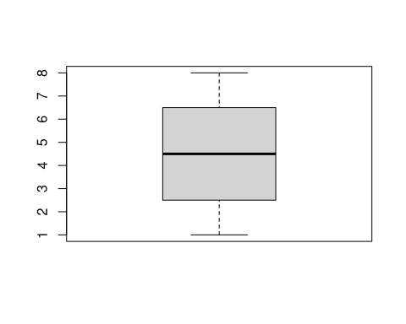

**Figure** **1**: A boxplot

### A barplot

barplot(1:8)

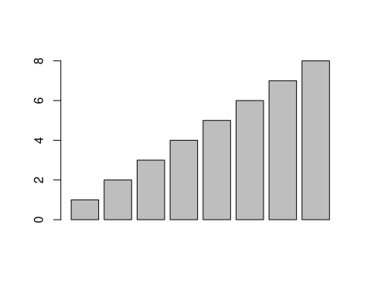

**Figure** **2**: What a barplot

## Lists

Amet nunc eros curabitur tellus massa, eros maximus porttitor sociosqu, pellentesque.

* Erat mauris egestas finibus tincidunt sed in rhoncus a tellus etiam.
  + A adipiscing per ultricies justo tellus lorem.
    - Imperdiet ut dui primis, sed gravida, at sed nulla.
    - Sem posuere lacus consequat inceptos dapibus duis malesuada finibus.
  + Urna sed dui, ornare, eu turpis mus pellentesque amet amet bibendum.
* Himenaeos tincidunt, auctor dapibus scelerisque, montes nunc faucibus sodales malesuada ridiculus sed cubilia ligula.

1. Erat mauris egestas finibus tincidunt sed in rhoncus a tellus etiam.
   1. A adipiscing per ultricies justo tellus lorem.
      1. Imperdiet ut dui primis, sed gravida, at sed nulla.
      2. Sem posuere lacus consequat inceptos dapibus duis malesuada finibus.
   2. Urna sed dui, ornare, eu turpis mus pellentesque amet amet bibendum.
2. Himenaeos tincidunt, auctor dapibus scelerisque, montes nunc faucibus sodales malesuada ridiculus sed cubilia ligula.

Lorem dolor interdum orci eros pellentesque semper tristique, sodales, et sed ut! Porta mattis natoque et. Ac facilisi ipsum viverra elementum vestibulum ligula amet enim magnis luctus ullamcorper. Rhoncus rhoncus elit in at nisl. Tincidunt habitant sit.

* Aptent conubia quam montes id sagittis.
  + Mattis nisi nascetur, aliquam duis ex, tristique.
    - Imperdiet ut dui primis, sed gravida, at sed nulla.
    - Donec ligula nulla ac. Nisl ac at accumsan sagittis eros felis lobortis amet nec phasellus urna bibendum sapien.
  + Eu dui ac id, dictum proin consectetur convallis.
* Facilisi eu lectus mauris lorem. Et sed sapien pellentesque sed etiam vehicula.
* In porttitor id lorem eu efficitur, nisl dis!

## Reference

see figure **1** and table **1**!

## Citas y referencias bibliográficas

Las referencias se generan directamente con Pandoc (pandoc-citeproc), siendo muy fácil introducirlas. P. ej., en cuanto a su número:

* se pueden meter una (Congdon, 2014) a una (Daniels & Hogan, 2008),
* de dos (Gelman et al., 2014; Harrell, 2015) en dos (Bivand et al., 2013; Blangiardo & Cameletti, 2015),
* a cascoporro (Chang, 2012; Duda et al., 2001; Fawcett, 2006; Greenland et al., 2008; Lash et al., 2014),
* o a cholón (Bivand et al., 2013; Blangiardo & Cameletti, 2015; Chang, 2012; Congdon, 2014; Daniels & Hogan, 2008; Duda et al., 2001; Fawcett, 2006; Gelman et al., 2014; Greenland et al., 2008; Harrell, 2015; Lash et al., 2014; Lunn et al., 2012; Matloff, 2016; Rothman et al., 2008; Wickham, 2015).

Respecto a su apariencia, se puede obtener una cita entre paréntesis o contextual, en función del comando que se use. P. ej.:

* [@documento\_a\_citar]: tal cosa es así, al menos eso dice la literatura específica (Fawcett, 2006),
* [-@documento\_a\_citar]: Fawcett ya lo dijo en su momento (2006),
* @documento\_a\_citar: por otro lado, y siempre según (2006), tal cosa no es así (en absoluto),

# Referencias bibliográficas

Bivand, R. S., Pebesma, E., & Gómez-Rubio, V. (2013). *Applied spatial data analysis with R* (p. 405). Springer. <https://doi.org/10.1007/978-1-4614-7618-4>

Blangiardo, M., & Cameletti, M. (2015). *Spatial and Spatio-temporal Bayesian Models with R-INLA*. Wiley.

Chang, W. (2012). *R Graphics Cookbook* (p. 413). O’Reilly.

Congdon, P. (2014). *Applied Bayesian Modelling* (2nd ed., p. 464). Wiley.

Daniels, M., & Hogan, J. (2008). *Missing Data in Longitudinal Studies: Strategies for Bayesian Modeling and Sensitivity Analysis*. CRC. <https://doi.org/10.1080/00107510903093086>

Duda, R. O., Hart, P. E., & Stork, D. G. (2001). *Pattern Classification* (2nd ed.). Wiley.

Fawcett, T. (2006). An introduction to ROC analysis. *Pattern Recognition Letters*, *27*(8), 861–874. <https://doi.org/10.1016/j.patrec.2005.10.010>

Gelman, A., Carlin, J. B., Stern, H. S., Dunson, D. B., Vehtari, A., & Rubin, D. B. (2014). *Bayesian Data Analysis* (3rd ed.). CRC.

Greenland, S., Lash, T. L., & Rothman, K. J. (2008). Concepts of Interaction. In K. J. Rothman, S. Greenland, & T. L. Lash (Eds.), *Modern epidemiology* (3rd ed.). Lippincott Williams & Wilkins.

Harrell, F. E. Jr. (2015). *Regression Modeling Strategies: With Applications to Linear Models, Logistic and Ordinal Regression, and Survival Analysis* (2nd ed.). Springer. <https://doi.org/10.1007/978-3-319-19425-7>

Lash, T. L., Fox, M. P., MacLehose, R. F., Maldonado, G., McCandless, L. C., & Greenland, S. (2014). Good practices for quantitative bias analysis. *International Journal of Epidemiology*, *July*, 1–17. <https://doi.org/10.1093/ije/dyu149>

Lunn, D. J., Jackson, C., Best, N., Thomas, A., & Spiegelhalter, D. (2012). *The BUGS Book*. CRC.

Matloff, N. (2016). *Parallel Computing for Data Science*. CRC.

Rothman, K. J., Greenland, S., & Lash, T. L. (Eds.). (2008). *Modern epidemiology* (3rd ed.). Lippincott Williams & Wilkins.

Wickham, H. (2015). *Advanced R*. CRC.