
MOBNET NGTA
R0.0

Global Operational Requirements Specification
LM Functional Specification Level 1 (NGTA)
PXXX

Internal chat system

In addition to the authors named on the cover page the following persons have
collaborated on this document:

For internal use only!

Issued by
Siemens Com

Copyright © Siemens AG 2026 All Rights Reserved.
Siemens Aktiengesellschaft
Author: | Reinhard Pichler | PSE MCS TS 2

0 General Information 4
The document comprises 23 pages, all pages have issue no 05.
The document is based on template .
This issue was last saved on 27.05.2007 16:29.
This document was edited with MS WinWord version 11.0.
The filename of the main document file was 0000.doc.

1 Introduction 5
2 Realization 6
2.1 Functional Requirements 6
2.2 Class diagram 9
3 Interfaces 11
3.1 Client Requests 11
3.2 Server Responses 12
3.3 Data Structures 13
3.4 Messages summary 15
3.5 Linking client requests with server responses 16
4 Use Cases 17
4.1 Enter 17
4.2 Exit 17
4.3 1st message to 1 18
4.4 1st message to > 1 18
4.5 Message 19
4.6 Message to added 19
4.7 Enter chat 20
4.8 Exit chat 20
4.9 Rename chat 21
5 Test Strategy 22
6 Appendix 23

General Information

Introduction
Some kind of Instant messenger is needed for geographically distributed team working together on one project on Windows workstations over corporation intranet. The best solution for a teamwork would be readily available and configurable voice/text connection of several participants dealing with particular problem. Features to consider:
- a participant is available for a session (text/voice messaging)
- a participant can initiate a session with one or more participants (everyone participating is able to listen as sharing the same room ie. chat or phone conference)
- a participant can freely without invitation join a session already started by others (as entering room ie. chat)
- a participant can leave a session
- privacy as we know it from widely spread instant messengers (ICQ, AIM,MSN) is desired too.
- a participant should be able to select and invite others to his session
- system safety. System serves only members of a team defined by its administrator.
- system portability

Realization
Several existing messaging systems were reviewed: AIM, ICQ, IRC, MSN, Skype. Skype and MSN allows to invite or add another user to a chat already established with several users. IRC allows entering already started named chat by different user. It is possible to subscribe with several chats for one user. Private communication 1 to 1 is possible too.
We are about to adopt the most of the mentioned characteristic and extending them some other functionality
Chosen programming language is Java and Java Swing library for GUI.
Chosen network protocol is TCP for it checks success of data transfer and guarantees their order.

Functional Requirements
The system is going to use client/server priciple on port out of the range as specified by RCF1700 (http://www.faqs.org/rfcs/rfc1700.html).
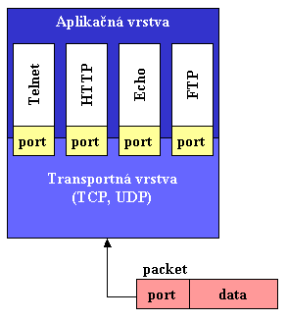
Figure 2-1 example of TCP aplication layer
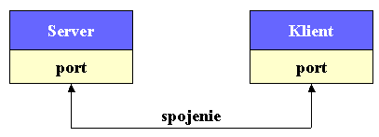
Figure 2-2 client server connection
List of features:
- List of users available
- List of chats available
- Private chat between 1 to 1
- Public chat for more than 2 participants in named chat
- Upon entering (registering for) a chat history of messages shows up
- Each chat lists actual participants
- One user can be registered for several chats simultaneously

GUI examples are showing a private chat of two users and a user participating in a named chat.

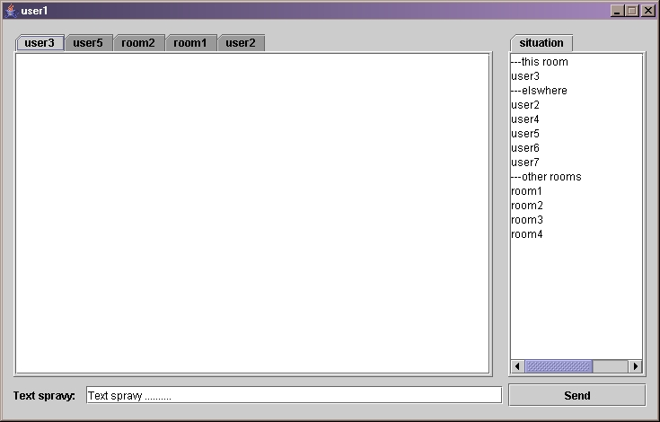
Figure 2-3user1 in private chat with user3

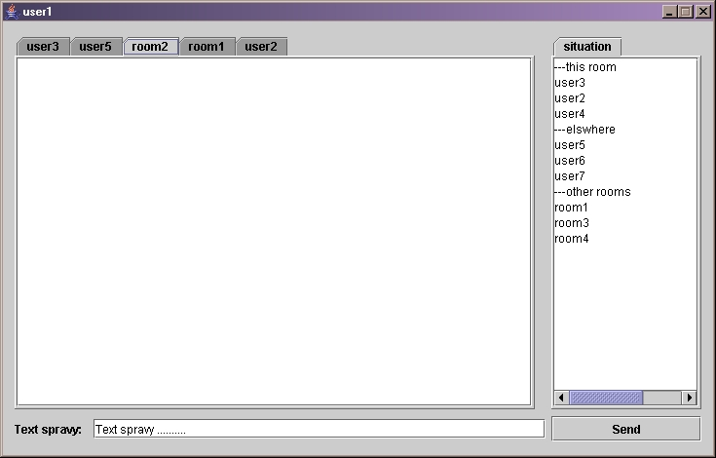
Figure 2-4 user1 in public chat named room2 with other 3 users listed

Class diagram
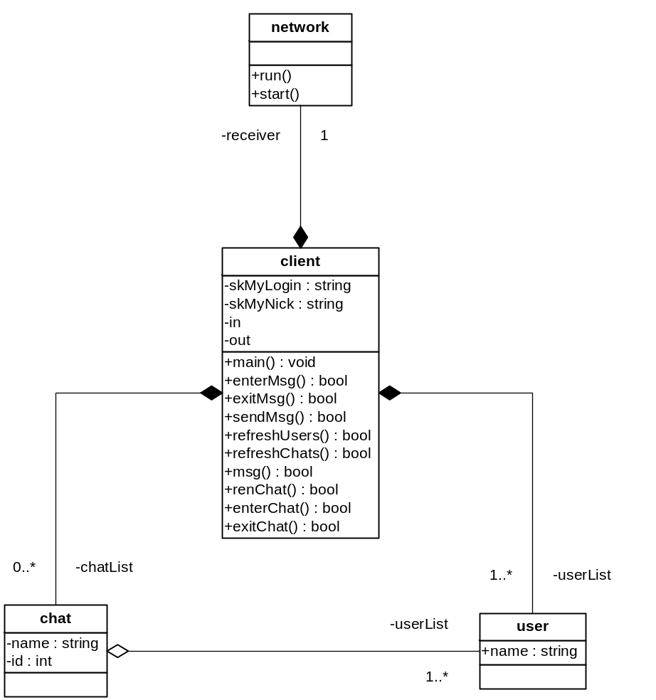
Figure 2-5 client
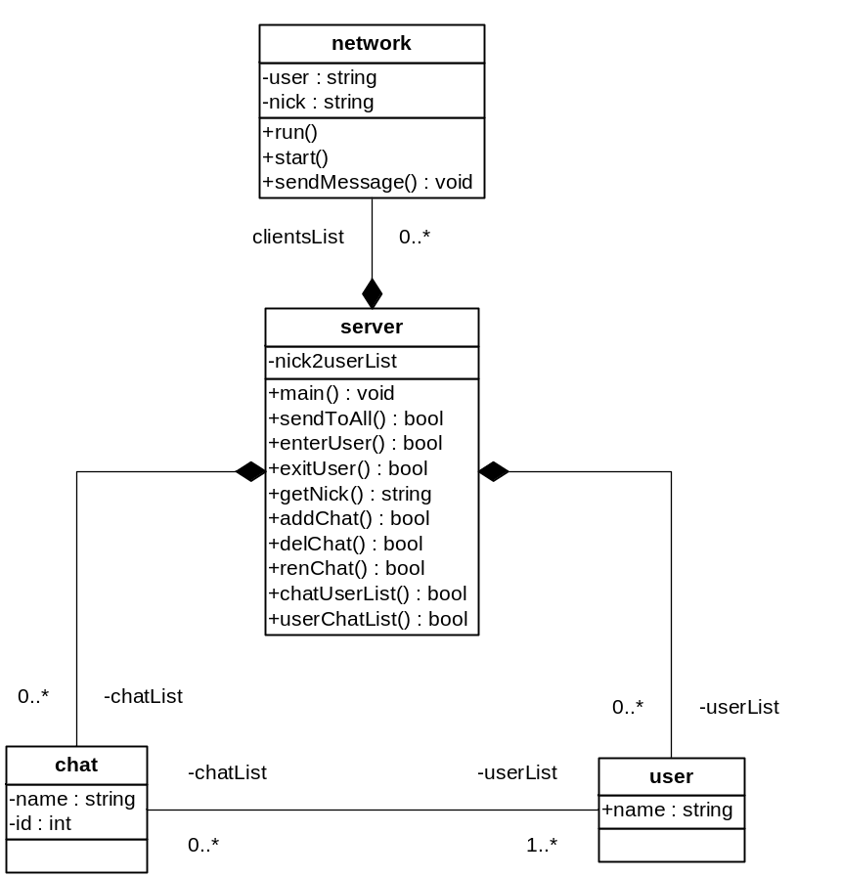
Figure 2-6 server

Interfaces

Client Requests

textMsg
{
String msgcode=“0\n“,
int chatid=0,
byte chatnamelen=0,
char[] chatname=””,
byte textlen,
char[] text,
int users_no=0,
user[users_no] list =null
}

user
{
int id,
byte namelen,
char[] name
}

clientEnter
{
String msgcode=“6\n“,
String login,
String endl=“\n“
}

String msgcode= clientExit=“7\n“,

chatEnter
{
String msgcode=“8\n“,
int chatid
}

chatExit
{
String msgcode=“9\n“,
int chatid
}

renChat
{
String msgcode=“10\n“,
byte chatnamelen,
char[] chatname
}

Server Responses

globalUserList
{
String msgcode=“1\n“,
int users_no,
user[users_no] list
}

chatUserlist
{
String msgcode=“2\n“,
int chatid,
int users_no,
user[users_no] list
}

chat {int id, byte namelen,byte[] name}

chatList
{
String msgcode=“3\n“,
int chats_no,
chat[chats_no] list
}

textDistMsg
{
String msgcode=“4\n“,
int chatid,
int textlen,
byte[] text,
}
histDistMsg
{
String msgcode=“5\n“,
int chatid,
int histlen,
byte[] hist,
}

Data Structures

Int chatid;
char[] chatname;

User
{
int userid,
byte usernamelen,
char[] username
}

user[] globalUserList, chatUserList;
Byte[] text,history;

chat
{
int chatid,
byte chatnamelen,
char[] chatname
}

chat[] chatList, userChatList;

The client keeps
- chatList – all available chats
- globalUserList – all users present
- userChatList - for each user using subset of all available chats
  - chatUserList for each chat showing users in a chat
the server keeps
- globalUserList – all users present
  - userChatList – lists chats subset each user is subscribed to
- chatList – all available chats
  - chatUserList - lists users in each chat

Messages summary

Client sends | Msg  Code | Chat ID | Userlist | Text | login | Chat  Name
Enter  Exit  -while in chat  1st message to 1  1st message to >1  Message  Message to added  Enter chat  Exit chat  Rename chat | 6  7  7  0  0  0  0  8  9  10 | X(?)  X  X  X  X  X | X  X  X | X  X  X  X  X | X | X?  X?  X?  X

Server sends | msg  code | Chat  ID | Global  Userlist | Chat  Userlist | Text | History | Chat  List
globalUserList  chatUserList  chatList  distTextMsg  histDistMsg | 1  2  3  4  5 | c  c  c  f | a | c | c | f | a
Table 3-1 messges sent from client and server

Linking client requests with server responses

Client req/serv resp | Chat  ID | Global  Userlist | Chat  Userlist | Text | History | Chat  List | failed | client  codes | server  codes
Enter  Exit  -while in chat  1st message to 1  1st message to >1  Message  Message to added  Enter chat  Exit chat  Rename chat  +failed||new one | c  c  c  c  c  c  c  c  f | a  a  a  f? | c  c  c  c  c  c  f | c  c  c  c  c  c  c  c | f | a?  a  a?  a?  a?  a  f? | +?  +?  +  +?  +? | 6  7  7  0  0  0  0  8  9  10 | 1  1  1,2,4,3?  2,4  2,4,3  4,3?  2,4,3?  2,4  2,4,3?  2,3  2,5,3?,1?
a - Broadcast to all  c - To chat registered  f - To failed||new | X  X | X  X | X  X | X | X | X  X
Table 3-2 map of client messages to server messages

Subset relations:
(a – all ( c – chat ( f – failed||new ))))

meaning f is subset of c which is subset of a

Use Cases

Enter

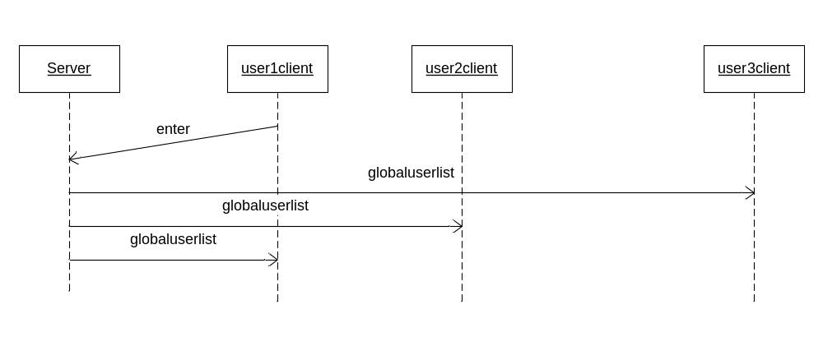

Exit

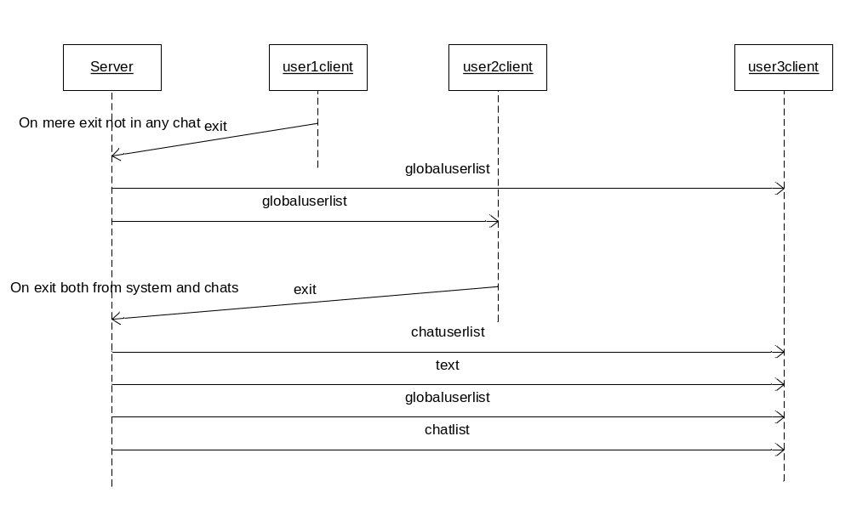

1st message to 1

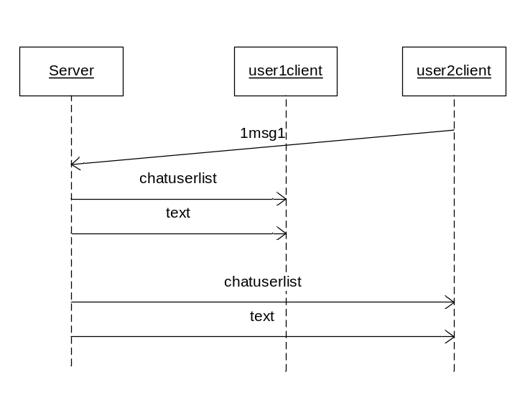

1st message to > 1

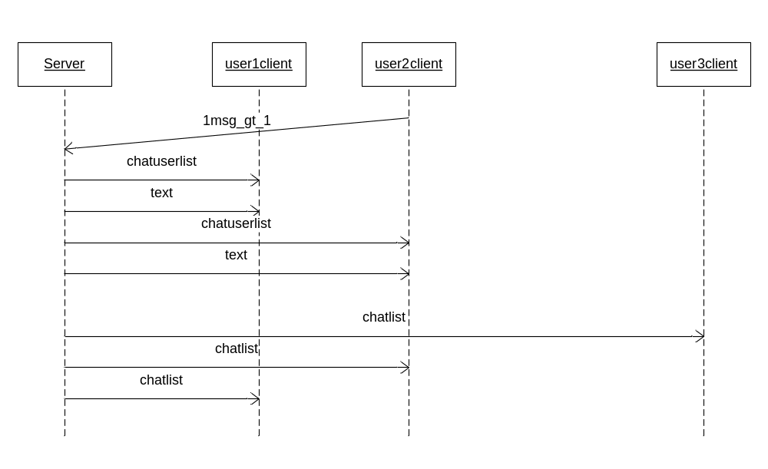

Message

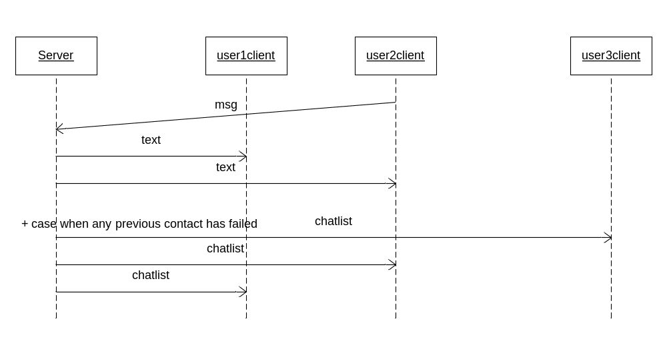

Message to added

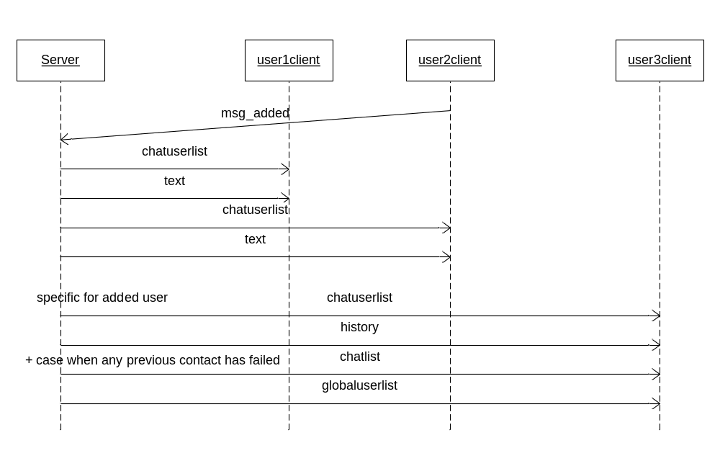

Enter chat

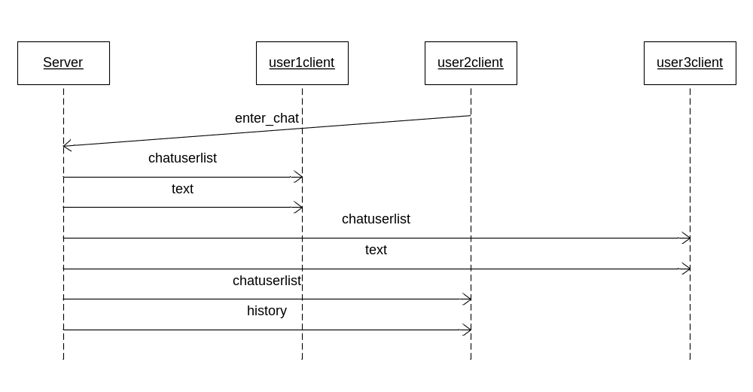

Exit chat

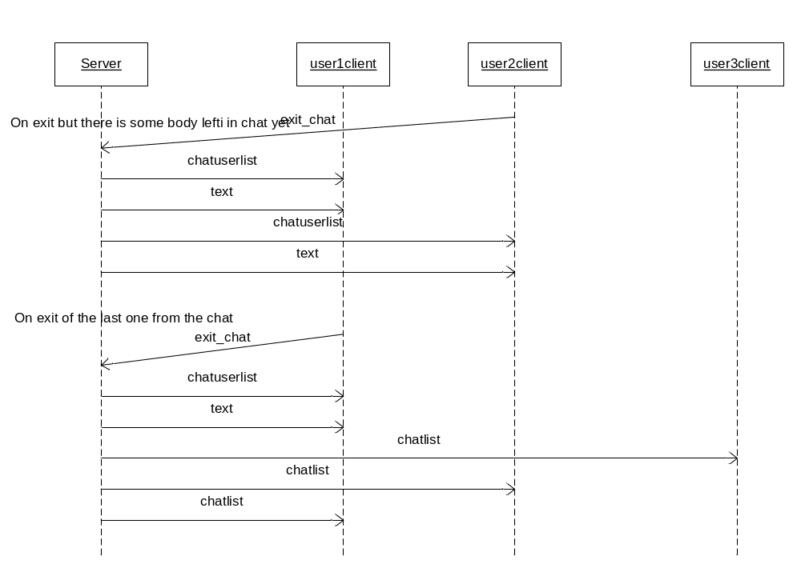

Rename chat

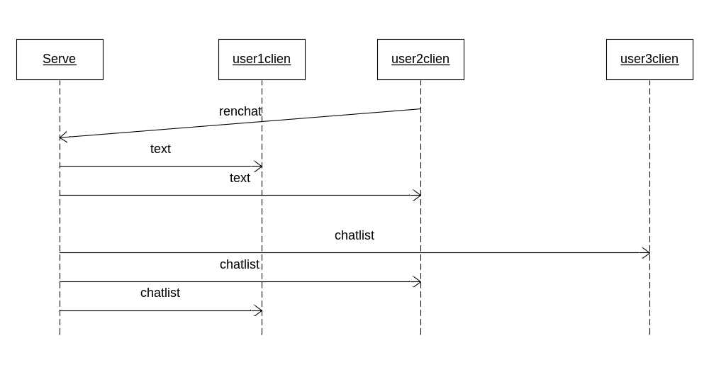

Test Strategy

Appendix
Not applicable

Chat is a session of one or more participants where two can be in private unnamed conversation and more than two can be in public named conversation room, channel etc
Chat ID could be sent but in general a user can be registered in several chats leaving them all
? means this value is suplied only occasionally
+ means another set of messages follows ? means otpionally

