Benford’s Project

Figure 11: Digital Development

Edward Stansfeld

January 2022

## Introduction

Digital progression is the property that the extreme ends of natural distributions of data tend to deviate from the Benford’s distribution, with the smallest items being more uniform, and the largest being “Benford’s extreme” (Kossovsky 2014). Accordingly, the highest and lowest bins by magnitude were plotted.

The plots for confirmed cases do indeed show the expected digital progression, with the low band flatter than Benford’s, and the high band more extreme. The plots for deaths are interesting as the low band actually conforms more closely to the expected distribution than the full dataset, which as noted above has a restricted range and has few high values. This indicates that digital progression would be a useful technique to apply at the state level, with an expectation that Benford’s Law applies at the lowest level of magnitude, and that the distribution is more extreme at the next.

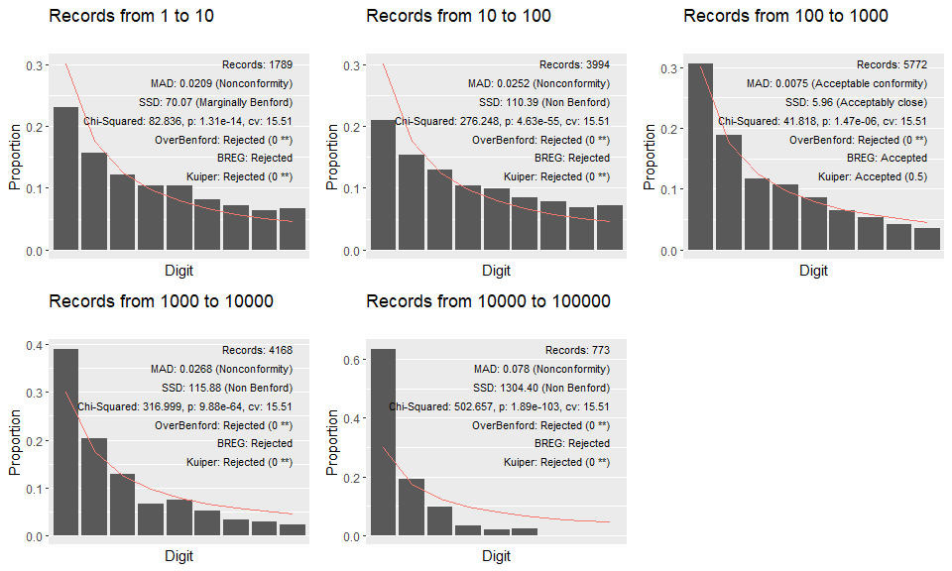

## Conclusion

The Scotland deaths dataset are deficient for tests of Benfords Law owing to their limited range and preponderance of low values. This causes the distributions to be heavily skewed by the “Benford’s extreme” effect.

It was established that the pandemic dataset is expected to follow Benford’s Law for natural data, because of the exponential way in which an epidemic spreads. It was also established that there are sufficient records and that they have sufficient range for a Benford’s study.

## References

DataScienceScotland (2021) COVID-19-Management-Information: The data provide past data for the daily updates published by the Scottish Government, GitHub. Available at: <https://github.com/DataScienceScotland/COVID-19-Management-Information> (Accessed: 21 December 2021).

Scottish Government (2021) Deaths involving coronavirus (COVID-19), statistics.gov.scot. Available at: <https://statistics.gov.scot/resource?uri=http%3A%2F%2Fstatistics.gov.scot%2Fdata%2Fdeaths-involving-coronavirus-covid-19> (Accessed: 21 December 2021).