Benford’s Project

Figs 5,6,8,9,10: Summary Charts

Edward Stansfeld

January 2022

## Introduction

The India data contain 36 sets of regional data, each containing around 500 records, and the Scotland 14 sets of regional data. This paper focuses on the properties of the datasets for confirmed cases, deaths and recoveries. The distributions are plotted for each region and indicative statistics are calculated.

## Results

As shown in Appendix 1, the state results have a wide variety, though most are clearly conformant over the leading digits, especially among the confirmed and cured cases. There are some notable exceptions; Jammu and Kashmir have a distribution that has uniform features (but passes Kossovsky’s test) and Tamil Nadu and Uttarakhand have a disproportionate number of “4”s and 5"s. West Bengal has a strange two-layered uniform distribution.

The deaths data has a more limited range and there is a tendency for the Benford’s extreme distribution to appear. The Benford’s extreme distribution is associated with digital progression (Kossovsky 2019). In digital progression, when the logs of sampled data covering several orders of magnitude are binned, they should approximate to a normal distribution. The rising end of the distribution tends to digital equality, whereas the falling end tends to Benford’s extreme. In the state deaths data, many of the magnitude plots have a sharply right-skewed distribution, and this is a predictor that the Benford’s distribution will be extreme.

The last digit results also have a wide variety, and most of them look conformant. The deaths plots are much affected by the limited range and in several cases, the last digit distributions are more like first digit distributions. This would seem to be a digital progression effect, with the high end effect dominant over the low end.

## Conclusion

The state-level data has a wide range of results, with most passing at least one of the tests for Benford’s conformance. There are also some that appear anomalous, in particular West Bengal, Uttarkhand and Tamil Nadu, which performed strangely in the leading digit tests. Visual inspection showed that some of the deaths graphs have the “Benford’s extreme” profile of more low digits than expected. It is particularly common with datasets that have a limited range of just one or two orders of magnitude. A Benford’s extreme profile is associated with digital progression and is caused by a reducing number of data points as the log of the data increases.

## References

Breiman L., Friedman J. H., Olshen R. A., and Stone, C. J. (1984) Classification and Regression Trees. Wadsworth

Kossovsky, A. E. (2014) Benford’s Law: Theory, The General Law Of Relative Quantities, And Forensic Fraud Detection Applications. New Jersey: World Scientific. Available at: <https://web-b-ebscohost-com.libezproxy.dundee.ac.uk/ehost/ebookviewer/ebook/ZTAwMHh3d19fODM5NjQ0X19BTg2?sid=0ce4142b-5c35-4f8c-844d-1030e6c91e4f%40pdc-v-sessmgr02&vid=0&format=EK&rid=1> (Accessed: 29 August 2021).

Kossovsky, A. E. (2019) ‘The General Law of Relative Quantities and Digital Development Forensics’, in Benford’s Law Conference, Stresa, Italy. Available at: <https://ec.europa.eu/jrc/en/event/workshop/benfords-law-conference> (Accessed: 29 August 2021).

Kossovsky, A. E. (2021) ‘On the Mistaken Use of the Chi-Square Test in Benford’s Law’, Stats 2021, Vol. 4, Pages 419-453, 4(2), pp. 419–453. doi: 10.3390/STATS4020027.

Nigrini, M. (2012) Benford’s Law: Applications for Forensic Accounting, Auditing, and Fraud … - Mark J. Nigrini - Google Books. Available at: <https://books.google.co.uk/books?hl=en&lr=&id=Bh5Vr_I1NZoC&oi=fnd&pg=PP11&ots=qcigiizrOi&sig=Zyv0EV3snhVKH3yOC9z117ieSlI&redir_esc=y#v=onepage&q&f=false> (Accessed: 11 August 2021).

## Appendix 1

### Plots of mantissa, magnitudes, Benford’s first digit and last digits for confirmed cases, deaths and cured of daily Covid returns from Indian states.

## Warning in self$trans$transform(x): NaNs produced

## Warning: Transformation introduced infinite values in continuous y-axis

## Warning: Removed 123 rows containing non-finite values (stat_smooth).

## Warning: Transformation introduced infinite values in continuous y-axis

## Warning: Removed 418 rows containing non-finite values (stat_smooth).

## Warning: Transformation introduced infinite values in continuous y-axis

## Warning: Removed 136 rows containing non-finite values (stat_smooth).

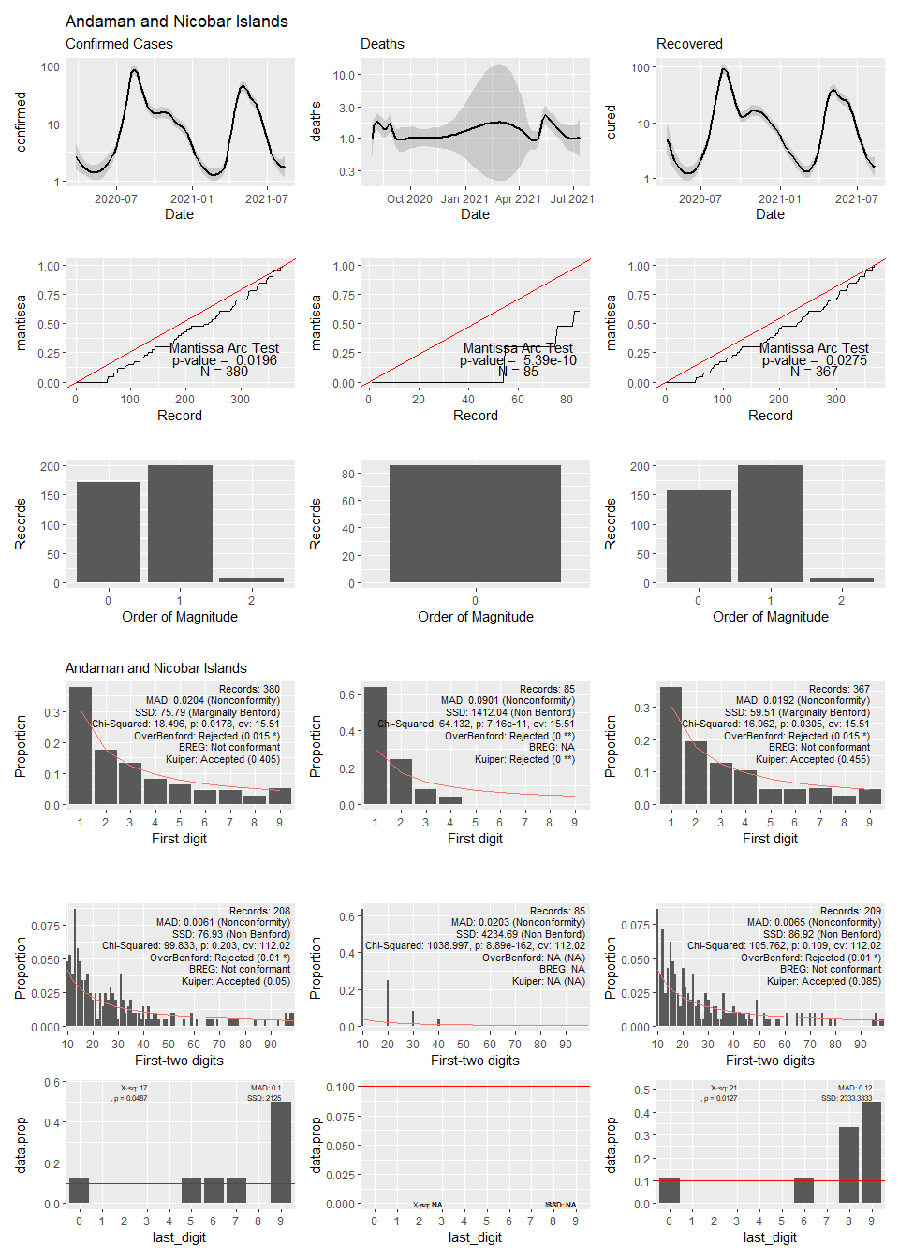

## Warning in self$trans$transform(x): NaNs produced

## Warning: Transformation introduced infinite values in continuous y-axis

## Warning: Removed 123 rows containing non-finite values (stat_smooth).

## Warning: Transformation introduced infinite values in continuous y-axis

## Warning: Removed 418 rows containing non-finite values (stat_smooth).

## Warning: Transformation introduced infinite values in continuous y-axis

## Warning: Removed 136 rows containing non-finite values (stat_smooth).



## Warning: Transformation introduced infinite values in continuous y-axis

## Warning: Removed 13 rows containing non-finite values (stat_smooth).

## Warning: Transformation introduced infinite values in continuous y-axis

## Warning: Removed 82 rows containing non-finite values (stat_smooth).

## Warning: Transformation introduced infinite values in continuous y-axis

## Warning: Removed 31 rows containing non-finite values (stat_smooth).

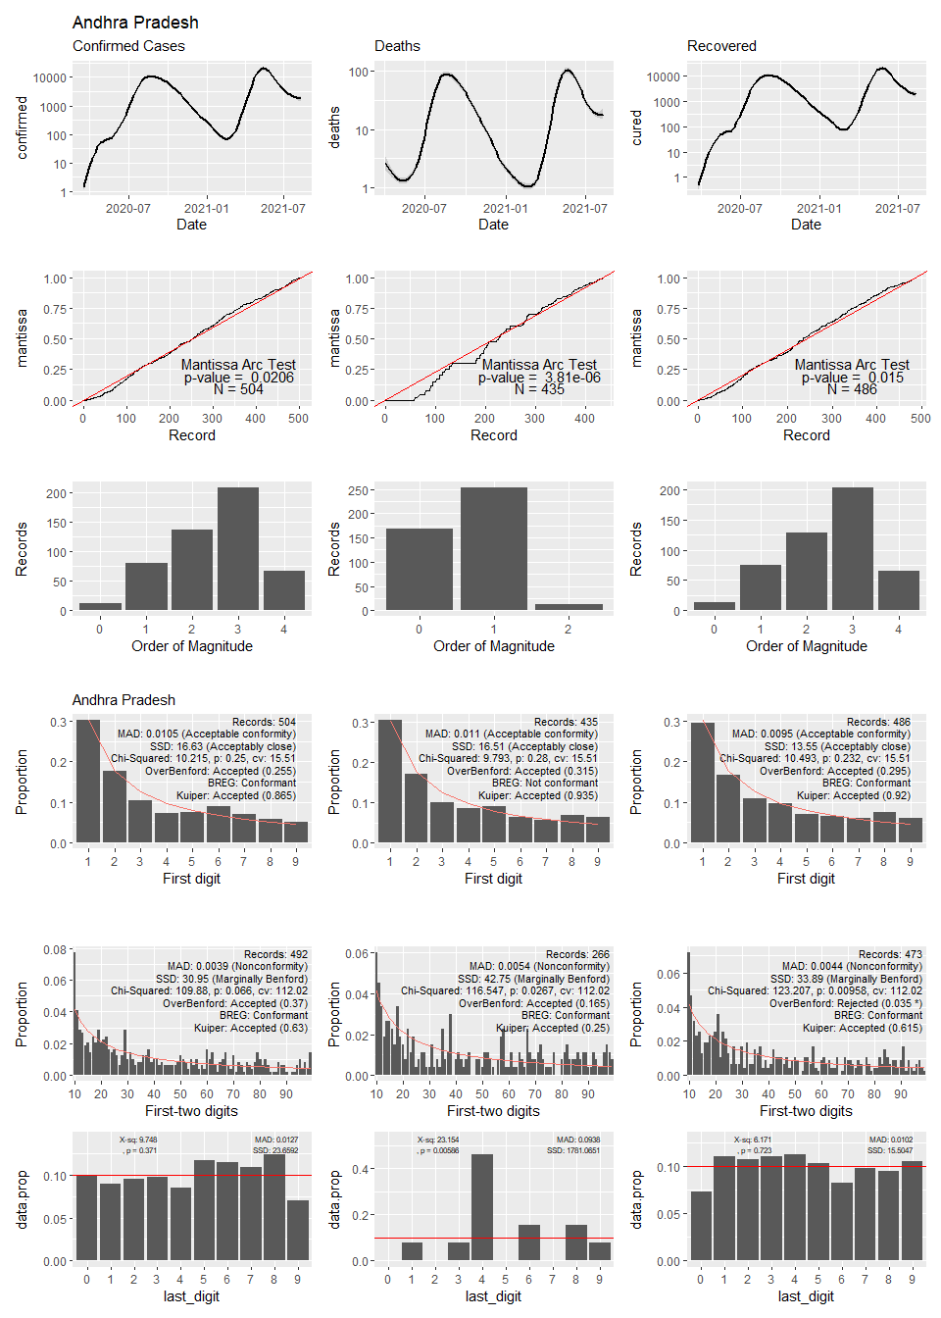

## Warning: Transformation introduced infinite values in continuous y-axis

## Warning: Removed 116 rows containing non-finite values (stat_smooth).

## Warning: Transformation introduced infinite values in continuous y-axis

## Warning: Removed 371 rows containing non-finite values (stat_smooth).

## Warning: Transformation introduced infinite values in continuous y-axis

## Warning: Removed 129 rows containing non-finite values (stat_smooth).

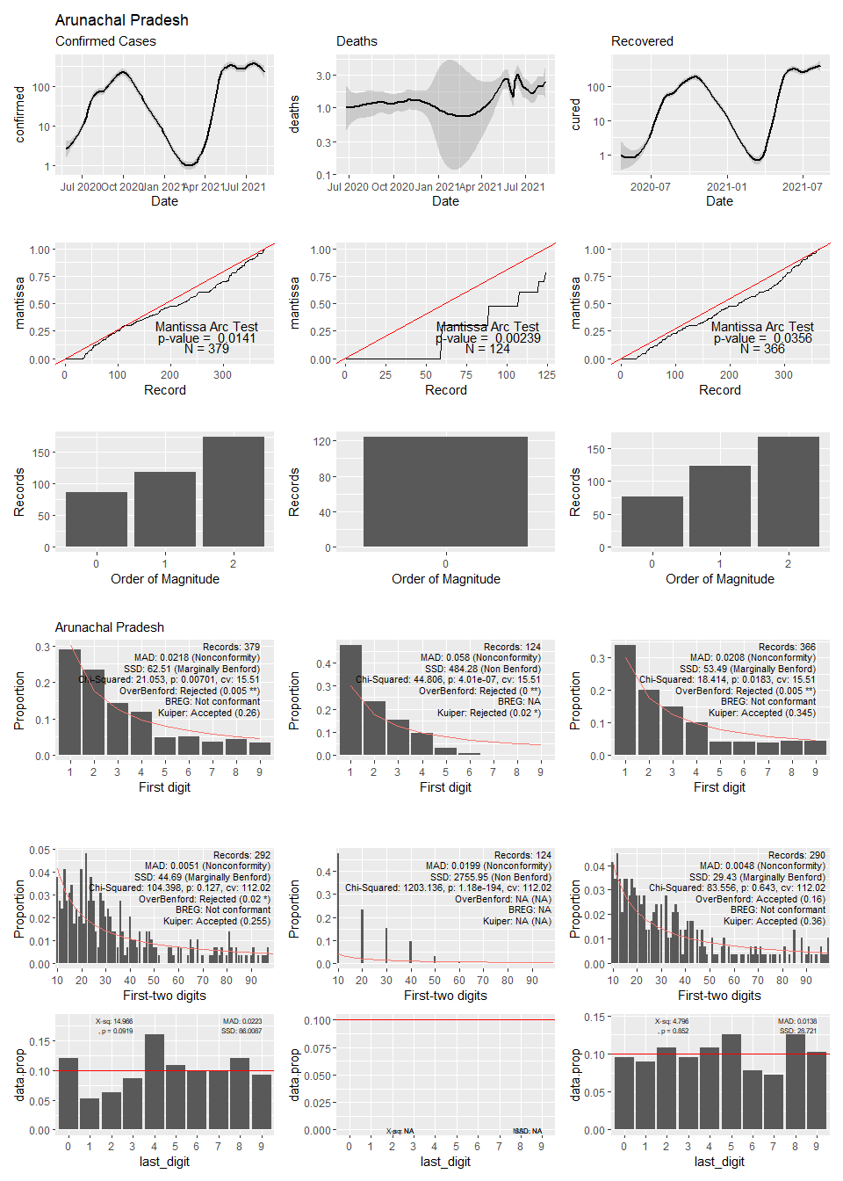

## Warning in self$trans$transform(x): NaNs produced

## Warning: Transformation introduced infinite values in continuous y-axis

## Warning: Removed 27 rows containing non-finite values (stat_smooth).

## Warning: Transformation introduced infinite values in continuous y-axis

## Warning: Removed 154 rows containing non-finite values (stat_smooth).

## Warning: Transformation introduced infinite values in continuous y-axis

## Warning: Removed 46 rows containing non-finite values (stat_smooth).

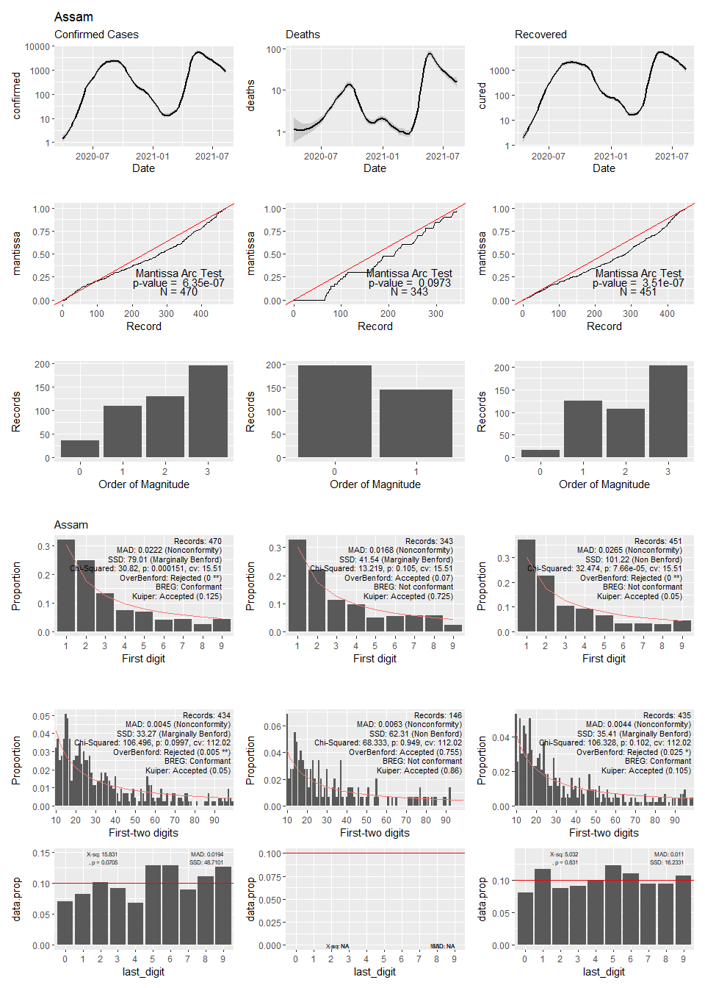

## Warning in self$trans$transform(x): NaNs produced

## Warning: Transformation introduced infinite values in continuous y-axis

## Warning: Removed 9 rows containing non-finite values (stat_smooth).

## Warning: Transformation introduced infinite values in continuous y-axis

## Warning: Removed 93 rows containing non-finite values (stat_smooth).

## Warning: Transformation introduced infinite values in continuous y-axis

## Warning: Removed 32 rows containing non-finite values (stat_smooth).

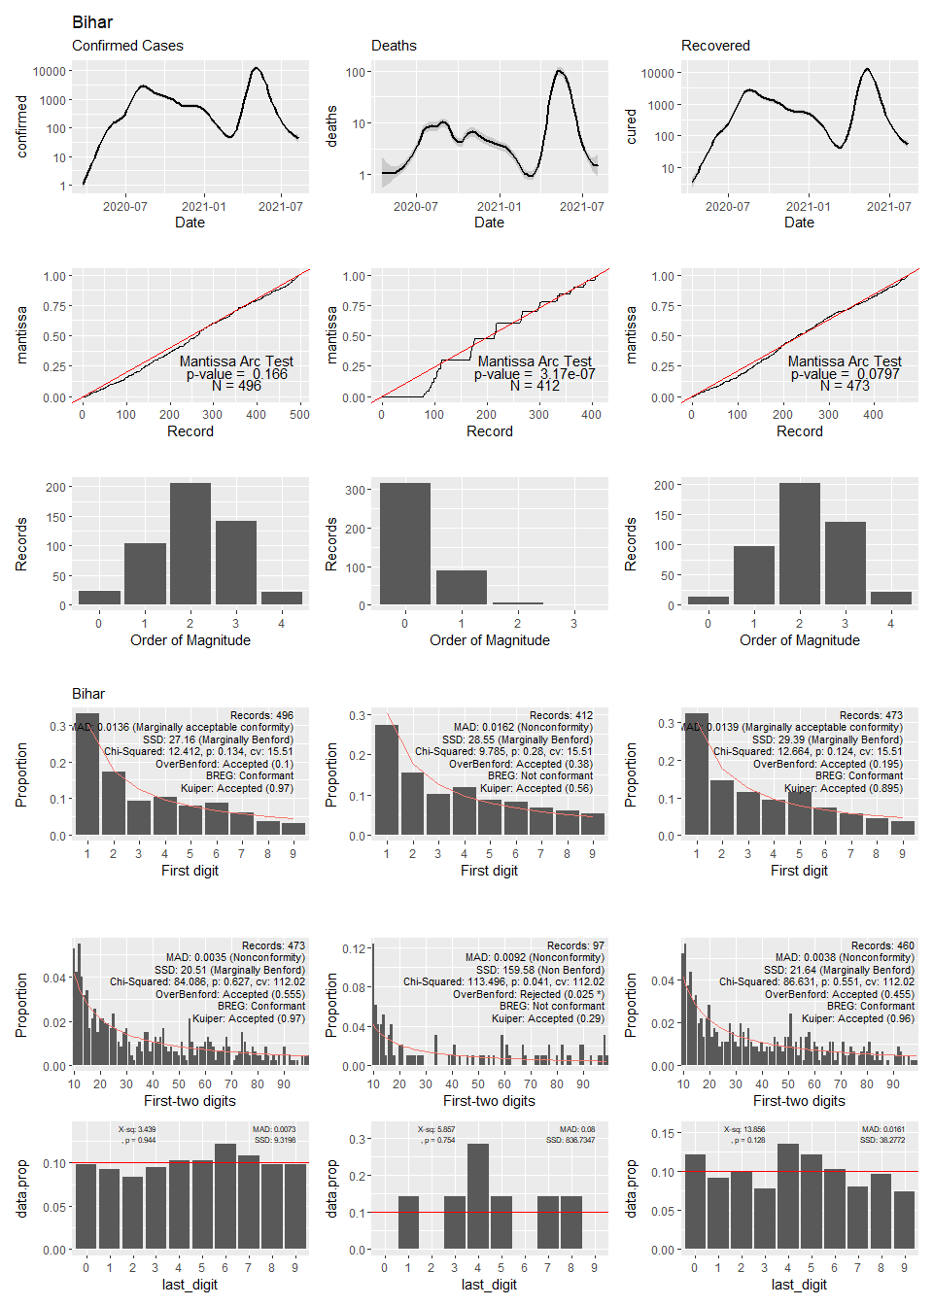

## Warning: Transformation introduced infinite values in continuous y-axis

## Warning: Removed 40 rows containing non-finite values (stat_smooth).

## Warning: Transformation introduced infinite values in continuous y-axis

## Warning: Removed 231 rows containing non-finite values (stat_smooth).

## Warning: Transformation introduced infinite values in continuous y-axis

## Warning: Removed 70 rows containing non-finite values (stat_smooth).

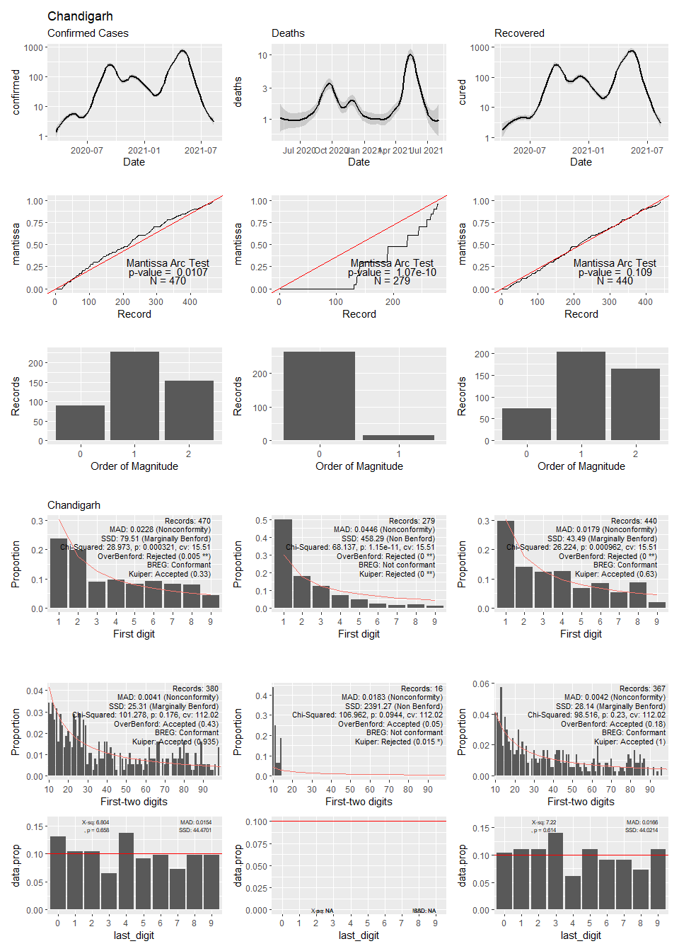

## Warning: Transformation introduced infinite values in continuous y-axis

## Warning: Removed 41 rows containing non-finite values (stat_smooth).

## Warning: Transformation introduced infinite values in continuous y-axis

## Warning: Removed 110 rows containing non-finite values (stat_smooth).

## Warning: Transformation introduced infinite values in continuous y-axis

## Warning: Removed 44 rows containing non-finite values (stat_smooth).

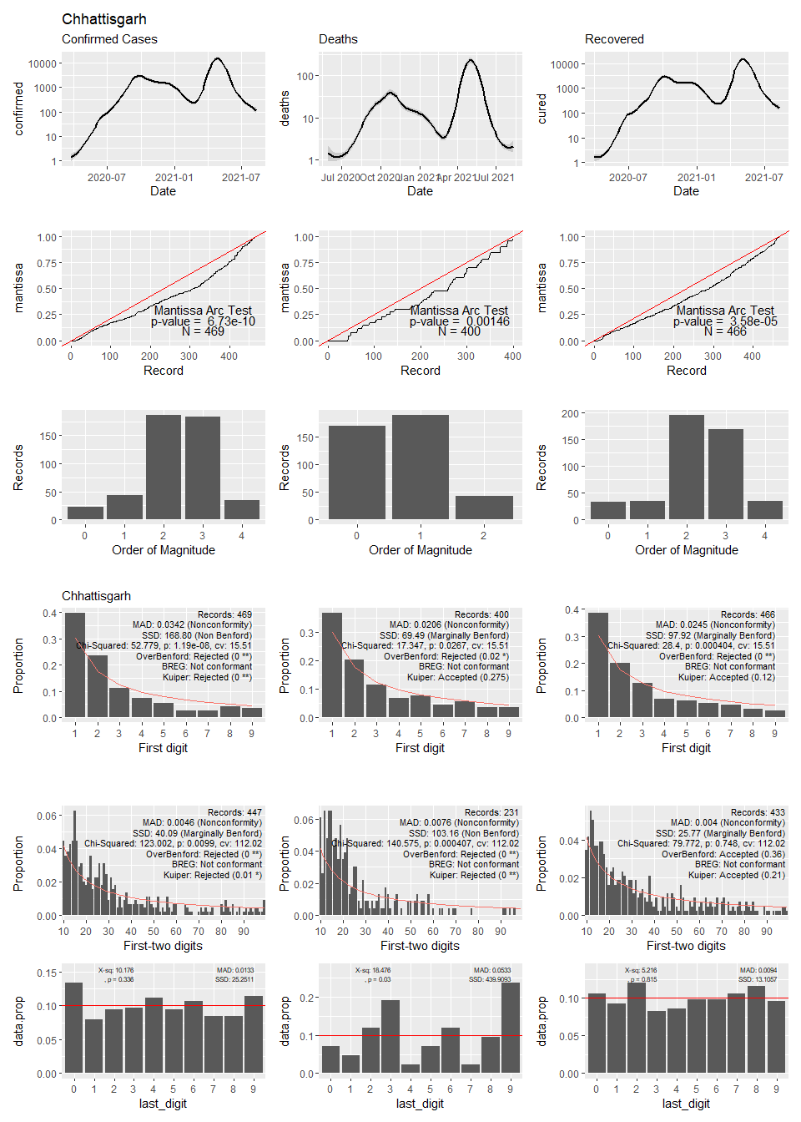

## Warning: Transformation introduced infinite values in continuous y-axis

## Warning: Removed 102 rows containing non-finite values (stat_smooth).

## Warning: Transformation introduced infinite values in continuous y-axis

## Warning: Removed 457 rows containing non-finite values (stat_smooth).

## Warning: Computation failed in `stat_smooth()`:  
## span is too small

## Warning: Transformation introduced infinite values in continuous y-axis

## Warning: Removed 108 rows containing non-finite values (stat_smooth).

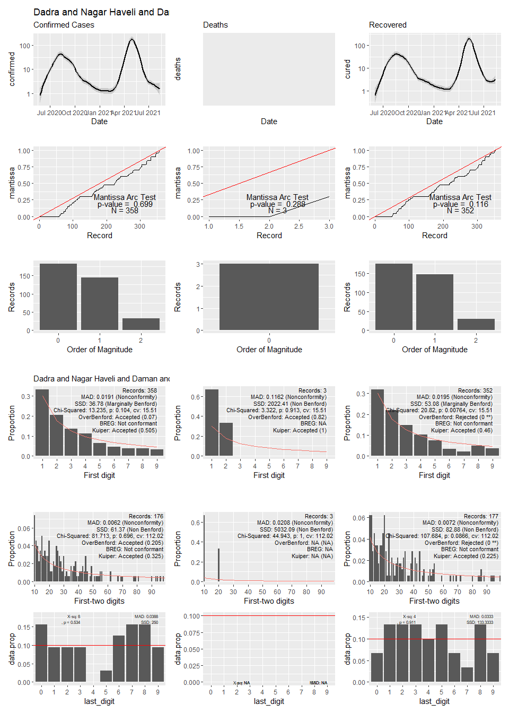

## Warning in self$trans$transform(x): NaNs produced

## Warning: Transformation introduced infinite values in continuous y-axis

## Warning: Removed 16 rows containing non-finite values (stat_smooth).

## Warning: Transformation introduced infinite values in continuous y-axis

## Warning: Removed 55 rows containing non-finite values (stat_smooth).

## Warning: Transformation introduced infinite values in continuous y-axis

## Warning: Removed 38 rows containing non-finite values (stat_smooth).

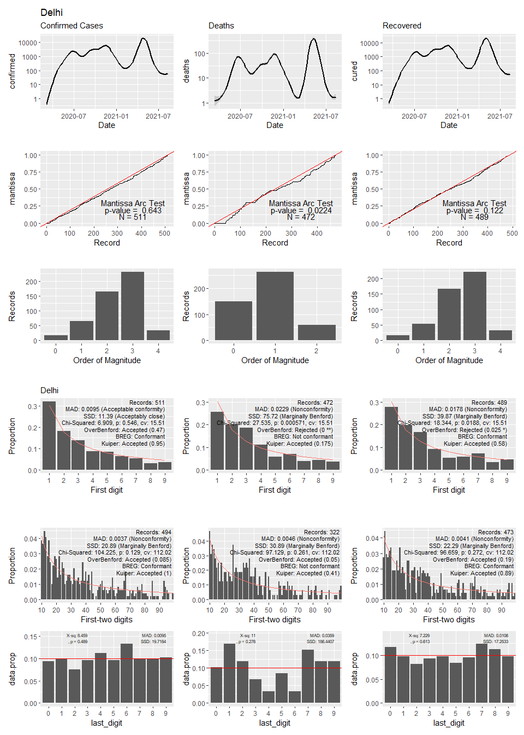

## Warning: Transformation introduced infinite values in continuous y-axis

## Warning: Removed 54 rows containing non-finite values (stat_smooth).

## Warning: Transformation introduced infinite values in continuous y-axis

## Warning: Removed 154 rows containing non-finite values (stat_smooth).

## Warning: Transformation introduced infinite values in continuous y-axis

## Warning: Removed 69 rows containing non-finite values (stat_smooth).

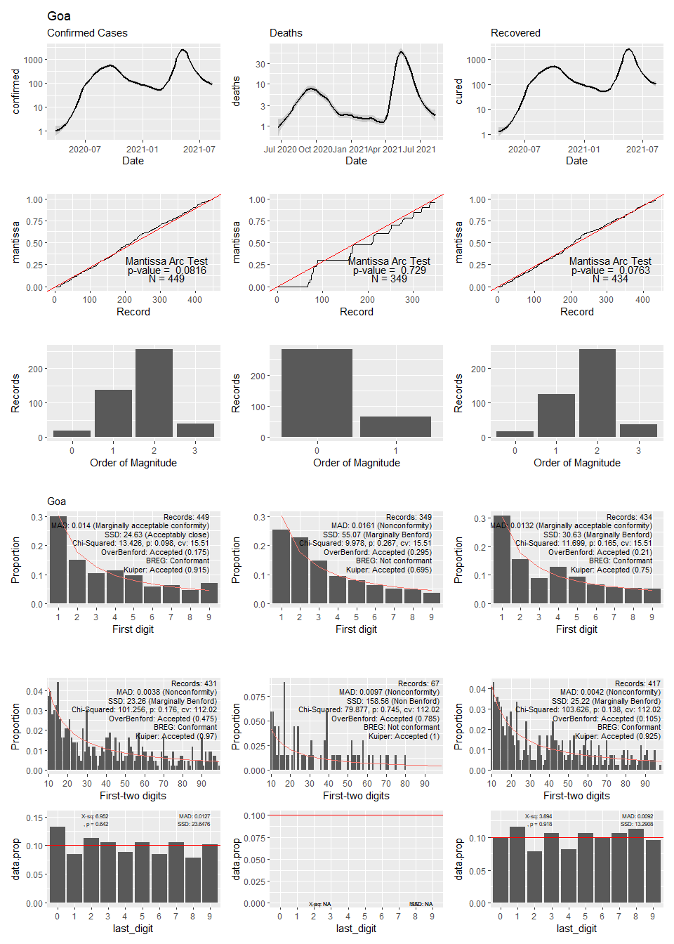

## Warning: Transformation introduced infinite values in continuous y-axis

## Warning: Removed 3 rows containing non-finite values (stat_smooth).

## Warning: Transformation introduced infinite values in continuous y-axis

## Warning: Removed 52 rows containing non-finite values (stat_smooth).

## Warning: Transformation introduced infinite values in continuous y-axis

## Warning: Removed 12 rows containing non-finite values (stat_smooth).

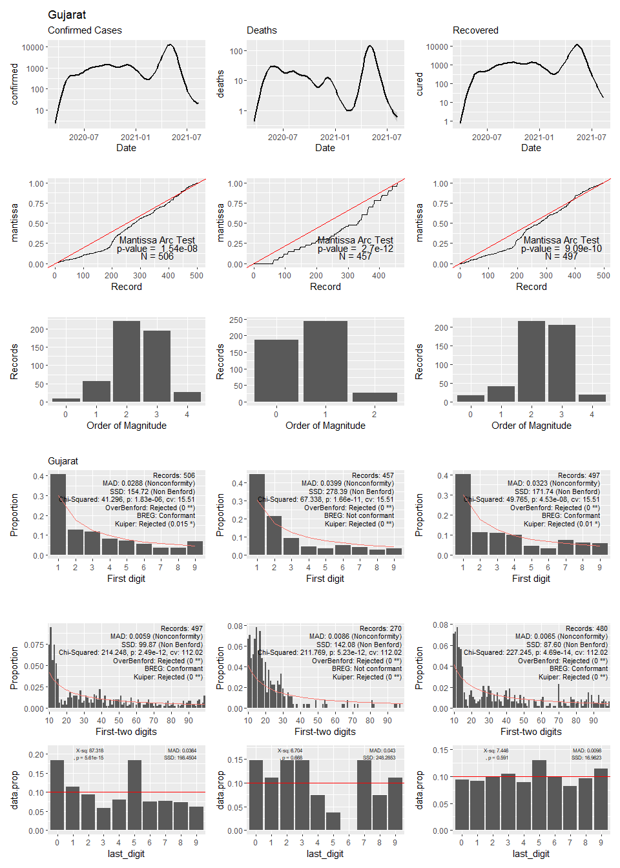

## Warning: Transformation introduced infinite values in continuous y-axis

## Warning: Removed 31 rows containing non-finite values (stat_smooth).

## Warning: Transformation introduced infinite values in continuous y-axis

## Warning: Removed 93 rows containing non-finite values (stat_smooth).

## Warning: Transformation introduced infinite values in continuous y-axis

## Warning: Removed 50 rows containing non-finite values (stat_smooth).

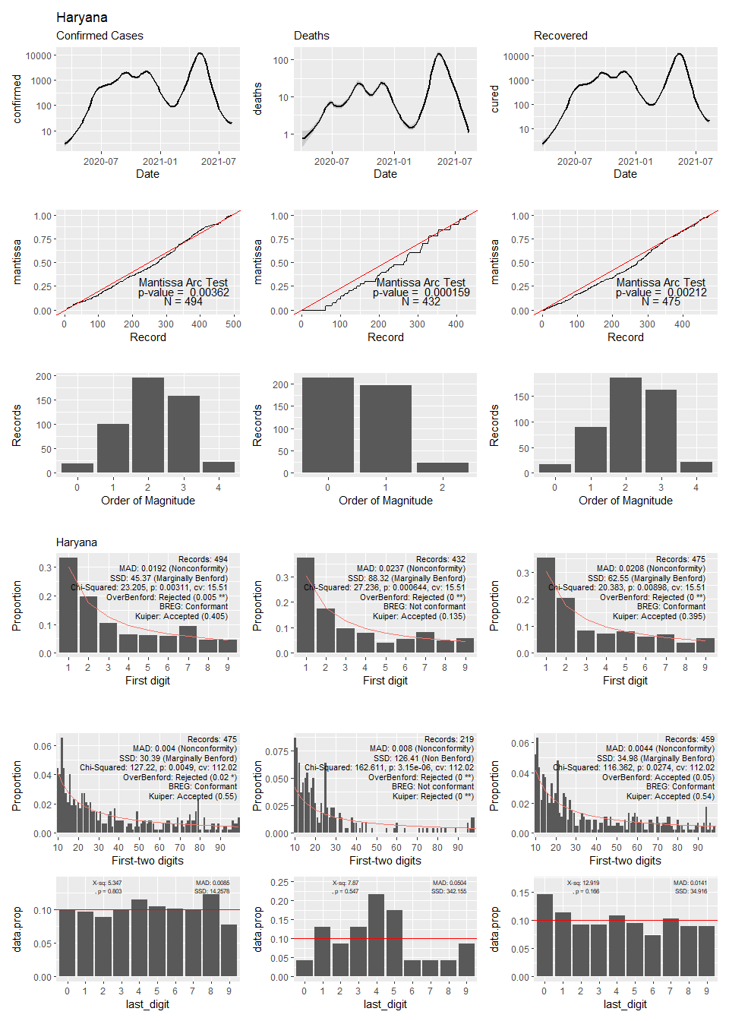

## Warning in self$trans$transform(x): NaNs produced

## Warning: Transformation introduced infinite values in continuous y-axis

## Warning: Removed 36 rows containing non-finite values (stat_smooth).

## Warning: Transformation introduced infinite values in continuous y-axis

## Warning: Removed 182 rows containing non-finite values (stat_smooth).

## Warning: Transformation introduced infinite values in continuous y-axis

## Warning: Removed 48 rows containing non-finite values (stat_smooth).

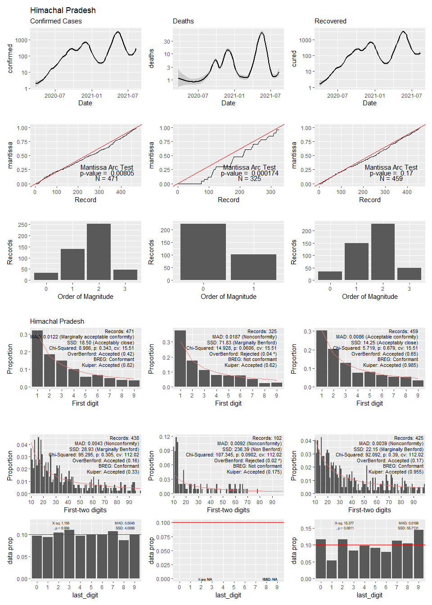

## Warning: Transformation introduced infinite values in continuous y-axis

## Warning: Removed 17 rows containing non-finite values (stat_smooth).

## Warning: Transformation introduced infinite values in continuous y-axis

## Warning: Removed 101 rows containing non-finite values (stat_smooth).

## Warning: Transformation introduced infinite values in continuous y-axis

## Warning: Removed 33 rows containing non-finite values (stat_smooth).

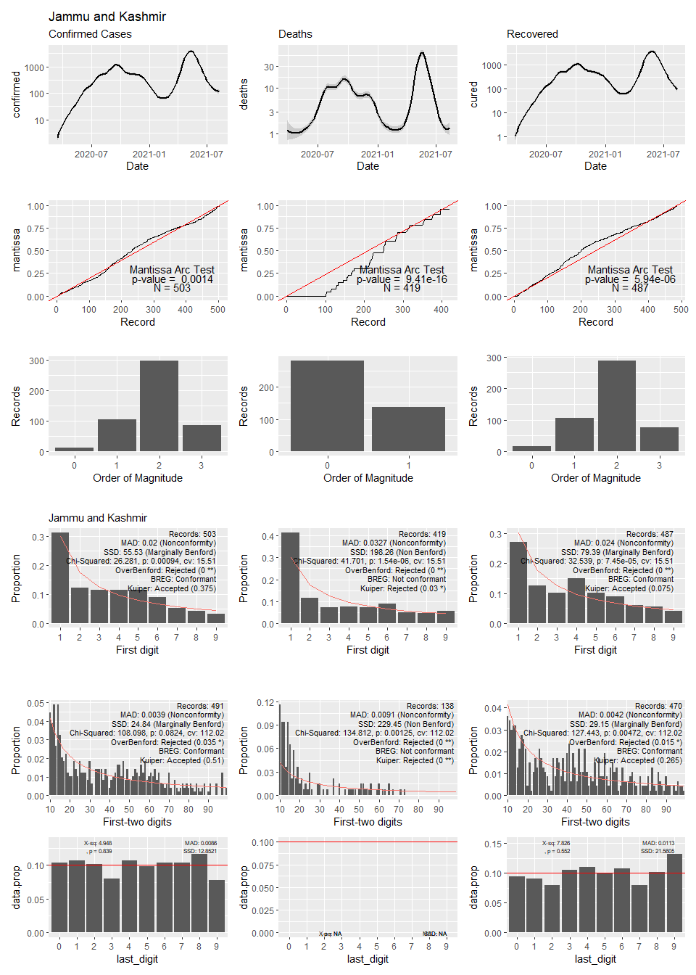

## Warning in self$trans$transform(x): NaNs produced

## Warning: Transformation introduced infinite values in continuous y-axis

## Warning: Removed 15 rows containing non-finite values (stat_smooth).

## Warning: Transformation introduced infinite values in continuous y-axis

## Warning: Removed 169 rows containing non-finite values (stat_smooth).

## Warning: Transformation introduced infinite values in continuous y-axis

## Warning: Removed 37 rows containing non-finite values (stat_smooth).

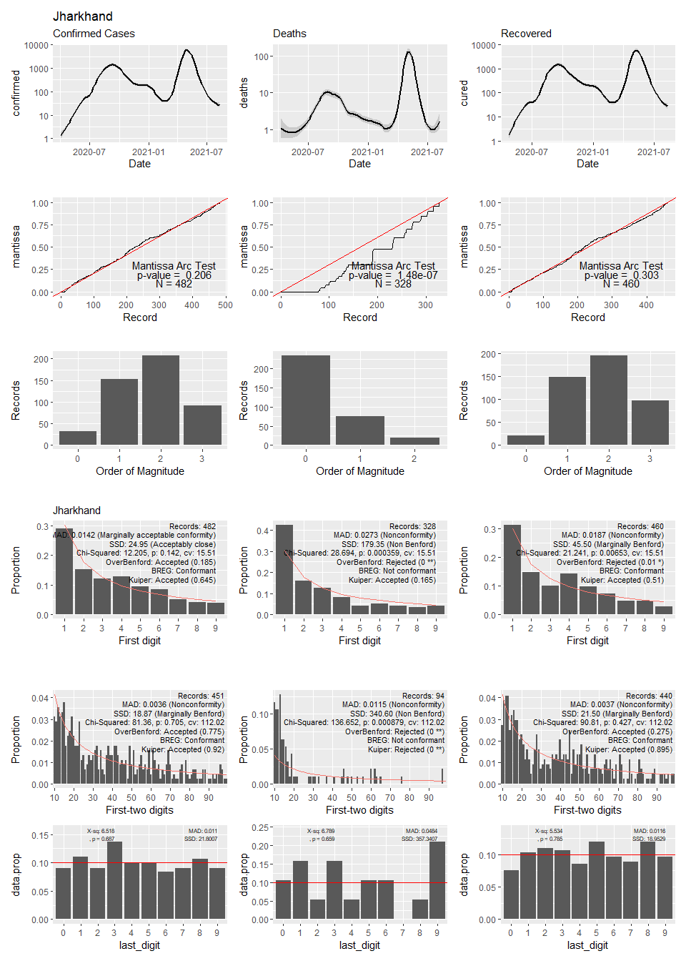

## Warning in self$trans$transform(x): NaNs produced

## Warning: Transformation introduced infinite values in continuous y-axis

## Warning: Removed 13 rows containing non-finite values (stat_smooth).

## Warning: Transformation introduced infinite values in continuous y-axis

## Warning: Removed 54 rows containing non-finite values (stat_smooth).

## Warning: Transformation introduced infinite values in continuous y-axis

## Warning: Removed 24 rows containing non-finite values (stat_smooth).

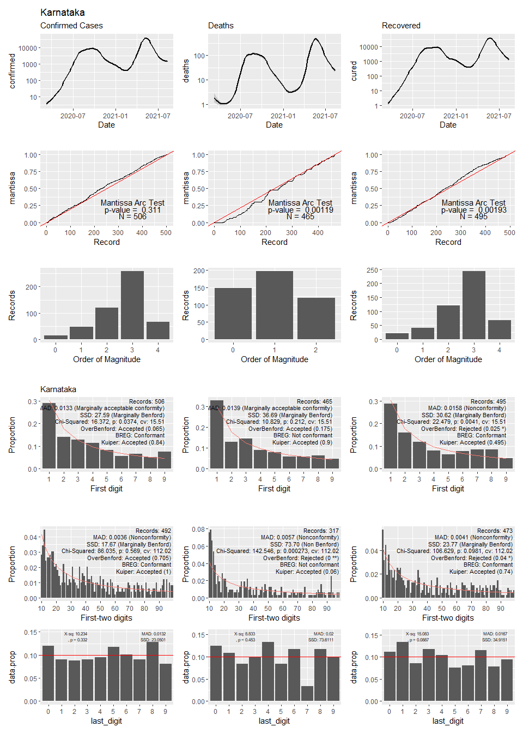

## Warning: Transformation introduced infinite values in continuous y-axis

## Warning: Removed 45 rows containing non-finite values (stat_smooth).

## Warning: Transformation introduced infinite values in continuous y-axis

## Warning: Removed 142 rows containing non-finite values (stat_smooth).

## Warning: Transformation introduced infinite values in continuous y-axis

## Warning: Removed 63 rows containing non-finite values (stat_smooth).

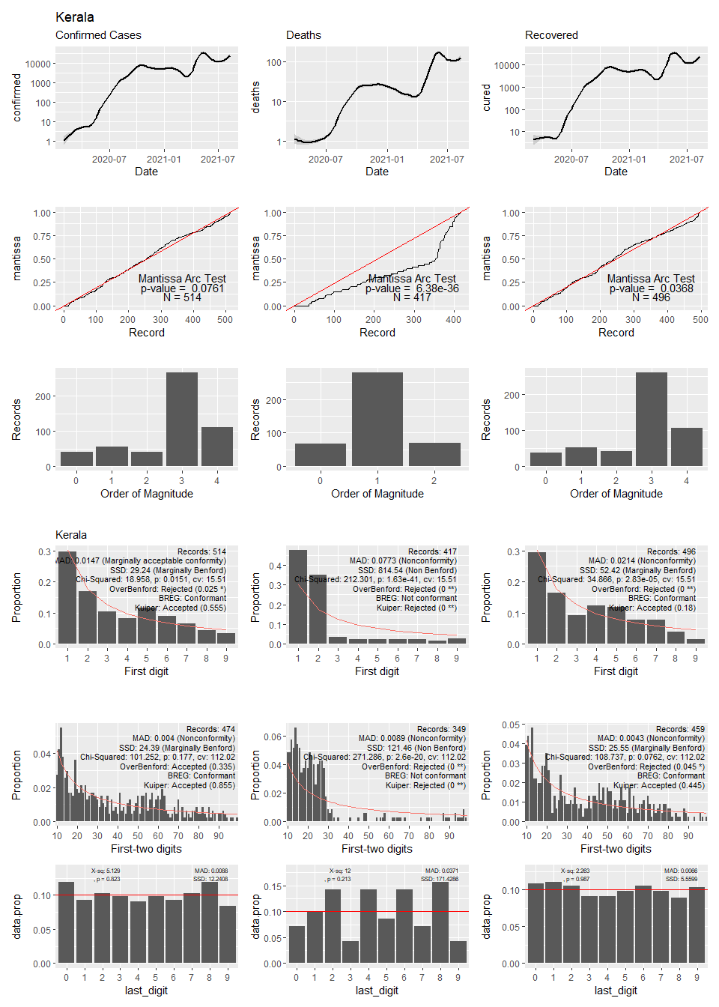

## Warning: Transformation introduced infinite values in continuous y-axis

## Warning: Removed 84 rows containing non-finite values (stat_smooth).

## Warning: Transformation introduced infinite values in continuous y-axis

## Warning: Removed 394 rows containing non-finite values (stat_smooth).

## Warning: Transformation introduced infinite values in continuous y-axis

## Warning: Removed 94 rows containing non-finite values (stat_smooth).

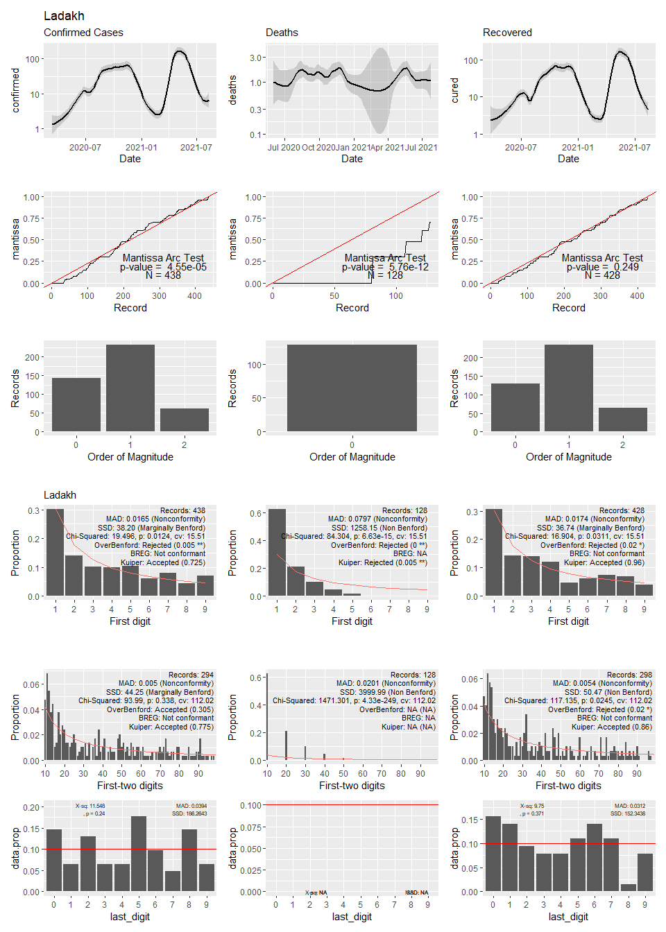

## Warning: Transformation introduced infinite values in continuous y-axis

## Warning: Removed 46 rows containing non-finite values (stat_smooth).

## Warning: Transformation introduced infinite values in continuous y-axis

## Warning: Removed 208 rows containing non-finite values (stat_smooth).

## Warning: Transformation introduced infinite values in continuous y-axis

## Warning: Removed 61 rows containing non-finite values (stat_smooth).

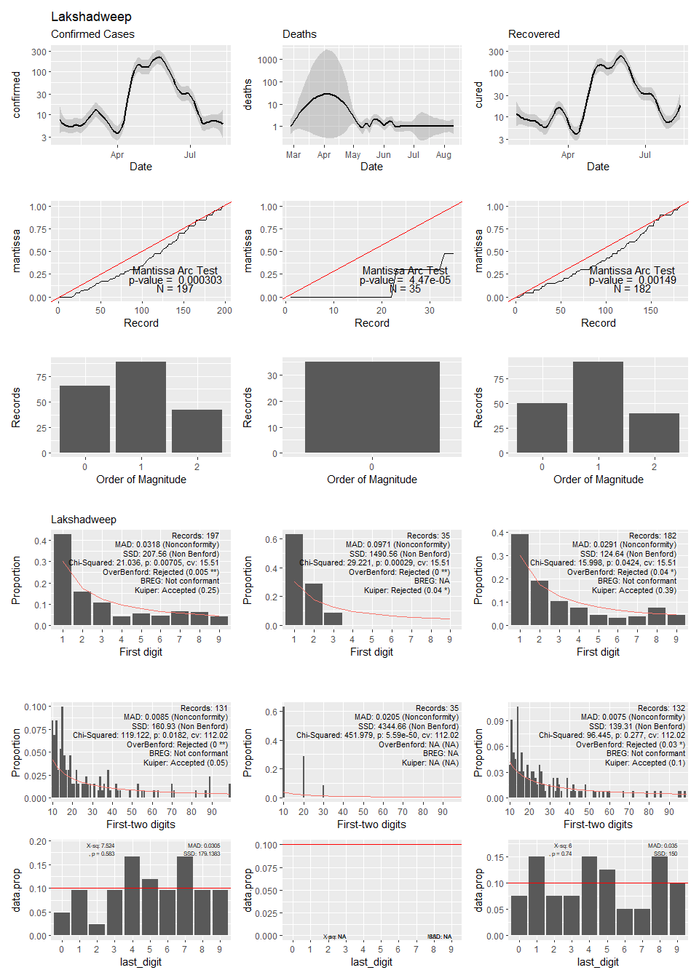

## Warning in self$trans$transform(x): NaNs produced

## Warning: Transformation introduced infinite values in continuous y-axis

## Warning: Removed 13 rows containing non-finite values (stat_smooth).

## Warning: Transformation introduced infinite values in continuous y-axis

## Warning: Removed 48 rows containing non-finite values (stat_smooth).

## Warning: Transformation introduced infinite values in continuous y-axis

## Warning: Removed 32 rows containing non-finite values (stat_smooth).

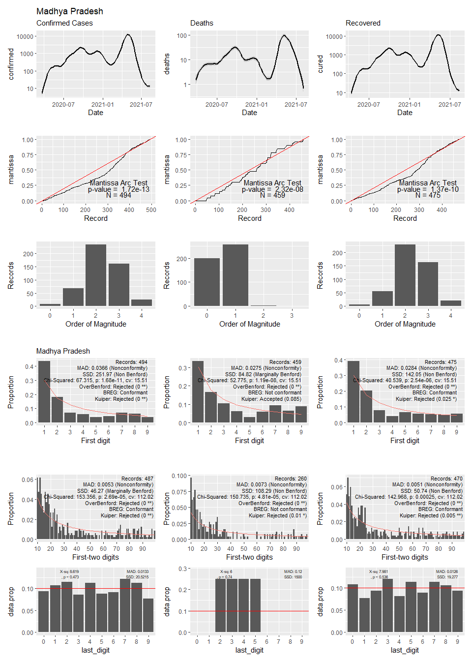

## Warning in self$trans$transform(x): NaNs produced

## Warning: Transformation introduced infinite values in continuous y-axis

## Warning: Removed 9 rows containing non-finite values (stat_smooth).

## Warning: Transformation introduced infinite values in continuous y-axis

## Warning: Removed 17 rows containing non-finite values (stat_smooth).

## Warning: Transformation introduced infinite values in continuous y-axis

## Warning: Removed 24 rows containing non-finite values (stat_smooth).

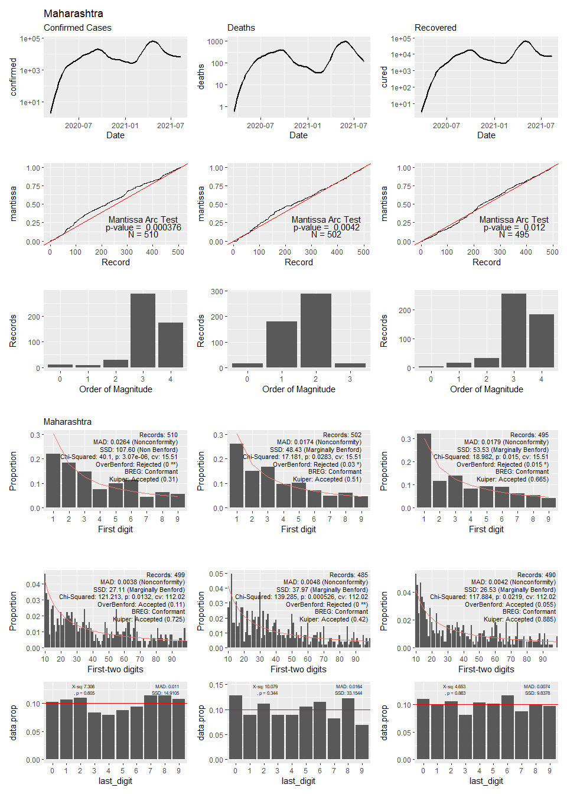

## Warning: Transformation introduced infinite values in continuous y-axis

## Warning: Removed 58 rows containing non-finite values (stat_smooth).

## Warning: Transformation introduced infinite values in continuous y-axis

## Warning: Removed 249 rows containing non-finite values (stat_smooth).

## Warning: Transformation introduced infinite values in continuous y-axis

## Warning: Removed 74 rows containing non-finite values (stat_smooth).

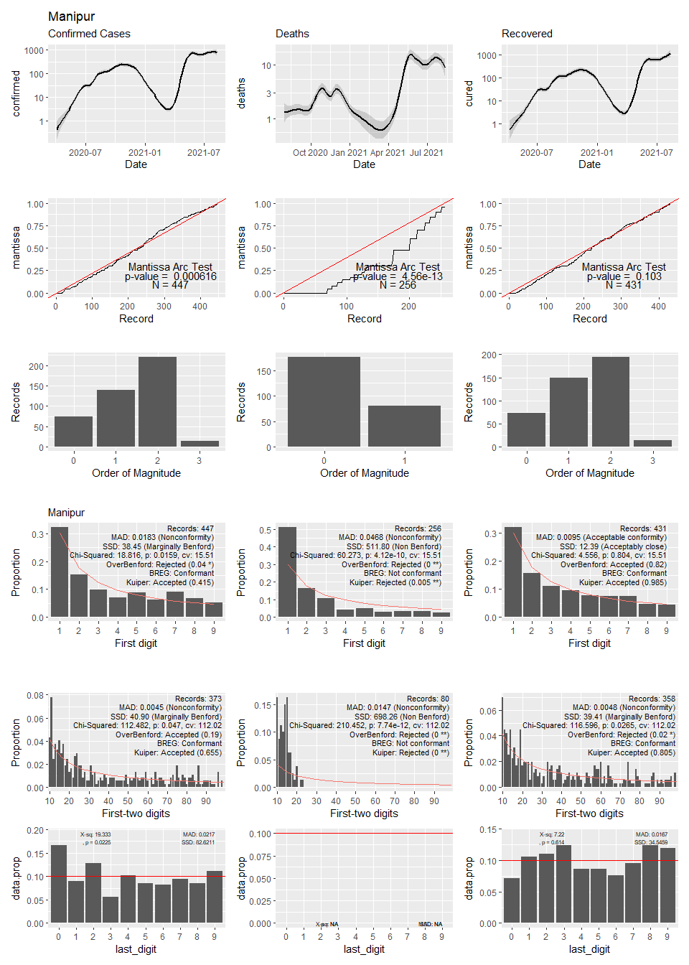

## Warning in self$trans$transform(x): NaNs produced

## Warning: Transformation introduced infinite values in continuous y-axis

## Warning: Removed 79 rows containing non-finite values (stat_smooth).

## Warning: Transformation introduced infinite values in continuous y-axis

## Warning: Removed 277 rows containing non-finite values (stat_smooth).

## Warning: Transformation introduced infinite values in continuous y-axis

## Warning: Removed 91 rows containing non-finite values (stat_smooth).

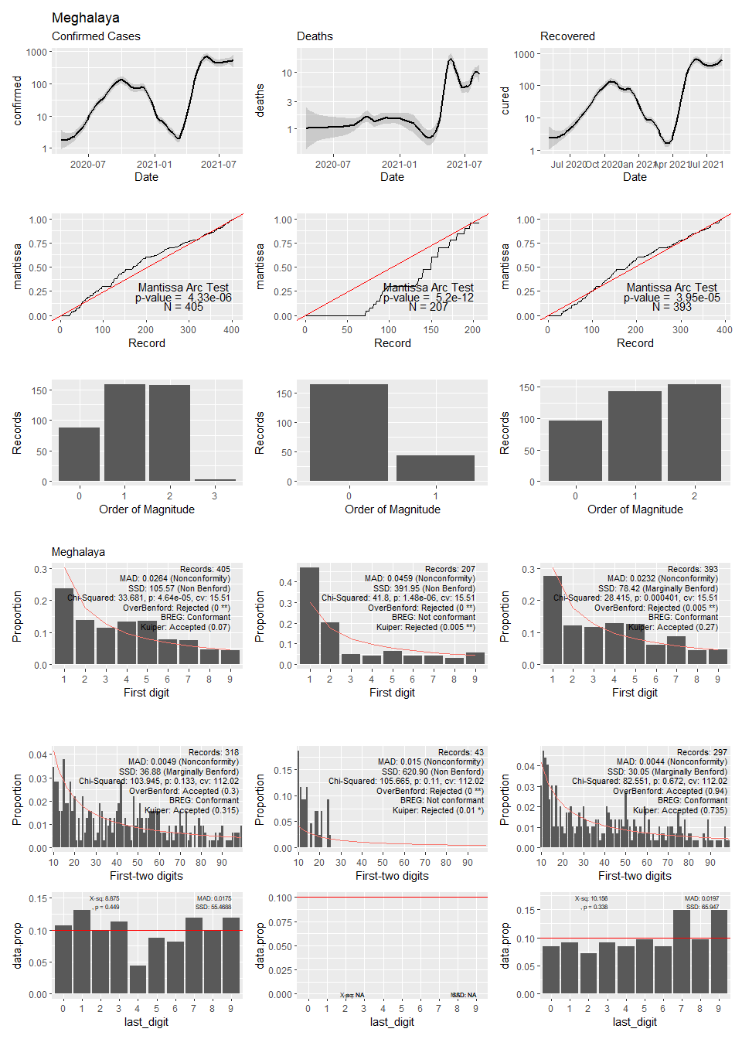

## Warning: Transformation introduced infinite values in continuous y-axis

## Warning: Removed 119 rows containing non-finite values (stat_smooth).

## Warning: Transformation introduced infinite values in continuous y-axis

## Warning: Removed 412 rows containing non-finite values (stat_smooth).

## Warning: Transformation introduced infinite values in continuous y-axis

## Warning: Removed 128 rows containing non-finite values (stat_smooth).

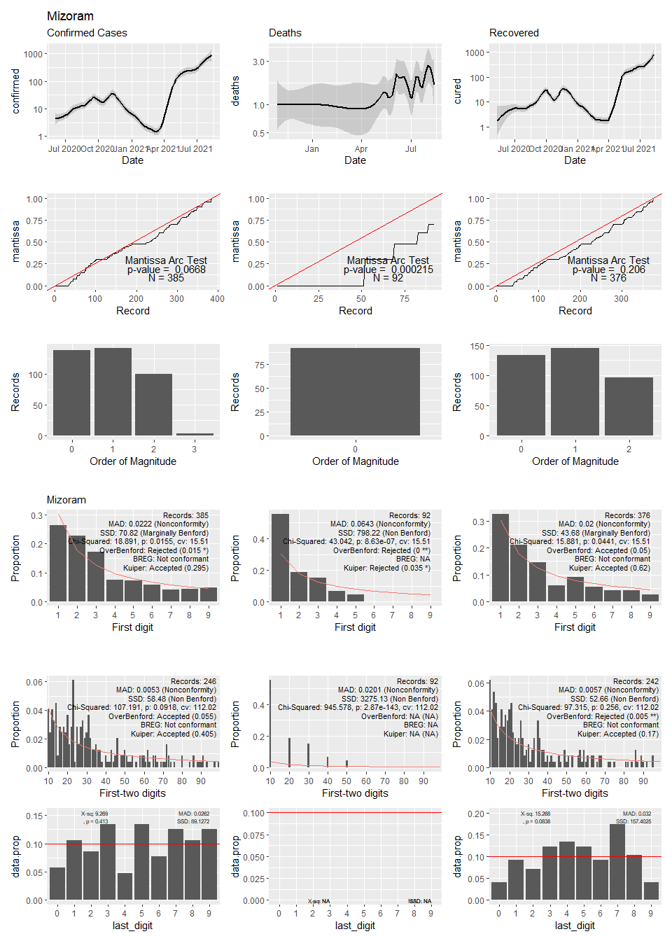

## Warning in self$trans$transform(x): NaNs produced

## Warning: Transformation introduced infinite values in continuous y-axis

## Warning: Removed 46 rows containing non-finite values (stat_smooth).

## Warning: Transformation introduced infinite values in continuous y-axis

## Warning: Removed 299 rows containing non-finite values (stat_smooth).

## Warning: Transformation introduced infinite values in continuous y-axis

## Warning: Removed 66 rows containing non-finite values (stat_smooth).

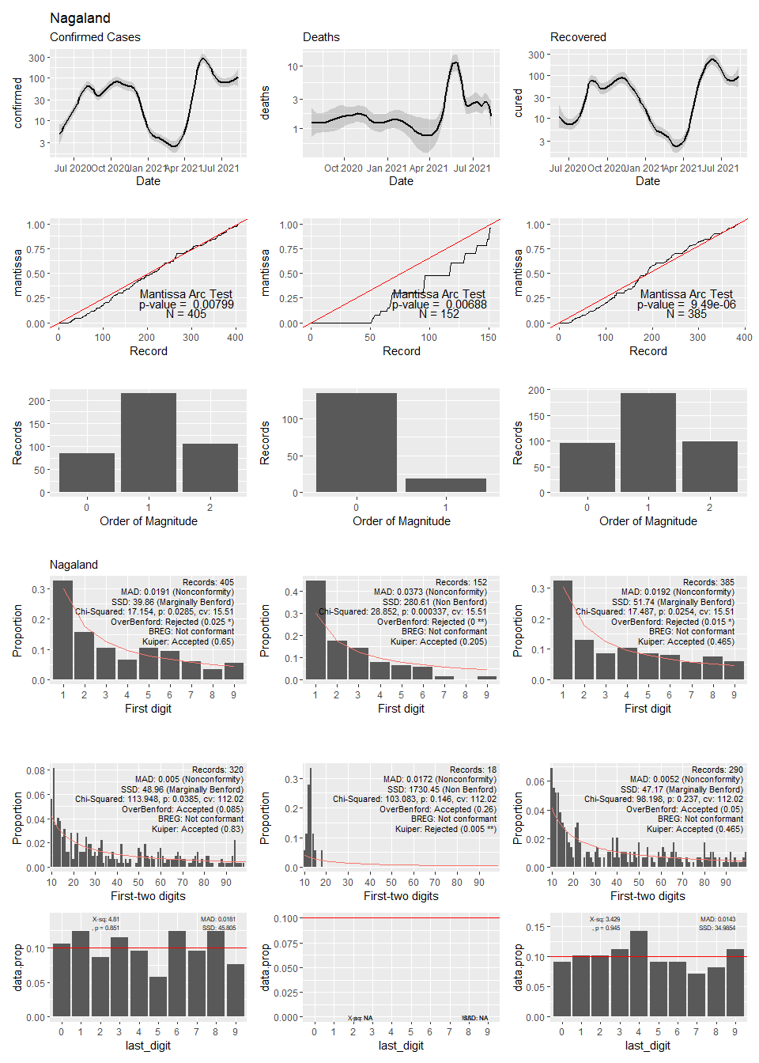

## Warning: Transformation introduced infinite values in continuous y-axis

## Warning: Removed 22 rows containing non-finite values (stat_smooth).

## Warning: Transformation introduced infinite values in continuous y-axis

## Warning: Removed 150 rows containing non-finite values (stat_smooth).

## Warning: Transformation introduced infinite values in continuous y-axis

## Warning: Removed 40 rows containing non-finite values (stat_smooth).

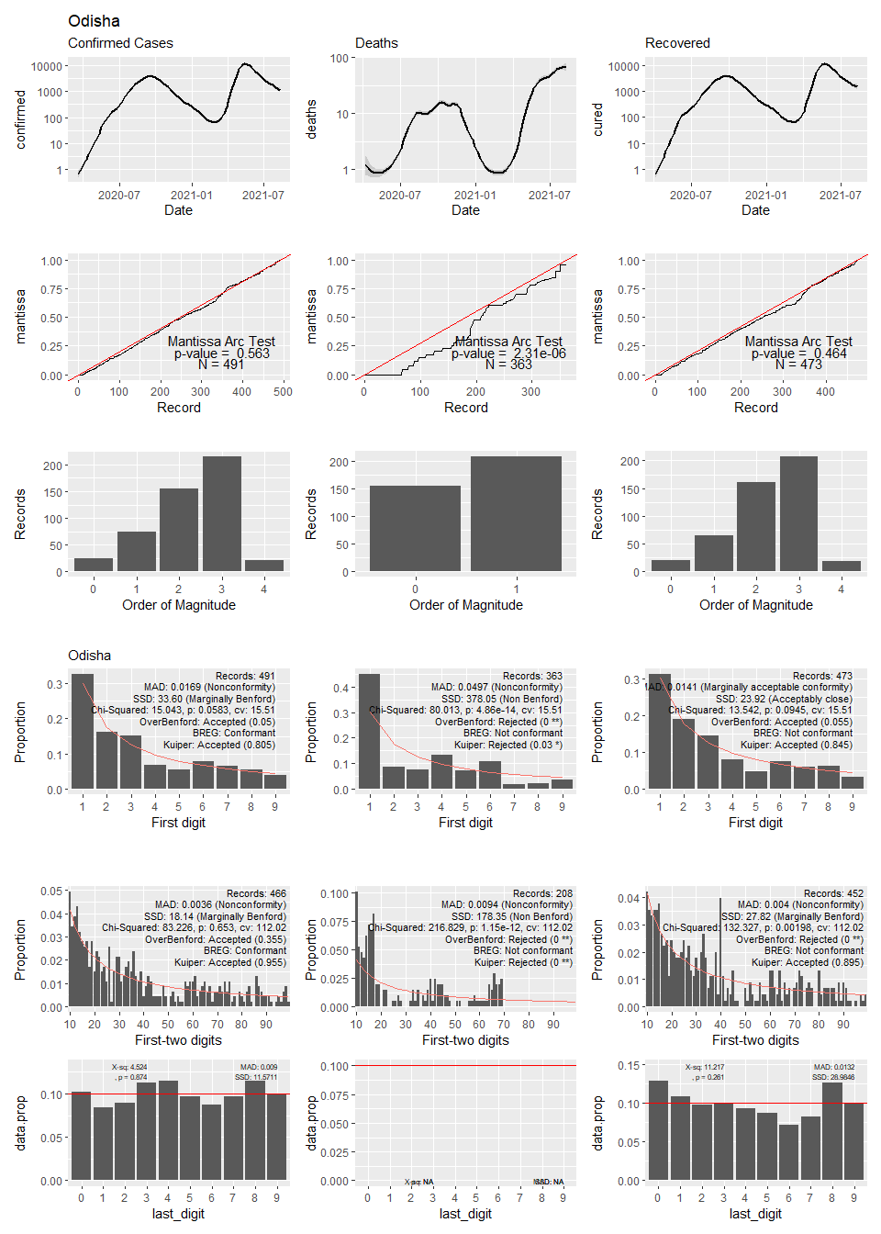

## Warning: Transformation introduced infinite values in continuous y-axis

## Warning: Removed 78 rows containing non-finite values (stat_smooth).

## Warning in self$trans$transform(x): NaNs produced

## Warning: Transformation introduced infinite values in continuous y-axis

## Warning: Removed 216 rows containing non-finite values (stat_smooth).

## Warning: Transformation introduced infinite values in continuous y-axis

## Warning: Removed 96 rows containing non-finite values (stat_smooth).

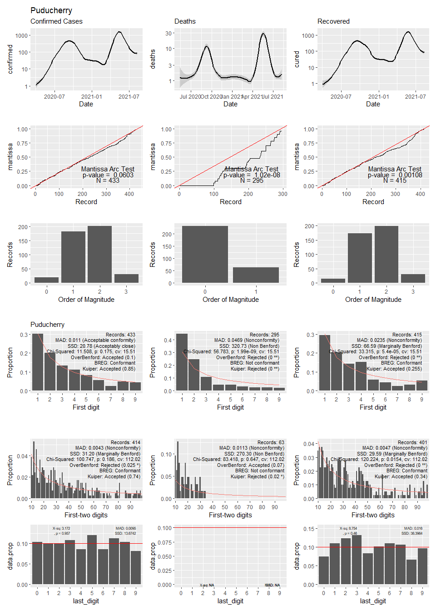

## Warning in self$trans$transform(x): NaNs produced

## Warning: Transformation introduced infinite values in continuous y-axis

## Warning: Removed 31 rows containing non-finite values (stat_smooth).

## Warning: Transformation introduced infinite values in continuous y-axis

## Warning: Removed 62 rows containing non-finite values (stat_smooth).

## Warning: Transformation introduced infinite values in continuous y-axis

## Warning: Removed 47 rows containing non-finite values (stat_smooth).

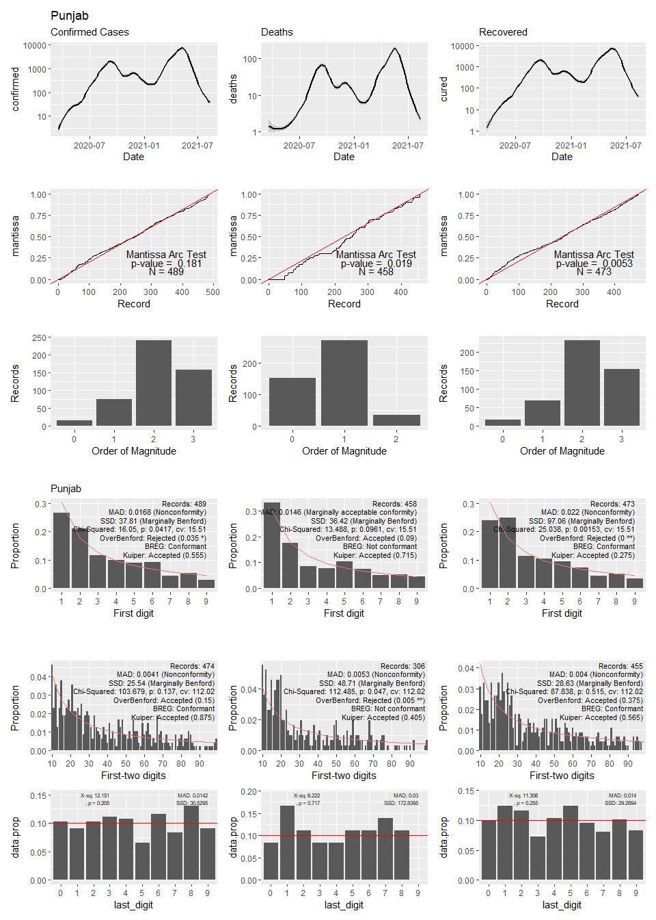

## Warning in self$trans$transform(x): NaNs produced

## Warning: Transformation introduced infinite values in continuous y-axis

## Warning: Removed 18 rows containing non-finite values (stat_smooth).

## Warning: Transformation introduced infinite values in continuous y-axis

## Warning: Removed 117 rows containing non-finite values (stat_smooth).

## Warning: Transformation introduced infinite values in continuous y-axis

## Warning: Removed 47 rows containing non-finite values (stat_smooth).

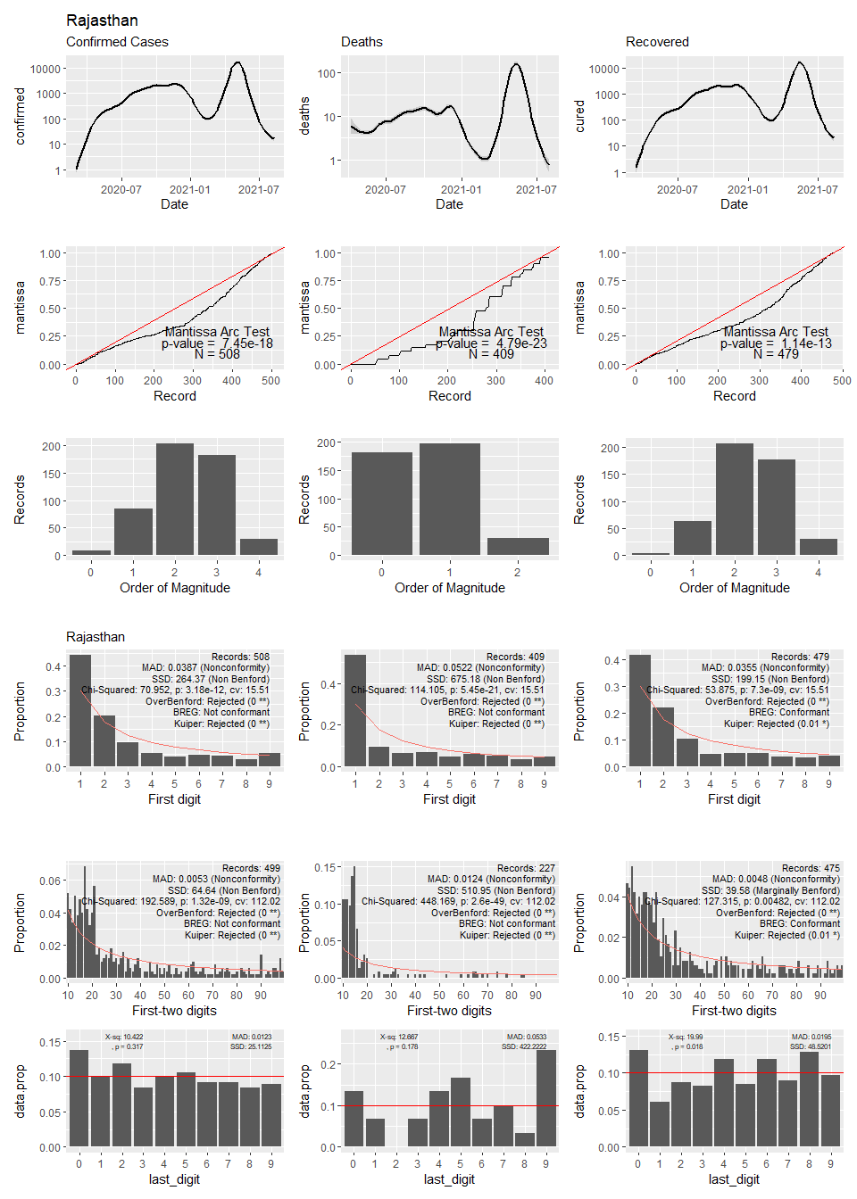

## Warning: Transformation introduced infinite values in continuous y-axis

## Warning: Removed 42 rows containing non-finite values (stat_smooth).

## Warning: Transformation introduced infinite values in continuous y-axis

## Warning: Removed 267 rows containing non-finite values (stat_smooth).

## Warning: Transformation introduced infinite values in continuous y-axis

## Warning: Removed 45 rows containing non-finite values (stat_smooth).

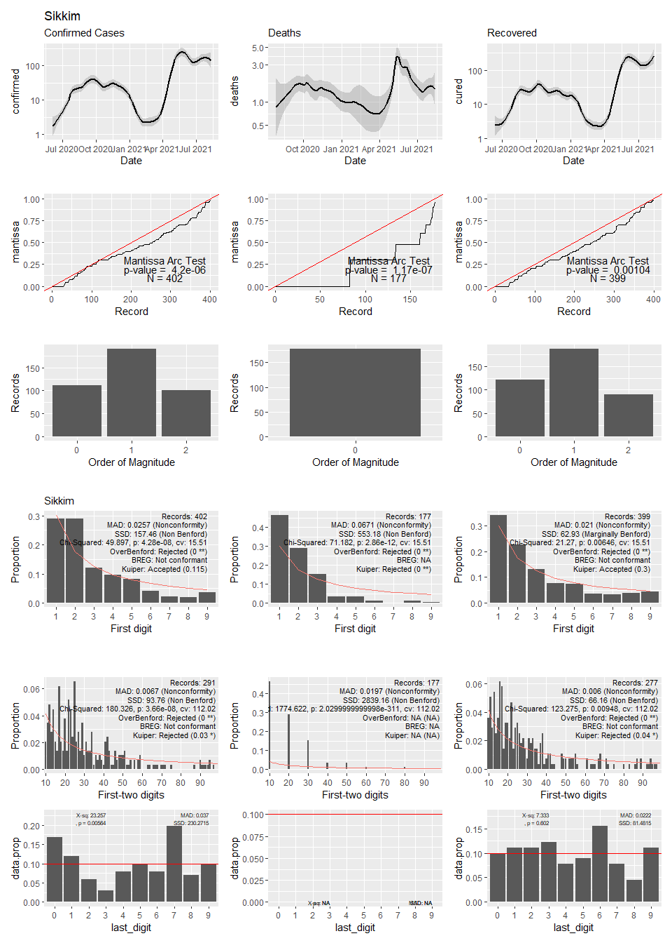

## Warning: Transformation introduced infinite values in continuous y-axis

## Warning: Removed 14 rows containing non-finite values (stat_smooth).

## Warning: Transformation introduced infinite values in continuous y-axis

## Warning: Removed 37 rows containing non-finite values (stat_smooth).

## Warning: Transformation introduced infinite values in continuous y-axis

## Warning: Removed 29 rows containing non-finite values (stat_smooth).

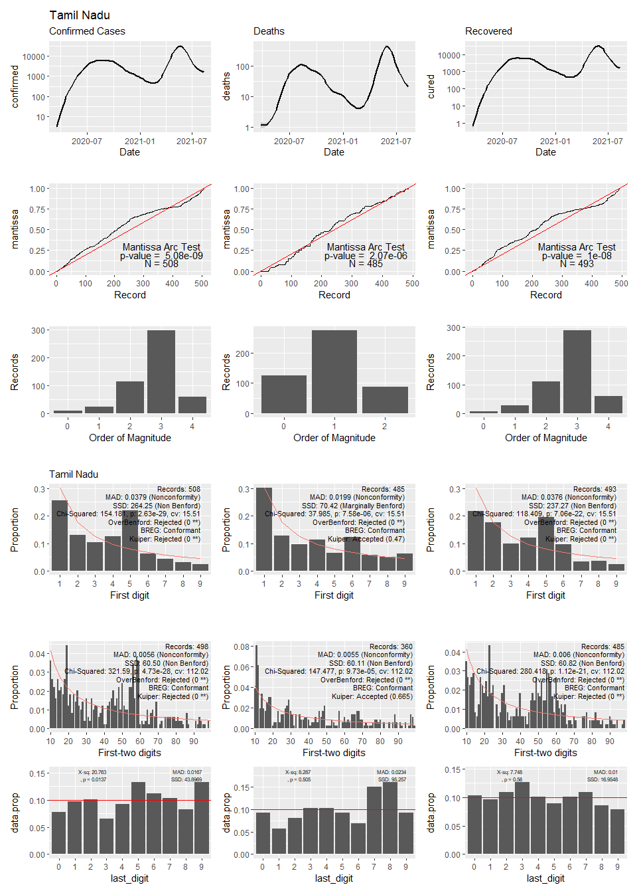

## Warning in self$trans$transform(x): NaNs produced

## Warning: Transformation introduced infinite values in continuous y-axis

## Warning: Removed 23 rows containing non-finite values (stat_smooth).

## Warning: Transformation introduced infinite values in continuous y-axis

## Warning: Removed 71 rows containing non-finite values (stat_smooth).

## Warning: Transformation introduced infinite values in continuous y-axis

## Warning: Removed 53 rows containing non-finite values (stat_smooth).

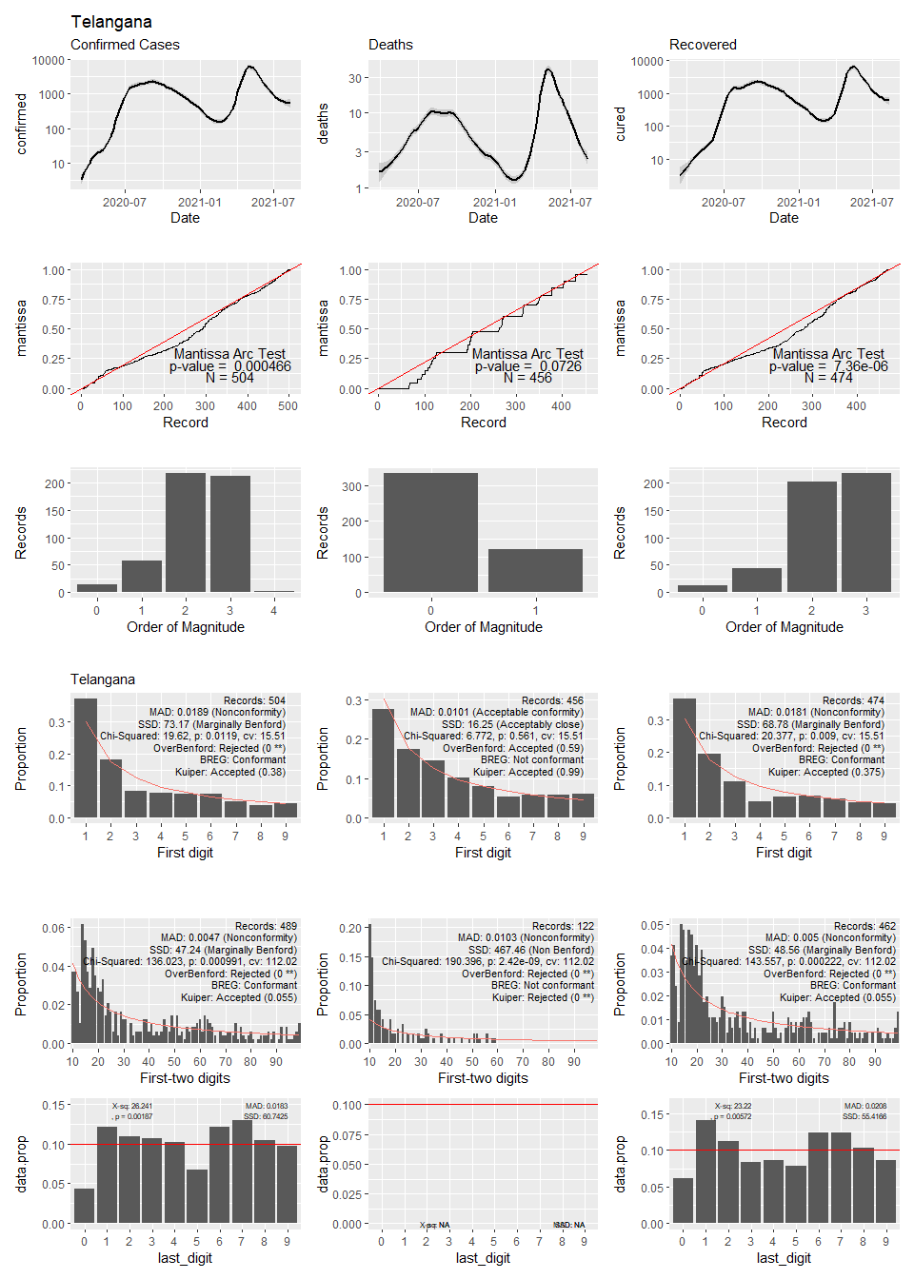

## Warning: Transformation introduced infinite values in continuous y-axis

## Warning: Removed 62 rows containing non-finite values (stat_smooth).

## Warning: Transformation introduced infinite values in continuous y-axis

## Warning: Removed 266 rows containing non-finite values (stat_smooth).

## Warning: Transformation introduced infinite values in continuous y-axis

## Warning: Removed 79 rows containing non-finite values (stat_smooth).

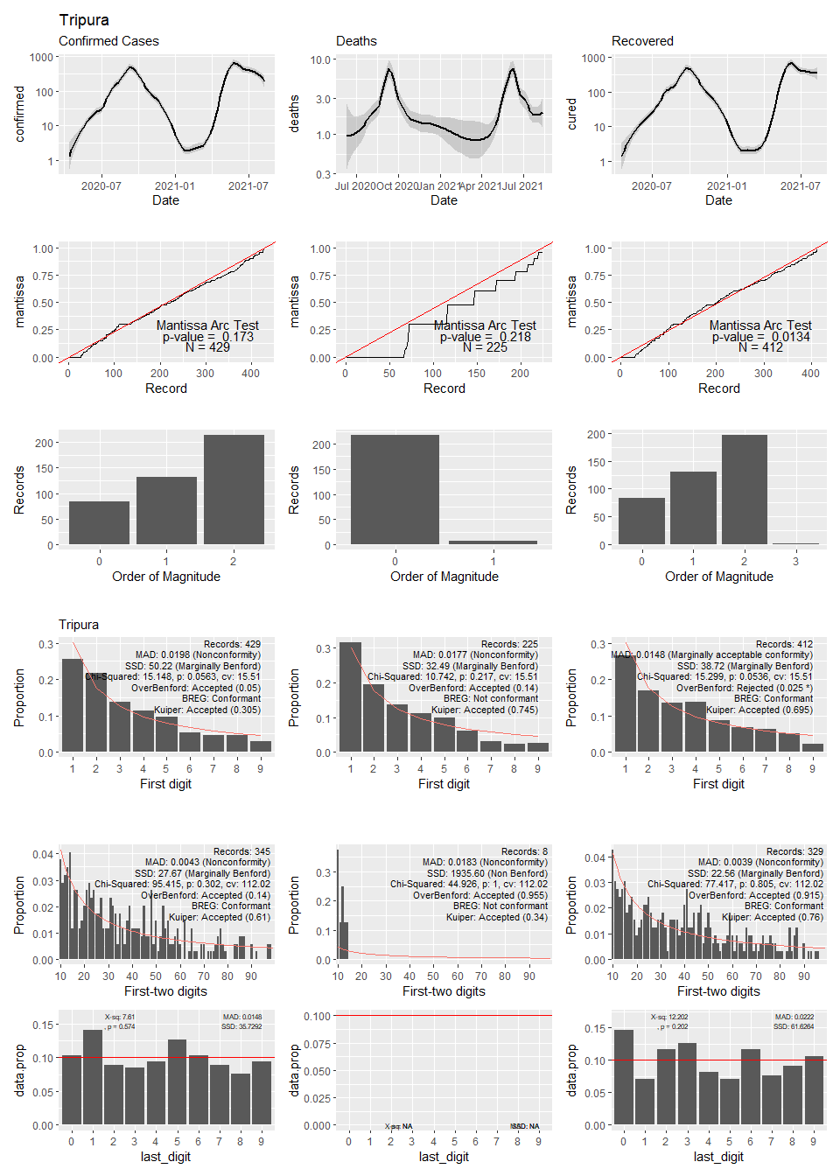

## Warning in self$trans$transform(x): NaNs produced

## Warning: Transformation introduced infinite values in continuous y-axis

## Warning: Removed 13 rows containing non-finite values (stat_smooth).

## Warning: Transformation introduced infinite values in continuous y-axis

## Warning: Removed 61 rows containing non-finite values (stat_smooth).

## Warning in self$trans$transform(x): NaNs produced

## Warning: Transformation introduced infinite values in continuous y-axis

## Warning: Removed 32 rows containing non-finite values (stat_smooth).

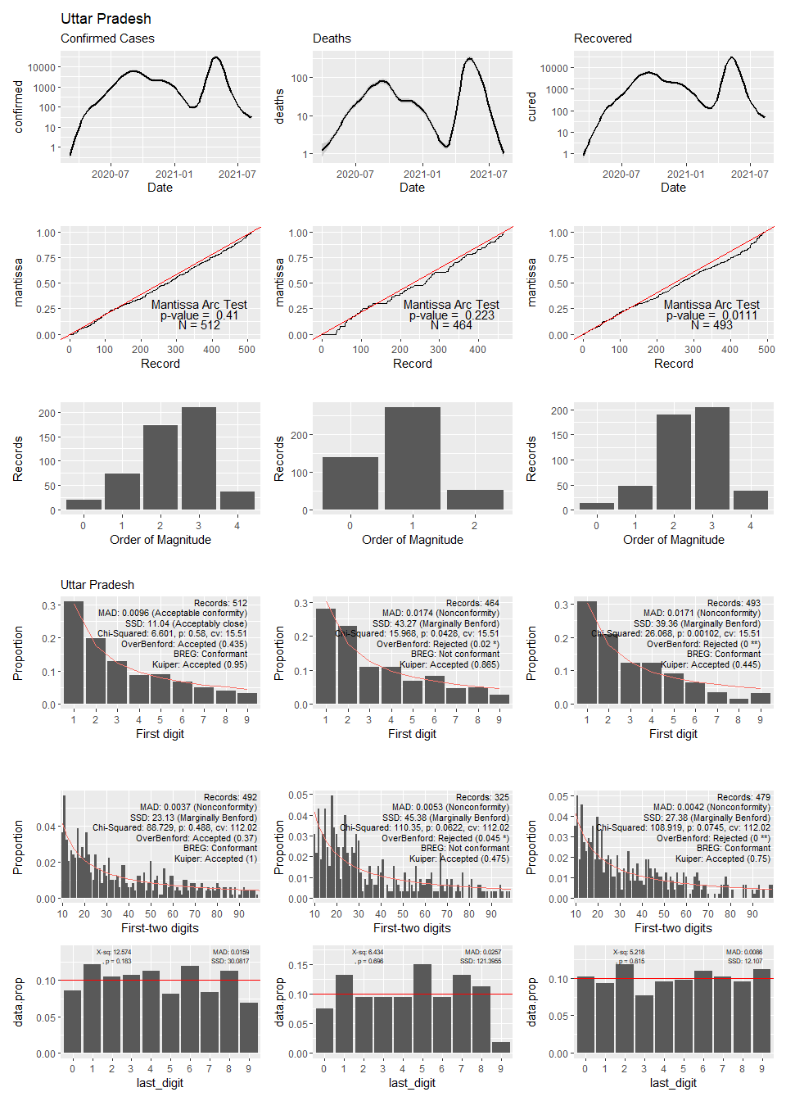

## Warning: Transformation introduced infinite values in continuous y-axis

## Warning: Removed 42 rows containing non-finite values (stat_smooth).

## Warning: Transformation introduced infinite values in continuous y-axis

## Warning: Removed 144 rows containing non-finite values (stat_smooth).

## Warning: Transformation introduced infinite values in continuous y-axis

## Warning: Removed 63 rows containing non-finite values (stat_smooth).

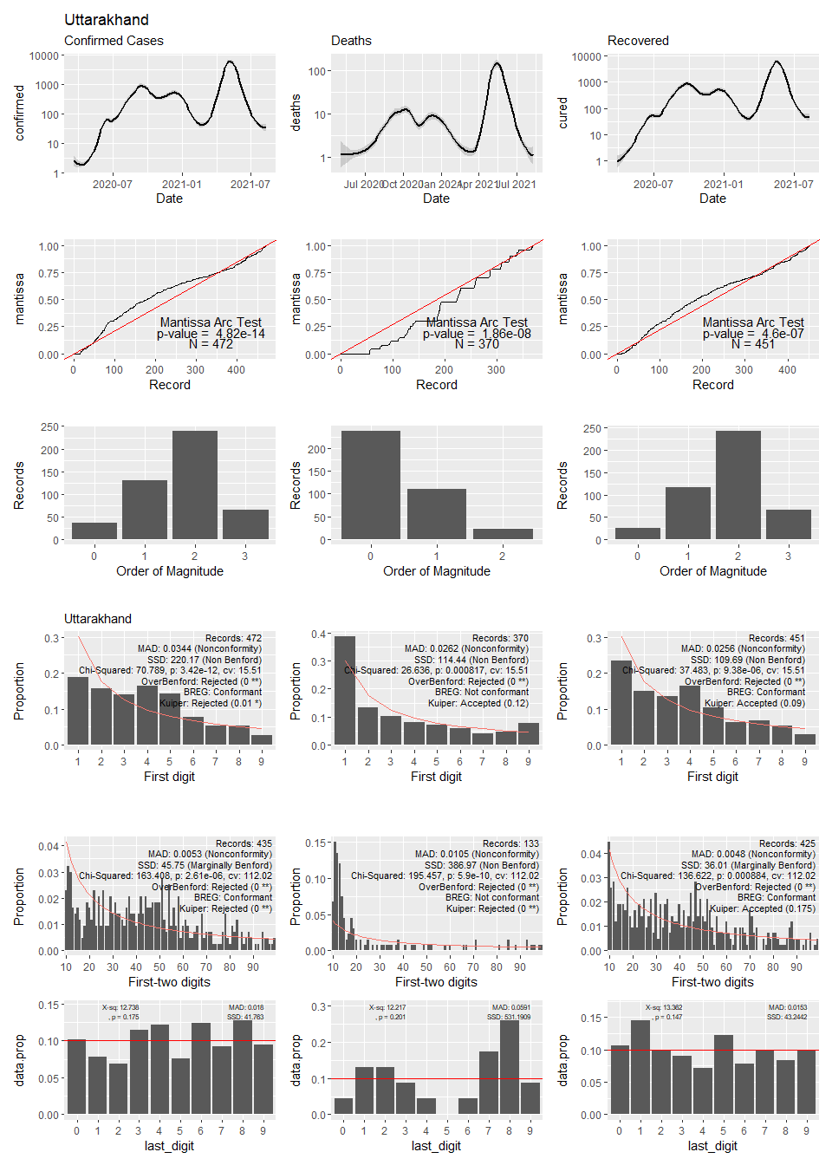

## Warning: Transformation introduced infinite values in continuous y-axis

## Warning: Removed 6 rows containing non-finite values (stat_smooth).

## Warning: Transformation introduced infinite values in continuous y-axis

## Warning: Removed 36 rows containing non-finite values (stat_smooth).

## Warning in self$trans$transform(x): NaNs produced

## Warning: Transformation introduced infinite values in continuous y-axis

## Warning: Removed 29 rows containing non-finite values (stat_smooth).

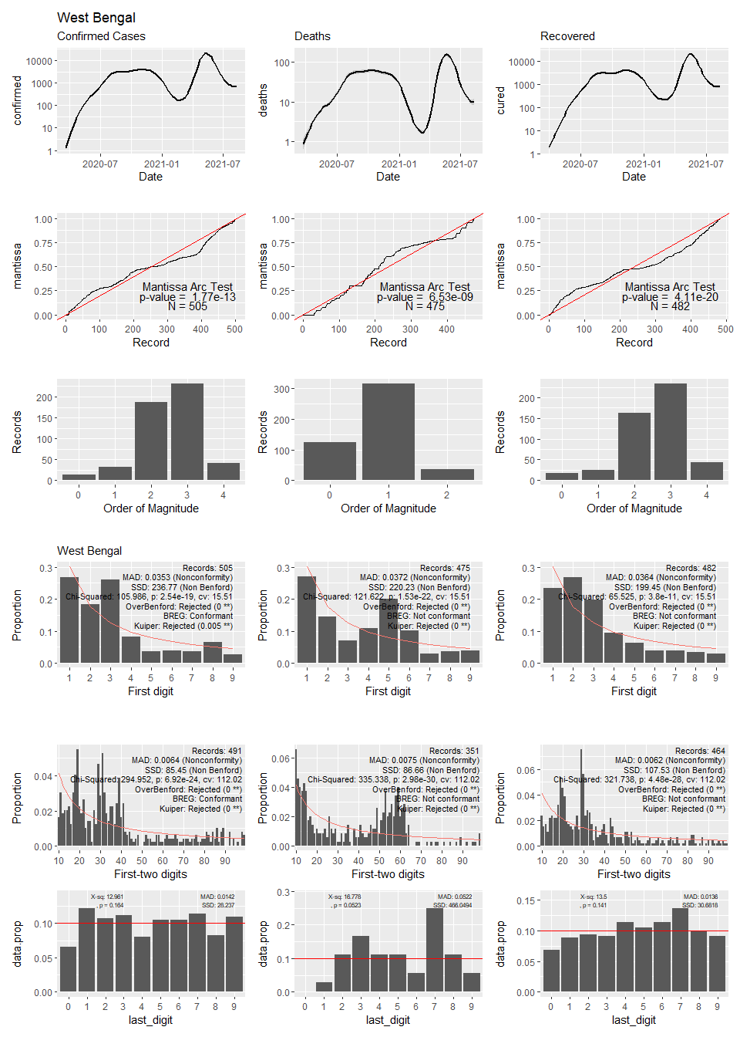

## Appendix 2

### Plots of mantissa, magnitudes, Benford’s first digit and last digits for confirmed cases, deaths and cured of daily Covid returns from Scotland regions.

## Warning: Transformation introduced infinite values in continuous y-axis

## Warning: Removed 14 rows containing non-finite values (stat_smooth).

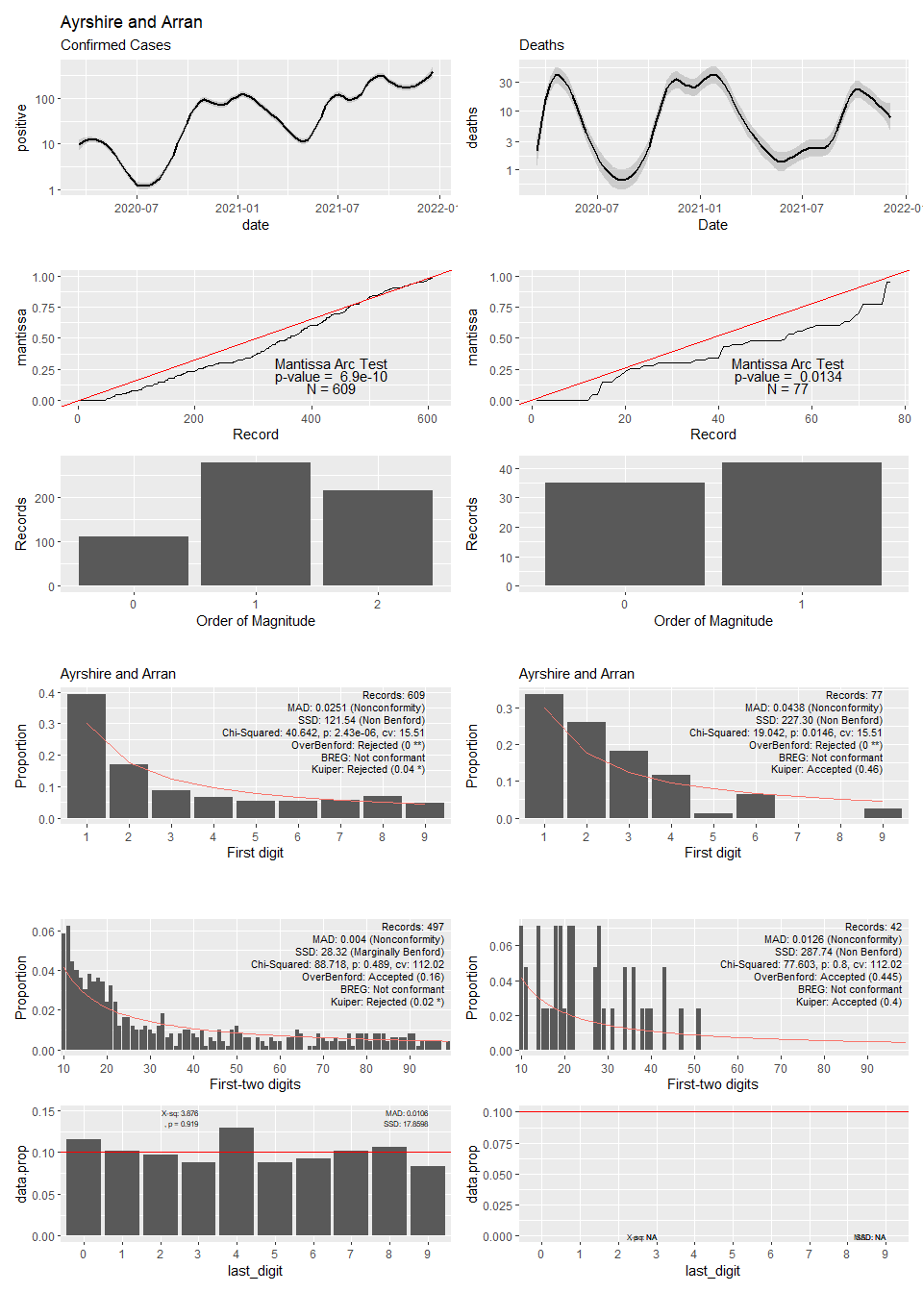

## Warning in self$trans$transform(x): NaNs produced

## Warning: Transformation introduced infinite values in continuous y-axis

## Warning: Removed 2 rows containing non-finite values (stat_smooth).

## Warning: Transformation introduced infinite values in continuous y-axis

## Warning: Removed 31 rows containing non-finite values (stat_smooth).

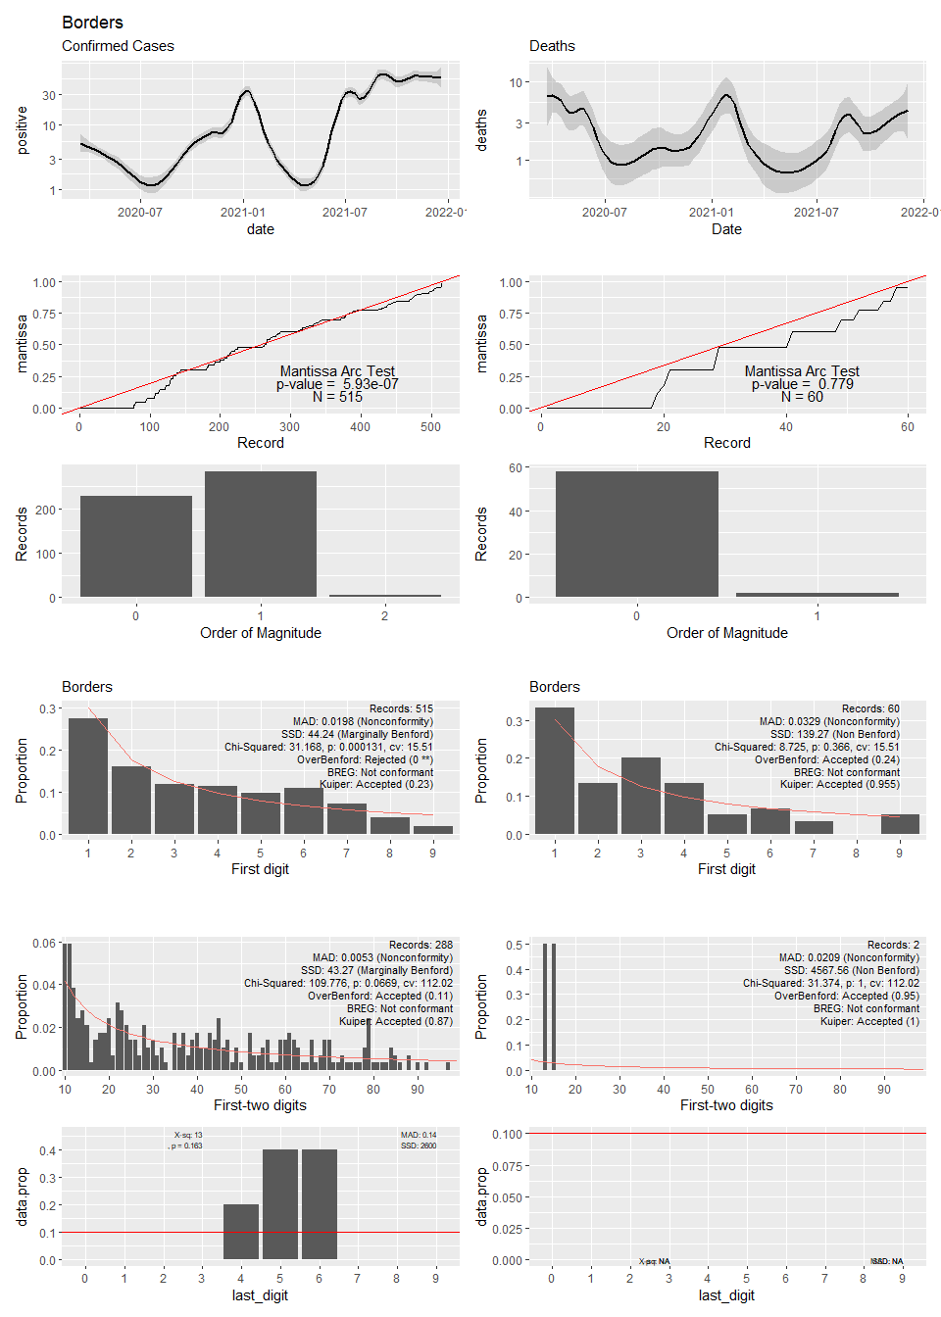

## Warning in self$trans$transform(x): NaNs produced

## Warning: Transformation introduced infinite values in continuous y-axis

## Warning: Removed 3 rows containing non-finite values (stat_smooth).

## Warning: Transformation introduced infinite values in continuous y-axis

## Warning: Removed 92 rows containing non-finite values (stat_smooth).

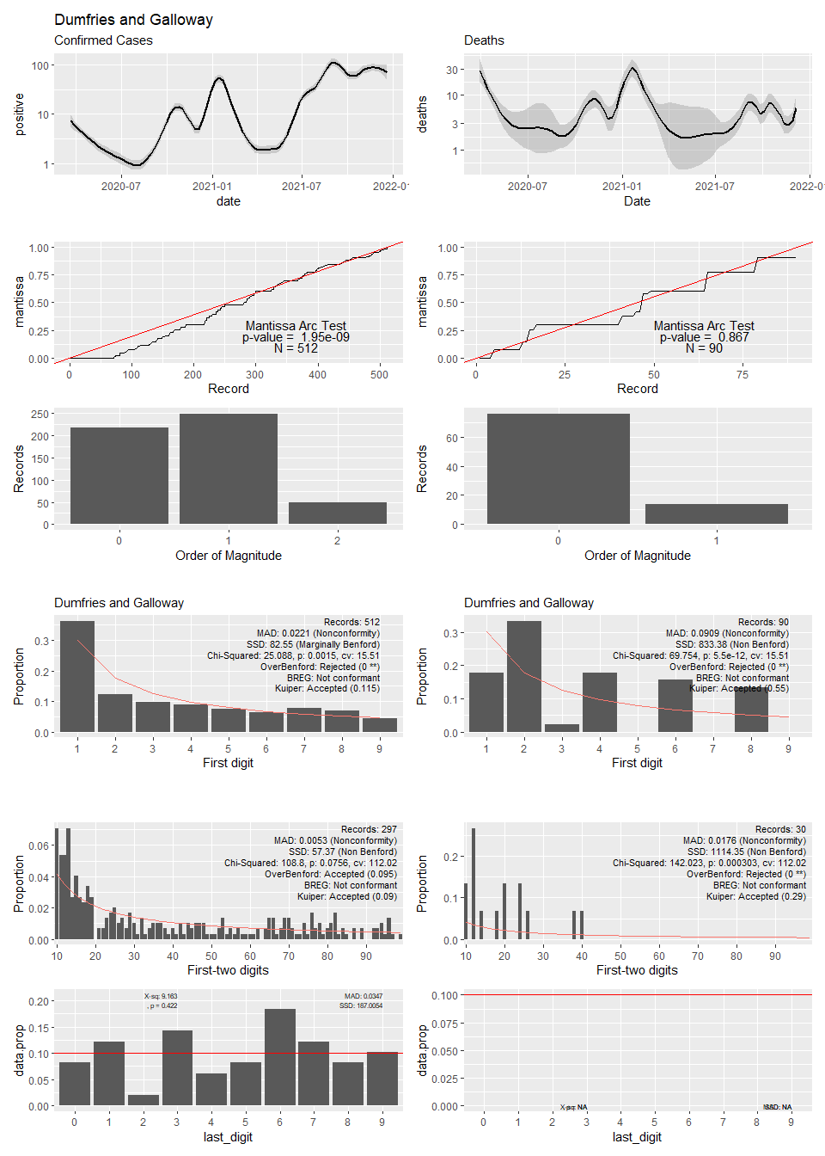

## Warning in self$trans$transform(x): NaNs produced

## Warning: Transformation introduced infinite values in continuous y-axis

## Warning: Removed 2 rows containing non-finite values (stat_smooth).

## Warning: Transformation introduced infinite values in continuous y-axis

## Warning: Removed 40 rows containing non-finite values (stat_smooth).

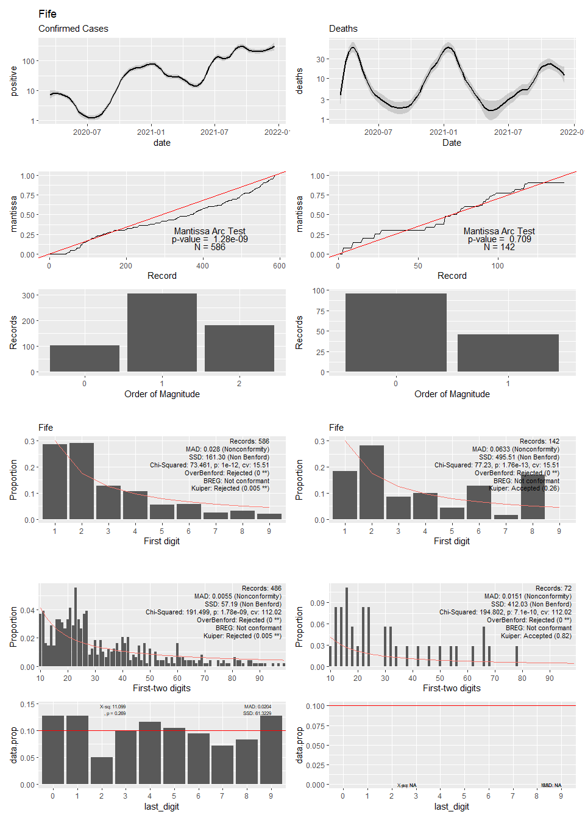

## Warning in self$trans$transform(x): NaNs produced

## Warning: Transformation introduced infinite values in continuous y-axis

## Warning: Removed 3 rows containing non-finite values (stat_smooth).

## Warning: Transformation introduced infinite values in continuous y-axis

## Warning: Removed 13 rows containing non-finite values (stat_smooth).

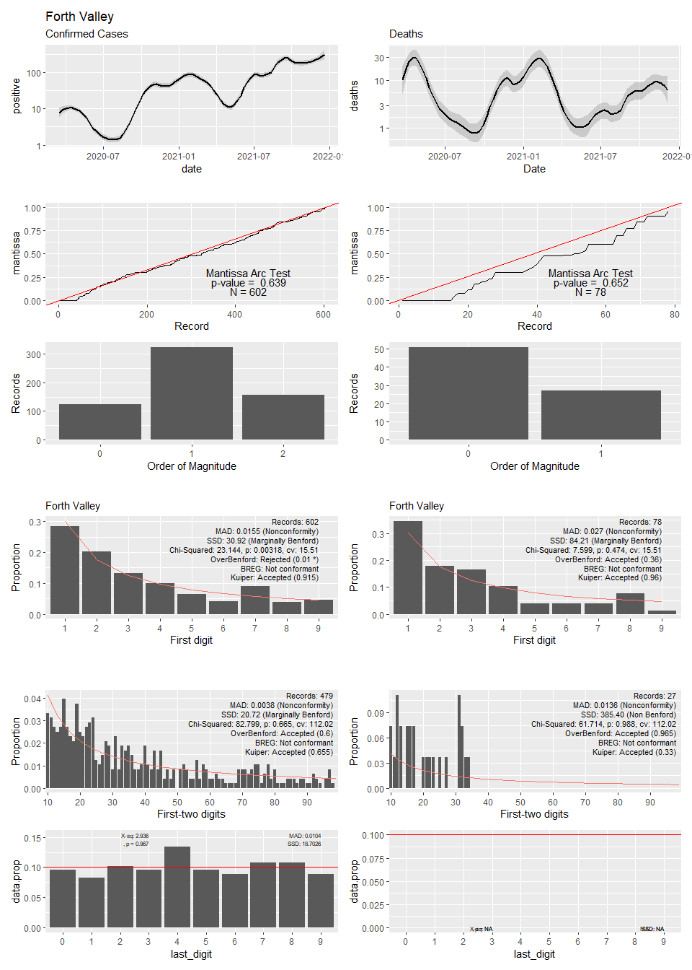

## Warning in self$trans$transform(x): NaNs produced

## Warning: Transformation introduced infinite values in continuous y-axis

## Warning: Removed 1 rows containing non-finite values (stat_smooth).

## Warning: Transformation introduced infinite values in continuous y-axis

## Warning: Removed 18 rows containing non-finite values (stat_smooth).

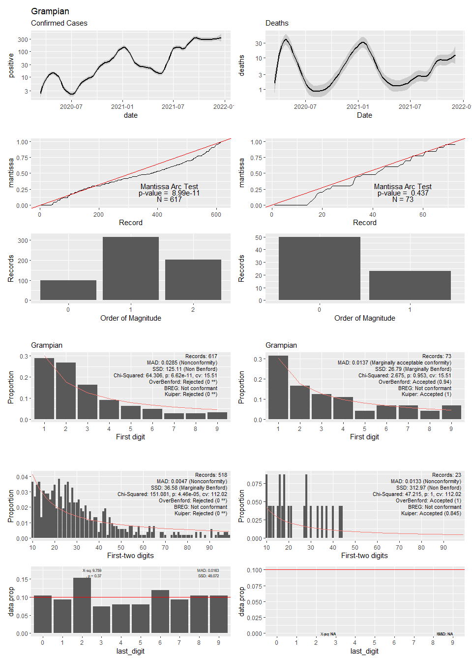

## Warning in self$trans$transform(x): NaNs produced

## Warning: Transformation introduced infinite values in continuous y-axis

## Warning: Removed 1 rows containing non-finite values (stat_smooth).

## Warning: Transformation introduced infinite values in continuous y-axis

## Warning: Removed 1 rows containing non-finite values (stat_smooth).

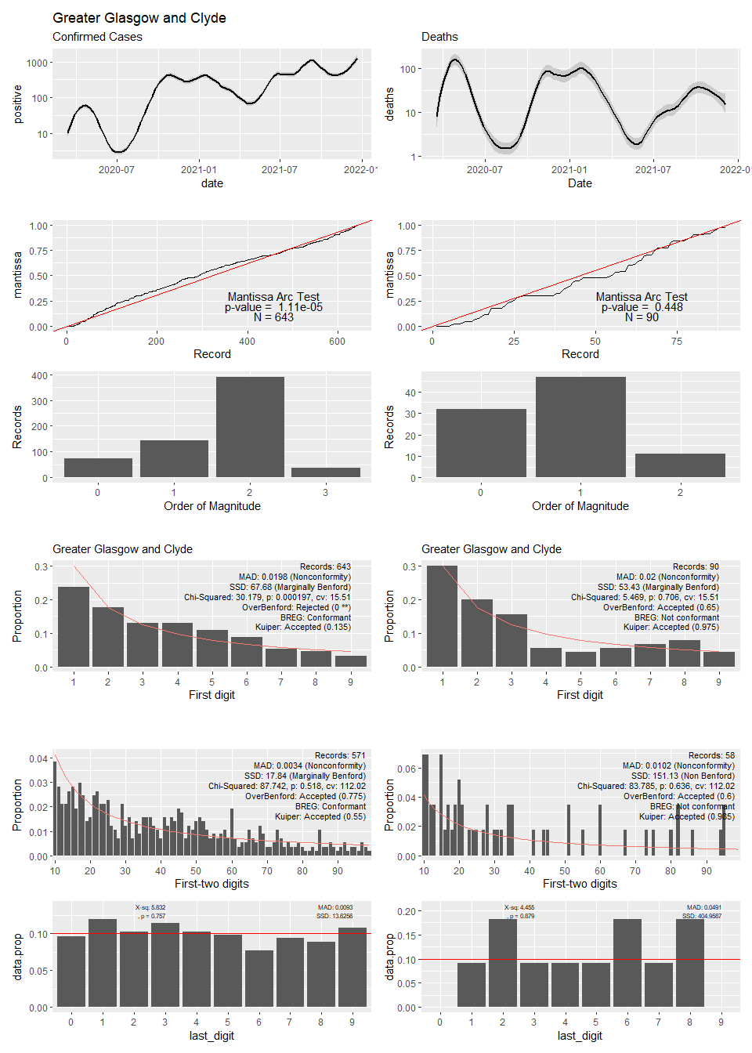

## Warning in self$trans$transform(x): NaNs produced

## Warning: Transformation introduced infinite values in continuous y-axis

## Warning: Removed 2 rows containing non-finite values (stat_smooth).

## Warning: Transformation introduced infinite values in continuous y-axis

## Warning: Removed 62 rows containing non-finite values (stat_smooth).

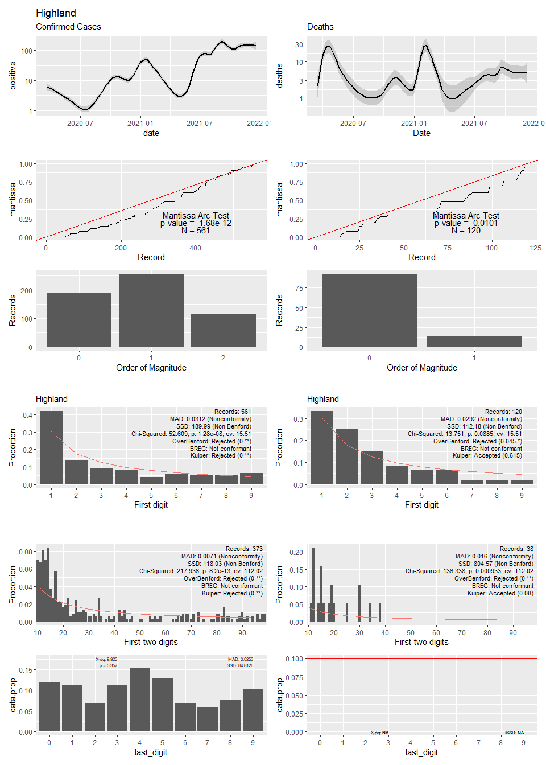

## Warning: Transformation introduced infinite values in continuous y-axis

## Warning: Removed 6 rows containing non-finite values (stat_smooth).

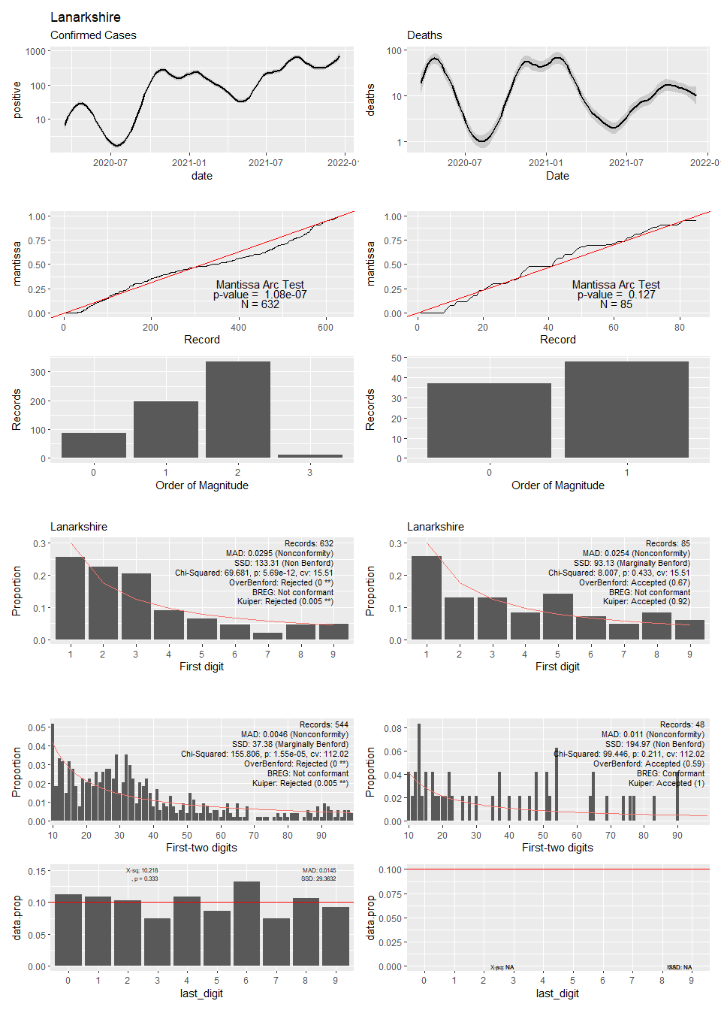

## Warning in self$trans$transform(x): NaNs produced

## Warning: Transformation introduced infinite values in continuous y-axis

## Warning: Removed 3 rows containing non-finite values (stat_smooth).

## Warning: Transformation introduced infinite values in continuous y-axis

## Warning: Removed 11 rows containing non-finite values (stat_smooth).

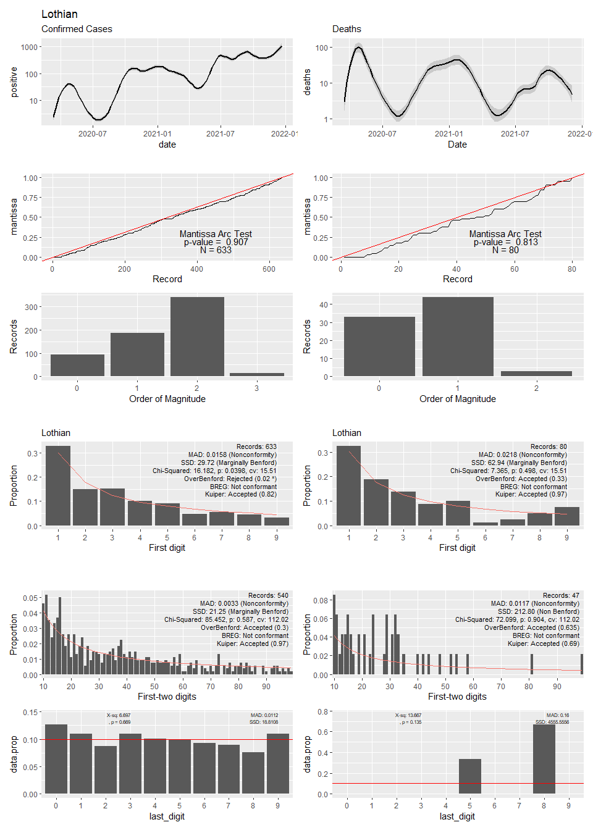

## Warning in self$trans$transform(x): NaNs produced

## Warning: Transformation introduced infinite values in continuous y-axis

## Warning: Removed 2 rows containing non-finite values (stat_smooth).

## Warning: Transformation introduced infinite values in continuous y-axis

## Warning: Removed 83 rows containing non-finite values (stat_smooth).

## Warning in simpleLoess(y, x, w, span, degree = degree, parametric =  
## parametric, : span too small. fewer data values than degrees of freedom.

## Warning in simpleLoess(y, x, w, span, degree = degree, parametric =  
## parametric, : at 18355

## Warning in simpleLoess(y, x, w, span, degree = degree, parametric =  
## parametric, : radius 9.0601

## Warning in simpleLoess(y, x, w, span, degree = degree, parametric =  
## parametric, : all data on boundary of neighborhood. make span bigger

## Warning in simpleLoess(y, x, w, span, degree = degree, parametric =  
## parametric, : pseudoinverse used at 18355

## Warning in simpleLoess(y, x, w, span, degree = degree, parametric =  
## parametric, : neighborhood radius 3.01

## Warning in simpleLoess(y, x, w, span, degree = degree, parametric =  
## parametric, : reciprocal condition number 1

## Warning in simpleLoess(y, x, w, span, degree = degree, parametric =  
## parametric, : at 18963

## Warning in simpleLoess(y, x, w, span, degree = degree, parametric =  
## parametric, : radius 9.0601

## Warning in simpleLoess(y, x, w, span, degree = degree, parametric =  
## parametric, : all data on boundary of neighborhood. make span bigger

## Warning in simpleLoess(y, x, w, span, degree = degree, parametric =  
## parametric, : There are other near singularities as well. 9.0601

## Warning in simpleLoess(y, x, w, span, degree = degree, parametric =  
## parametric, : zero-width neighborhood. make span bigger  
  
## Warning in simpleLoess(y, x, w, span, degree = degree, parametric =  
## parametric, : zero-width neighborhood. make span bigger  
  
## Warning in simpleLoess(y, x, w, span, degree = degree, parametric =  
## parametric, : zero-width neighborhood. make span bigger  
  
## Warning in simpleLoess(y, x, w, span, degree = degree, parametric =  
## parametric, : zero-width neighborhood. make span bigger  
  
## Warning in simpleLoess(y, x, w, span, degree = degree, parametric =  
## parametric, : zero-width neighborhood. make span bigger  
  
## Warning in simpleLoess(y, x, w, span, degree = degree, parametric =  
## parametric, : zero-width neighborhood. make span bigger  
  
## Warning in simpleLoess(y, x, w, span, degree = degree, parametric =  
## parametric, : zero-width neighborhood. make span bigger  
  
## Warning in simpleLoess(y, x, w, span, degree = degree, parametric =  
## parametric, : zero-width neighborhood. make span bigger

## Warning: Computation failed in `stat_smooth()`:  
## NA/NaN/Inf in foreign function call (arg 5)

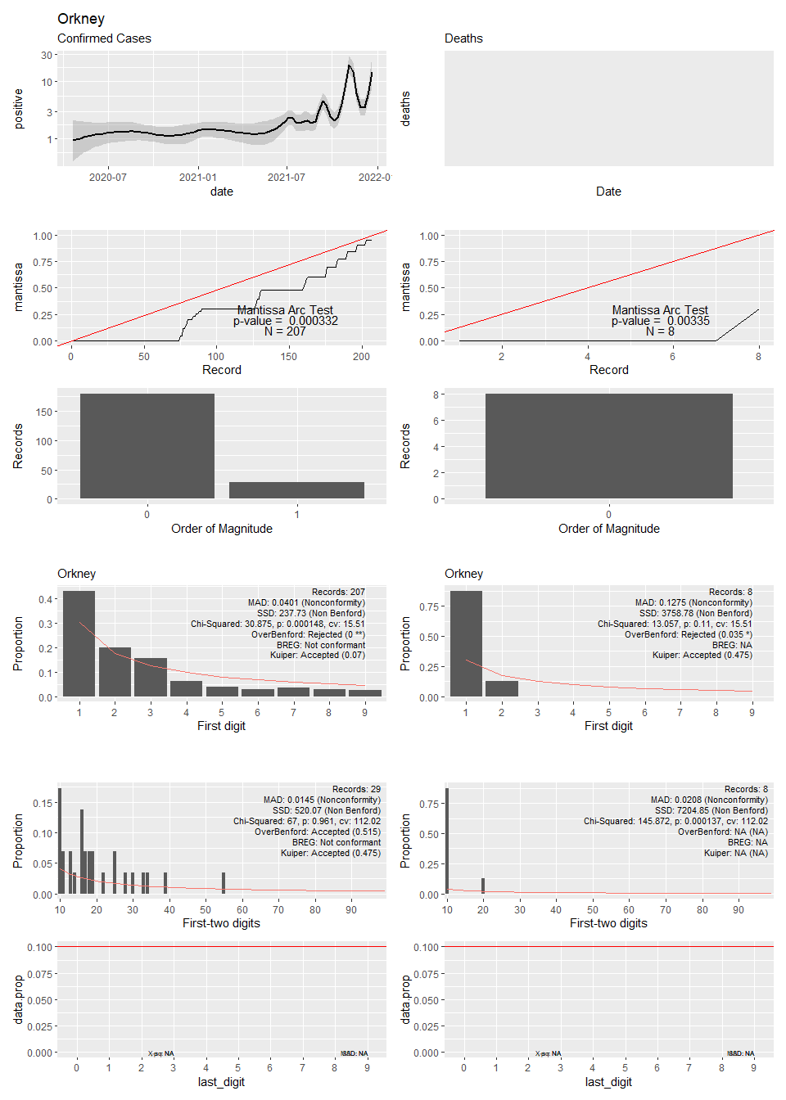

## Warning in self$trans$transform(x): NaNs produced

## Warning: Transformation introduced infinite values in continuous y-axis

## Warning: Removed 2 rows containing non-finite values (stat_smooth).

## Warning: Transformation introduced infinite values in continuous y-axis

## Warning: Removed 82 rows containing non-finite values (stat_smooth).

## Warning in simpleLoess(y, x, w, span, degree = degree, parametric =  
## parametric, : span too small. fewer data values than degrees of freedom.

## Warning in simpleLoess(y, x, w, span, degree = degree, parametric =  
## parametric, : at 18348

## Warning in simpleLoess(y, x, w, span, degree = degree, parametric =  
## parametric, : radius 6.8906

## Warning in simpleLoess(y, x, w, span, degree = degree, parametric =  
## parametric, : all data on boundary of neighborhood. make span bigger

## Warning in simpleLoess(y, x, w, span, degree = degree, parametric =  
## parametric, : pseudoinverse used at 18348

## Warning in simpleLoess(y, x, w, span, degree = degree, parametric =  
## parametric, : neighborhood radius 2.625

## Warning in simpleLoess(y, x, w, span, degree = degree, parametric =  
## parametric, : reciprocal condition number 1

## Warning in simpleLoess(y, x, w, span, degree = degree, parametric =  
## parametric, : at 18879

## Warning in simpleLoess(y, x, w, span, degree = degree, parametric =  
## parametric, : radius 6.8906

## Warning in simpleLoess(y, x, w, span, degree = degree, parametric =  
## parametric, : all data on boundary of neighborhood. make span bigger

## Warning in simpleLoess(y, x, w, span, degree = degree, parametric =  
## parametric, : There are other near singularities as well. 6.8906

## Warning in simpleLoess(y, x, w, span, degree = degree, parametric =  
## parametric, : zero-width neighborhood. make span bigger  
  
## Warning in simpleLoess(y, x, w, span, degree = degree, parametric =  
## parametric, : zero-width neighborhood. make span bigger  
  
## Warning in simpleLoess(y, x, w, span, degree = degree, parametric =  
## parametric, : zero-width neighborhood. make span bigger  
  
## Warning in simpleLoess(y, x, w, span, degree = degree, parametric =  
## parametric, : zero-width neighborhood. make span bigger  
  
## Warning in simpleLoess(y, x, w, span, degree = degree, parametric =  
## parametric, : zero-width neighborhood. make span bigger  
  
## Warning in simpleLoess(y, x, w, span, degree = degree, parametric =  
## parametric, : zero-width neighborhood. make span bigger  
  
## Warning in simpleLoess(y, x, w, span, degree = degree, parametric =  
## parametric, : zero-width neighborhood. make span bigger  
  
## Warning in simpleLoess(y, x, w, span, degree = degree, parametric =  
## parametric, : zero-width neighborhood. make span bigger  
  
## Warning in simpleLoess(y, x, w, span, degree = degree, parametric =  
## parametric, : zero-width neighborhood. make span bigger

## Warning: Computation failed in `stat_smooth()`:  
## NA/NaN/Inf in foreign function call (arg 5)

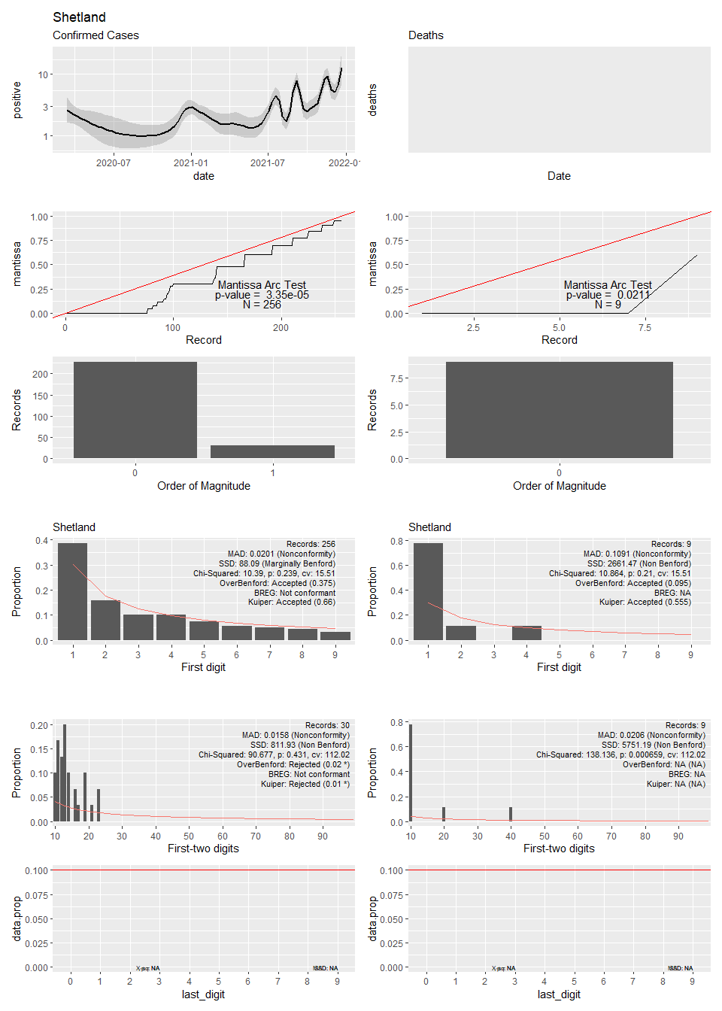

## Warning in self$trans$transform(x): NaNs produced

## Warning: Transformation introduced infinite values in continuous y-axis

## Warning: Removed 1 rows containing non-finite values (stat_smooth).

## Warning: Transformation introduced infinite values in continuous y-axis

## Warning: Removed 17 rows containing non-finite values (stat_smooth).

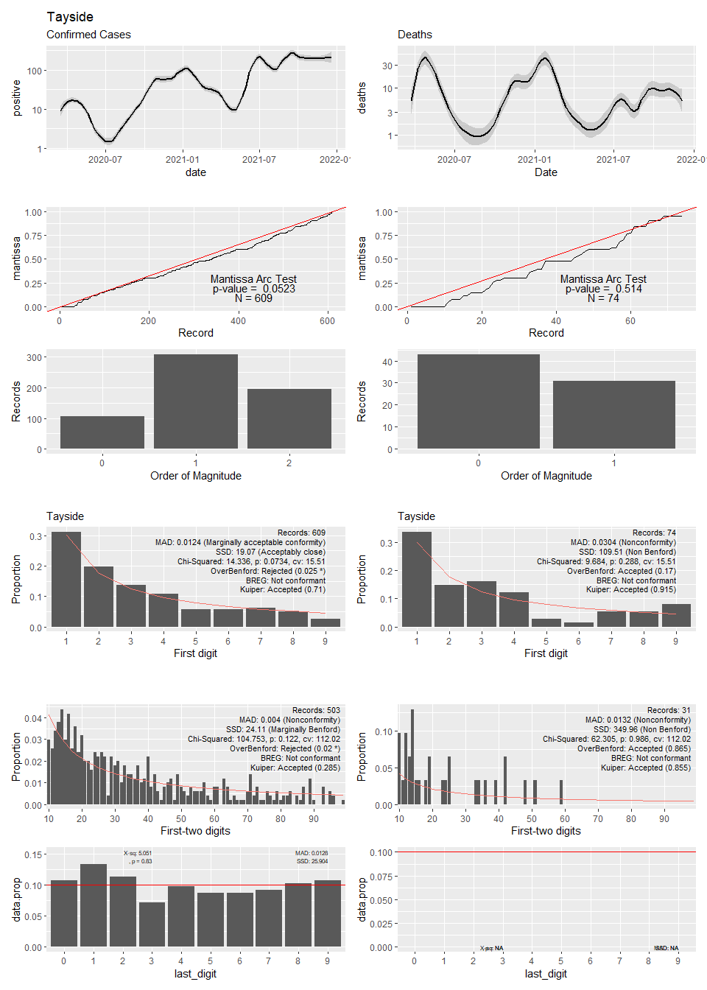

## Warning in self$trans$transform(x): NaNs produced

## Warning: Transformation introduced infinite values in continuous y-axis

## Warning: Removed 1 rows containing non-finite values (stat_smooth).

## Warning: Transformation introduced infinite values in continuous y-axis

## Warning: Removed 75 rows containing non-finite values (stat_smooth).

## Warning in simpleLoess(y, x, w, span, degree = degree, parametric =  
## parametric, : span too small. fewer data values than degrees of freedom.

## Warning in simpleLoess(y, x, w, span, degree = degree, parametric =  
## parametric, : pseudoinverse used at 18545

## Warning in simpleLoess(y, x, w, span, degree = degree, parametric =  
## parametric, : neighborhood radius 114.06

## Warning in simpleLoess(y, x, w, span, degree = degree, parametric =  
## parametric, : reciprocal condition number 0

## Warning in simpleLoess(y, x, w, span, degree = degree, parametric =  
## parametric, : There are other near singularities as well. 258.08

## Warning in sqrt(sum.squares/one.delta): NaNs produced

## Warning in predLoess(object$y, object$x, newx = if  
## (is.null(newdata)) object$x else if (is.data.frame(newdata))  
## as.matrix(model.frame(delete.response(terms(object)), : span too small. fewer  
## data values than degrees of freedom.

## Warning in predLoess(object$y, object$x, newx = if  
## (is.null(newdata)) object$x else if (is.data.frame(newdata))  
## as.matrix(model.frame(delete.response(terms(object)), : pseudoinverse used at  
## 18545

## Warning in predLoess(object$y, object$x, newx = if  
## (is.null(newdata)) object$x else if (is.data.frame(newdata))  
## as.matrix(model.frame(delete.response(terms(object)), : neighborhood radius  
## 114.06

## Warning in predLoess(object$y, object$x, newx = if  
## (is.null(newdata)) object$x else if (is.data.frame(newdata))  
## as.matrix(model.frame(delete.response(terms(object)), : reciprocal condition  
## number 0

## Warning in predLoess(object$y, object$x, newx = if  
## (is.null(newdata)) object$x else if (is.data.frame(newdata))  
## as.matrix(model.frame(delete.response(terms(object)), : There are other near  
## singularities as well. 258.08

## Warning in stats::qt(level/2 + 0.5, pred$df): NaNs produced

## Warning in max(ids, na.rm = TRUE): no non-missing arguments to max; returning  
## -Inf

