master@unimi.it
informa studenti - piattaforma

markdown language → pandoc creat ppt

64k 2^16 = 65535 https://en.wikipedia.org/wiki/65,535
32 bit 4 gb RAM maximum
64 bit
128 bit

Velocità computer 3.5 GigaHz

Ogni cycle può essere scritto o cancellato un bit, 3.5 Giga Hz (in un secondo fa 3.5 giga cycles e-09)

(1024=1kbyte) 2^10
Tera byte 1024^4
Peta byte 1024^5

ClustalX problem – sorting problem
64k peptides
64kx64k neighbour joining algorithm

CPU vs GPU (CPU con ALU oversized, faster)
Cache and register and cpu and hard driver

CISC why we are still using CISC, reason is intel, and Microsoft do not want to rewrite everything to run on risc
RISC

20/03/2023

7 bit maximum number you can store in 7 bit? 2^7 = 128
Code unit ASCII 7 bits / UTF-8 8-bits / UTF-16 16-bits / UTF-32 per convertire da un codice all’altro: iconv

iconv –f iso-8859-15 –t utf-8 < input.txt > output.txt
-f “from” in iconv
-t “to” in iconv
netcat

example
cat exampleiso8859.txt | iconv –f iso-8859 –t utf-8 > exampleutf8
ISO8859 most used charset until 2010

In html the charset has to be declared

Base64 to handle images (B64)
Cat logoIFOM.png | base64 > LogoIfom.b64
cat logoIFOM.b64 | base64 –d logoIFOM.png
-d decoded
Prende un’immagine e la codifica secondo la funzione base64 in una stringa di codice (1), poi la risalva in un’atra immagine usando l’argomento –d che decodifica base64 to png (2)
Base64 trasmitting/storing images in database because it is costly in term of gb, double the size

URL
http protocol in order to open a file
only a limitation rfc requestforcomments
%escaping A can be represented by %41 Escape for blank spaces
www.a.com
www.%41.com

linux is just the kernel (bsd)
everything that is over linux is gnu
Bash shell contenitore in cui fai coding
Bios (bootstrap?) very connected to the hd part > Kernel (translator?) > Operative system > layer of applications | system software
Apache = web server
A program in a running state is called a process

OS
Functions:
- Memory management buffer overflow
- Processor mgmt
- Device mgmt. I/O input/output of the CPU
- File mgmt
- Network mgmt
- User mgmt
Top to see all processes going on
VM =virtual memory swapins / swapouts
Cache dynamic/spool /buffer

/bin
/etc must be root (root is user, the highest user)
/home is home
/opt optional
/tmp temporary, where you store temp file, it will clean up after switch off-on
/usr user
/var variables, web server

Regular Expression - https://www.grymoire.com/Unix/Regular.html
Used to find using grep utility - find everything that match that pattern (very fast utility)
.*? anything
.? character that can be or not
* the previous character set can appear any number of times, including zero

^##\s+(.*?)$ search from the beginning “##” there is a char anything anyline that has a ## followed by something like a space take everything until the end
\s uno spazio o underscore (spacer)
\s+ uno o due spazi

Replace ---\1--- (\1 prima parola che trova)
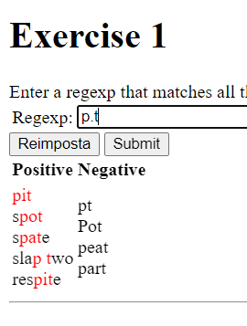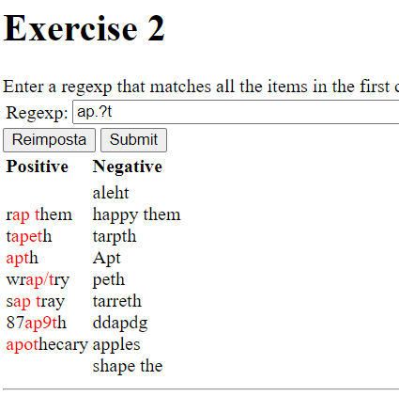
.? Il carattere prima può esserci o non esserci
a[a-z].?g.?k
[a,f]fg.?k
aff?g.?k
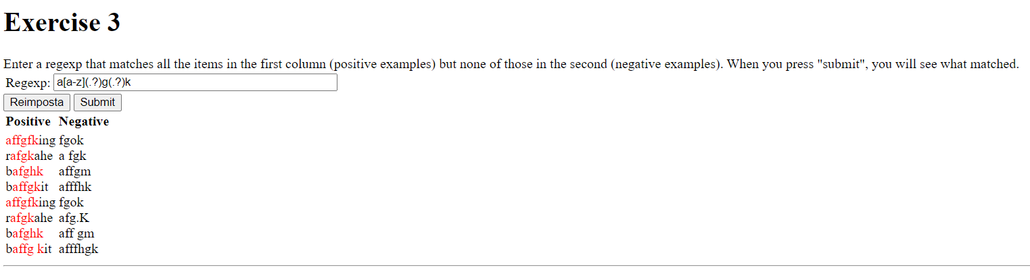

Unix

sandbox (interfaccia web unix) – powershell (windows shell) – bash – almaunix

non c’è undo
non c’è cestino
se copi/muovi in una cartella dove un file chiamato uguale esiste lo sovrascrivi
ACL = access control list
Sudo = super user do
G re p = global regular expression print

ALT+126 creates ~ ALT+123 creates { ALT+125 creates }
CTRL+e fine stringa di comand CTRL+a inizio stringa di comando

Sudo dnf install [tree, bc, vim] probably works only in home
tree / CTRL+c force the end of the command
CTRL+z freeze the task you are doing
fg to restart to the freezed task
& alla fine di un comando: run in background

Command | Meaning
man command | manual of a command (RTFM)
curl ifconfig.it | return IP address of the url
| | pipe put the output into other instructions
> | to create an output file
>> | append
< | from
ls | list of directory
ls –l | displayed as a list
ls –l directoryname/ | displayed as a list without moving really in the directory
ls –la [*.html *.?d] | also invisible files [but only html files, or *.md will works]
pwd | print workspace directory
cd | set different directory
cd .. cd ../ | va nel folder precedente
cd ~ | va in home
mkdir namefolder | create a new folder
cp [-r] file1 newfile | copy file [to copy a folder]
cp –r images/*.pdf testfolder | copy the entire folder but only pdf file into testfolder (important, the new testfolder has to be already created)
mv filename filename2 | move file, non mi è chiara la sintassi
rm [-i] file1 | revome file [asking for confirmation]
rm –r | remove the entire directory
touch file.txt | create a new empty file
echo “prova” | stampa a video prova
echo prova | stampa a video prova
echo prova this > filename | crea un nuovo file “filename” con all’interno “prova this”
echo nuova riga >> filename | append the new line to a file filename
cat filename | stampa a video un file or concatenate/grab content
command >> filename.txt | append the command output into the file “filename”
tail [-f –n 10] filename | last rows of filename [force if the file is continuously compiling; last 10 rows]
tail -f –n 10 | grep lunch filename [| wc –l] | last 10 rows of filename containing “lunch” (force if the file is continuously compiling) pipe wordcount number rows
head filename
more
less
time xxx | compute how long it takes to execute xxx command
ls –la | wc -lmw | wordcount contained in the list, print out number of lines, chars and words (-l –m –w)
bc | basic calculator
groups estanzani | return the level of permission of the user estanzani (user wheel can run sudo command)
chmod [-R] 754 filename.txt | to change permission [recursive to change also file contained into the folder]
chown root:staff /u | Change the owner of /u to "root", but also change its group to "staff".
vim filename.txt | open a text editor to text into the filename.md  Per uscire senza salvare ESC+ :q  Per uscire salvando ESC+ :wq

installing R in linux
cd ~
sudo dnf update # update the available system packages
sudo dnf install epel-release # enable the EPEL and CRB
sudo dnf config-manager --set-enabled crb
sudo dnf install R # install R
R -- version # check the version
R # run R

permissions
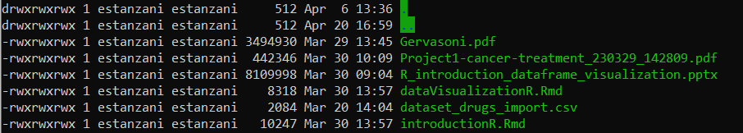
d rwx user rwx gruppo rwx all
“d” when the element is a folder
“rwx” read – write – execute
three levels of permission: “ugo” user group others

groups estanzani or student #to interrogate software for the current user permissions estanzani : estanzani adm wheel cdrom
Wheel = group of people that can run a sudo program

chmod [you can both use number or letter] to change permissions
chmod [-R] 754 filename.txt change recursively file to rwxr-xr--
Chmod u+r file 1 user (u) gains read permission (r)

0000 0 ---
0001 1 --x
0010 2 -w-
0011 3 -wx
0100 4 r--
0101 5 r-x
0110 6 rw-
0111 7 rwx

Chown user:group chown sdipietr:staff ffile
chown root /u Change the owner of /u to "root".
chown root:staff /u Likewise, but also change its group to "staff".
Chown –R recursive (to change also file contained into the folder)

Sudo dnf intall net-tools - Per installare ifconfig ma è deprecated, ip addr/ip link

History Intel o arm processor 1980-1983 when bbc asked to chip producer to build a very simple chip low expensive and low consumption and they did the ARM (the first risc)

*.tar address
Sh –c “$(curl –fsSL https:…)\n” \n is like typing enterenter

File structured => so it is a database (tabella) db
xargs –I{} grep –I {} oui.txt

Txt tab-separated meglio che csv perchè è sempre variabile come script

Comprimere un file
Tar –cvzf newdirectory.tgz olddirectory compress
Tar –xvf new newdirectory.tgz extract

unzip only for zipped file, tar doesn’t work

programma sshfs ssh file system
sudo dnf install sshfs
montare una risorsa remota sul tuo disco locale struffando ssh fuse mount

14/04/23

DATA STRUCTURE
Before writing a single line of code think about performances, our machines are incredibly fast but software are designed as incredibly slow.
working with array objects is time-consuming
lineary search is time-consuming, binary-search is quicker (of a log fold)
everything is a matter of time-complexity

objects:
- array memory space problem in case we need to modify and add information
- linked list the array contains the address of another chunk head – end the elements are not stored at contiguous memory locations
- stack linear data structure that follows a particular order in which the operation are performed. the order may be LIFO (Last In First Out) or FILO (First In Last Out), a warehouse is a stack
- queue like a stack order FIFO (first in first out), it is open in both ends
- binary tree hugely used (balance binary tree, ..) there is a hierarchy and a root, each node has at most 2 children, “b-tree”. “parent”, “child”, “root” has no parent, “edge” is the connection, “sub-tree”
- heap min and max
- hash table
- graph facebook, road map, AI
- matrix

usage:
- search algoritms
- sorting algoritm
- database system

