Physical Design Report
RISC-V Pipelined CPU
RTL to Routed Layout on Nangate 45 nm
Design Author: Elliot Staresinic
Design: pipelined_cpu_core | Run: confirm-clk4p0-u71-ts06
Tools: Cadence Genus 23.1, Innovus 23.12, Conformal LEC, Xcelium 24.03
Enablement: Nangate 45 nm Open Cell Library | Date: 2026-08-13
SIGNOFF RESULT: CLOSED (0 setup violations, 0 hold violations, DRC clean)

1. Executive Summary
This report documents the physical implementation of a five-stage pipelined RV32I processor, taken from register transfer level source to a routed, design-rule-clean layout on the Nangate 45 nm open cell library using Cadence Genus and Innovus.
Result: the design closes at 4.00 ns, 250 MHz, at the slow corner (SS, 0.95 V, 125 °C), with setup worst negative slack of 0.014 ns and hold worst negative slack of 0.026 ns, both with zero violating paths. The layout is DRC clean, connectivity clean, and formally equivalent to the source RTL across 1,515 key points. The routed netlist executes the verification program correctly at four simulation tiers.
The result is repeatable rather than fortunate. This configuration was run four times with utilisation perturbed by ±0.01 to sample the optimiser, and closed four times out of four with a mean slack of +5 ps and a standard deviation of 6 ps. Innovus is deterministic, so re-running an identical configuration returns an identical answer; perturbing utilisation is what makes repeatability measurable at all.
Two qualifiers travel with every number in this report and neither is optional: the corner it was measured at, and the on-chip variation derate applied. A typical-corner figure for this design is roughly 2.2 ns of slack better than the slow-corner figure and describes something else entirely.

2. Design Under Test
The design is a five-stage pipelined RV32I-subset processor with a Harvard memory interface: separate instruction and data ports presented at the core boundary. The pipeline implements full forwarding, load-use hazard detection with a single-cycle stall, and branch resolution in the decode stage with a flush of the instruction fetch and decode registers on a taken branch.

2.1 Physical Hierarchy
Synthesis preserves the datapath and control hierarchy, which is what allows the timing and area reports later in this document to attribute results to named blocks rather than to flattened gate names.
pipelined_cpu_core
|- pipelined_cpu_control decode and control generation
|- pipelined_cpu_datapath pipeline registers and execution
|- registers 32 x 32 register file, write-forward bypass
|- immediate_generation I/S/B/U/J immediate formats
|- pc_plus_4 32-bit ripple-carry adder
|- pc_plus_imm 32-bit ripple-carry adder, branch target
|- alu_fwd_unit EX-stage operand forwarding
|- branch_fwd_unit ID-stage forwarding for branch compare
|- hzrd_detection_unit load-use interlock

2.2 Technology and Enablement
Item | Value
Library | Nangate 45 nm Open Cell Library
Corners | slow (SS 0.95 V 125 °C), typical, fast (FF 1.25 V −40 °C)
Metal stack | 10 layers, metal1 through metal10
Routing layers used | metal1 through metal7 for signal
Power layers | metal8 and metal9 for ring and stripes
Extraction | QRC, NG45.tch
Standard cell row height | 1.4 µm

3. Implementation Flow
The flow runs as a single command per experiment, from RTL to routed layout with three-corner reporting from one routed database. Each run writes into its own directory so no experiment can overwrite the evidence of another.

3.1 Flow Configuration
Parameter | Value | Purpose
Clock period | 4.00 ns | Target, and the constraint the design is judged against
Core utilisation | 0.71 | Floorplan density request before filler
Synthesis effort | medium | Genus generic and mapped optimisation
Optimisation target slack | 0.06 ns | Where the optimiser stops, not where signoff is
OCV derate | 1.0 | Analysis mode is onChipVariation; no margin applied
Input/output delay | 0.30 × clock period | An assumption, quoted with every result

3.2 Optimisation Margin
The optimiser is told to stop at +60 ps rather than at zero. This matters more than it sounds. Detailed routing reveals delay that placement did not model, so an optimiser that stops exactly at zero slack hands routing a design with no room, and closure becomes a coin flip. Margin given to the optimiser through setOptMode moves where it stops without moving the requirement it is judged against.
Margin added to clock uncertainty instead would achieve nothing here: there is a single constraint mode, active for both optimisation and final analysis, so uncertainty moves the target and the signoff requirement by the same amount and the slack lands where it started. Margin in a constraint moves the ruler along with the target.

3.3 The Routed Layout
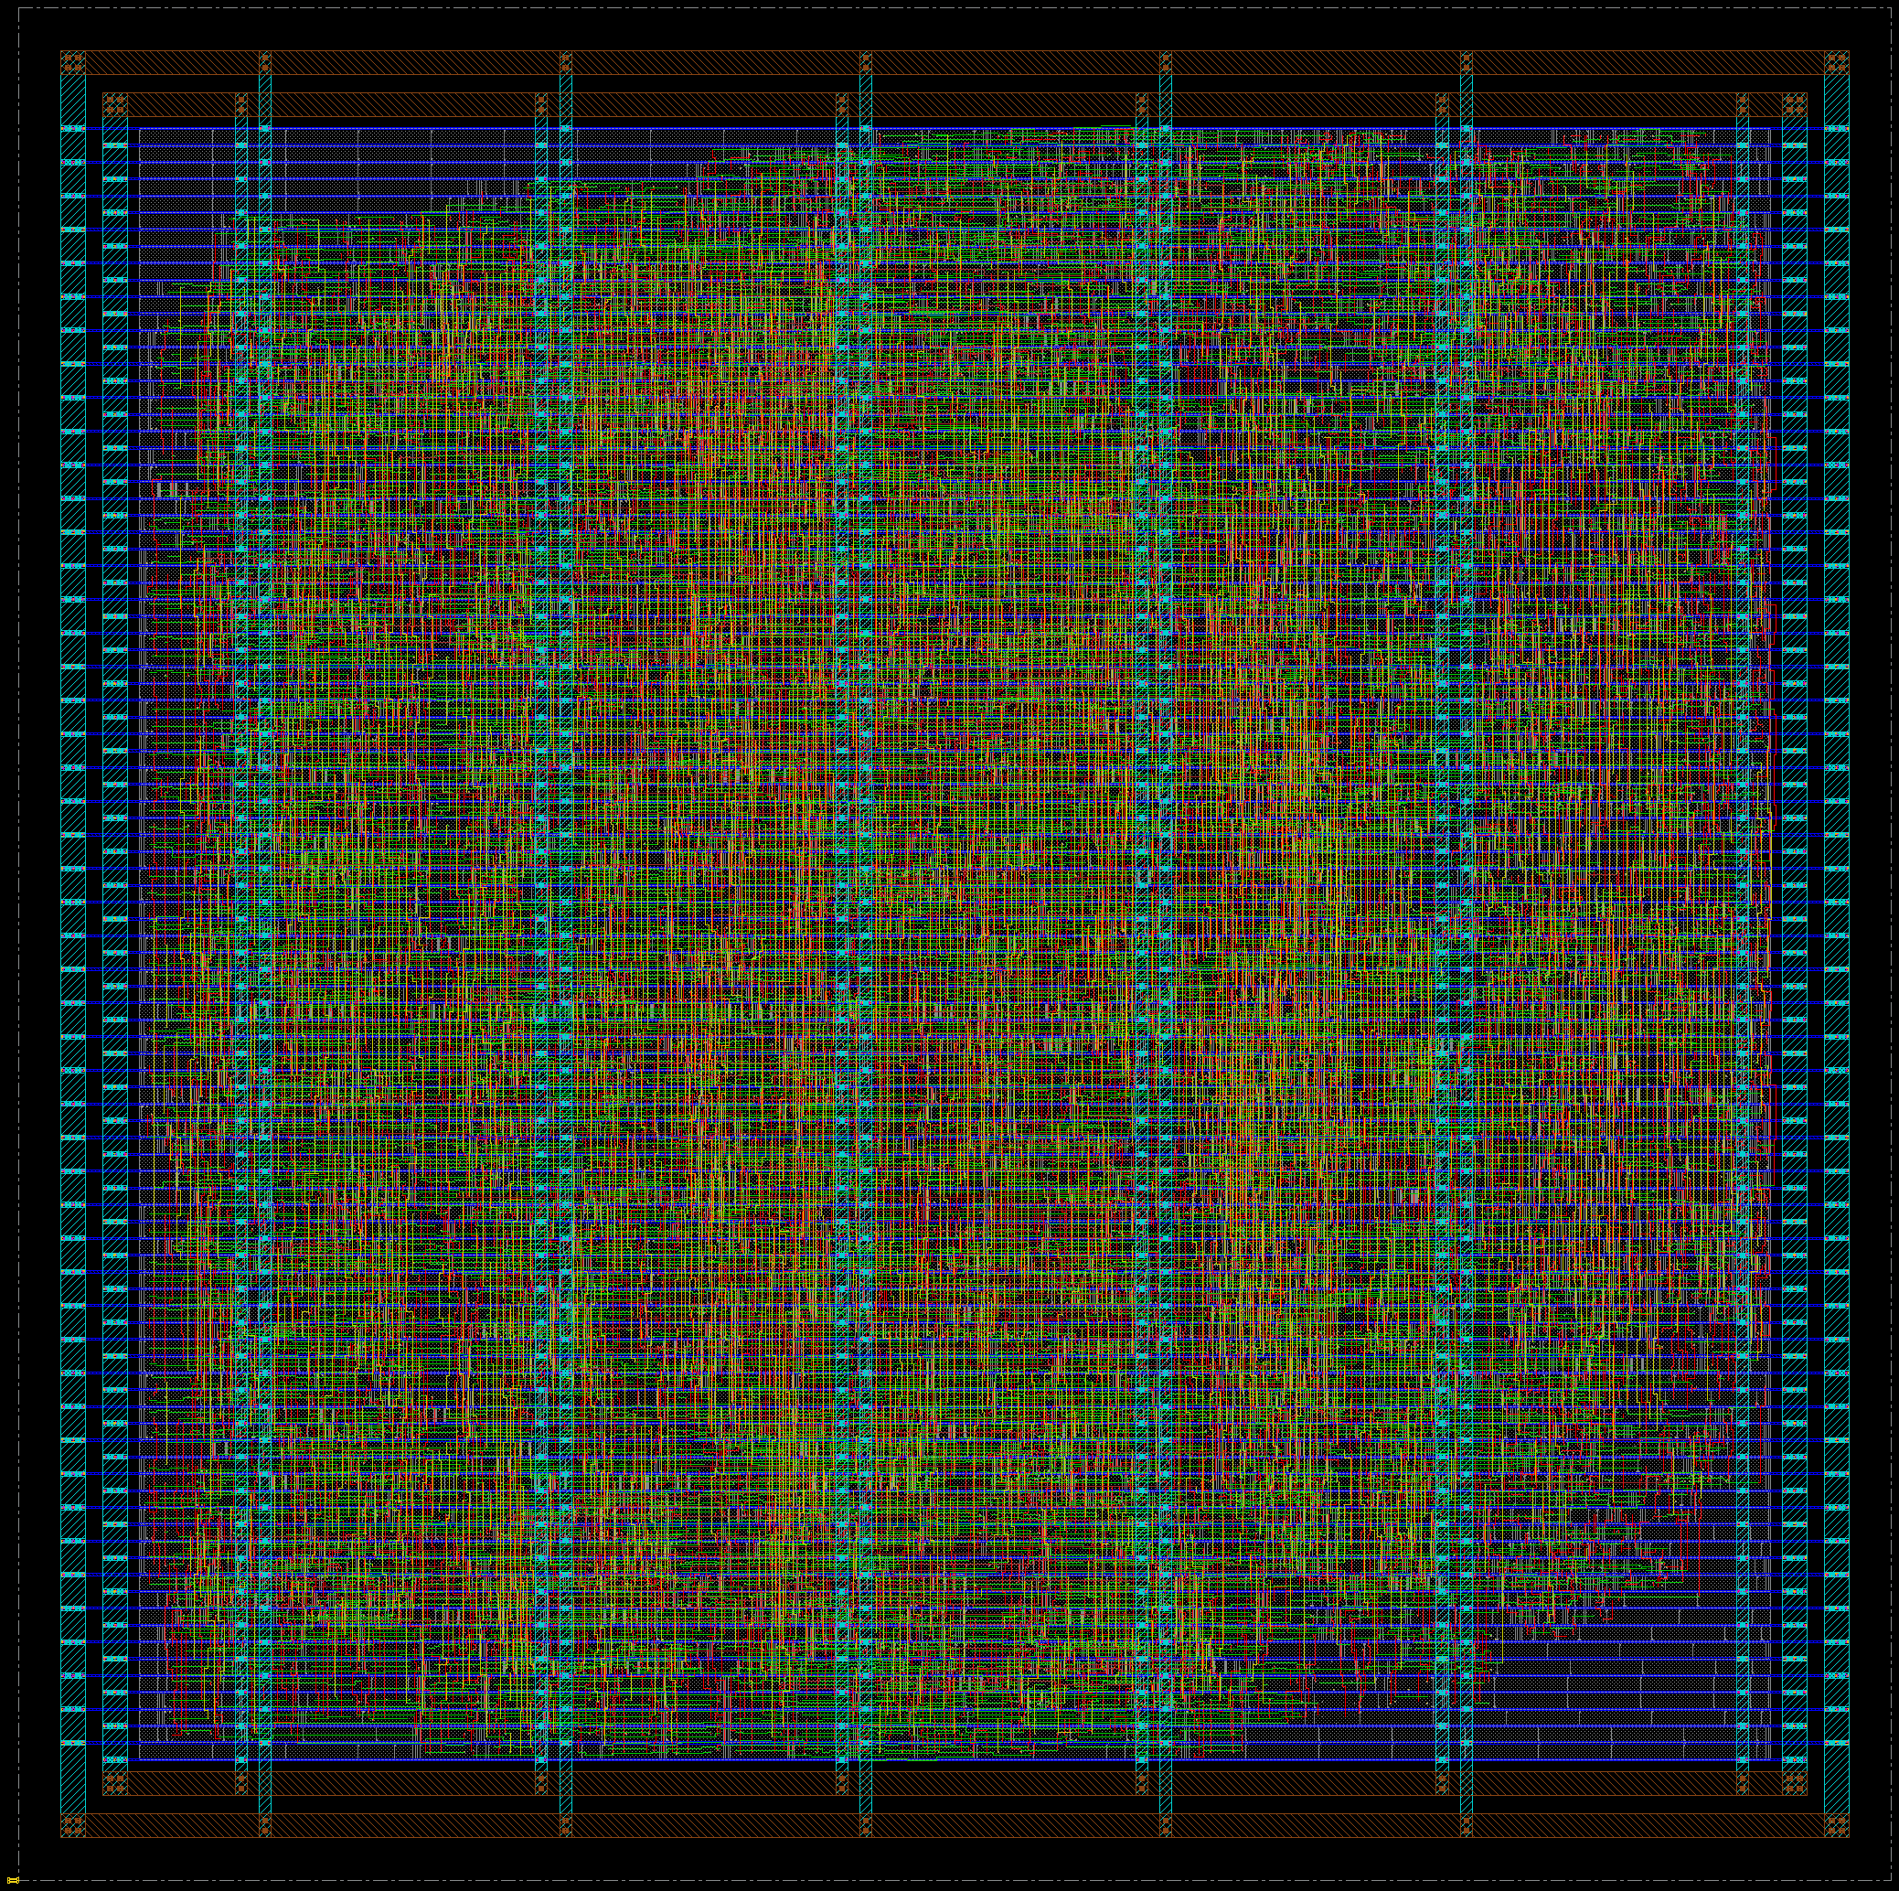
Figure 1: The routed die. The power ring occupies the 10 µm margin outside the core; five vertical stripes carry power inward. The blue horizontals are the metal1 supply rails, one per standard cell row.
The die is 155.99 × 155.96 µm. The core, where standard cells sit, is 135.85 × 135.80 µm across 97 rows of 1.4 µm each. The 10 µm border between them carries the power ring on metal8 and metal9 and contains no cells and no signal routing.
Achieved density is 73.9%, so roughly a quarter of the core is filler. It is not evenly distributed: measured from the placed design, the upper-left region is about 70% filler against 49% in the band right of centre. That is the placer minimising wirelength. Connected logic clusters, and the slack collects furthest from the netlist's centre of gravity. Routing overflow is 0.00% in both directions, so nothing was starved by it.

4. Timing Closure

4.1 Multi-Corner Results
Every run reports all three corners from a single routed database, so a typical number and a slow number can never be quoted apart. Implementation targets slow for setup and fast for hold.
Corner | Setup WNS (ns) | Setup violations | Hold WNS (ns) | Hold violations
Slow — SS 0.95 V 125 °C | 0.014 | 0 | 0.211 | 0
Typical | 2.229 | 0 | 0.056 | 0
Fast — FF 1.25 V −40 °C | 2.401 | 0 | 0.026 | 0

The slow corner is the signoff number. The typical figure is included because it is the one that flatters, and stating both is the point: a design reported only at typical has not been signed off.

4.2 On-Chip Variation
Analysis runs in onChipVariation mode. Setting that mode applies no margin on its own, so the headline figures above carry derates of 1.0. Re-judging the identical netlist with 5% derates is a measured result rather than an estimate:
Quantity | Derate 1.0 (as signed off) | Derate ±5%
Launch clock latency | 0.031 ns | 0.060 ns
Capture clock latency | 0.066 ns | 0.034 ns
Arrival time | 3.865 ns | 4.086 ns
Required time | 3.879 ns | 3.849 ns
Setup slack | 0.014 ns | -0.237 ns

The cost is 251 ps. Roughly 220 ps of that is the data path slowing by 5%. The remainder is the clock skew reversing sign: on-chip variation derates the launch clock late and the capture clock early, so 35 ps of useful skew becomes a 26 ps penalty. That second effect is the one most easily overlooked when estimating a derated result from an underated one.
A practical note for anyone reopening this database. restoreDesign initialises derates to the analysis mode's ±5% default rather than to the value the run used, so a restored session re-times this design at −0.237 ns until derates are explicitly set back to 1.0. Both sessions report the same analysis view and nothing warns.

4.3 The Critical Path
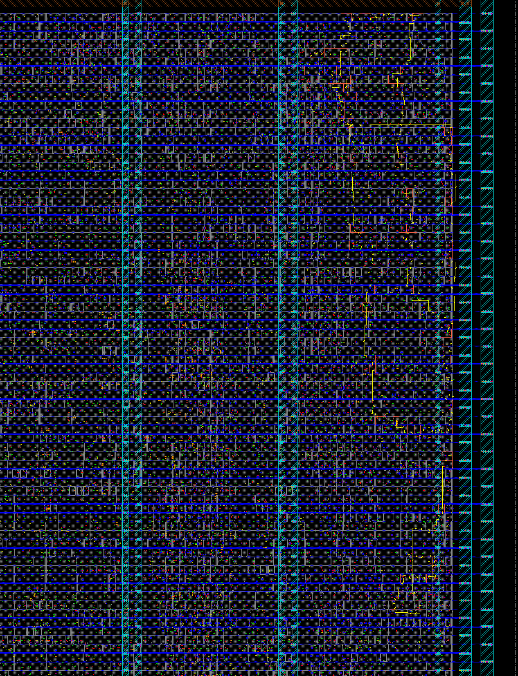
Figure 2: The worst setup path highlighted on the die. It runs down a narrow column against the right edge, which is the physical shape of the adder's carry chain.
The worst setup path launches from bit 5 of the instruction register in the fetch/decode boundary, crosses the immediate generator, and then walks the carry chain of pc_plus_imm, the 32-bit ripple-carry adder that computes the branch target, before arriving at bit 31 of the program counter. Sixty of its seventy-three instances are that carry chain.
Beginpoint datapath/IFID_instr_reg[5]/QN (v) triggered by clk
Endpoint datapath/IF_pc_reg[31]/D (^) checked with clk
Path group reg2reg Analysis view WC_VIEW
Required Time 3.879
- Arrival Time 3.865
= Slack Time 0.014 MET
The shape in Figure 2 is the structure of the adder. A ripple carry is linear, bit 0 feeding bit 1 feeding bit 2, so the placer lays it out as a line: pc_plus_imm occupies a column roughly 18 µm wide spanning 95 µm of the core's height, hard against the right edge. The critical path is that column. The floorplan shows the arithmetic.
A carry-lookahead alternative was implemented and measured rather than assumed. At the slow corner it came out 12 ps slower than ripple carry, 1,241 ps against 1,229 ps, at 741 cells against 1,129. Synthesis never sees a 32-bit addition to restructure, because the design instantiates one full adder per bit, so the topology change bought fewer cells and no speed.

4.4 Repeatability
Innovus is deterministic: an identical configuration returns a byte-identical result, so a single closure demonstrates nothing about repeatability. Utilisation was perturbed by ±0.01, which the utilisation sweep had already shown has almost no real effect between 0.60 and 0.70, and the configuration was run four times.
Utilisation | Setup WNS (ns) | Hold WNS (ns) | Closes
0.68 | +0.003 | +0.020 | yes
0.69 | +0.000 | +0.022 | yes
0.71 (signed off) | +0.014 | +0.026 | yes
0.72 | +0.002 | +0.015 | yes

Four closures of four, mean +5 ps, standard deviation 6 ps. The signed-off run at 0.71 measured the best of the four draws; the repeatability, not that individual figure, is the result.

5. Physical Verification

5.1 Design Rule Checking
verify_drc reports: No DRC violations were found.
A DRC count is not a DRC report. The summary says how many; only the geometry names the rule and the amount. The geometry report is archived with the run for that reason. An earlier iteration of this design carried four metal-spacing violations, every one exactly 1.000 µm wide, which pointed directly at a power ring spacing of 1 µm against a parallel-run-length rule that wanted 1.5.

5.2 Connectivity
verify_connectivity with geometric connection checking and zero permitted errors reports the design clean: no opens, no floating metal, no unconnected pins.

5.3 Logic Equivalence
Conformal LEC compares the routed netlist against the source RTL and reports 1,515 key points equivalent, with 2 unmapped. Both unmapped points are bit 0 of a program counter register, which is constant zero on word-aligned fetches and is therefore removed by synthesis. Nothing else is unmapped.
Unmapped points deserve reading rather than skimming. An unmapped key point is excluded from the comparison, so a clean equivalence count sitting above a list of unmapped registers is not the clean result it appears to be. Every entry here was classified before the result was accepted.

5.4 What Equivalence Cannot Catch
Formal equivalence compares two artifacts. If both were built from the same stale source, they are equivalent to each other and equally wrong. That failure mode cost two sessions on this project, and the first check on any gate-level anomaly is now the modification time of the netlist against the RTL.

6. Functional Verification of the Layout
Static timing analysis establishes that the layout meets its constraints. It does not establish that the layout computes the right answer. The routed netlist is therefore simulated against the same program and the same independently derived oracle used to verify the RTL.

6.1 Results
Tier | Delay model | Result
Zero delay | none | PASS, 0 errors
Typical | SDF, typical corner | PASS, 0 errors
Slow | SDF, SS 0.95 V 125 °C | PASS, 0 errors
Fast | SDF, FF 1.25 V −40 °C | PASS, 0 errors

All four tiers observe 25 of 25 architectural register writes, reach the last write at cycle 48 for a cycles-per-instruction of 1.41 over 34 dynamic instructions, and match the hand-derived final-state oracle exactly.

6.2 What This Proves, Stated Precisely
It proves that the routed netlist executes the program and reproduces every architectural register write. It does not prove the absence of timing violations. The Nangate cell models only enforce their setup and hold checks when the TETRAMAX macro is undefined, and that macro is required for these models to handle asynchronous reset correctly, so the conditioned timing checks are inactive during simulation. Setup and hold come from static timing analysis, in Section 4.
The distinction is worth labouring because the two claims look identical in a log file. A run that reports no violations and a run in which no check is alive produce the same output.

6.3 Reset Architecture
The reset is asynchronous and the port drives every flop's reset pin directly, with a false path declared from the port in the constraints. That waiver is stated rather than hidden: it leaves 4,041 unconstrained endpoints and 1,349 recovery checks untested.
It is the right constraint for this design. Asserting a reset asynchronously requires no timing, and with a single clock domain and no reset domain crossing there is no second clock for the release to be unrelated to. Recovery and removal become real checks only once the reset is sourced by a register, which is what a synchroniser provides.
A reset synchroniser was implemented and evaluated. It closed those checks, and it broke gate-level simulation from the first instruction of the program, reproducibly, across two synchroniser variants and at every corner. The failure was established as causal by a controlled A/B on an identical harness. The design ships with the waiver rather than with a reset network that cannot be simulated, and closing that gap properly is the first item of future work.

7. Area and Power

7.1 Area
Quantity | Value
Standard cells | 5,319
Sequential elements | 1,347
Filler cells | 7,857
Core area | 18,448 µm²
Achieved density | 73.9%
Total wirelength | 86,521 µm

7.2 Power
Total power is 3.199 mW at 250 MHz, estimated by Innovus against the routed parasitics with default switching activity.
Component | Power (mW) | Share
Sequential | 1.589 | 49.69%
Combinational | 0.877 | 27.42%
Clock network | 0.7323 | 22.89%
Total | 3.199 | 100%

Roughly half the power is in the sequential elements and nearly a quarter in the clock network, which is the expected shape for a design with 1,347 flops and no clock gating. Clock gating is the obvious first optimisation and is not implemented here.

7.3 Cell-Level Detail
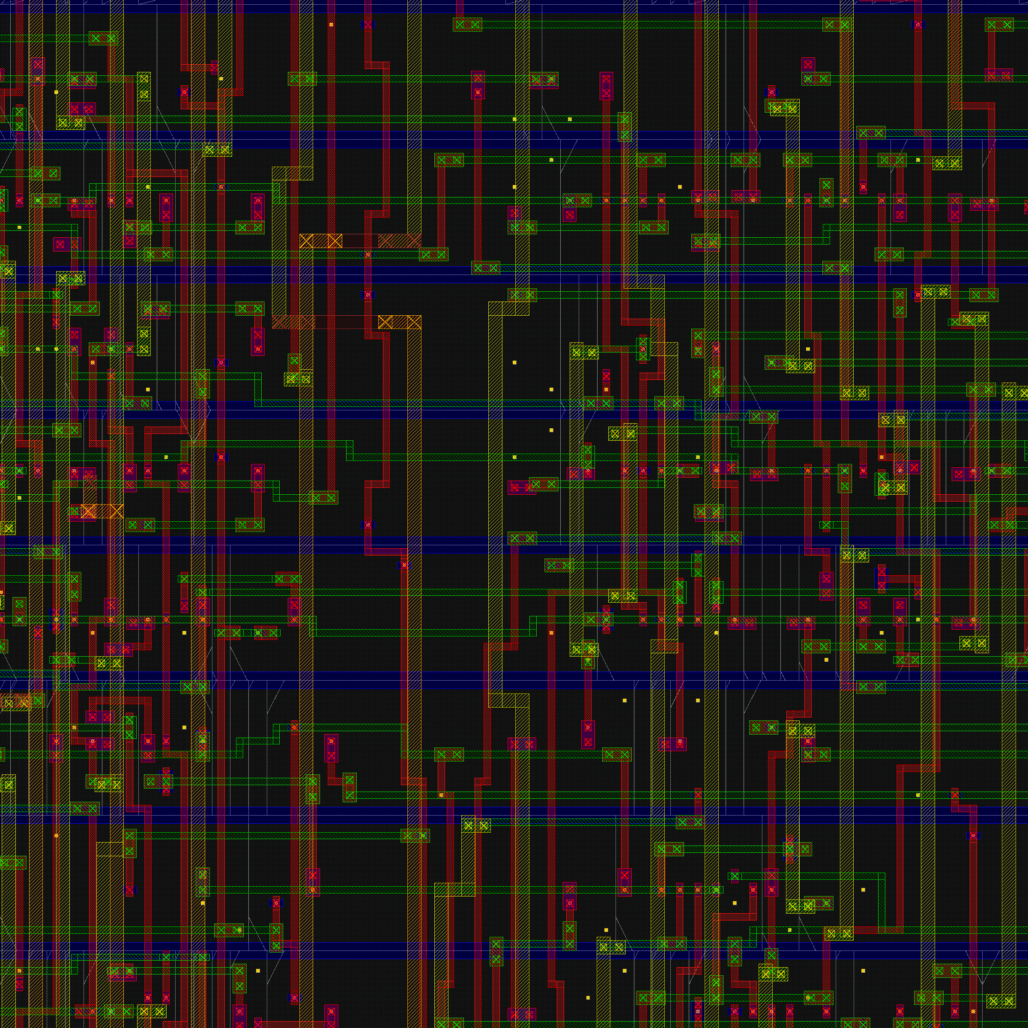
Figure 3: A 10 µm window into the standard cell rows. Blue horizontals are the metal1 supply rails bounding each row; red verticals and green horizontals are signal routing on the layers above; the crossed squares are vias.

8. Limitations
These are stated rather than omitted. Each has a specific cause, and the distinction between what the environment cannot do and what was not attempted is kept explicit.

8.1 Not Possible in This Environment
Check | Reason
Antenna | The Nangate 45 LEF carries no ANTENNAGATEAREA or ANTENNADIFFAREA properties, so there is no ratio to check against
LVS | No Pegasus available; there is no layout-versus-schematic tool in this environment
Signoff DRC | As above. The verify_drc result in Section 5.1 is the router's own checker, not an independent signoff tool
Independent signoff STA | No Tempus available, so Innovus serves as its own signoff timer
Hold coverage enumeration | report_analysis_coverage on Innovus 23.12 accepts neither -check_type hold nor -early. Hold results are verified directly instead

8.2 Not Attempted
Item | Note
IR drop analysis | Voltus rail analysis against the routed design has not been run. The power grid is unverified beyond connectivity
Design for test | No scan insertion, no test compression, no ATPG
Clock gating | Not implemented; see Section 7.2
Input/output delay | Set to 0.30 × the clock period rather than to a characterised figure. All fifty worst paths are register-to-register, so this does not contaminate the frequency result, but it remains an assumption

9. Conclusion
The pipelined RV32I processor has been implemented from RTL to a routed layout and closes at 4.00 ns, 250 MHz, at the slow corner with derates at 1.0. Setup worst negative slack is 0.014 ns and hold is 0.026 ns, both with zero violating paths across three corners. The layout is DRC clean and connectivity clean, formally equivalent to its source across 1,515 key points, and executes its verification program correctly at four simulation tiers.
The closure is repeatable, four times out of four at a mean of +5 ps. Under 5% on-chip variation derates the same netlist stands at −0.237 ns, and recovering that is an optimisation-margin problem rather than a clock-period one: the measured physical limit of this netlist is 3.83 ns, so the constraint rather than the silicon is what sets 4.00.
The two gaps worth naming are the reset synchroniser, which closes the recovery and removal checks the constraints currently waive but breaks gate-level simulation for reasons not yet explained, and IR drop analysis, which has not been attempted. Neither affects the results reported here, and both are stated so that the boundary of what has been verified is unambiguous.

