Design Verification Report
RISC-V Single-Cycle CPU
Top-Level Integration Testbench
Design Author: Elliot Staresinic
DUT: sc_cpu_top_level | Stimulus: program.mem (30 instructions)
Simulator: Icarus Verilog (iverilog -g2012)
Date: 2026-05-31 | Status: PASS
VERIFICATION RESULT: PASS (0 errors)



Contents
Contents 1
1. Executive Summary 1
2. Design Under Test 1
2.1 Supported Instruction Subset 1
2.2 Module Hierarchy 1
3. Verification Methodology and Testbench 1
3.1 Key Parameters 1
3.2 Lockstep Golden Model 1
3.3 Final-State Oracle 1
3.4 Supported Instruction Subset 1
3.5 Halt Condition and Watchdog 1
3.6 Waveform Dump 1
3.7 Per-Instruction Trace and Disassembler 1
3.8 Hierarchical References 1
3.9 Verification Task Reference 1
4. Program Under Test 1
4.1 Execution Trace 1
5. Verification Results 1
5.1 Lockstep Check 1
5.2 Final-State Oracle 1
5.3 Final Register File 1
5.4 Final Data Memory (non-zero words) 1
6. Functional Coverage 1
6.1 Coverage Matrix 1
6.2 Dead-Code Lines 1
7. Issues and Recommendations 1
7.1 Open Issues 1
7.2 Recommendations 1
8. Conclusion 1
Appendix A. Simulation Waveform

1. Executive Summary
This report documents the functional verification of a single-cycle RISC-V CPU at the top level (module sc_cpu_top_level). The design under test (DUT) was exercised with a 30-instruction program and checked against two independent reference oracles. All checks passed: the DUT register file, data memory, and program counter matched the golden reference at every committed instruction, and the hand-derived end-of-program state matched as well.
Result: PASS, 0 errors. 28 instructions executed before clean halt; the design terminated without watchdog intervention.
This program is a strong functional test of the supported instruction subset: every instruction type is exercised, and critically, all three conditional branches (beq, bne, blt) are tested in both the taken and not-taken directions. A small number of coverage gaps remain and are listed in Section 6.

2. Design Under Test
The DUT is a non-pipelined, single-cycle RV32I-subset processor using a Harvard architecture (separate instruction and data memories). Each instruction completes in one clock cycle. The program counter is reset asynchronously and advances on the rising clock edge.

2.1 Supported Instruction Subset
Category | Instructions | Notes
R-type | add, sub, and, or, slt | funct7 bit 5 selects sub vs. add
I-type | addi, andi, ori, slti | Immediate arithmetic; slti decodable
Load / Store | lw, sw | Word-aligned, computed base + offset
Branch | beq, bne, blt | One-hot branch control; PC-relative

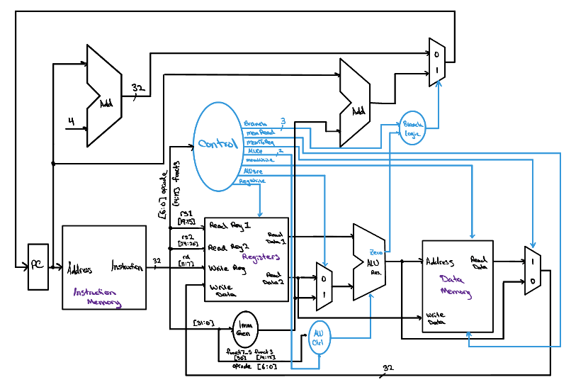
Figure 1: System Architecture

2.2 Module Hierarchy
sc_cpu_top_level
├── sc_cpu_control Main control unit (combinational, opcode-decoded)
├── alu_control ALU control unit (funct3/funct7 decode)
└── sc_cpu_datapath
├── instruct_mem Read-only instruction memory (loaded from program.mem)
├── imm_gen Immediate generator (I, S, SB, U, UJ formats)
├── reg_file 32x32-bit register file (2 read ports, 1 write port)
├── mux_2x1 ALU source mux; write-back mux; branch/increment mux (×3)
├── alu_full 32-bit ALU (ripple-carry, parameterized)
│ ├── alu_slice 1-bit ALU slice (bits [30:0])
│ │ ├── mux_2x1 Output select (ALU result vs. pass-through)
│ │ ├── mux_4x1 Operation select (add/sub, and, or, slt)
│ │ └── full_adder 1-bit full adder
│ └── alu_msb MSB ALU slice (overflow detection, setLess)
│ ├── mux_2x1 Output select (ALU result vs. pass-through)
│ ├── mux_4x1 Operation select (add/sub, and, or, slt)
│ └── full_adder 1-bit full adder (MSB, feeds overflow logic)
├── data_mem Clocked data memory (word-aligned, read/write enable)
└── ripple_carry_adder PC + 4 adder; PC + immediate adder (×2)

3. Verification Methodology and Testbench
The testbench (tb_sc_cpu_top_level) is a self-checking, top-level integration testbench targeting Icarus Verilog (iverilog -g2012). Verification uses two independent oracles so that a bug in either the design or the checking code is unlikely to escape undetected.

3.1 Key Parameters
Parameter | Value / Purpose
CLK_PERIOD | 10 ns — drives the always block that toggles clk
NUM_INSTR | 30 — halt boundary; simulation stops when ref_pc word index >= 30
DMEM_WORDS | 256 — number of 32-bit data-memory words checked each step
IMEM_WORDS | 256 — reference instruction-memory size (mirrored from program.mem)
MAX_STEPS | 1000 — runaway watchdog limit

3.2 Lockstep Golden Model
A behavioral RV32I-subset simulator (task ref_step) decodes and executes one RV32I instruction per call, maintaining its own ref_regs[0:31], ref_dmem[0:255], and ref_pc. It runs one instruction ahead of each DUT clock edge, encoding the correct architectural semantics. After every posedge clk the task check_state compares the DUT PC (dut.datapath.pc), all 32 register-file entries (dut.datapath.registers.RF[k]), and all 256 data-memory words (dut.datapath.data_memory.memory[k]) against the reference. Any mismatch is logged immediately with step number and field name.

3.3 Final-State Oracle
The tasks load_expected and check_final encode a hand-derived, independently computed table of the expected end-of-program register and memory state, checked once after halt. Because it is produced by a completely different method from the lockstep model (manual trace), agreement among DUT, lockstep model, and this table gives high confidence that a latent bug in the lockstep model itself has not masked a DUT defect.

3.4 Supported Instruction Subset
The golden model (task ref_step) decodes and executes the following RV32I instructions:
Opcode group | Instructions | Notes
OPC_RTYPE (0110011) | add, sub, and, or, slt | funct7[5] selects sub; signed compare for slt
OPC_ITYPE (0010011) | addi, andi, ori, slti | 12-bit sign-extended immediate
OPC_LOAD (0000011) | lw | Byte address = rs1 + imm_i; word-aligned
OPC_STORE (0100011) | sw | Byte address = rs1 + imm_s; word-aligned
OPC_BRANCH (1100011) | beq, bne, blt | PC-relative; signed compare for blt

3.5 Halt Condition and Watchdog
The main execution loop terminates when ref_pc[31:2] >= NUM_INSTR (30). Because the DUT uses the same program image and identical control flow, it reaches the same halt condition on the same clock edge. A global watchdog (initial block with absolute delay) triggers $finish after CLK_PERIOD * (MAX_STEPS + 50) nanoseconds if the loop has not already exited, preventing the simulator from hanging on a runaway design.

3.6 Waveform Dump
The testbench calls $dumpfile("waveforms/dump.vcd") and $dumpvars(0, tb_sc_cpu_top_level) in an initial block, producing a Value Change Dump covering the full hierarchy. The VCD is viewable in EPWave (EDA Playground) or any compatible waveform viewer such as GTKWave.

3.7 Per-Instruction Trace and Disassembler
After each step the task trace_print emits a formatted line containing the step counter, PC (hex), instruction word (hex), a pseudocode disassembly produced by the task disasm, and a plain-English description of the architectural effect (register write, store, branch taken/not taken, or no state change). The disasm task covers all opcodes in the supported subset and falls back to .word 0xXXXXXXXX for any unrecognized encoding.

3.8 Hierarchical References
The testbench accesses DUT internal state directly via hierarchical dot-notation paths, which must match the actual module and signal names in the RTL:
dut.datapath.pc — program counter
dut.datapath.registers.RF[k] — register file array (k = 0..31)
dut.datapath.data_memory.memory[k] — data memory array (k = 0..255)
If the RTL uses different instance or signal names, these three paths must be updated accordingly for the testbench to compile and link.

3.9 Verification Task Reference
Task | Role
disasm | Decode one 32-bit instruction word into pseudocode; covers all supported opcodes, falls back to .word for unknowns
ref_step | Decode and execute one instruction in the behavioral model; update ref_regs, ref_dmem, ref_pc; set trace variables
check_state | Compare DUT PC, all 32 registers, and all 256 data-memory words against the reference; print any mismatch
trace_print | Emit a human-readable per-instruction trace line: PC, hex encoding, pseudocode disassembly, effect
dump_final_state | Print the complete register file and all non-zero data-memory words at end of simulation
load_expected | Populate the hand-derived final-state oracle (exp_regs, exp_dmem)
check_final | Compare DUT final state against the oracle; report PASS or error count

4. Program Under Test
The 30-instruction program (program.mem) is loaded into both the DUT instruction memory and the reference model at simulation start via $readmemh. The execution trace below shows every committed instruction, the disassembled pseudocode, and the architectural effect. For detailed waveshape, see Appendix A.

4.1 Execution Trace
Step | PC | Encoding | Pseudocode | Effect
1 | 0x00000000 | 0x00100093 | addi x1, x0, 1 | x1 ← 0x00000001 (1)
2 | 0x00000004 | 0x00500113 | addi x2, x0, 5 | x2 ← 0x00000005 (5)
3 | 0x00000008 | 0x002081B3 | add x3, x1, x2 | x3 ← 0x00000006 (6)
4 | 0x0000000C | 0x40118233 | sub x4, x3, x1 | x4 ← 0x00000005 (5)
5 | 0x00000010 | 0xFFE20293 | addi x5, x4, -2 | x5 ← 0x00000003 (3)
6 | 0x00000014 | 0x0042E333 | or x6, x5, x4 | x6 ← 0x00000007 (7)
7 | 0x00000018 | 0x005273B3 | and x7, x4, x5 | x7 ← 0x00000001 (1)
8 | 0x0000001C | 0x00522433 | slt x8, x4, x5 | x8 ← 0x00000000 (0) — 5 < 3 false
9 | 0x00000020 | 0x0042A4B3 | slt x9, x5, x4 | x9 ← 0x00000001 (1) — 3 < 5 true
10 | 0x00000024 | 0x00302223 | sw x3, 4(x0) | dmem[1] ← 0x00000006
11 | 0x00000028 | 0x00800513 | addi x10, x0, 8 | x10 ← 0x00000008 (8)
12 | 0x0000002C | 0x00652223 | sw x6, 4(x10) | dmem[3] ← 0x00000007
13 | 0x00000030 | 0x407105B3 | sub x11, x2, x7 | x11 ← 0x00000004 (4)
14 | 0x00000034 | 0xFFC52603 | lw x12, -4(x10) | x12 ← dmem[1] = 0x00000006 (6)
15 | 0x00000038 | 0x00410663 | beq x2, x4, +12 | beq: x2=5 == x4=5 → TAKEN → 0x00000044
— | 0x0000003C | 0x003002B3 | add x5, x0, x3 | dead code — skipped by branch at step 15
— | 0x00000040 | 0x00F17693 | andi x13, x2, 15 | dead code — skipped by branch at step 15
16 | 0x00000044 | 0x00A02823 | sw x10, 16(x0) | dmem[4] ← 0x00000008
17 | 0x00000048 | 0x00F17713 | andi x14, x2, 15 | x14 ← 0x00000005 (5)
18 | 0x0000004C | 0x00411A63 | bne x2, x4, +20 | bne: x2=5 != x4=5? NOT taken
19 | 0x00000050 | 0x00311463 | bne x2, x3, +8 | bne: x2=5 != x3=6 → TAKEN → 0x00000058
— | 0x00000054 | 0x407105B3 | sub x11, x2, x7 | dead code — skipped by branch at step 19
20 | 0x00000058 | 0x00610233 | add x4, x2, x6 | x4 ← 0x0000000C (12)
21 | 0x0000005C | 0xFE1048E3 | blt x0, x1, -16 | blt: x0=0 < x1=1 → TAKEN → 0x0000004C
22 | 0x0000004C | 0x00411A63 | bne x2, x4, +20 | bne: x2=5 != x4=12 → TAKEN → 0x00000060
23 | 0x00000060 | 0x00326793 | ori x15, x4, 3 | x15 ← 0x0000000F (15)
24 | 0x00000064 | 0x00208663 | beq x1, x2, +12 | beq: x1=1 == x2=5? NOT taken
25 | 0x00000068 | 0x00114463 | blt x2, x1, +8 | blt: x2=5 < x1=1? NOT taken
26 | 0x0000006C | 0x00902A23 | sw x9, 20(x0) | dmem[5] ← 0x00000001
27 | 0x00000070 | 0x00928013 | addi x0, x5, 9 | x0 write discarded (result = 0x0000000C)
28 | 0x00000074 | 0x40238833 | sub x16, x7, x2 | x16 ← 0xFFFFFFFC (-4)
Instructions at PCs 0x3C, 0x40, and 0x54 are dead code: the branches at steps 15 and 19 cause execution to skip them entirely in this deterministic program.

5. Verification Results

5.1 Lockstep Check
The lockstep check fires after every clock edge and compares the DUT PC, all 32 registers, and all 256 data-memory words against the golden model. Zero mismatches were recorded across all 28 executed steps.

5.2 Final-State Oracle
The hand-derived oracle was compared against the DUT final state after halt. Zero mismatches were recorded. The complete expected and observed state is shown below.

5.3 Final Register File
Register | Expected (hex) | Observed (hex) | Comment
x0 | 0x00000000 | 0x00000000 | Hardwired zero — write at step 27 discarded
x1 | 0x00000001 | 0x00000001 | addi x1, x0, 1
x2 | 0x00000005 | 0x00000005 | addi x2, x0, 5
x3 | 0x00000006 | 0x00000006 | add x3, x1, x2
x4 | 0x0000000C | 0x0000000C | add x4, x2, x6 (step 20)
x5 | 0x00000003 | 0x00000003 | addi x5, x4, -2
x6 | 0x00000007 | 0x00000007 | or x6, x5, x4
x7 | 0x00000001 | 0x00000001 | and x7, x4, x5
x8 | 0x00000000 | 0x00000000 | slt x8, x4, x5 — false; not in non-zero set
x9 | 0x00000001 | 0x00000001 | slt x9, x5, x4 — true
x10 | 0x00000008 | 0x00000008 | addi x10, x0, 8
x11 | 0x00000004 | 0x00000004 | sub x11, x2, x7
x12 | 0x00000006 | 0x00000006 | lw x12, -4(x10) — loads dmem[1] = 6
x13 | 0x00000000 | 0x00000000 | Dead code — andi x13 skipped
x14 | 0x00000005 | 0x00000005 | andi x14, x2, 15
x15 | 0x0000000F | 0x0000000F | ori x15, x4, 3
x16 | 0xFFFFFFFC | 0xFFFFFFFC | sub x16, x7, x2
x17–x31 | 0x00000000 | 0x00000000 | Not written

5.4 Final Data Memory (non-zero words)
Word index | Byte address | Expected (hex) | Observed (hex) | Source instruction
1 | 0x04 | 0x00000006 | 0x00000006 | sw x3, 4(x0)
3 | 0x0C | 0x00000007 | 0x00000007 | sw x6, 4(x10)
4 | 0x10 | 0x00000008 | 0x00000008 | sw x10, 16(x0)
5 | 0x14 | 0x00000001 | 0x00000001 | sw x9, 20(x0)

6. Functional Coverage

6.1 Coverage Matrix
Coverage Point | Status | Notes
R-type: add | COVERED | Steps 3, 20
R-type: sub | COVERED | Steps 4, 13, 28
R-type: and | COVERED | Step 7
R-type: or | COVERED | Step 6
R-type: slt (false result) | COVERED | Step 8
R-type: slt (true result) | COVERED | Step 9
I-type: addi (positive imm) | COVERED | Steps 1, 2, 11
I-type: addi (negative imm) | COVERED | Step 5 (-2)
I-type: addi to x0 (discard) | COVERED | Step 27: addi x0, x5, 9 — write suppressed
I-type: andi | COVERED | Step 17 (andi x14)
I-type: ori | COVERED | Step 23
I-type: slti | NOT COVERED | Decodable but not present in program
Load: lw (negative offset) | COVERED | Step 14: lw x12, -4(x10) → loads dmem[1]
Store: sw (positive offset) | COVERED | Steps 10, 12, 16, 26
Branch: beq taken | COVERED | Step 15: beq x2, x4 (both = 5)
Branch: beq not taken | COVERED | Step 24
Branch: bne taken | COVERED | Steps 19, 22
Branch: bne not taken | COVERED | Step 18: bne x2, x4 (both = 5)
Branch: blt taken | COVERED | Step 21: blt x0, x1 (0 < 1)
Branch: blt not taken | COVERED | Step 25: blt x2, x1 (5 < 1 false)
x0 write suppression | COVERED | Step 27 confirms hardwired-zero behaviour
Registers x17–x31 written | NOT COVERED | Only x0–x16 are touched
Data memory word index > 5 | NOT COVERED | Only indices 1, 3, 4, 5 written

6.2 Dead-Code Lines
Three instructions are never executed: add x5, x0, x3 at PC 0x3C, andi x13, x2, 15 at PC 0x40, and sub x11, x2, x7 at PC 0x54. The first two are skipped by the taken branch at step 15; the third is skipped by the taken branch at step 19. All three are present in the program image and decoded by the reference disassembler but contribute no architectural effect.

7. Issues and Recommendations

7.1 Open Issues
# | Issue | Details
1 | slti not exercised | The I-type ALU slice for slti (funct3=010) is present in both the RTL and the golden model but is never triggered by the current program. A one-instruction extension to the test program would close this gap.
2 | Upper registers unexercised | Registers x17 through x31 are never written. A follow-on test that exercises the full register file would increase confidence in the register-file address decoding.
3 | Data memory sparsely exercised | Only word indices 1, 3, 4, and 5 are written. A supplementary program that exercises boundary indices (0, 255) and adjacent words would improve confidence in the address decoder.

7.2 Recommendations
- Supplement program.mem with a short follow-on sequence that covers slti and at least one upper register (x17+).
- Consider adding a `timescale directive to each RTL module to eliminate the Icarus Verilog timing-precision warning that appears when mixed-timescale designs are compiled together.
- Add a fault-injection run: force one register to a wrong value mid-simulation and confirm that the lockstep check flags it immediately.
- Extend data-memory testing to include word index 0 and the upper boundary (index 255) to stress the address decoder.

8. Conclusion
The single-cycle RISC-V CPU (sc_cpu_top_level) passes all verification checks on the 30-instruction test program. The dual-oracle testbench reported zero errors from the lockstep comparison and zero errors from the independent hand-derived final-state check. The design correctly implements addition, subtraction, bitwise AND/OR, set-less-than, immediate arithmetic, load-word (negative offset), store-word, and all six branch cases (beq/bne/blt, both taken and not-taken). The x0 write-suppression path was also exercised. The remaining coverage gaps are minor and are addressed by the recommendations in Section 7.

Appendix A. Simulation Waveform
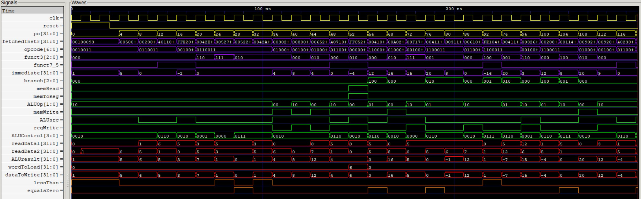
The waveform below shows the DUT signal activity captured during the 30-instruction simulation run. Signals are grouped by function: clock, reset, and pc (yellow), instruction decode (violet), control (green), data words (red), and ALU control signals (orange).

