AWS NETWORKING LAB
Custom VPC Build Guide

ez-custom-vpc
End-to-end walkthrough: VPC · Subnets · Route Tables · EC2 · NAT Gateway

Version 1.0 · AWS Infrastructure

Overview
This guide walks through the complete setup of a custom AWS Virtual Private Cloud (VPC) named ez-custom-vpc, including subnets, route tables, internet and NAT gateways, EC2 instances, security groups, and IAM roles for Session Manager access.

VPC Name: ez-custom-vpc
CIDR Block: 10.0.0.0/24
Region: Multi-AZ (us-east-1a / us-east-1c)
DNS Resolution: Enabled | DHCP Option Set: Enabled

Step 1 — Create the VPC
STEP 01 VPC Configuration
Create a new VPC with the following settings in the AWS Console under VPC → Your VPCs → Create VPC.

Setting | Value
Name tag | ez-custom-vpc
IPv4 CIDR | 10.0.0.0/24
DNS hostnames | Enabled
DNS resolution | Enabled
DHCP option set | Enabled (default)

Step 2 — Internet Gateway & Subnets
STEP 02 Create & Attach Internet Gateway
Navigate to VPC → Internet Gateways → Create Internet Gateway. After creation, attach it to ez-custom-vpc.

- Name: E-IGW-Custom
- Action: Attach to VPC → ez-custom-vpc
- Verify: IGW State should show Attached

STEP 03 Create Subnets
Navigate to VPC → Subnets → Create Subnet. Associate each subnet with ez-custom-vpc and assign the CIDR blocks below. Enable auto-assign public IPv4 on the two public subnets.

Subnet Name | CIDR Block | AZ | Type / Notes
Public-1a | 10.0.0.0/26 | us-east-1a | Public — Auto-assign IPv4
Public-1c | 10.0.0.64/26 | us-east-1c | Public — Auto-assign IPv4
Private-1a | 10.0.0.128/26 | us-east-1a | Private
Private-1c | 10.0.0.192/26 | us-east-1c | Private

The subnet layout covers the full 10.0.0.0/24 block, split into four /26 subnets (64 IPs each):
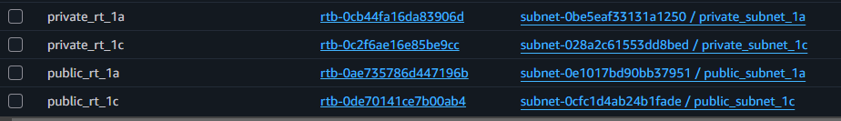
Figure 1 — Subnet CIDR allocation across availability zones

Step 3 — Route Tables
STEP 04 Create Route Tables
Create four route tables — one per subnet — and associate each with ez-custom-vpc. Navigate to VPC → Route Tables → Create Route Table.

- private_rt_1a → Associate with Private-1a
- private_rt_1c → Associate with Private-1c
- public_rt_1a → Associate with Public-1a
- public_rt_1c → Associate with Public-1c

Add Internet Route for Public Subnets
For each public route table, add a route that sends all outbound traffic (0.0.0.0/0) to the internet gateway E-IGW-Custom. This enables full internet access from public subnets.

Destination | Target | Route Table
0.0.0.0/0 | E-IGW-Custom (igw-xxxxx) | public_rt_1a, public_rt_1c

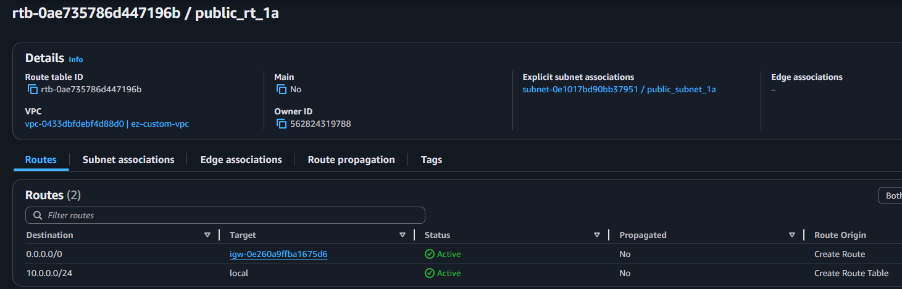
Figure 2 — Public route table with 0.0.0.0/0 → E-IGW-Custom

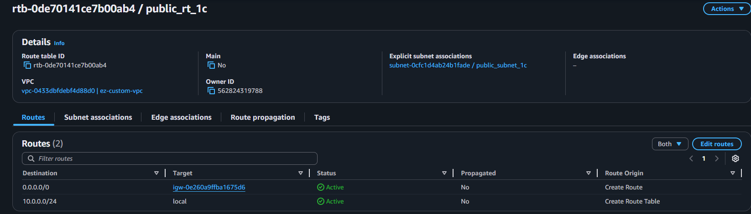
Figure 3 — Route table association view

Step 4 — EC2 Instances
STEP 05 Launch Public & Private EC2 Instances
Launch two Amazon Linux 2 EC2 instances to validate routing. Navigate to EC2 → Launch Instance.

Public Instance
- AMI: Amazon Linux 2
- VPC: ez-custom-vpc
- Subnet: Public-1a
- Auto-assign Public IP: Enabled

Private Instance
- AMI: Amazon Linux 2
- VPC: ez-custom-vpc
- Subnet: Private-1a
- Auto-assign Public IP: Disabled

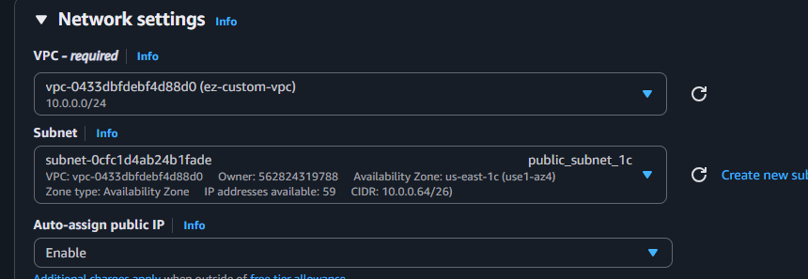
Figure 4 — EC2 network configuration panel

Step 5 — Security Group
STEP 06 Create Security Group for Testing
Navigate to EC2 → Security Groups → Create Security Group. Attach this security group to both EC2 instances. Configure inbound rules appropriate for your testing needs (e.g., SSH from your IP, or restrict all and rely solely on Session Manager).

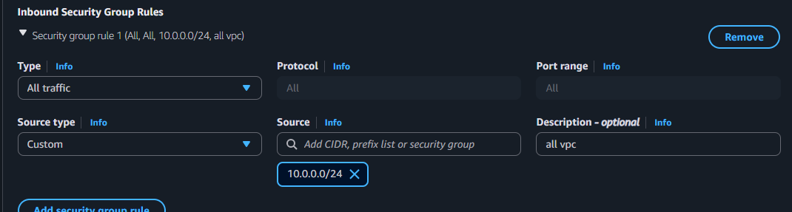
Figure 5 — Security group inbound rule configuration

Step 6 — IAM Instance Profile & Session Manager
STEP 07 Create IAM Role for SSM
To connect EC2 instances via AWS Systems Manager Session Manager (without SSH or a bastion host), the instance requires an IAM role with SSM permissions.

Create the Role
- Navigate to IAM → Roles → Create Role
- Trusted entity: AWS Service → EC2
- Attach policy: AmazonSSMManagedInstanceCore
- Name the role (e.g., EC2-SSM-Role) and create

Attach Role to EC2 Instance
- Go to EC2 → Instances → select your public instance
- Actions → Security → Modify IAM Role
- Select the role you just created → Update IAM role

Figure 6 — IAM instance profile attached to EC2

Connect via Session Manager
Once the role is attached, navigate to EC2 → Instances → select instance → Connect → Session Manager tab → Connect.

Note: SSM Agent must be running on the instance. Amazon Linux 2 includes it by default.
Ensure the instance has internet access (or VPC endpoints) to reach the SSM service endpoints.

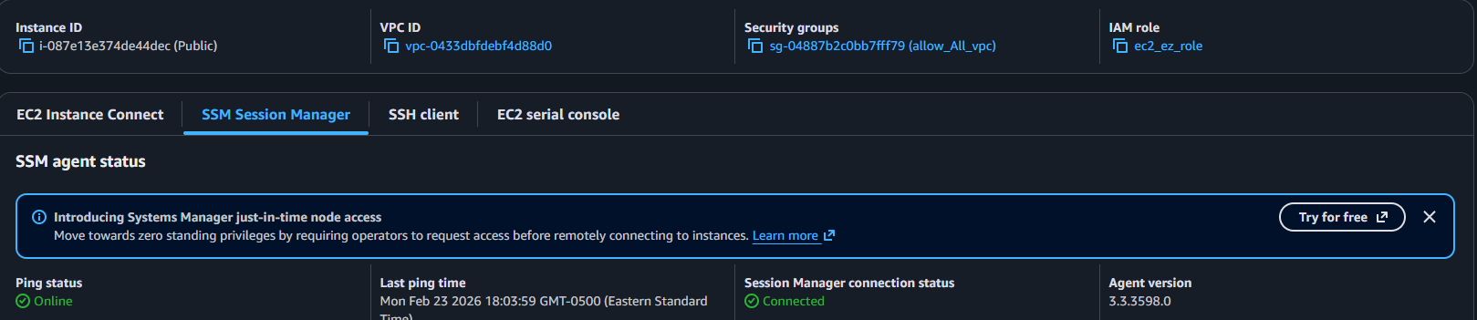
Figure 7 — Successful Session Manager connection to public EC2

Verify SSM Permissions
Confirm the attached role includes AmazonSSMManagedInstanceCore. Without this policy, Session Manager connectivity will fail.
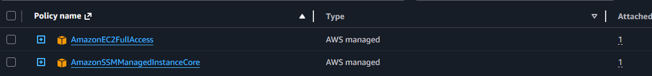
Figure 8 — IAM role policy verification

Test Internet Routing
From the Session Manager terminal on the public EC2 instance, run a traceroute to verify the IGW routing path:
$ traceroute www.google.com
A successful trace confirms the public subnet → route table → IGW path is functioning correctly.

Step 7 — NAT Gateway for Private Subnets
STEP 08 Enable Outbound Internet for Private Subnets
Private subnets do not have a direct path to the internet. To allow outbound internet access from private instances (e.g., for software updates), you must deploy a NAT Gateway or configure VPC endpoints for AWS services.

Create the NAT Gateway
- Navigate to VPC → NAT Gateways → Create NAT Gateway
- Subnet: Deploy into a public subnet (Public-1a or Public-1c)
- Connectivity type: Public
- Subnet level: Zonal
- Elastic IP: Click Allocate Elastic IP to assign a static public IP

Important: NAT Gateways must be deployed into a public subnet.
They route traffic from private subnets out through the IGW.
Hourly charges apply — delete the NAT Gateway when no longer needed.

Update Private Route Tables
After the NAT Gateway is available, add a route in each private route table to send outbound traffic through it.

Destination | Target | Route Table
0.0.0.0/0 | nat-xxxxxxxxxxxxxxxxx | private_rt_1a, private_rt_1c

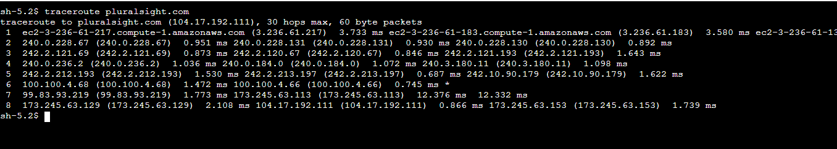
Figure 9 — Private subnet route table with NAT Gateway route

Alternative: VPC Endpoints
If you only need private instances to communicate with AWS services (SSM, S3, etc.) without full internet access, consider using three Interface VPC Endpoints instead of a NAT Gateway:
- com.amazonaws.<region>.ssm
- com.amazonaws.<region>.ssmmessages
- com.amazonaws.<region>.ec2messages

Notes:
- Private DNS must be enabled for fully private subnets
- Security groups attached to endpoints allow inbound TCP 443 from EC2 SG
- Test DNS resolution of SSM endpoints: nslookup ssm.us-east-1.amazonaws.com

Architecture Summary
Component | Resource | CIDR / ID | Notes
VPC | ez-custom-vpc | 10.0.0.0/24 | DNS + DHCP enabled
IGW | E-IGW-Custom | — | Attached to VPC
Subnet | Public-1a | 10.0.0.0/26 | Auto-assign public IP
Subnet | Public-1c | 10.0.0.64/26 | Auto-assign public IP
Subnet | Private-1a | 10.0.0.128/26 | No public IP
Subnet | Private-1c | 10.0.0.192/26 | No public IP
Route Table | public_rt_1a/1c | 0.0.0.0/0 | → E-IGW-Custom
Route Table | private_rt_1a/c | 0.0.0.0/0 | → NAT Gateway
NAT Gateway | nat-xxx | Elastic IP | In public subnet
EC2 (public) | Amazon Linux 2 | Public-1a | SSM + public IP
EC2 (private) | Amazon Linux 2 | Private-1a | SSM via NAT/endpoints
IAM Role | EC2-SSM-Role | — | AmazonSSMManagedInstanceCore

End of Document — ez-custom-vpc Build Guide

