Notes for LMI

02/23/2024
Setting up the ZigBee network with a raspberry pi 5 device, ZigBee MQTT mosquito, and a ZigBee Dongle P
Capture using the nRF52480 dongle device
Able to capture information when a device joining a ZigBee network
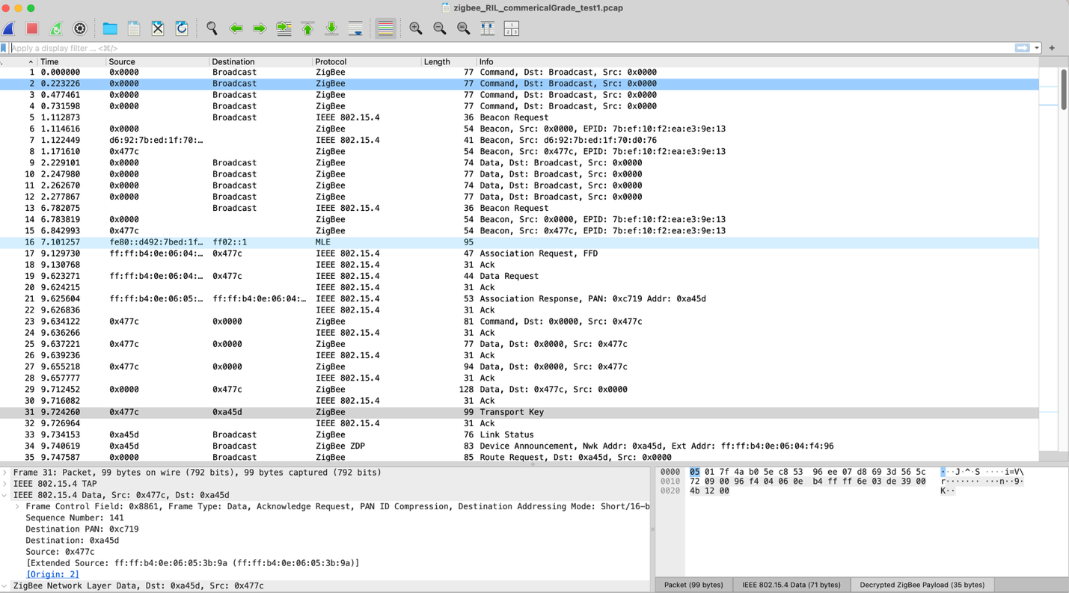
Able to apply a filter to get the transport keys
Able to narrow it down to packet 31 contains:
- Standard Network Key transmitted at Transport Key
