Quiz 1
Esteban Calvo

1) To show that there exists a unique stable matching of students and hospitals if and only if we can first start by proving that if there exists a unique stable matching, then . This part is self explanatory as a unique stable matching by definition requires there be only one matching and so must be equal to . Now, we need to prove that if , then there exists a unique stable matching. For this, can say for the sake of contradiction there is not one unique stable matching. In this case and have at least one different pairing (h,s) than and where h and s are matched differently than and . The problem with this is that the Gale-Shapley algorithm by definition always produces the same matching so the only way to change the pairing would be to change the order of picks. Therefore, there is no way to get a different matching assuming the same ordering and thus the proof by contradiction is complete.

2) Given the following chart

we can apply the Gale-Shapley algorithm which guarantees a unique stable matching. To do this, we can start with h1 which will choose s1 as it is unmatched. Then, we can go to h2 which prefers s1 but s1 prefers h1 and thus h2 will take s2. Then, h3 will try and get s1, but s1 prefers h1 and s2 prefers s2 so h3 gets s3. This same pattern repeats for all iterations since the students preferred hospital is shifted over one after every iteration ensuring the next hospital pick will never get any of their first picks. Therefore, we are left with a diagonal matching such that h1 matches s1, h2 matches s2, h3 matches s3, h4 matches s4, and h5 matches s5.

Now, to ensure this matching is unique, we need to run it in the reverse direction such that the students are the proposers in this scenario. Starting with s1, s1 prefers h1 and h1 is unmatched therefore s1 matches with h1. Now, s2 proposes to h2 and h2 is unmatched so s2 matches with h2. Because the order is shifted over one for each, s1-s5 will all match with the corresponding h1-h5 and therefore the matches are the same either way and we ensure there is a unique stable matching as shown in the proof for problem 1 as M1 = M2 in this problem.

3) The main difference between Big O and Little O is that for Big O, there exists a constant such that f(n) cg(n) where as with Little O, this must hold for every constant c > 0. We can therefore use a counterexample to show that this does not hold. Assume we are given that f(n) = 2n and g(n) = n. f(n) in this case is O(n) as we can say that 2n < cn when c is 3. Now, we must show that f(n) is not o(n). To do this, we can again set this up as 2n cn but if c = 1, then c > 0 and 2n > n thus g(n) must be for it to be o(g(n)) of f(n).

4)

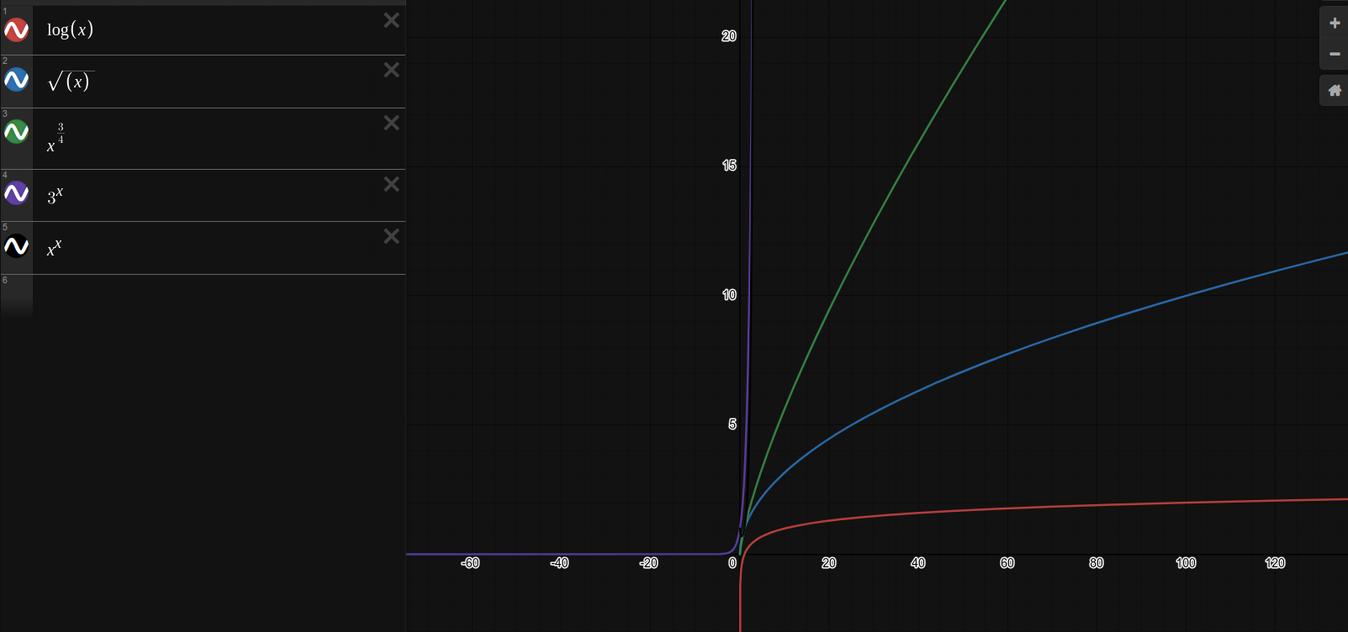
A simple way to tell was to plot the graphs, we can see clearly that log(n) < < and is larger than as evident when n = 4 as . Therefore, the final ordering is

5) To disprove this statement, we can provide a counter example with 8 nodes such that there is only one edge between every node.

a – b – c – d – e – s – v – t

In this example, the only path between s, t and v has 2 edges and therefore the statement is false.

6)

a) In a tree, there is a unique path to get from one node to another. Nodes on the same level are not connected and must traverse up a common ancestor. However, in this example, the weights could be negative. Consider the following tree

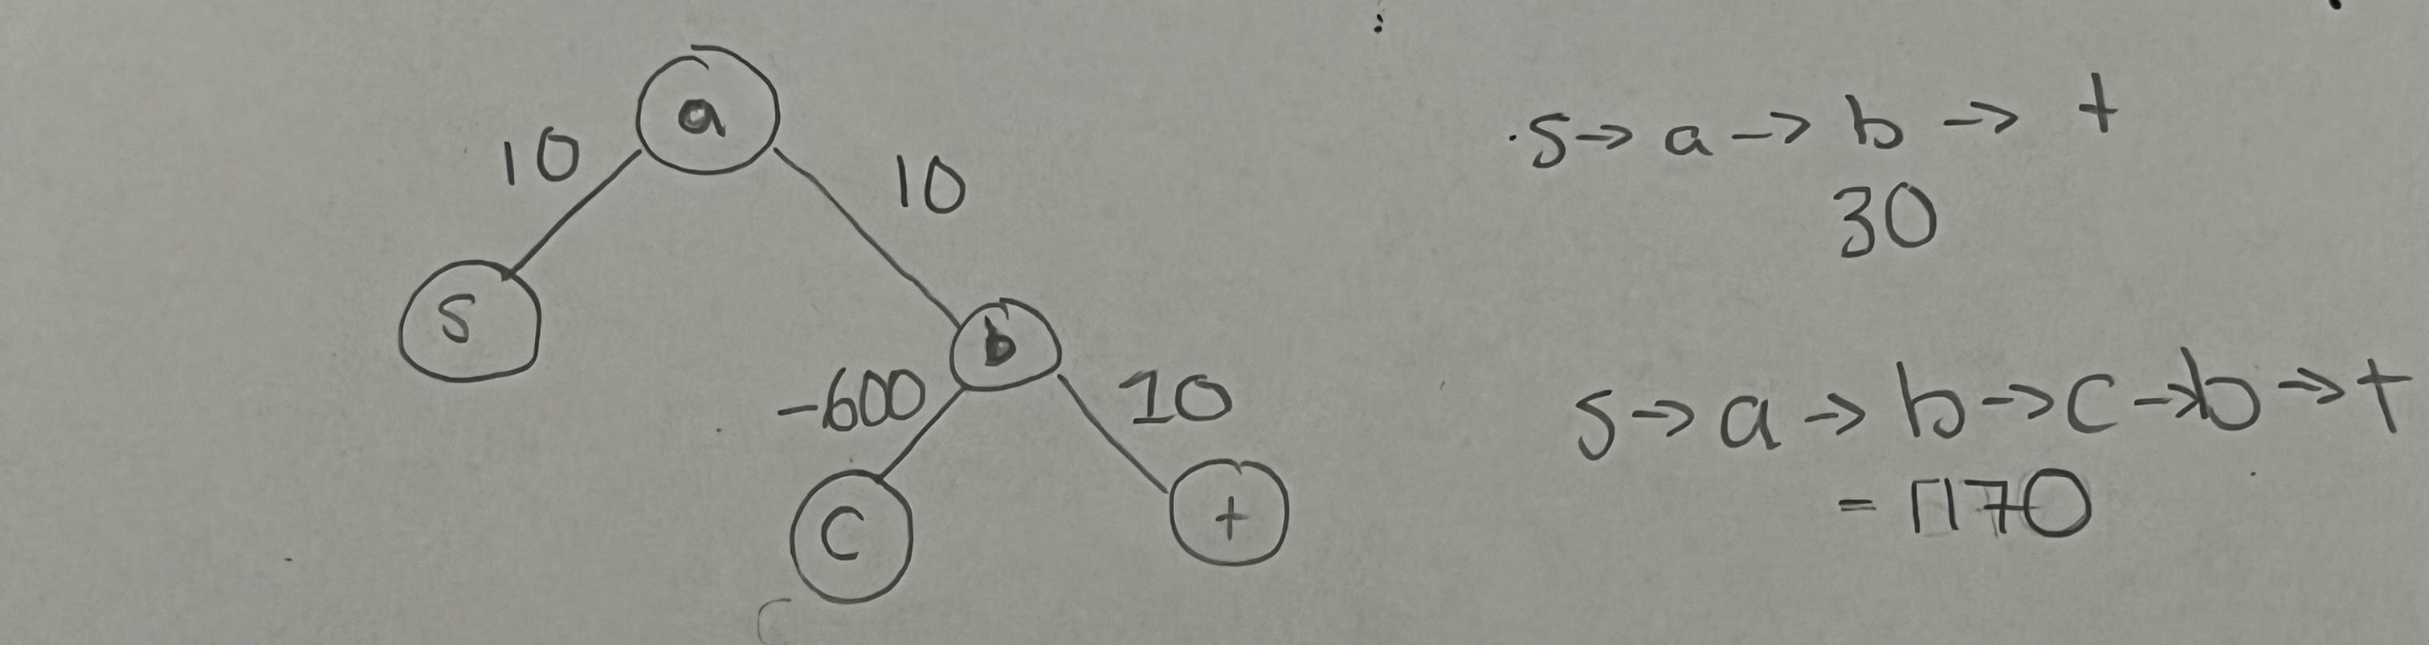
In this example, we can loop around from b to c and then back to b and because we use a negative weight, the weight of the path is much lower than going directly to t.

b) If we require the path to be a simple path, then there is only one path from s to t as we can only travel up and down ancestors and cannot hop around on the same level. Therefore, the only path is by definition also the minimum-weight path.

c) If we now add a stipulation that there are no negative weights, then any additional edge will only increase the weight. Therefore, the simple path that goes directly to t will be the shortest path and the minimum weight path.

