Key 1:
find / -type f -name “KEY*” 2>/dev/null to find the file with word key in it and discard files I don’t have access to.

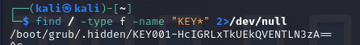

Key 2:
man ps | grep “must have a tty” was used to see what command to use and then ps -x | grep “KEY002” was used to find the second key.
