Simple Clock
The purpose of this exercise is to draw a simple and static clock on the screen, displaying today’s hour.

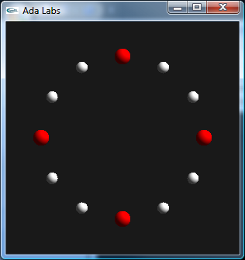
Question 1
Draw twelve balls on the screen, representing the twelve hours.
The packages Display and Display.Basic contain the necessary primitives for drawings simple shapes on the screen. More specifically, the function New_Circle creates a circle on the board.
This board is centered on [0.0, 0.0], and goes from [-100.0, -100.0] to [100.0, 100.0].
Cos, Sin functions and the value of Pi will be needed to perform this operation – they can be found in the packages Ada.Numerics and Ada.Numerics.Elementary_Functions.

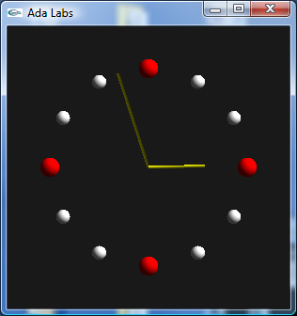
Question 2
Draw the needles according to the current minute and hour. Time can be retrieved using the function Clock from the package Ada.Calendar. The package Ada.Calendar.Formatting contains the necessary subprogram to extract the actual minute and hour from the result of clock.
Getting the precise hour requires some additional work – it needs to take into account the UTC time offset. Computing the current hour is given by the following line of code:
T : Time := Clock;
H : Hour_Number := Hour (T, UTC_Time_Offset (T));

