Live Clock
The purpose of this exercise is to draw a clock on the screen that moves as time evolves

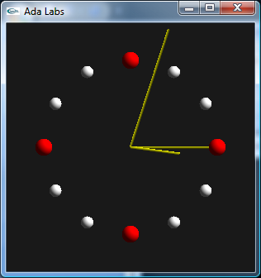 | Question 1  Go back to the Clock exercise. Now instead of creating twelve variables for the twelve balls, use only one variable in a loop from 1 to 12.  Question 2  After the creation of the balls, create an infinite loop, updating the hours, minutes and seconds hands at each iteration. In order to avoid implementing an active loop, you may want to wait one second between iterations, using the delay or delay until Ada instruction.

