Shooting at a red ball
The purpose of this exercise is to refactor a simple game containing a foe, a bullet and a player.

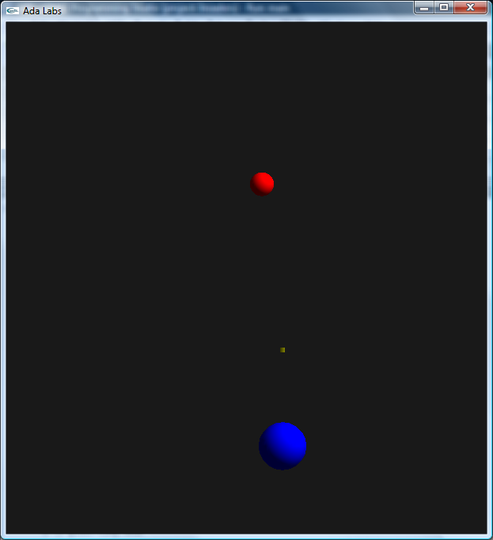 | In this game, the player is represented by a blue ball at the bottom of the screen. He can move left and right using the left and right key of the keyboard – but can’t go outside of the [-100.0, 100.0] region. The red balls are enemies, falling from the top of the screen to the bottom. They appear randomly, and move left or right. Each time they reach a horizontal boundary of the screen, they rebound.  If a ball manages to go beyond the bottom of the screen, then the player has lost. In order to avoid that, he can fire a bullet by pressing “space”, these bullets will go straight from the location of the player to the top of the screen, and will destroy the first ball they encounter.  Question  Look at the code in main.adb. Create a new package Invaders, and move as many services to this package, abstracting as much as possible the notion of Player, ball and ammo.

