Completely hidden ball
The purpose of this exercise is to improve the refactoring done in the previous exercise.

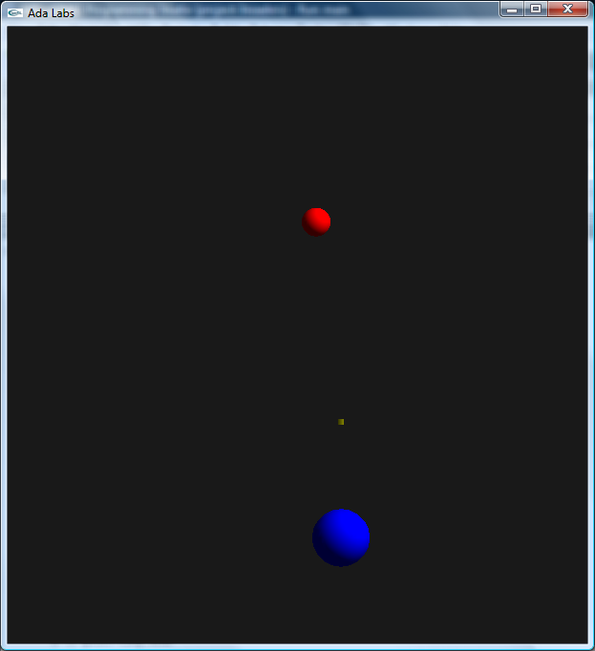 | Question 1  Take the solution from the packages exercise. Introduce three private types, Ammo_Type, Player_Type and Foe_Type, completely hidden, and use these subprograms in the main subprogram. Do not expose the coordinates of objects through setter & getter, but try to introduce new functions if needed.  Question 2  Discuss the introduction of the relationship between these objects in the public part (e.g. Ammo_Type derives from Object, etc). What are the improvements in terms of structure? Are there drawbacks?

