Simple Space Invaders
The purpose of this exercise is to create a simple game.
In this game, the player is represented by a blue ball at the bottom of the screen. He can move left and right using the left and right key of the keyboard – but can’t go outside of the [-100.0, 100.0] region. The red balls are enemies, falling from the top of the screen to the bottom. They appear randomly, and move left or right. Each time they reach a horizontal boundary of the screen, they rebound.
If a ball manages to go beyond the bottom of the screen, then the player has lost. In order to avoid that, he can fire bullet by pressing space. These bullets will go straight up from the player location to the top of the screen, and will destroy the first ball they encounter.

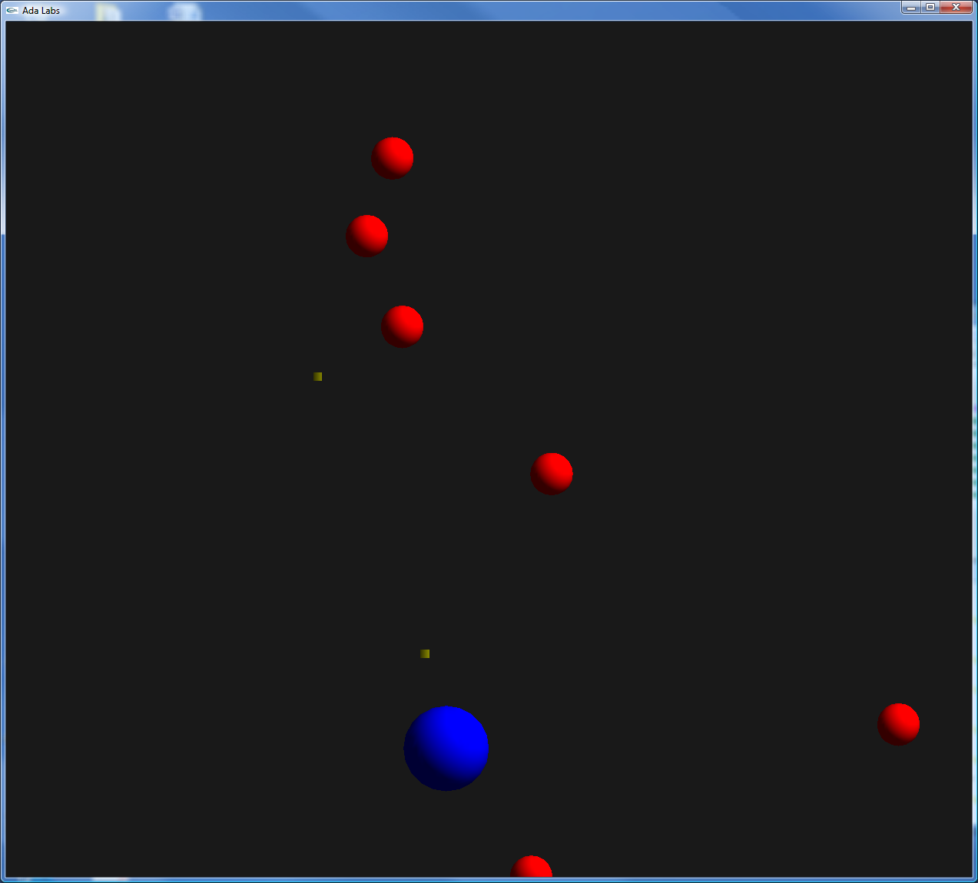
Question 1
Look at the suggested API for Invaders.ads.
- Complete the function Create_Game by initializing the player object.
- Update the Redraw subprogram to draw player objects as a blue ball.
- Complete the Set_X and Get_X subprogram – adds checks to that Set_X do not go out of the screen bounds.
- Update the main subprogram to move the player according to keys pressed by the user. You can retrieve those keys using Display.Basic. Current_Key_Press.

Question 2
Complete the Create_Foe subprogram, creating an enemy at the top of the screen, on a random X-axis position. Now update the Iterate subprogram: at each iteration all foes move down a little bit; if they reach the bottom of the screen, the game is over. This can be handled by an exception.
In the main subprogram, add some random generation of foes.

Question 3
Complete the Shoot subprogram. Now update the Iterate subprogram: at each iteration, all ammo move up a little bit; if they reach the top of the screen, they are deleted. If they enter in collision with a foe, then both the ammo and the foe are deleted.
Update the main subprogram so that the player can shoot by pressing space.

Question 4
Implement a linked list of Object types – do not use Ada.Containers. Replace the use of arrays of objects by this linked list.

