Space Invaders with OOP
The purpose of this exercise is to use an inheritance-based solution for the access exercise.
In this game, the player is represented by a blue ball at the bottom of the screen. He can move left and right using the left and right key of the keyboard – but can’t go outside of the [-100.0, 100.0] region. The red balls are enemies, falling from the top of the screen to the bottom. They appear randomly, and move left or right. Each time they reach a horizontal boundary of the screen, they rebound.
If a ball manages to go beyond the bottom of the screen, then the player has lost. In order to avoid that, he can fire bullet by pressing space. These bullets will go straight up from the player location to the top of the screen, and will destroy the first ball they encounter.

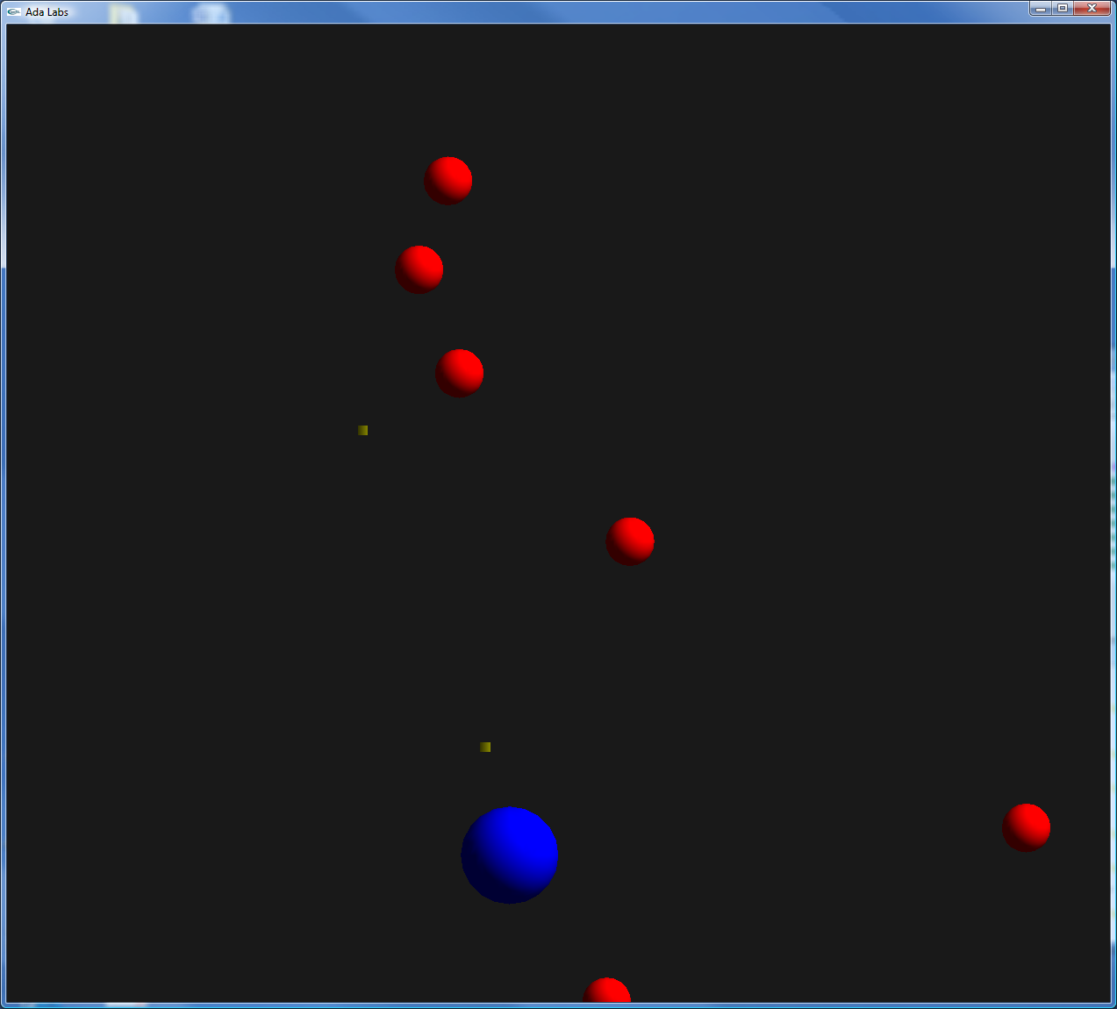
Question

Take either your answer or the official solution of the access exercise. Change the implementation of the objects, from a discriminant-based record to a hierarchy of objects.

