Extensible Space Invaders
The purpose of this exercise is to create an extensible Space Invaders game.
In this new game, the player is still represented by a blue ball at the bottom. However, the enemies’ behavior can now be customized by the developer – as well as ammo. An enemy falling down through the whole screen will just disappear, not creating a game over anymore.

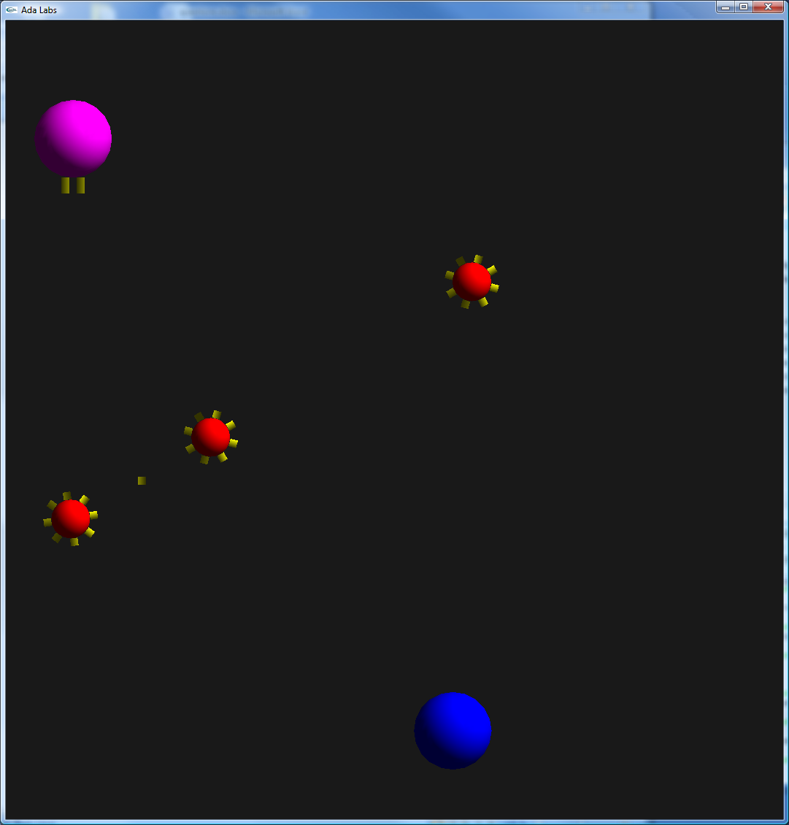
Question 1
Extend the type Ammo in a non-abstract type, representing a simple bullet. Implement all abstract subprograms. In particular, the Iterate primitive of the ammo is supposed to move it, and delete it when it goes off the screen.
Update Invaders.Players.Iterate, so that a bullet gets created when the player presses space.

Question 2
Extend the type Foe into a Kamikaze type. This object will only fall down from the top of the screen, like in the previous example. Implement the collision handling mechanism so that when it enters in collision with a bullet, it gets deleted.
Update the collision handling mechanism of the bullet so that it gets deleted when it enters in collision with an enemy.
Update the collision handling mechanism of the player so that a game over is raised when it enters in collision with an enemy.
Update the main subprogram so that foes are generated randomly.

Question 3
Create a new kind of enemy – with a different behavior. You may want to get implementations for other people as well.

