A Smart Shooter
The purpose of this exercise is to extend the type Shooter with a custom movement.
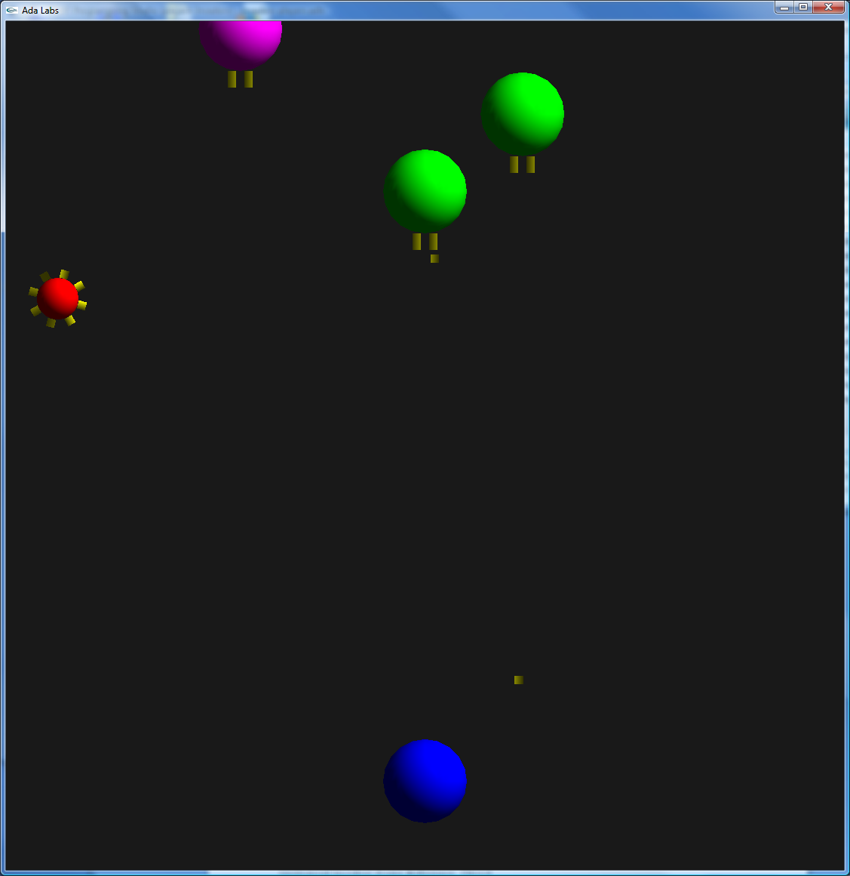

Question 1
Look at the Shooter_Type type that is provided with the specification. Factorize the code doing the movement as a new Move primitive defined as follows:
not overriding
procedure Move
(V : in out Shooter_Type;
The_Game : not null access Invaders.Games.Game_Record);

Call this primitive from the Iterate subprogram.

Question 2
Extend the type Shooter by a new type Smart_Shooter. Implement a new version of Create in order to initialize this object. Add a field Aim to the object, and override Move so that the shooter always moves in the direction of its target.
Update the main subprogram so that regular and smart shooters get randomly created.
Check that the call to the Move subprogram is indeed dispatching.

