Score keeping and shield building
The purpose of this exercise is to extend the space invaders application using interfaces
The previous lab has been enhanced with a text box keeping the score of the player, and a shield around the player in order to protect him against some collisions.

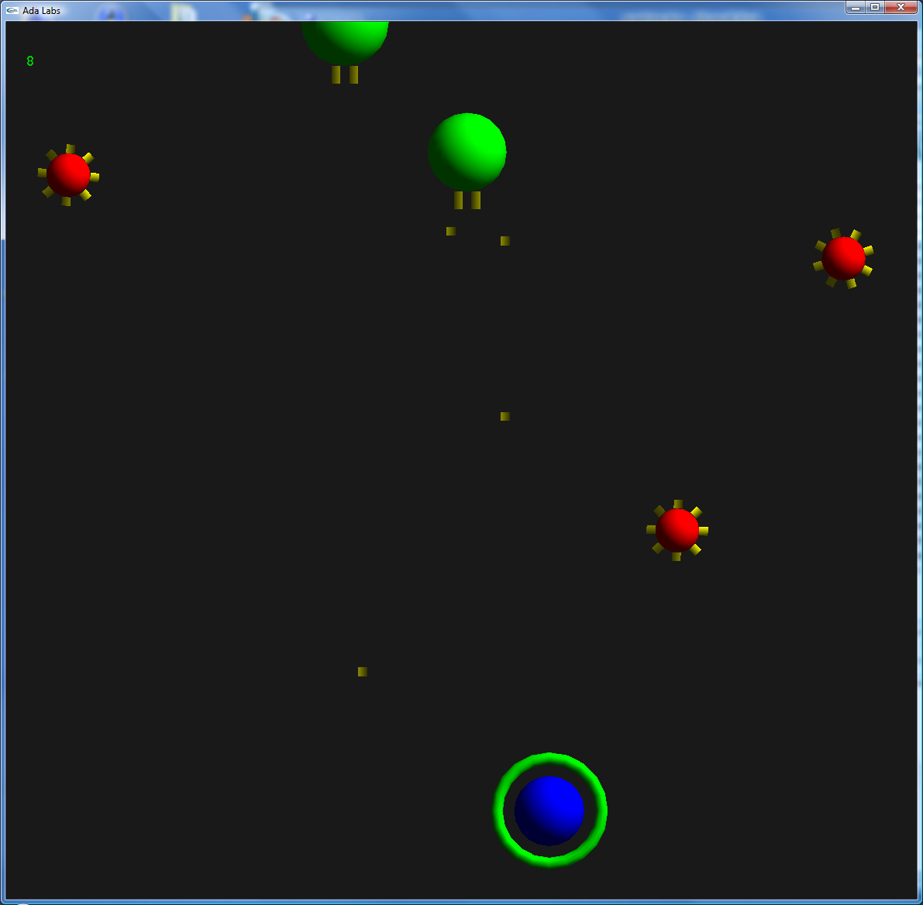
Question 1
The interface Score_Provider declared in Invaders.Objects.Extensions adds the possibility – if implemented – to increment the player score. Implement this interface in the type Kamikaze_Type and Shooter_Type.
Update Invaders.Games.Iterate. Each time an object is destroyed, if this object implements the Score_Provider extension, update the score.

Question 2
Objects that implement the interface Invaders.Games.Object_Deleted_Listener are supposed to be able to react to the destruction of an object. Implement this interface in the type Player_Type, so that when an enemy is deleted, the shield gets thicker by a small increment.
Update the Invaders.Games.Iterate subprogram so that all listeners are called upon object destruction. Don’t forget to register the player in the list of destruction listener, using the Invaders.Game.Register_Listener subprogram.

Question 3
You may notice that no matter how an object is destroyed, whether killed by the player or auto-destroyed by getting to the end of the screen – the score gets updated and the shield gets thicker. Create a new extension in the Invaders.Objects.Extensions package providing a reason for the deletion, and implement this extension in Kamikaze_Type. Modify the code updating score and shield in order to dismiss objects implementing this interface and specifying that the enemy has not been killed by the player.

