Super-kamikazes
The purpose of this exercise is to create a generic API for physics movements.

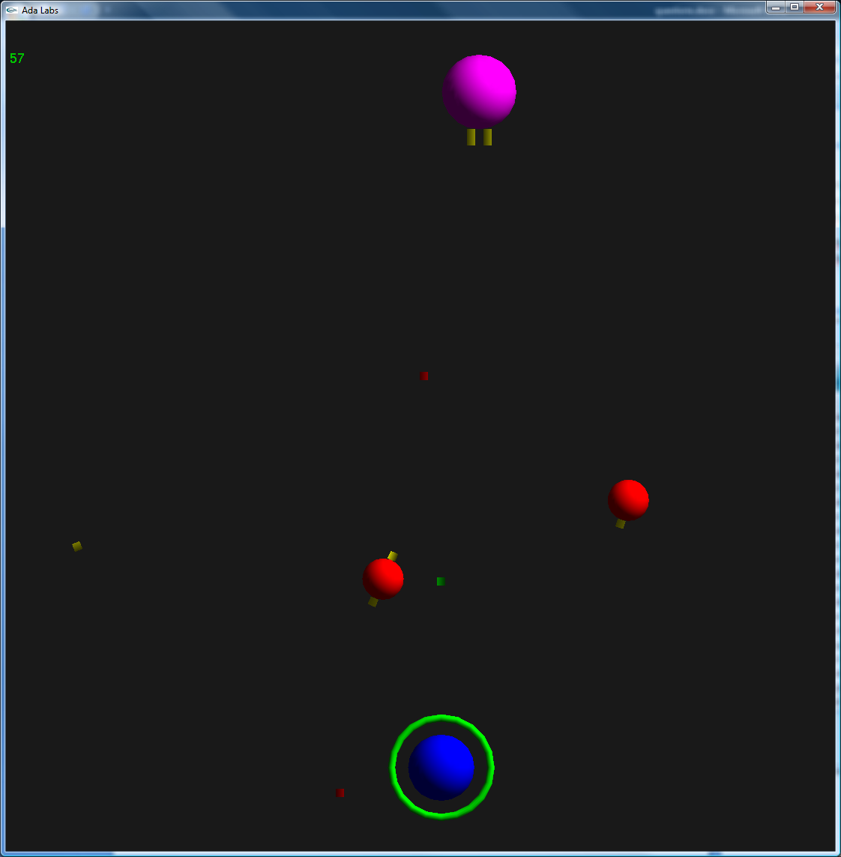
Question 1
The package Physics contains support for performing various physics computations. Change it to a generic package, using a generic Coordinate_Type and Object_Type. Add the necessary accessors to the generic declaration.

Question 2
Instantiate the new generic package in Invaders.Object, using Root_Object’Class. Use the instantiated Board_Type to store objects, and to compute collisions, in the package Invaders.Games.

Question 3
Describe the movement of a bullet using the Translation_Movement type of the physics package.
You may have noticed that kamikazes now have a random number of boxes around them. When they are destroyed, modify the code so that bullets are created from their positions.

