Space Invaders in DO-178C OOP

“Space Invaders” is a video game. It consists of the following components:
- A player, at the bottom of the screen. The player can only move along the X-axis, using the keyboard. When the space bar is hit, it fires a bullet – knowing that there is a maximum bullet fire frequency allowed.
- A shield around the player that grows every time an enemy is destroyed and shrinks when a bullet hits the shield. If there is no shield and the player is hit, the game is over.
- A score, updated each time an enemy is destroyed. Each enemy is worth a given number of points. Note that extension should be available so that score can be updated by other objects kinds in future versions of the game, such as bonuses.
- Enemies of various kinds. Enemies have their custom way of moving and firing, as well as a number of health points. They are randomly created at a known rate. The following kinds are implemented:
  - Kamikazes move from the top of the screen to the bottom in diagonal or straight direction. They carry a certain number of sub-munitions, which are launched in straight line either when they are destroyed or when they reach the bottom of the screen. They only have one point of life.
  - Simple shooters. These move only on the X-Axis, from one end of the screen to the other. They will fire on the player at a given rate when they are above it. They have 10 health points and shrink every time they are hit.
  - Smart shooters. They operate in a similar way as the simple shooters, but instead of moving from one end of the screen to the other, they move in the direction of the player.
- Bullets, created either by enemies or player. They are destroyed either when they reach the end of the screen, or when they hit their target. Bullets sent by the enemies target the player, and vice-versa.
The game area is defined by a height and width from -100 units to 100 units. No object should go beyond those limits.

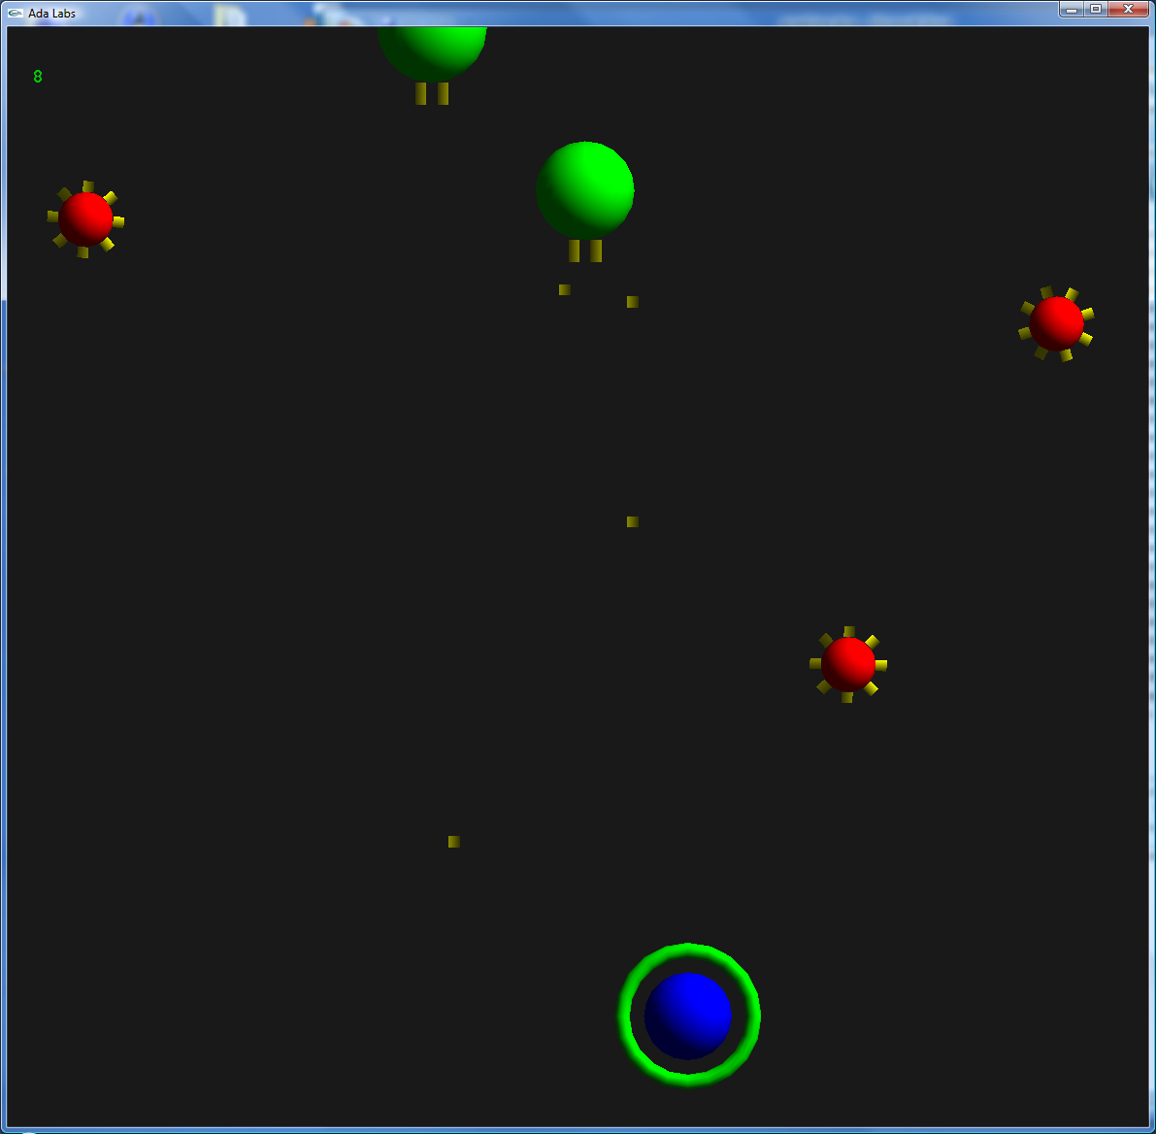
Question 1
Reorganize the exercise in the form of High Level Requirements (HLRs). Define additional constraints when appropriate.

Question 2
- Describe the various data of the game, gathered in classes. Identify an object root for all possible objects in the game, and describe a derivation tree.
- Identify other objects of potential interest outside of this derivation tree.
- Describe a game loop, with a sequence of operation that should be done of all objects of the game.
- Identify members that should be provided by these objects.
- Implement the score providing capability using interfaces.
- Consider that objects may need to react to object deletion on the board, such as the shield or the score, and use an OOP design pattern to implement this behavior.

Question 3
Write Low Level Requirements (LLRs) based on the HLRs and the architecture. Identify when LLRs are interesting to express in the form of pre-conditions, post-conditions and invariants.

Question 4
Concentrate on the derivation tree Object -> Enemy -> Simple Shooter -> Smart Shooter. Verify Local Type Consistency on the Iterate subprogram.

Question 5
Consider memory management. What are the possible memory management models? How would you handle each of the vulnerabilities for these?

