The Sun, the Earth, the Moon and one Satellite

The purpose of this exercise is to animate planets on the screen, one planet turning around the other.
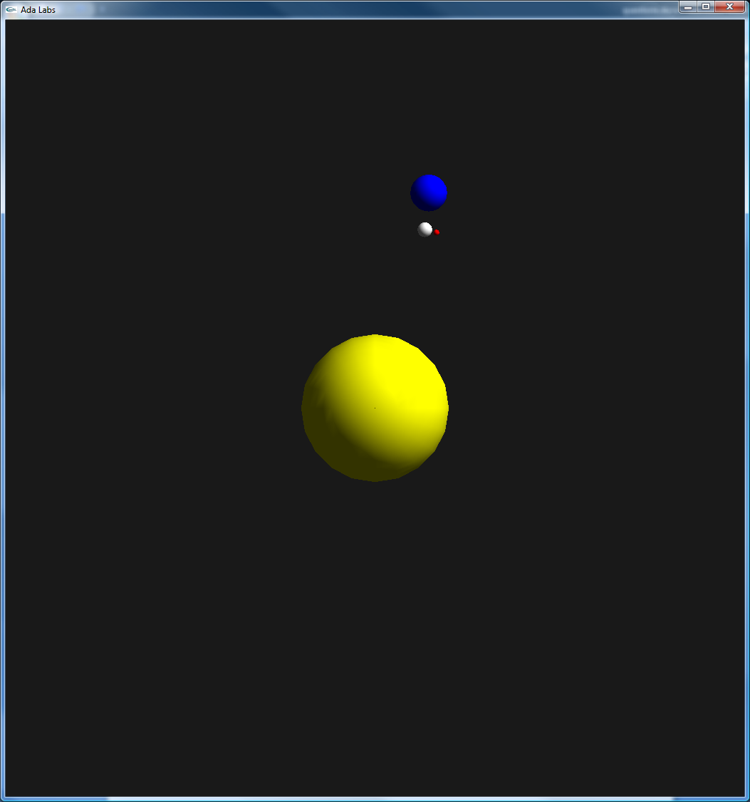 | Question 1  Create an enumeration type for various celestial bodies (Sun, Earth, Moon, and Satellite) and an enumeration for various metrics (Speed, Distance, and Angle). Create two arrays, one array of one dimension containing the different shapes to store, and one array of two dimensions for the various metrics to store.  Initialize the various values of the array with the following semantics:  - Speed: angle step (in radian) that has to be added to the star angle at each iteration  - Distance: distance from the star to the previous one (does not have any sense for the Sun star). This distance is computer in arbitrary board units.  - Angle: current angle between the star and the previous star (does not have any sense for the Sun star). This angle may be initialized by 0.  Question 2  Create an infinite loop that moves the four bodies by one predefined step on every iteration. Each object is supposed to rotate around the previous one in the star kind enumeration. In order to avoid having an active loop, use a delay statement in the loop.  Refine the values chosen in the previous question in order to have a smooth movement.

