The Satellite around the Earth
The purpose of this exercise is to use records to store information about the planets.
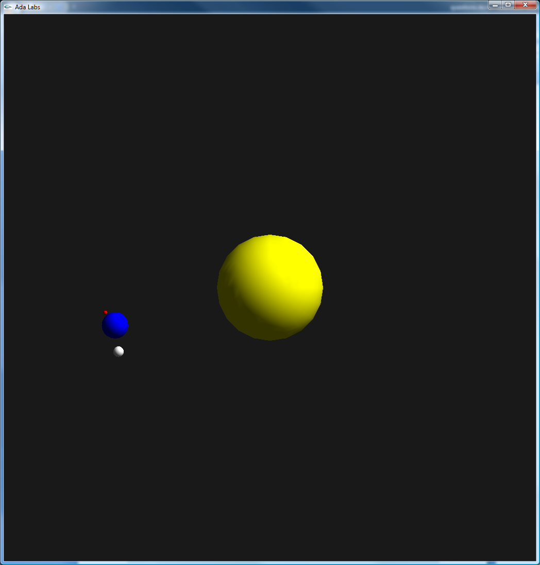 | Question 1  Go back to the solution of the exercise 01_array_types. Create a record type that holds all the information needed to describe an object, that is to say, (Speed, Distance, Angle, and Shape). Replace the two arrays solution of the previous exercise by one array indexed by star kind and containing components of this record.  Question 2  Add a Turns_Around field to the record, in order to store the object around which the object rotates, instead of forcing it to always rotate around the previous object of the system. Have both the Satellite and the Moon turn around the Earth.

