A Simple Comet
The purpose of this exercise is to animate the planets using subprograms.
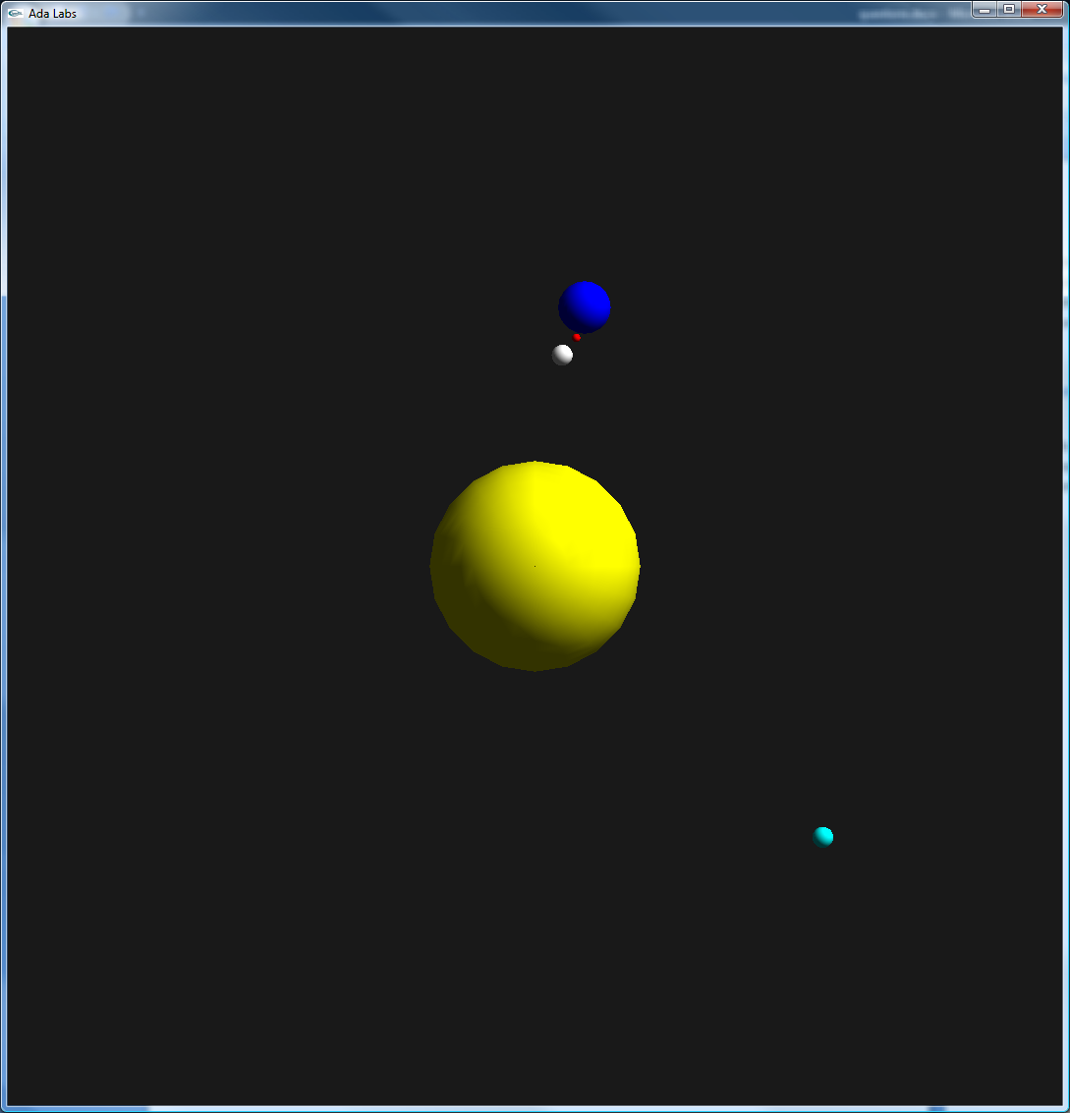 | Question 1  Go back to the exercise 02_record_types. Implement the Move subprogram, and use it to move the objects instead of doing all computations in the main loop.  Question 2  Add a comet in motion around the Sun.

