The Solar_System API
The purpose of this exercise is to write a driver for a Random Number Generator (RNG)
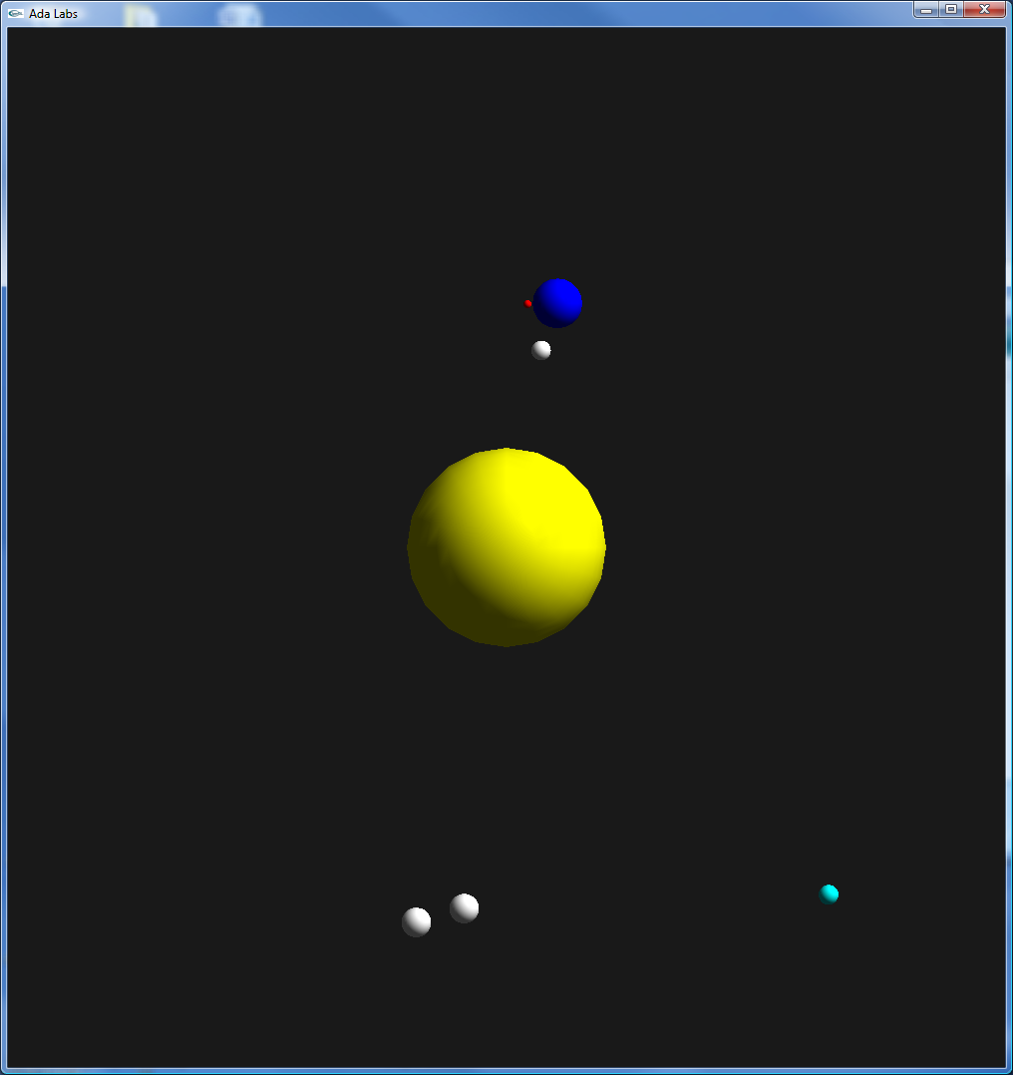 | Question 1  The section 24 of the STM32F429Discovery board datasheet contains the description of the hardware Random Number Generator peripheral.  Use this description to write code that will map this peripheral and its associated registers (24.4 section) in the stm32_svd.rng.ads specification file. Don’t forget to use the Ada language constructs specifically designed for this (records, representation clauses etc.).  Question 2  Implement the missing subprograms in stm32-rng.adb in order to fully control the Random Number Generator module.  All the documentation needed to implement these subprograms is present in the 6.3.6 and 24.3 sections of the STM32F429Discovery board datasheet.  Question 4  Now that we have all the subprograms needed to enable/disable the RNG module, implement the missing subprograms in stm32-rng-interrupts.adb to have a RNG module working via an interrupt mechanism.  Question 4  The purpose of this question is to implement a T_Change_Color_To_Random task that will set a random color of all the solar system bodies, every 2 seconds. This task should preempt all the other running tasks.  In order to achieve that, implement a Random_Color_Timing_Event type that will derive from the Ada.Real_Time.Timing_Event type and its associated protected object Random_Color_Timimng_Event_PO.  This protected object will be responsible for synchronizing the timing event with the T_Change_Color_To_Random task via a Wait_On_Random_Color_Timing_Event entry.

