Saturn and a Comet
The purpose of this exercise is to extend the Star API and protect its data.

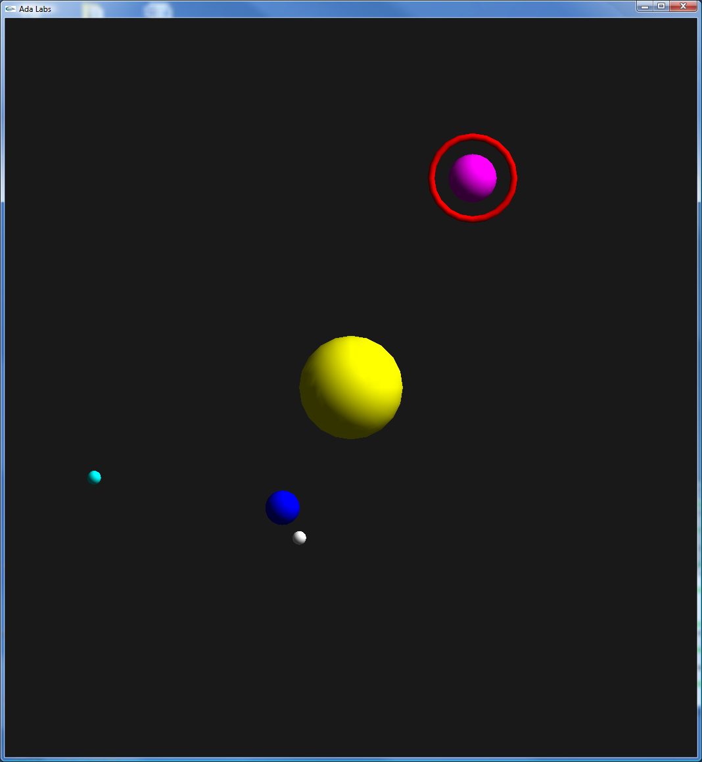
Question 1
Look at the suggested API of the Star package. There are two types, Star_Record and Star_System. Implement Star_Record for a simple star, and Star_System using a discriminant to give a dimension to an internal array, containing a list of Star_Record. Implement the following subprograms:
- Create_Star_System
- Create_Solar_Star
- Create_Simple_Planet
- Move_All
Update the Main in order to display these objects.

Question 2
Implement a type of the different kind of stars that can be represented on the board, plus a special case when there’s no graphical object associated to the star: {Solar_Star, Simple_Star, Moving_Position, Simple_Planet, Planet_With_Rings, Comet}. Update the type Star_Record with a discriminant of that type.
Create a discriminant part – e.g. Solar_Star does not need {Speed, Distance, Angle, Turns_Around}.
Implement Create_Planet_With_Moon. Update the Main to use this new subprogram.

Question 3
Extend the type Star_Record to support properly Planet_With_Rings, and implement the subprogram Create_Planet_With_Rings. You can use Display.Basic.New_Torus in order to draw the ring. Update the Main in order to use that new subprogram.

Question 4
Extend the type Star_Record so that it supports the Comet type. Implement the subprogram Create_Comet. Update Move_All so that the comet describes an ellipse instead of a circle. Update the Main in order to display a comet.

