The Asteroid Field
The purpose of this exercise is to create a field of asteroids around the star.
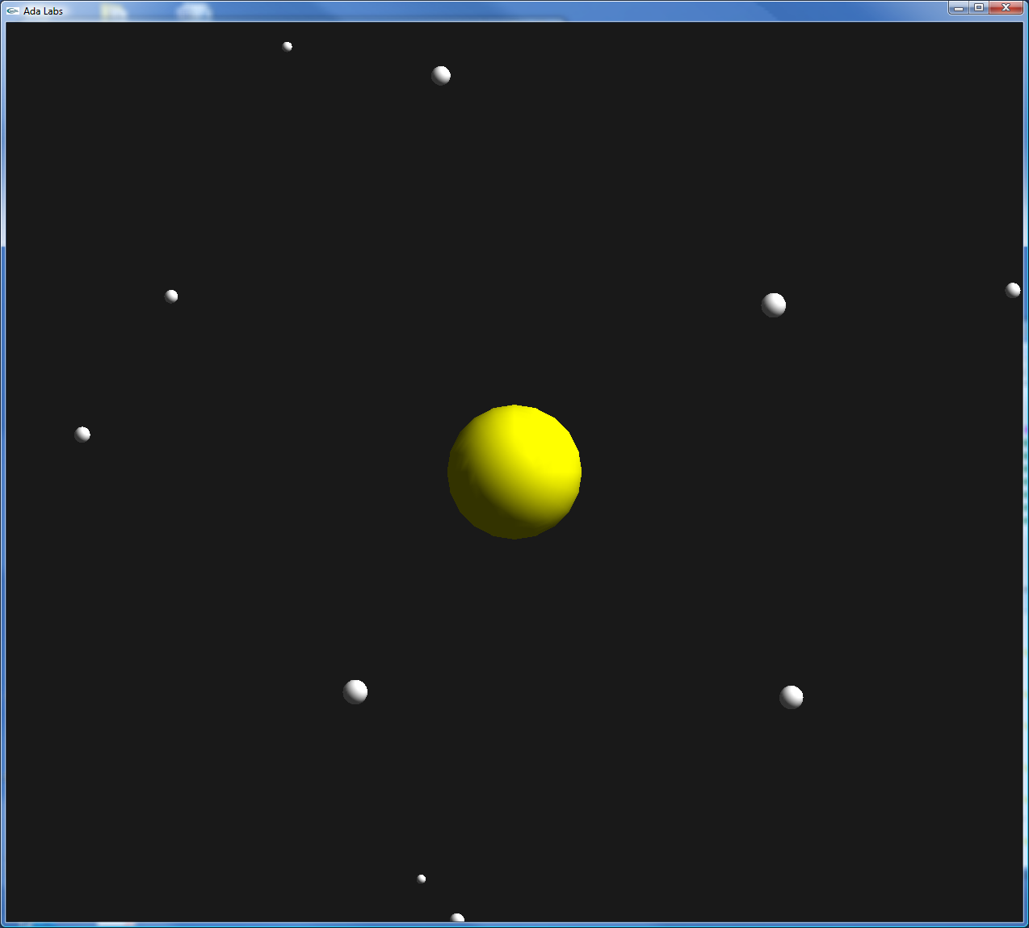 | Question 1  Implement the function Create_Asteroid of the package Stars. The asteroid should be a ball of a random Size between two values defined in the subprogram, of a random speed between Min_Speed and Max_Speed, and at a random distance between Min_Distance and Max_Distance. See the package Ada.Numerics.Float_Random for random number generation.  Create an array of asteroids around the sun – depending on the speed of your machine, between 50 – 200 asteroids.  Question 2  Take into account the parameter Handle_Collision in the Move subprogram – test all objects together. Each time a collision is found, raise the exception Collision_Exception.  In the Move_All loop, add an exception handler around Move and treat the exception by removing one of the two objects in collision.  Run the application – there should be no more asteroids in collision after a few seconds.  Bonus task: Ensure that it’s always the smaller of the two asteroids that’s removed.

