Getting further in the architecture
The purpose of this exercise is to extend the architecture of the application including aliasing.

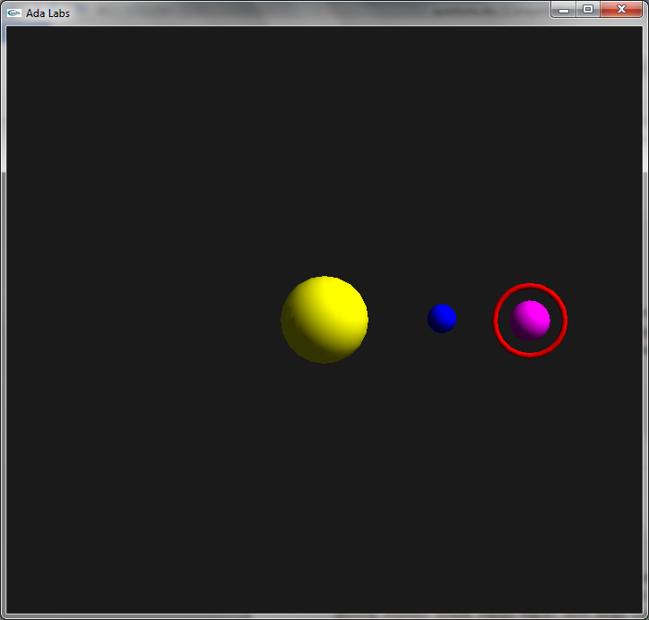
Question 1
Look at the suggested program. It is a re-architecture of the solution of the private types exercise, separating services into four different packages (Stars and 3 children, Physics, Solar_Systems and Systems). However, the latest changes introduced a bug and the stars are not moving anymore.
Look at Stars.Physiscs.Move_All. As you can see, there is a clear bug here. We get a copy of a Star_Record, and then modify this copy. So the initial record in the container will never be moved. Replace the copy by an access type, pointing directly to the star in the array.
Hints
1 – In order to reference an object in the array, the components will need to be declared aliased
2 – You will not be able to have a pointer to a part of a Star_System with an “in out” mode. Instead, you will need to pass a pointer to this object to the function Get.
3 – The solar system will need to be aliased to be passed by pointer to Get.

Question 2
Use an access to Star to implement the field Turns_Around in the Star record instead of a Star_Index.

Question 3
Improve the safety of the application by declaring the pointer to star to be “not null”. Update the code as necessary.

